• Next, create a directory named **textData** in the HDFS.

• Copy the CSV file, **csvFile.csv**, into the **textData folder** in the HDFS.

• Copy the TXT file, **textFile.txt**, into the **textData folder** in the HDFS.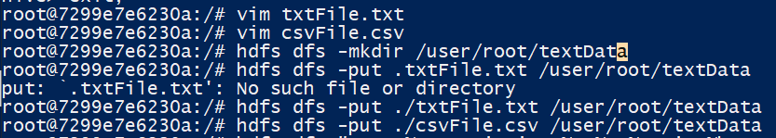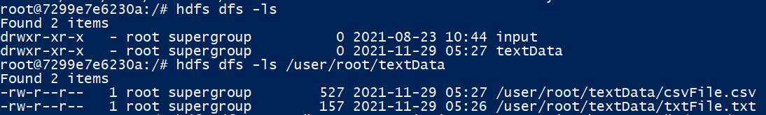

* Finally use the stat command to get the file statistics:

