Copy local file ‘file01.txt’ to HDFS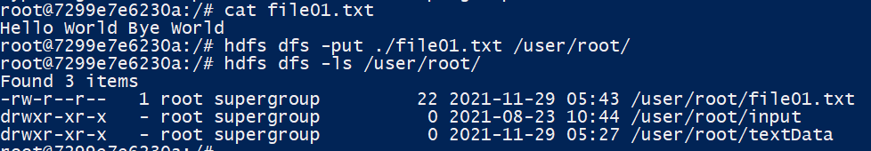

Creating .pig file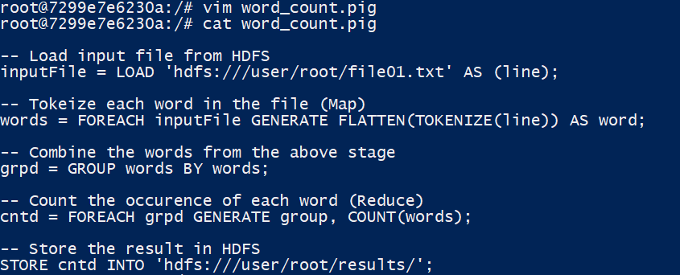

MapReduce using .pig file