Copy local file ‘salesCSV.csv’ to HDFS

Creating .pig file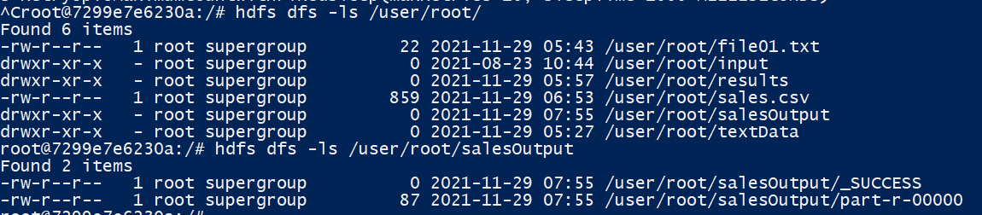

MapReduce using .pig file