Creating file ‘file01.txt’ in Linux local machine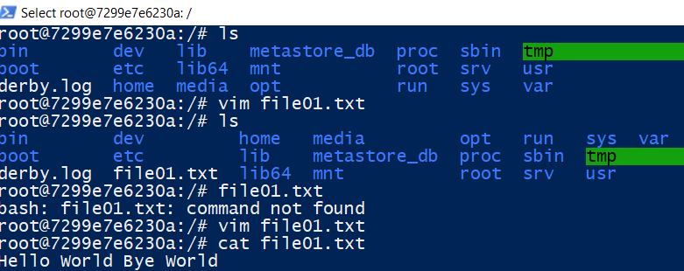

Creating table in Hive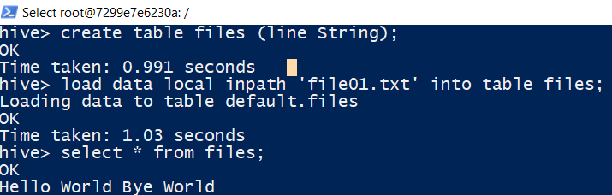

Creating table to store data after MapReduce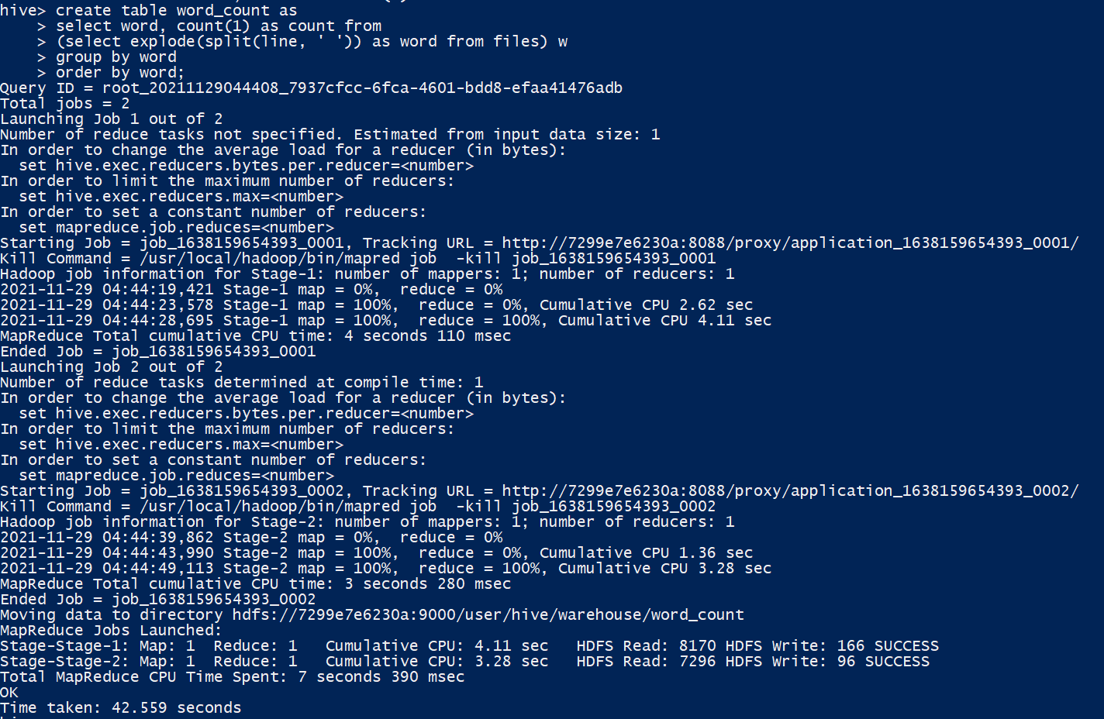

Select data from word_count table