How are you?

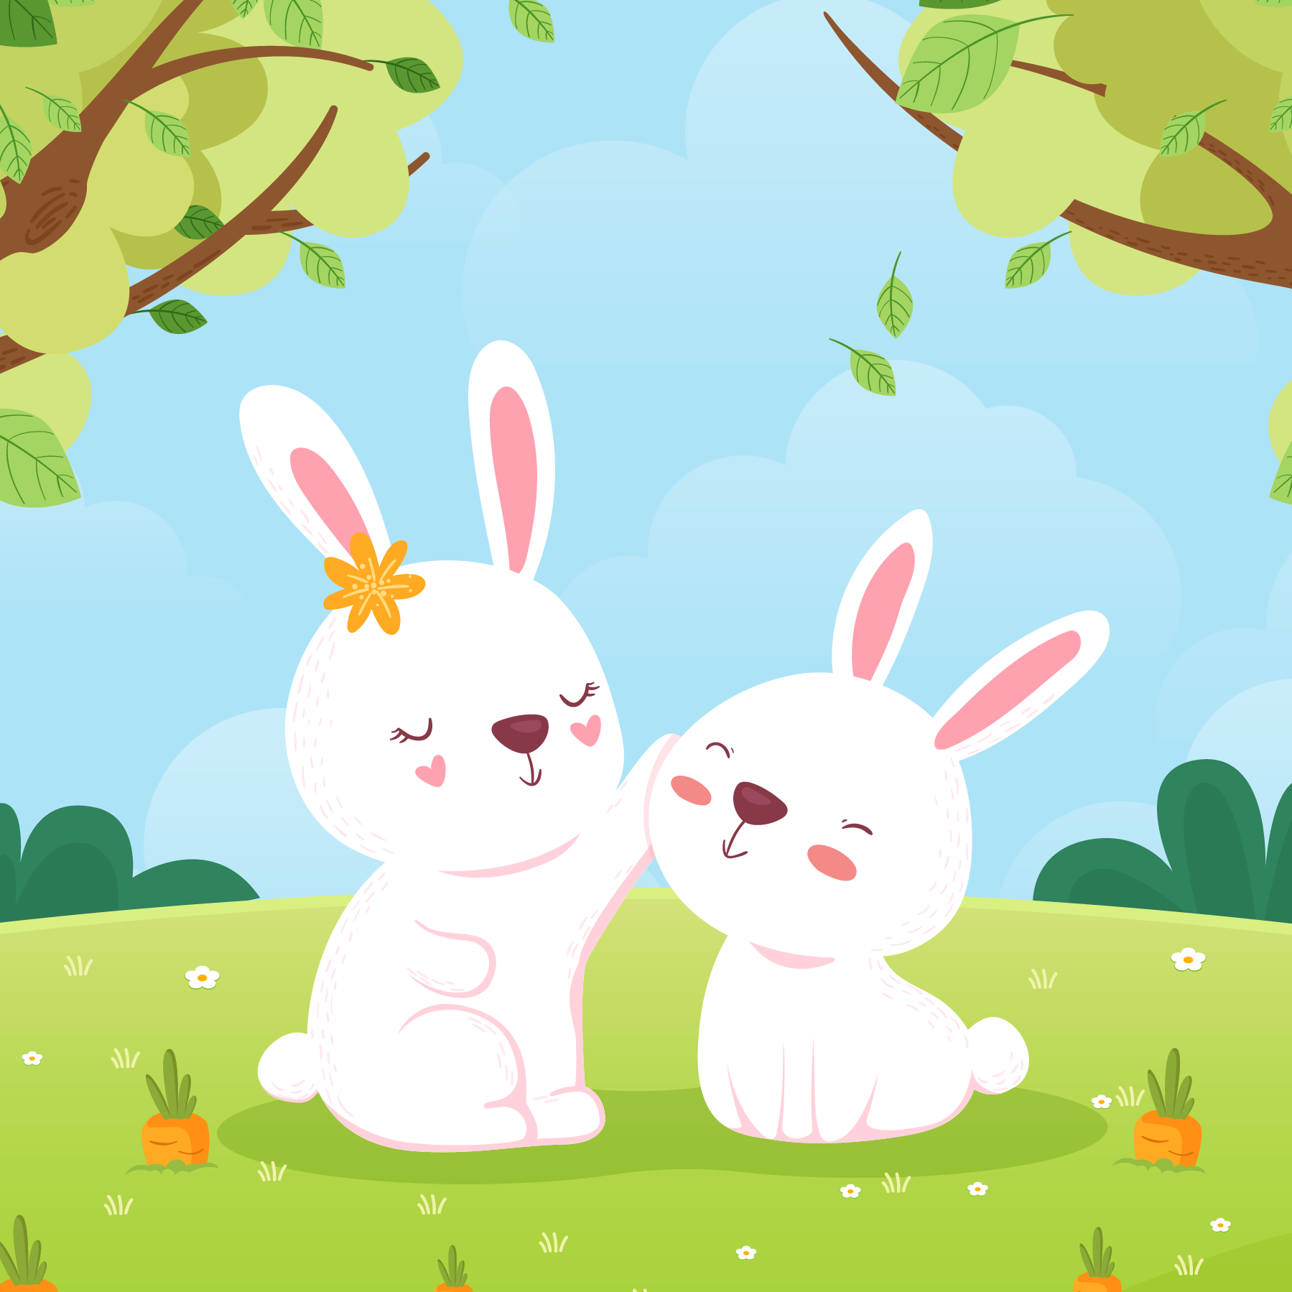

How are you?

What’s up?

I’m fine,thank you.

Very well,thanks.

What’s going on?

How are you doing?

What have you been up to?

Same old same old.

Same thing different day.