Happy Birthday

**一、数字**

(**注意十几vs几十的发音**)

zero

one,two,three,four,five,six,seven,eight,nine,ten

eleven,twelve,thirteen,fourteen,fifteen,sixteen,seventeen,eighteen,nineteen

twenty,twenty-one,thirty,forty,fifty,sixty,seventy,eighty,ninety

one hundred,one thousand,ten thousand

1,001,001,000

Billion Million Thousand

**扩展**

1.十进制

2.五进制

Ⅰ Ⅱ Ⅲ Ⅳ Ⅴ

Ⅵ Ⅶ Ⅷ Ⅸ Ⅹ

Ⅺ Ⅻ

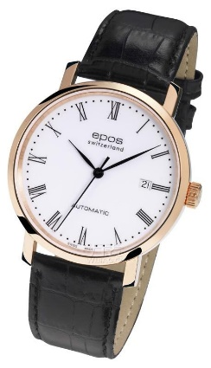 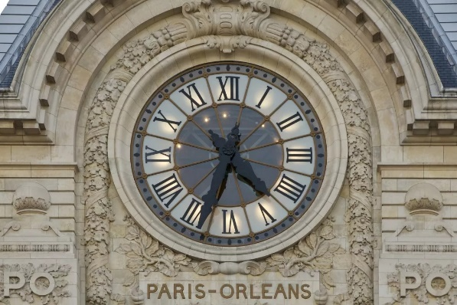 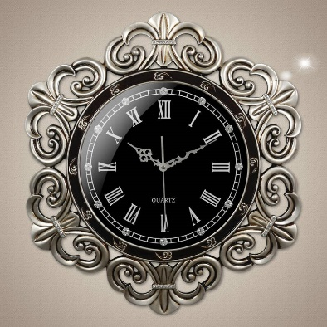

3.二进制

01,10,11,100

520 = 1000001000

**二、第几**

first,second,third,fourth,fifth,sixth,seventh,eighth,ninth,tenth

eleventh, twelfth, thirteenth..

twentieth, twenty-first..

**扩展：**日期

Mar. 1st,2019

Mar. 2nd,2019

Mar. 3rd,2019

Mar. 4th,2019

**三、生日与星座**

**When**’s your birthday？ - 你的生日是什么时候？

July 4th,2012 / Jul**.**4th,2012 / 07-04-2012 （美式：月/日/年）

1st, September,1963 / 1st, Sep**.**,1963 / 01-09-1963 （英式：日/月/年）

What’s your **sign**? – 你是什么星座？

I’m **a** Cancer.

**四、many/much 许多,多少**

Many +可数复数

How many pens?

There **are** so **many pens**.

Much +不可数

How much water?

There **is** so **much water**.

How much **is it**?

100 Yuan.

I don’t know how much **it is**.

It **cost** 100 Yuan.

I **spent** 100 Yuan to buy it.