SST English Test One

Name:______ Score:______

Part A. Reading

***Ⅰ.Read and Choose.*** (2’×40=80’ 可多选)

1. Terry:I will ______ in the morning.
2. Mum: I will ______ to pick Terry up.
3. go to school B.go to the school

3. Could you borrow(借) me ______ eraser?

4.It’s ______ big apple.

1. a B.an

5.Look at our ______ !

1. foot B.feet

6.These(这些) ______ are about seven ______ .

A.story,monkey B.stories,monkeies C.stories,monkeys D.story,monkies

7.Penelope ______ a lot of greetings yesterday.

1. learned B.learn C.learnt

8.Valency: I didn’t ______ your name earlier, I’m Valency.

Terry: Oh.I’m Terry.

1. catch B.know

9.Terry: Hi, Shadow, what’s up?

Shadow:Hi,Terry,______

1. what’s up? B.no,thanks.

10.Sebast: What have you been up to? Terry:______

A.Same old same old B.bye bye

11.This year is ______

1. pig year B.the year of the pig C.a pig year D.the pig year

12. Valency: What’s your Chinese zodiac? Terry:I’m ______ dragon.

13. Sebast: What’s your sign? Shadow I’m ______ Taurus.

1. a B.the C.one D.belong to

14. My father was born in the year of the ______.

A.chick B.cock C.hen D.rooster

15. I like ______ the milk.

1. eating B.drinking

16. Let’s go to ______ riddles（猜灯谜）.

1. guess B.solve C.ask D.think

17. We can swim in ______,and animals can hibernate(冬眠) in ______.

1. spring B.summer C.autumn D.winter.

18. When I go to school, I need to walk for 5 minutes and then take a ______.

1. left B.right

19. He has a lot of _____ .

A.money B.moneies C.moneys

20. Valency: ______ some bread. Terry: Thank you.

A. Eat B.Have C.Drink D.Chi

21. Terry: Thank you very much. Sebast: ______.

A. You are welcome B. Not at all C.That’s all right D. It’s OK.

22. I like the book ______.

A.too B.either

23. I don’t like eating chilies(辣椒) ______.

A. too B.either

24. The date is ______.

A.Mar3rd,2019 B.Mar3th,2019 C.2019,Mar3th D.2019,Mar3rd

25. Four times seven equals ______.

A.11 B.-3 C.28 D.4/7

26. Eleven plus eight equals ______.

A.19 B.3 C.88 D.11/8

27. Twelve minus nine equals ______.

A.21 B.3 C.108 D.4/3

28. Forty-nine divided by seven equals ______.

A.58 B.42 C.343 D.7

29. Terry: I’m so ______. Granny: Have some noodles.

A.hungry B.thirsty

30. ______is the middle day of a week.

A.Wednesday B.Thursday C.Tuesday

31. There are so ______ pears.

32. There is so ______ juice.

A.many B.much

33.Terry:How ______ is this?

Shadow: One hundred Yuan.

A.much B.many C.price D.money

34. He ate so much every day, ______ was so fat.

35. He was so fat, ______ he ate a lot every day.

A.because B.so

36. I ______ 8 yuan to buy the bread.

37.The bread ______ 8 yuan.

A.cost B.spent

38.The

39.

40.

***Ⅱ.Color.***(1’×15=15’)

1. ***Wire the color block with its correct name***

Red Orange Yellow Green Cyan Blue



Purple Black White Pink Megenta Brown

1. ***When mixing the colors, write the probable color name.***

Red + Yellow = ______ Red + Blue = ______ Green + Blue = ______

***Ⅲ. Read and Choose.*** (1’×10=10’)

A.hands B.foot C.mouse D.legs E.arms F.body G.face H.teeth I.lips J.mouth

Wave your ______. （挥挥手）

Clap your ______. （拍拍手）

Shake your ______.（晃晃腿）

Stamp your ______.（跺跺脚）

Turn around your ______.（转转身）

We should brush our ______ every day.

Valency always puts lipstick（涂口红）, so her ______ are red.

I use my ______ to eat, not ______.

She is so shy（害羞）, then her ______ turns red.

***Ⅳ. Read and Choose.*** (2.5’×4=10’)

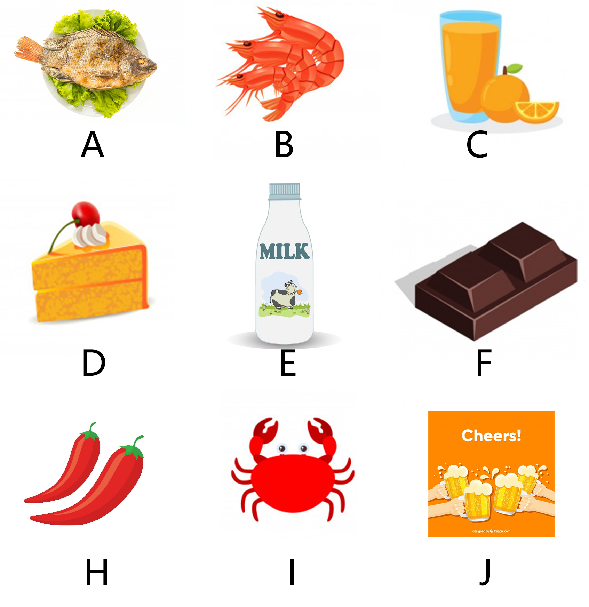

***Terry***: I’m so hungry. I’d like some fish, prawns, and juice.

***Shadow***: Can I have some cake and milk, please?

***Sebast***: Sure.How about you, Valency?

***Valency***: I’d like some bread and chocolate.

***Shadow***: Have some milk, too.

***Valency***: OK. Thank you.

***Shadow***: Can I have some chilies?

***Terry***: No chili, please.

Terry: ____________

Shadow: ____________

Valency: ____________

Sebast: ____________

***Shadow***: OK.

***Sebast***: I ordered the same as Terry. Let’s drink some beer too.

Cheers!

Part B. Writing

***Ⅴ.Writing the English diary.*** (1’×5=5’)

今天天气晴朗，我读了1本书，然后我和妈妈一起玩了游戏，我过得很开心。

Tips read（读）、together（一起）、play（玩）、game（游戏）、happy（开心）