Test Report
for
Design and Implementation of a Lightweight
Education Data Bay Area (E-DBA)
Version 1.0 approved
Prepared by
Taian Yu (FULL) Yolanda Yin (FULL)
Justin Zhang (FULL) Aaron Liu (FULL)
Steven Luo (FULL) Younger Yang (FULL)
Group C01
May 3, 2025
Contents
1. Brief description 1
2. Test date and performer 1
3. References 1
4. Error report 1
5. Appendix 2

Brief description
This test effort aimed to perform a quick system-level validation of the E-DBA core modules (Organization Registration, Thesis Access, Service Payment, Course Information Provision) with the testing time 0.008 s. It covered both positive and negative scenarios, focusing on functional correctness, boundary conditions, and error handling to ensure the system meets specified requirements.

Test date and performer

Test date | Tester name
2 May | Justin Zhang
2 May | Younger Yang
2 May | Steven Luo
2 May | Aaron Liu

References
Reference Documents:
Software Requirements Specification (SRS)
SE_SDW_Project Long Description V2.3
Test_plan

Error report

Register Organization (by O-Convener)
Test case ID | Expected result | Actual result
1 | When user attempts to register an application with an already existing organization name and/or email, the system prevents successful submission and insertion of new data | The system does not prevent submission of application with an already existing organization name and/or email, thereby allowing multiple application and convener accounts using the same name/email

Access Thesis (by Public Data Consumer)
There are no failed test cases in Access Thesis.

Pay Service (by Public Data Consumer and O-Convener)
Test case ID | Expected result | Actual result
4 | Transfer is blocked and system displays an error message. | Transfer is not blocked and system does not display an error message.

Provide Course Info (by Private Data Provider)
There are no failed test cases in Provide Course Info.

Appendix
Here are two screenshots (in the next page) of using LoadRunner to test use case “Provide Course Info” to get a copy of a Vuser script:
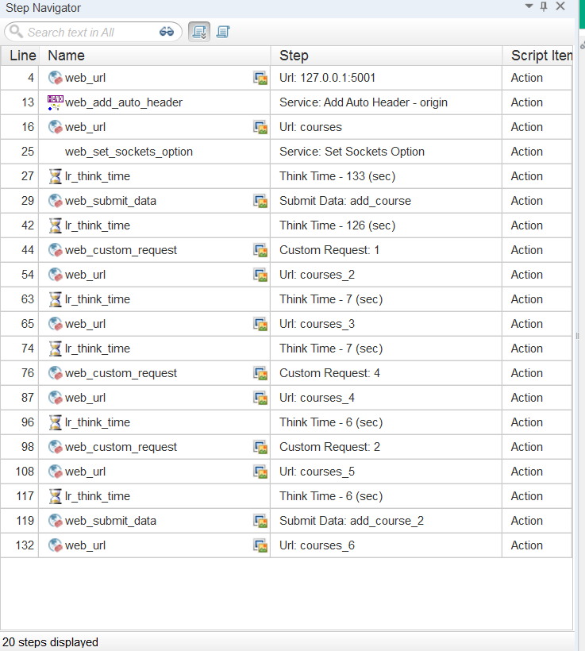

Figure 1: Step Navigator
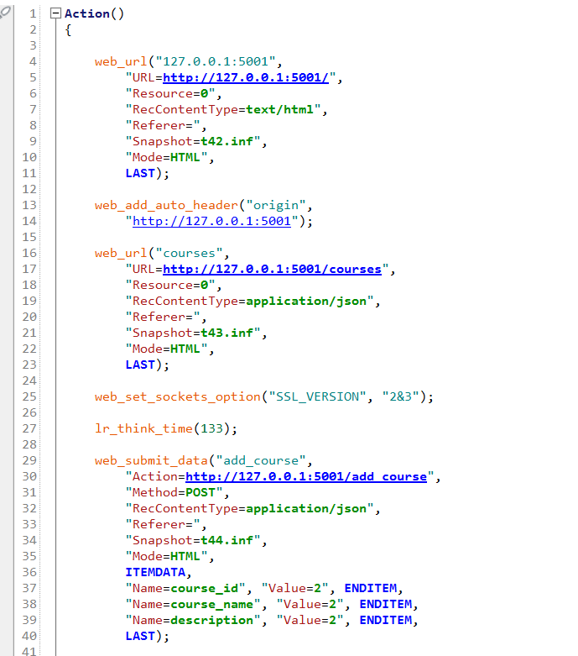

Figure 2: Action.c

