DeltaSeek: Toward Active Perception in Evolving Construction Environments
Sanjay Acharjee¹
Ph.D. Student, Dept. of Civil Eng.
University of Texas at Arlington
Arlington, TX, USA
E-mail: abirkhan.ratul@uta.edu
Md Nazmus Sakib, Ph.D.^{2*}
Assistant Professor, Dept. of Civil Eng.
University of Texas at Arlington
Arlington, TX, USA
E-mail: mdnazmus.sakib@uta.edu
Abstract—Construction environments evolve continuously: elements are installed, temporary objects appear and disappear, and surfaces that were visible last week are inaccessible today. Perception in such settings cannot be treated purely as a static mapping problem in which observations are gathered first and interpreted afterward, because large geometric change reduces the correspondence between observations taken at different times and makes registration progressively harder. This motivates an active formulation, in which the robot deliberately selects sensing configurations that resolve the current state of the environment.
We present DeltaSeek, an initial framework toward active perception in evolving built environments. The broader objective is a robot that reasons about where to observe, how to observe, and ultimately when enough evidence has been gathered; as a first step we address a prerequisite common to all three, namely how far sensing embodiment constrains the observations available at all. We formalise the admissible observation set of an embodiment and evaluate a Husky A300 with a UR5e on an IFC-derived benchmark under chassis-mounted and wrist-mounted RGB-D configurations, scoring observations by geometric visibility and effort by drivable distance. In a room-scale scene with eight controlled changes spanning four observability conditions, exhaustive evaluation over 240 admissible base poses shows that two changes admit no chassis viewpoint whatsoever while the wrist camera resolves both, and that where both embodiments succeed the median drivable distance to first observation rises from 6.0 m to 14.2 m. The results separate two effects an active-perception system must treat differently—sensing capability, where embodiment decides whether an informative observation exists, and acquisition cost, where it exists but must be paid for in motion.
Keywords—active perception, viewpoint planning, construction robotics, building information modelling, mobile manipulation
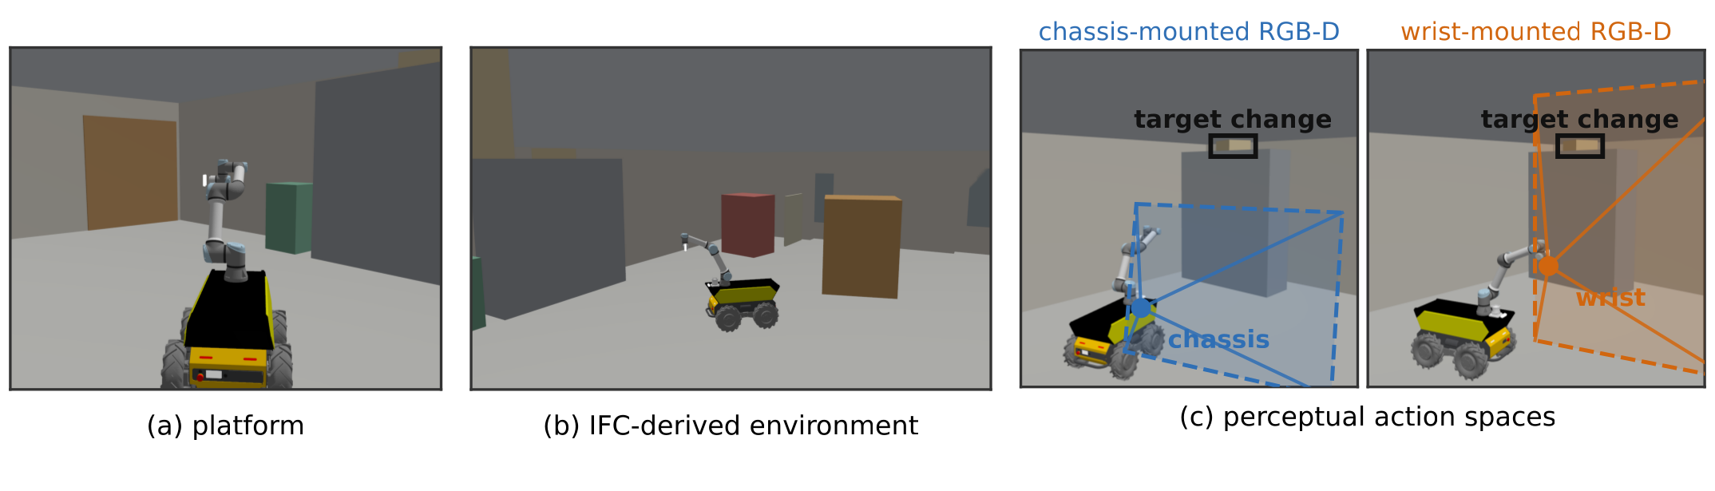
- The study, in simulation. (a) A Husky A300 with a UR5e, carrying a chassis RGB-D camera and a lidar on the deck and an identical RGB-D camera at the wrist. (b) Hall B, clipped from a real Revit IFC export, with the eight injected changes. (c) Admissible observation sets: each sub-panel uses the base yaw that aims its sensor at the same target, since the arm rotates the wrist camera 90° off the base heading. Frusta are drawn to the target's depth; the change falls outside the chassis frustum and inside the wrist one. Renders and frusta come from the evaluation's camera poses.

Introduction
A construction site is not a scene to be mapped once. Between two visits walls are erected, services are hung, pallets are delivered and consumed, and formwork is struck; the regions that changed are precisely the regions a verification system cares about. Robotic capture pipelines are nevertheless organised predominantly around passive accumulation: a coverage route is driven, point clouds or images are collected, registered to the model, and differenced offline [1], [2], [3]. Registration depends on correspondence between what was observed before and what is observed now, and large change is exactly the regime in which that correspondence becomes sparse: the information the robot most requires is the information its pipeline is least equipped to acquire.
Active perception provides the alternative framing [4], [5]: sensor placement is treated as a decision that resolves a specific uncertainty. Applied to an evolving building, this amounts to asking where to look next in order to determine whether part of the model still describes reality, which requires answering, in sequence, where to observe, how to observe, and when sufficient evidence has been gathered.
This paper takes a deliberately narrow first step. Before a planner can choose among sensing configurations, the set of observations the robot's embodiment makes available must be characterised. A mobile manipulator can place a camera almost anywhere in its reachable workspace; a fixed chassis sensor cannot. That freedom is commonly assumed valuable and seldom measured. Our contributions are a formulation separating the admissible observation set of an embodiment from the cost of reaching it; a reproducible IFC-derived benchmark that clips a real Revit export into a room-scale scene and injects controlled changes labelled by an observability class describing why they are hard to observe; and an exhaustive sensor-configuration study whose central finding is a distinction we believe generalises—embodiment partitions scene changes into those a configuration cannot observe at all, and those it can observe only at greater cost.

Related Work
As-built verification against a building model is well established, from dimensional compliance checking [1] to progress tracking [2], [3]. Such systems consume data rather than plan it: the route is set by coverage or an operator, and the verification objective does not influence where the sensor goes.
Active perception treats sensing as an action to be planned [4], [5]. Next-best-view methods maximise expected information for reconstruction [6], [7] or exploration [8], [9], typically under an unknown-space objective. Our setting differs: a strong prior exists, and the question concerns what has changed. Mounting the sensor on a manipulator enlarges the achievable viewpoint set, but the magnitude of that gain is rarely quantified.

Problem Formulation
Let M denote prior knowledge of the environment, such as a BIM model, a previous map, or a registered scan, and let E_{t} denote the unknown physical state at time t. A sensing configuration q consists of a mobile-base configuration q_{b} and an arm configuration q_{a}:
$q=\left(q_{b} , q_{a}\right)$ (1)
A general active-perception system would select a feasible configuration by trading the expected task-relevant utility of a future observation against its acquisition cost:
$q^{∗}=\underset{q∈Q}{arg max}\left[U\left(q | M, B_{t}\right) − λC\left(q\right)\right]$ (2)
Here Q is the feasible sensing-action space, B_{t} denotes the evidence or belief accumulated so far, U is the expected utility of the observation for the current task, and C is the cost of acquiring it. The long-term DeltaSeek objective is to instantiate U using perceptual evidence such as RGB, depth, point-cloud completeness, registration confidence, or task-specific uncertainty, and to introduce a stopping rule for deciding when further sensing is unnecessary.
The present paper deliberately isolates the geometric prerequisite for (2). For a scene change or observation target e and sensing configuration q, let V(e, q) ∈ [0, 1] be the visible supporting-surface fraction after range, frustum, incidence, and occlusion tests. An observation is considered geometrically admissible when
$V\left(e , q\right) ≥ τ_{v}, with τ_{v} = 0.05$ (3)
For sensing embodiment s (chassis or wrist), define the admissible observation set
$Q_{e}^{s} = \left\{q ∈ Q_{s} : V\left(e , q\right) ≥ τ_{v}\right\}$ (4)
The set Q_{e}^{s} provides the central decomposition studied in this paper. If Q_{e}^{s} is empty, the target lies outside the sensing capability of embodiment s and no routing policy can recover it. If Q_{e}^{s} is nonempty, the observation is feasible and the question becomes how much motion is required to reach one of its admissible configurations. With start configuration q₀, an idealised acquisition cost is
$C_{s}\left(e\right) = \min_{q ∈ Q_{e}^{s}}{d_{nav}\left(q_{0} , q\right)}$ (5)
where d_{nav} is collision-aware drivable distance; in planned runs the realised cost is the accumulated route length at which e is first observed. Fig. 3 visualises these two quantities directly: the left panel estimates the size of Q_{e}^{s}, the right panel the cost of reaching it.

Benchmark

From IFC to a room-scale scene
The benchmark derives its geometry from a Revit 2025 IFC2X3 [10] export of a single-storey building, 44.5 × 19.0 × 4.5 m, comprising 133 products that convert without failure through IfcOpenShell [11]. Each product is approximated by a box oriented in its own placement frame. Orientation is not a refinement: the export sits on a site grid rotated 0.90° from the world axes, and a world-aligned box expands a 0.203 m wall to 0.82 m—a fourfold error on the dimension deciding whether the robot fits between two walls.
A storey is an unsuitable unit for studying observation—one wall entity spans the full 39 m of a facade—so we clip the manifest to a rectangle, cutting in each element's own frame to preserve the rotation. The resulting scene, Hall B (Fig. 1b), measures 7.0 × 12.5 m and contains twelve modelled elements plus two added fit-out units, since the export has no furniture and both occlusion and height-limited observability need objects to stand behind or on top of.

Observation model
The visibility term V(e, q) of (3) is evaluated geometrically rather than from rendered imagery. An element's surface is sampled, and a sample counts when it lies within the view frustum, faces the camera within a 75° incidence limit, and is unoccluded. Each change type carries its own supporting surface: an unmodelled object is supported by seeing the object, a displaced element by seeing it in its new position or its modelled volume empty. The threshold τ_{v} = 0.05 stands in for detector sensitivity. The model assumes perfect recognition and localisation, so it measures viewpoint quality rather than perception robustness; in exchange it is fast enough to evaluate exhaustively over Q_{s}, which rendering is not.

Acquisition cost
The distance d_{nav} of (5) is a Dijkstra search over an occupancy grid inflated by the platform's Nav2 footprint (0.606 m circumscribed radius, 0.06 m resolution). The choice matters: on the storey-scale scene drivable distance averages 1.8× the straight line and reaches 11×, and a straight-line surrogate would let a robot pass through walls to reach a viewpoint.

Observability classes
The type of a change describes what moved; it says nothing about whether a sensor can observe it. We therefore label each change by why it is hard to observe: trivial, a large unmodelled object in open floor space; height, above the chassis camera's sightline; incidence, resolvable only from an oblique angle; and occluded, in another object's shadow from most base poses.
Eight changes were hand-placed in Hall B, two per class, in a committed scenario rather than sampled, so that each is explainable from geometry and the study is exactly reproducible. The trivial pair is a control: a configuration that misses it is demonstrably broken.

Sensing Configurations
The platform is a Clearpath Husky A300 with an AMP enclosure and a UR5e, generated from a single robot.yaml so simulation and hardware share one description. It carries two RGB-D cameras of the same model, so the comparison isolates where a camera is mounted rather than how capable it is. The chassis embodiment places the camera on the enclosure deck at (0.460, 0.000, 0.418) m in the base frame, pitched 0.17 rad down; its pose is a function of q_{b} alone. The wrist embodiment is eye-in-hand, its pose obtained by forward kinematics over the generated description across five inspection postures q_{a}, verified against the running simulation's transform tree to machine precision.
The base configurations q_{b} lie on a 1.0 m grid of navigable free space inside the room at four yaw bins 90° apart, giving |Q_{b}| = 240 admissible base poses from 60 positions; both embodiments share this set, so the comparison is not confounded by base sampling. Each base pose combines with the five arm postures, so |Q_{wrist}| = 1200 distinct camera poses while |Q_{chassis}| = 240, the chassis camera being invariant to q_{a}. In the both configuration an element is observed if either sensor observes it.
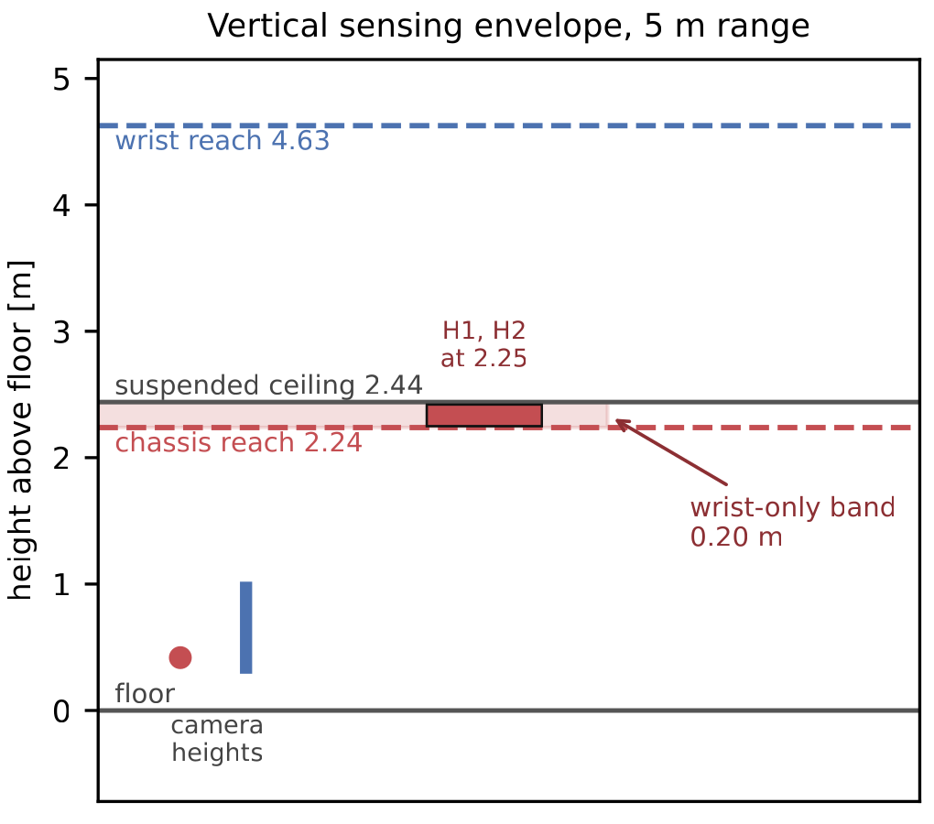
- Why exactly two changes admit no chassis viewpoint. At the 5 m range limit the chassis camera reaches 2.24 m and the wrist camera 4.63 m. The ceiling begins at 2.44 m, leaving a wrist-only band 0.20 m tall, in which the two height changes sit at 2.25 m. Both reaches are closed-form, and agree with a numeric sweep to 3 mm.

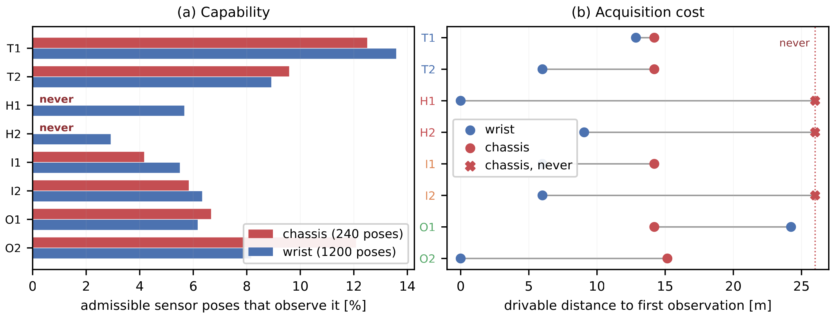
- (a) Capability: |Q_{e}^{s}| as a share of admissible sensor poses for each change; two changes admit no chassis viewpoint at all. (b) Acquisition cost: drivable distance to first observation under a 25 m budget.

Results

Capability: the structure of Q_{e}^{s}
Table I reports what each configuration observed within a 25 m budget; Fig. 3(a) reports the underlying capability.
- Changes observed, by observability class
Class | chassis | wrist | both
trivial | 2/2 | 2/2 | 2/2
height | 0/2 | 2/2 | 2/2
incidence | 1/2 | 2/2 | 2/2
occluded | 2/2 | 2/2 | 2/2
all | 5/8 | 8/8 | 8/8

The result of interest is not the 5/8 figure. A single planned run conflates Q_{e}^{s} = ∅ with the case in which one route failed to reach an admissible pose, so we separate the two by evaluating V(e, q) at every q ∈ Q_{s}. For two changes—both of class height—Q_{e}^{chassis} is empty, at zero visible fraction across all 240 chassis poses; this is a property of the embodiment. A third change that the chassis-only run missed satisfies |Q_{e}^{chassis}| = 14: the planner did not visit an admissible pose within budget, which is a routing outcome, not evidence for the manipulator. The distinction is not merely formal—repositioning the arm on the deck during development moved the planned chassis result from 6/8 to 5/8 while the capability figure did not move at all.
Fig. 2 explains why only the height class produces an empty admissible set. For a camera of pitch p at height h with vertical field of view v, the highest world point inside its frustum at range r is h + r(cos p tan(v/2) − sin p), with no yaw term: yaw rotates about the vertical axis and cannot alter the vertical extent. At r = 5 m this gives 2.24 m for the chassis camera and 4.63 m for the wrist, against a ceiling at 2.44 m. The wrist-only band is therefore 0.20 m tall, and the two height changes were placed within it at 2.25 m.

Acquisition cost: C_{s}(e) where both embodiments succeed
The occluded and incidence pairs were designed to require the manipulator and did not. The crate behind the pallet stack satisfies |Q_{e}^{chassis}| = 16 of 240—hidden from 93% of chassis poses, as intended—but a planner needs only one of those sixteen. Where both embodiments succeed the difference appears in C_{s}(e), not in detections (Fig. 3b): the median drivable distance to first observation is 6.0 m for the wrist and 14.2 m for the chassis, a factor of 2.4. Occlusion, the intuitive case for a manipulator, is in this environment a routing cost paid in metres rather than a sensing limit.

Discussion
Two effects follow, and an active-perception system must treat them differently. Sensing capability is binary and fixed by embodiment: when Q_{e}^{s} = ∅ no planning policy recovers the change, and the utility term U of (2) is identically zero over Q_{s}. Acquisition cost is continuous and fixed by the environment: the information exists, and the question is the value of C_{s}(e). This is where viewpoint planning has leverage, and where the 6.0 m against 14.2 m difference lives. Conflating the two is easy, since a single run reports only “observed” or “not observed” and an expensive change is then indistinguishable from an impossible one.
The capability boundary is also a design variable: the wrist-only band in Hall B is 0.20 m because the chassis camera sits at 0.418 m pitched 0.17 rad down, levelling it shrinks the band toward zero, and a taller space widens it. The useful output is therefore not the claim that the manipulator is worth two changes, but a method for locating that boundary before a platform design is committed.

Limitations and Future Work
The study is narrow: one room, one ceiling height, eight changes. The 0.20 m band is a property of this geometry, and a trend requires rooms of differing height. Detection is geometric—no detector, no renderer, no noise—so the reported quantities describe viewpoint quality, not whether a perception stack would recover the change. Elements are boxes, discarding the 48 opening entities in the source model, so Hall B is a sealed room the robot must be spawned inside. The height margin is thin: the height pair clears the chassis ceiling by 11.8 mm, so levelling or raising that camera would close the gap—the design-variable observation above, restated as a caution. Finally, the framework does not yet answer its third question: deciding when enough evidence has been gathered requires a graded belief B_{t} and a stopping rule, not binary detection.

Conclusion
DeltaSeek is a first step toward robots that plan perception in environments that do not hold still. We formalised the contribution of a mobile manipulator's embodiment as the structure of the admissible observation set Q_{e}^{s} and the cost C_{s}(e) of reaching it, and measured both on an IFC-derived benchmark. The answer is sharper and smaller than the usual assumption: two of eight changes lie outside the chassis camera's admissible set entirely, and the rest cost roughly 2.4× the travel. A robot that is one day to decide when it has seen enough must first distinguish a view it cannot obtain from one it has not yet paid for.

References
- F. Bosché, “Automated recognition of 3D CAD model objects in laser scans and calculation of as-built dimensions for dimensional compliance control in construction,” Advanced Engineering Informatics, vol. 24, no. 1, pp. 107–118, 2010.
- Y. Turkan, F. Bosché, C. T. Haas, and R. Haas, “Automated progress tracking using 4D schedule and 3D sensing technologies,” Automation in Construction, vol. 22, pp. 414–421, 2012.
- M. Golparvar-Fard, F. Peña-Mora, and S. Savarese, “Automated progress monitoring using unordered daily construction photographs and IFC-based building information models,” Journal of Computing in Civil Engineering, vol. 29, no. 1, 2015.
- R. Bajcsy, “Active perception,” Proceedings of the IEEE, vol. 76, no. 8, pp. 966–1005, 1988.
- J. Aloimonos, I. Weiss, and A. Bandyopadhyay, “Active vision,” International Journal of Computer Vision, vol. 1, no. 4, pp. 333–356, 1988.
- C. Connolly, “The determination of next best views,” in Proc. IEEE Int. Conf. Robotics and Automation (ICRA), 1985, pp. 432–435.
- S. Isler, R. Sabzevari, J. Delmerico, and D. Scaramuzza, “An information gain formulation for active volumetric 3D reconstruction,” in Proc. IEEE Int. Conf. Robotics and Automation (ICRA), 2016, pp. 3477–3484.
- A. Bircher, M. Kamel, K. Alexis, H. Oleynikova, and R. Siegwart, “Receding horizon ‘next-best-view’ planner for 3D exploration,” in Proc. IEEE Int. Conf. Robotics and Automation (ICRA), 2016, pp. 1462–1468.
- B. Yamauchi, “A frontier-based approach for autonomous exploration,” in Proc. IEEE Int. Symp. Computational Intelligence in Robotics and Automation (CIRA), 1997, pp. 146–151.
- ISO 16739-1:2018, Industry Foundation Classes (IFC) for data sharing in the construction and facility management industries, ISO, Geneva, 2018.
- IfcOpenShell IFC toolkit and geometry engine. [Online]. Available: https://ifcopenshell.org

