Write a detailed story of your house

For this assignment I need to give information about my house.  
Our house is an old farm that was built over 100 years ago with 252m2 ground and the previous occupants were my grandfather and grandmother but they left in 1994 to Dedemsvaart.

This house is split in 2 parts on 1 side is my uncle living and the other side am I living with my parents and brother. The reason that we living together is that we both needed a new house so we decided to split it. To save power and get money from the government we decided to built solar panels on top of the roof and it work fine in the summer to save money and power.

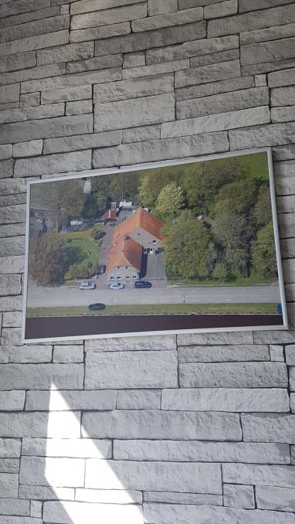  
The house consists of several rooms when you walk in from the front door you stand in a little hall where you can go left to the kitchen and right to the Livingroom   
or go upstairs. We have 3 bedrooms in this house because we live with four people. The basic parts of the house are comparable with other houses think of the toilet room, bathroom, kitchen and the Livingroom .