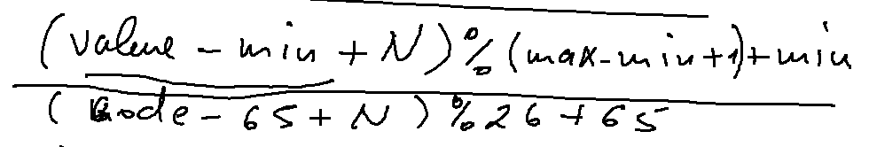

<script>

var symbol = prompt("Symbol", "");

var shift = +prompt("shift","2");

var code = symbol.charCodeAt(0);

var newCode = (code - 65 + shift) % 26 + 65;

var newSymbol = String.fromCharCode(newCode);

document.write("New symbol = " + newSymbol);

</script>