VWESIG Update 04/11/2015

I've made minor changes to the VWESIG application for Vista. Removed are:
- The checkbox to hide/unhide the signature code itself in the first edit box. As I was looking at the application, it struck me that I was way over-thinking the whole application. This app is SO tiny...well. Use Clear, Refresh, Save, etc as you want.
- The Save on Close form. Same as mentioned in above. if you have closed without saving, it's not big deal to simply start the app again and do your work.
- Removed "New" from the first label. Now reads Electronic Signature.
- Form now looks like:
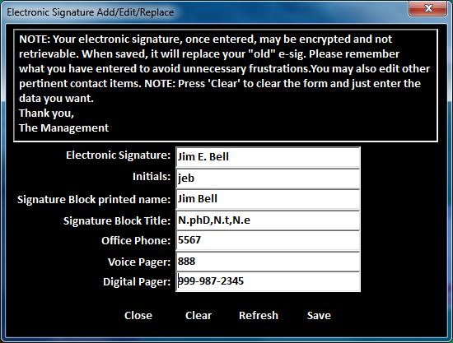

There are no changes to the M-side code. Included in the zip is the new executable.

Reminder: Rolling over any of the edit fields will produce the help text from the M-side Fileman fields.

As always recommended, rename you current ProjEsig.exe to something (e.g., xProjEsig.exe) to save it (just in case). Place the new exe at your location and, if applicable, make any adjustments to your short-cuts.

If you have my direct Email, feel free to contact me on that. Otherwise I can be contacted at jbellco65@gmail.com.

Jim Bell,
WorldVistA Volunteer

