Installation of Pediatric Growth Charts

- On the machine where you intend to install the PGC server, do the following as root (example is a Debian Linux machine):

apt-get install apache2
apt-get install php5 php5-gd php5-cli php5-common libapache2-mod-php5
cd /etc/apache2/mods-enabled
ln -s /etc/apache2/mods-available/php5.conf ./
ln -s /etc/apache2/mods-available/php5.load ./
ln -s /etc/apache2/mods-available/ssl.conf ./
ln -s /etc/apache2/mods-available/ssl.load ./
/etc/init.d/apache2 restart

- change to the root of you web server, which in this case, is /var/www and do the following (you can download the file directly from the URL in a browser if you prefer that to using the wget command):

cd /var/www
wget http://opensourcevista.net:8888/NancysVistAServer/PGC/PGC.tar.gz
tar -xzvf PGC.tar.gz

- If you don't have the directory /usr/X11R6/lib/X11/fonts/, make it and unpack the file you can wget in it as shown (or you can just download it from the URL without the wget)

cd /usr/X11R6/lib/X11/fonts/
wget http://opensourcevista.net:8888/NancysVistAServer/PGC/truetype.tgz
tar -xzvf truetype.tgz

- Now that Apache is in, check to see if you can connect to your server and get a report that says "It Works" from a browser. Supposing your server is at IP 79.38.64.22 or that you have a url of openforum.opensourcevista.net you would enter http://79.38.64.22 or http://openforum.opensourcevista.net and you would see something like this:

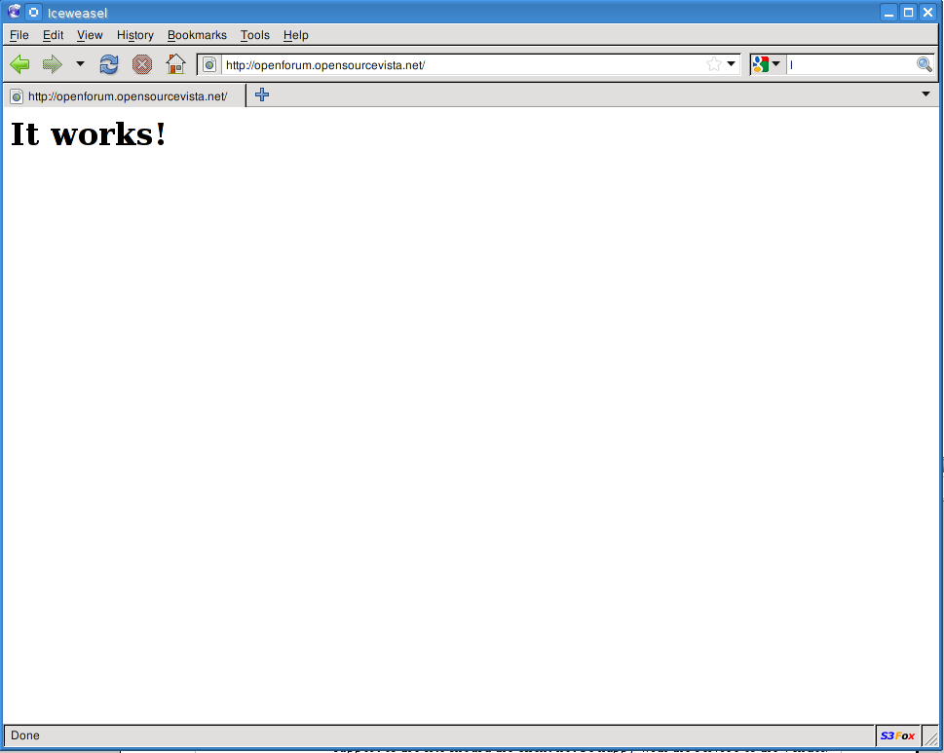
If not, check the error log in /var/log/apache2/error.log to see what the problem is. Most likely, you need to open port 80 on you server or your ISP does not allow connections on port 80.

- In most cases you are going to want this to be a secure server and you may wish to put it on an alternative port to allow port 80 to be available for other purposes. This example will make the port 9500 and use a self signed certificate for the site. You may wish to purchase a certificate instead. You can create one using the following commands as root:

cd /etc/apache2
openssl genrsa -des3 -out server.key 1024
openssl req -new -x509 -nodes -sha1 -days 365 -key server.key -out server.crt

This is what you will see:

/etc/apache2# openssl genrsa -des3 -out server.key 1024
Generating RSA private key, 1024 bit long modulus
...++++++
.................................++++++
e is 65537 (0x10001)
Enter pass phrase for server.key:
Verifying - Enter pass phrase for server.key:

/etc/apache2# openssl req -new -x509 -nodes -sha1 -days 365 -key server.key -out server.crto
Enter pass phrase for server.key:
You are about to be asked to enter information that will be incorporated
into your certificate request.
What you are about to enter is what is called a Distinguished Name or a DN.
There are quite a few fields but you can leave some blank
For some fields there will be a default value,
If you enter '.', the field will be left blank.
-----
Country Name (2 letter code) [AU]:US
State or Province Name (full name) [Some-State]:Maryland
Locality Name (eg, city) []:Gaithersburg
Organization Name (eg, company) [Internet Widgits Pty Ltd]:WorldVistA
Organizational Unit Name (eg, section) []:System Administration
Common Name (eg, YOUR name) []:Nancy Anthracite
Email Address []:nancy@worldvista.org

- Edit the apache2.conf file to include these lines. The DocumentRoot and ServerAdmin may already be there. Backing up the original apache2.conf is recommended.

cd /etc/apache2
cp apache2.conf apache2.confBU

Add this to the end of the file. Nano is one possible editor you can use.
nano apache2.conf
#LOCAL MODIFICATIONS
DocumentRoot /var/www
ServerAdmin webmaster@localhost
#ServerName openforum.opensourcevista.net
SSLEngine On
SSLCertificateFile /etc/apache2/server.crt
SSLCertificateKeyFile /etc/apache2/server.key

- Now I am going to change the ports file to allow the PGC server to use port 9500:

This is the original file contents of ports.conf:

ports.conf
# If you just change the port or add more ports here, you will likely also
# have to change the VirtualHost statement in
# /etc/apache2/sites-enabled/000-default
# This is also true if you have upgraded from before 2.2.9-3 (i.e. from
# Debian etch). See /usr/share/doc/apache2.2-common/NEWS.Debian.gz and
# README.Debian.gz

NameVirtualHost *:80
Listen 80

<IfModule mod_ssl.c>
# SSL name based virtual hosts are not yet supported, therefore no
# NameVirtualHost statement here
Listen 443
</IfModule>

This is the edited file contents of ports.conf allowing http connections to port 80 and https connections to port 9500:

ports.conf
# If you just change the port or add more ports here, you will likely also
# have to change the VirtualHost statement in
# /etc/apache2/sites-enabled/000-default
# This is also true if you have upgraded from before 2.2.9-3 (i.e. from
# Debian etch). See /usr/share/doc/apache2.2-common/NEWS.Debian.gz and
# README.Debian.gz

NameVirtualHost *:80
Listen 80

<IfModule mod_ssl.c>
# SSL name based virtual hosts are not yet supported, therefore no
# NameVirtualHost statement here
# Listen 443
NameVirtualHost *:9500
Listen 9500
</IfModule>

- If ssl.conf and ssl.load are not already in /etc/apache2/mods-enabled, add soft links to them and restart apache2:

cd ./mods-enabled
ln -s ./ssl.conf ../mods-available/ssl.conf
ln -s ./ssl.load ../mods-available/ssl.load
/etc/init.d/apache2 restart

- Now backup the default file in /etc/apache2/sites-available and edit the default file or replace it as follows:

<VirtualHost *:9500>
ServerAdmin webmaster@localhost
#ServerName openforum.opensourcevista.net
SSLEngine On
SSLCertificateFile /etc/apache2/server.crt
SSLCertificateKeyFile /etc/apache2/server.key
DocumentRoot /var/www/
<Directory />
Options FollowSymLinks
AllowOverride None
</Directory>
<Directory /var/www/>
Options Indexes FollowSymLinks MultiViews
AllowOverride None
Order allow,deny
allow from all
# This directive allows us to have apache2's default start page
# in /apache2-default/, but still have / go to the right place
RedirectMatch ^/$ /apache2-default/
</Directory>

ScriptAlias /cgi-bin/ /usr/lib/cgi-bin/
<Directory "/usr/lib/cgi-bin">
AllowOverride None
Options ExecCGI -MultiViews +SymLinksIfOwnerMatch
Order allow,deny
Allow from all
</Directory>

ErrorLog /var/log/apache2/error.log

# Possible values include: debug, info, notice, warn, error, crit,
# alert, emerg.
LogLevel warn

CustomLog /var/log/apache2/access.log combined
ServerSignature On

Alias /doc/ "/usr/share/doc/"
<Directory "/usr/share/doc/">
Options Indexes MultiViews FollowSymLinks
AllowOverride None
Order deny,allow
Deny from all
Allow from 127.0.0.0/255.0.0.0 ::1/128
</Directory>

</VirtualHost>

<VirtualHost *:80>
ServerAdmin webmaster@localhost

DocumentRoot /var/www/
<Directory />
Options FollowSymLinks
AllowOverride None
</Directory>
<Directory /var/www/>
Options Indexes FollowSymLinks MultiViews
AllowOverride None
Order allow,deny
allow from all
</Directory>

ScriptAlias /cgi-bin/ /usr/lib/cgi-bin/
<Directory "/usr/lib/cgi-bin">
AllowOverride None
Options +ExecCGI -MultiViews +SymLinksIfOwnerMatch
Order allow,deny
Allow from all
</Directory>

ErrorLog /var/log/apache2/error.log

# Possible values include: debug, info, notice, warn, error, crit,
# alert, emerg.
LogLevel warn

CustomLog /var/log/apache2/access.log combined

Alias /doc/ "/usr/share/doc/"
<Directory "/usr/share/doc/">
Options Indexes MultiViews FollowSymLinks
AllowOverride None
Order deny,allow
Deny from all
Allow from 127.0.0.0/255.0.0.0 ::1/128
</Directory>

</VirtualHost>

- As the VistA user, download the PGCHTML-T11.KID patch and install it:

wget http://opensourcevista.net:8888/NancysVistAServer/PGC/PEDHTML-T14.KID

$ wget http://opensourcevista.net:8888/NancysVistAServer/PGC/PEDHTML-T11.KID
--2010-09-18 20:58:49-- http://opensourcevista.net:8888/NancysVistAServer/PGC/PEDHTML-T11.KID
Resolving opensourcevista.net... 74.96.19.117
Connecting to opensourcevista.net|74.96.19.117|:8888... connected.
HTTP request sent, awaiting response... 200 OK
Length: 29813 (29K) [text/plain]
Saving to: `PEDHTML-T11.KID'

100%[=========================================================================================================================================>] 29,813 47.4K/s in 0.6s

2010-09-18 20:58:50 (47.4 KB/s) - `PEDHTML-T11.KID' saved [29813/29813]

vademo4-09@gtm:~$ gtm

GTM>S DUZ=10000000020 D ^XUP

Setting up programmer environment
This is a TEST account.

Terminal Type set to: C-VT100

You have 397 new messages.
Select OPTION NAME: eve
1 EVE Systems Manager Menu
2 EVET BLOCK/UNBLOCK DOWNLOAD Block/unblock Vet Download
3 EVET CHECK INCOMING Check for incoming responses from Health eVet
4 EVET DAILY DOWNLOAD ACTIVITY Daily download activity for date
5 EVET EMAIL DOWNLOAD REPORT Email weekly download report
Press <RETURN> to see more, '^' to exit this list, OR
CHOOSE 1-5: 1 EVE Systems Manager Menu

Core Applications ...
Device Management ...
FM VA FileMan ...
Menu Management ...
Programmer Options ...
Operations Management ...
Spool Management ...
Information Security Officer Menu ...
Taskman Management ...
User Management ...
Application Utilities ...
Capacity Management ...
Manage Mailman ...

You have PENDING ALERTS
Enter "VA to jump to VIEW ALERTS option

You've got PRIORITY mail!

<CPM> Select Systems Manager Menu Option: programmer Options

KIDS Kernel Installation & Distribution System ...
NTEG Build an 'NTEG' routine for a package
PG Programmer mode
Calculate and Show Checksum Values
Delete Unreferenced Options
Error Processing ...
Global Block Count
List Global
Map Pointer Relations
Number base changer
Routine Tools ...
Test an option not in your menu
Verifier Tools Menu ...

You have PENDING ALERTS
Enter "VA to jump to VIEW ALERTS option

You've got PRIORITY mail!

<CPM> Select Programmer Options Option: kid Kernel Installation & Distribution
System

Edits and Distribution ...
Utilities ...
Installation ...
Patch Monitor Main Menu ...

You have PENDING ALERTS
Enter "VA to jump to VIEW ALERTS option

You've got PRIORITY mail!

<CPM> Select Kernel Installation & Distribution System Option: installation

1 Load a Distribution
2 Verify Checksums in Transport Global
3 Print Transport Global
4 Compare Transport Global to Current System
5 Backup a Transport Global
6 Install Package(s)
Restart Install of Package(s)
Unload a Distribution

You have PENDING ALERTS
Enter "VA to jump to VIEW ALERTS option

You've got PRIORITY mail!

<CPM> Select Installation Option: load a Distribution
Enter a Host File: /home/vademo4-09/PEDHTML-T11.KID

KIDS Distribution saved on Nov 15, 2007@11:16:40
Comment: PEDIATRIC GROWTH CHARTS

This Distribution contains Transport Globals for the following Package(s):
PEDHTML 1.0
Distribution OK!

Want to Continue with Load? YES// yes YES
Loading Distribution...

PEDHTML 1.0
Use INSTALL NAME: PEDHTML 1.0 to install this Distribution.

1 Load a Distribution
2 Verify Checksums in Transport Global
3 Print Transport Global
4 Compare Transport Global to Current System
5 Backup a Transport Global
6 Install Package(s)
Restart Install of Package(s)
Unload a Distribution

You have PENDING ALERTS
Enter "VA to jump to VIEW ALERTS option

You've got PRIORITY mail!

<CPM> Select Installation Option: install Package(s)
Select INSTALL NAME: PEDHTML 1.0 Loaded from Distribution 9/18/10@21:00:2
0
=> PEDIATRIC GROWTH CHARTS ;Created on Nov 15, 2007@11:16:40

This Distribution was loaded on Sep 18, 2010@21:00:20 with header of
PEDIATRIC GROWTH CHARTS ;Created on Nov 15, 2007@11:16:40
It consisted of the following Install(s):
PEDHTML 1.0
Checking Install for Package PEDHTML 1.0

Install Questions for PEDHTML 1.0

Want KIDS to INHIBIT LOGONs during the install? NO//
Want to DISABLE Scheduled Options, Menu Options, and Protocols? NO//

Enter the Device you want to print the Install messages.
You can queue the install by enter a 'Q' at the device prompt.
Enter a '^' to abort the install.

DEVICE: HOME// <=== hit Enter here and you will see an install progress bar fly by.

- Add the PGC to the tools menu of CPRS and set up the server and default directory for the pedi growth chart files to be written to. You will have to look for an open position to put it in on the tools menu:

GTM>D ^XPAREDIT

Select PARAMETER DEFINITION NAME: CPRS GUI TOOLS MENU ORWT TOOLS MENU CPRS GU
I Tools Menu

ORWT TOOLS MENU may be set for the following:

1 User USR [choose from NEW PERSON]
2 Location LOC [choose from HOSPITAL LOCATION]
2.5 Service SRV [choose from SERVICE/SECTION]
3 Division DIV [choose from INSTITUTION]
4 System SYS [CAA.FO-ALBANY.MED.VA.GOV]
9 Package PKG [ORDER ENTRY/RESULTS REPORTING]

Enter selection: 1 User NEW PERSON
Select NEW PERSON NAME: `10000000020 MANAGER,SYSTEM SM

------------- Setting ORWT TOOLS MENU for User: MANAGER,SYSTEM -------------
Select Sequence: ?

Sequence Value
-------- -----
1 VistaWeb="http://vhaisatrn10/vistaweb/LoginFrameset.htm"

Select Sequence: 2
Are you adding 2 as a new Sequence? Yes// yese

Enter either 'Y' or 'N'.

Are you adding 2 as a new Sequence? Yes// YES

Sequence: 2// 2
Name=Command: Pedi Growth Charts="C:\PGC.bat" %DFN
Select Sequence:

- Now to connect the Windows machine to the directory where the html files are being placed for secure pickup. As root, make a new user on the linux machine called pgc

adduser pgc

- Now add the VistA user to the group pgc.

adduser vademo4-09 pgc

adduser vademo4-09 pgc
Adding user `vademo4-09' to group `pgc' ...
Adding user vademo4-09 to group pgc
Done.

- Now install putty-tools on Linux and use this command to generate a public key private-key pair to use with pscp for picking up the html files generated by VistA to reference on the Windows machine with CPRS.

aptitude install putty-tools
ssh-keygen
puttygen /path/to/ssh-gen-privatekeyfile -O private -o /path/to/putty-formatted-privatekeyfile

For example, here

ssh-keygen -t rsa
Generating public/private rsa key pair.
Enter file in which to save the key (/home/nancy/.ssh/id_rsa): /home/nancy/pgc_key
Enter passphrase (empty for no passphrase): [DO NOT USE A PASSPHRASE]
Enter same passphrase again:
Your identification has been saved in /home/nancy/pgc_key.
Your public key has been saved in /home/nancy/pgc_key.pub.
The key fingerprint is:
45:1d:b4:b1:dd:45:e8:81:0f:73:c6:b8:9a:67:7a:68 nancy@owl
The key's randomart image is:
+--[ RSA 2048]----+
| .o+= oo |
| . *=*.. |
| . oO... |
| . . o |
| S o |
| o o |
| = |
| E . |
| . . |
+-----------------+
puttygen /home/nancy/pgc_key -O private -o /home/nancy/pgc-key.ppk

- Now copy the pgc_key.pub into /home/pgc/.ssh and then add it to the authorized key file. Copy the pgc_key.ppk onto the Windows machine.

cp pgc_key.pub into /home/pgc/.ssh
cat pgc_key.pub >> authorized_keys

- Download pscp.exe from http://www.chiark.greenend.org.uk/~sgtatham/putty/download.html onto your Windows machine.

- Now create the PGC.bat file for the Windows machine:

pscp -i C:\Keys\pgc_key.ppk pgc@openforum.opensourcevista.net:/home/pgc/PGC/%1.html C:\PGC
“C:\Program Files\Mozilla firefox.exe” C:\PGC\%1.html

