 **COFFEE SHOP SALES**

Valuable Insights

* How do sales vary by day of the week and hour of the day?
* Are there any peak times for sales activity?
* Daily at 10 AM
* What is the total sales revenue for each month?
* How do sales vary by product category and type?
* Which products are the best-selling in terms of quantity and revenue?
* How do sales vary across different store locations?
* What is the percentage of size distribution based on orders?

The main objective of this project is to analyse the retail sales data to gain actionable insights that will help enhance the performance of the Coffee Shop.

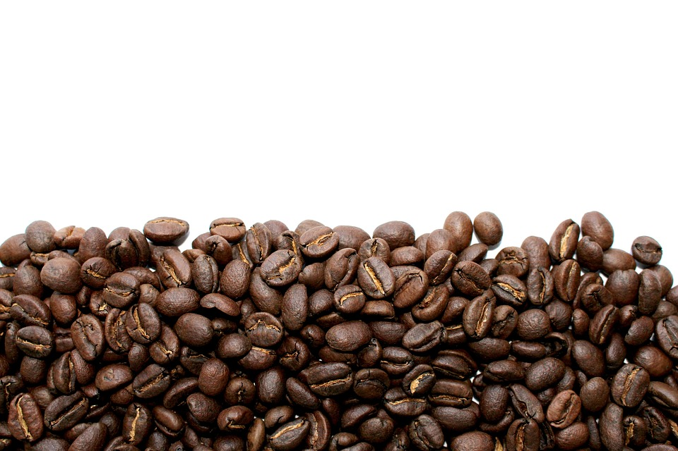

Valuable Insights

* What is the average price/order per person?
* 1.42 Avg order/person
* 4.75 Avg bill/person
* What are the total sales and footfall?
* $15,193.23 total sales
* 3201 footfalls