Chapter 1: Build a Large Language Model

Ismail TG

2024-11-14

# Introduction:

In this series on notebooks I will share my learning/note-taking of the book [**Build a Large Lunguage Model(From Scratch)**](https://www.amazon.com/Build-Large-Language-Model-Scratch/dp/1633437167) by the Author [**Sebastian Raschka**](https://x.com/rasbt).

## Structure of the Book:

├── chapters   
│ ├── chapter1_understanding_LLMs: high-level introduction to the fundamental concepts behind LLMs.   
│ ├── chapter2_text_data: It covers the process ofpreparing text for LLM training, including splitting text into word and subword tokens.   
│ ├── chapter3_attention_mechanisms: It introduces a basicself-attention framework and progresses to an enhanced self-attention mechanism.   
│ ├── chapter4_GPT_model: focuses on coding a GPT-like LLM that can be trained to generatehuman-like text.   
│ ├── chapter5_pretraining: implements the pretraining process of LLMs.   
│ ├── chapter6_text_classification: introduces different LLM fine-tuning approaches.   
│ ├── chapter7_instruction_following: explores the instruction fine-tuning process of LLMs.   
└──

* The aim of this chapter is to introduce the foundational concepts of large language models (LLMs) and the advancements in deep learning that made them possible
  + this chapter doesn’t contain any code.
* Large language models (LLMs), like OpenAI’s ChatGPT, are deep neural networks that revolutionized natural language processing (NLP) in recent years.
* Traditional NLP methods excelled in tasks like spam classification and simple pattern recognition but struggled with complex tasks requiring advanced understanding and generation abilities.
* Contemporary LLMs can handle sophisticated language tasks, such as writing an email from keywords, which was challenging for earlier models.
* When we say language models “understand,” we mean they can produce text that seems coherent and contextually appropriate, not that they have human-like awareness or true comprehension.
* The transformer architecture and large datasets have driven the shift in NLP, enabling more advanced language understanding and interaction.

### What’s an LLM:

* LLM’s are neural network designed to understand and produce huma-like text.
* Large in LLM refer to the size of the datasets those model trained on, but also on the size of parameters ( 100’s of billions)
  + Parameters are adjusted weights during training to predict next word in sentence.
* The architecture of an LLM is called transformers which apply the attention mechanism to different parts of the input while performing the next word prediction. ### Applications of LLM’s:
* LLM’s can be used in many contexts to perform different tasks:
  + machine translation
  + sentiments analysis
  + text generation  
    ..

### Stages of building and using LLMs:

* Building LLM form scratch allow us to understand the **mechanics** and **limitations** of language models, and provide us with skills set required for pretraining or fine-tuning phase.
* Custom-built LLM outperform general purpose one.
  + Many companies prefer to build their own domain-specific llm to keep their private data in-home and not share it with third party.
  + developing small lm open the door for deployment on devices like laptops or even mobiles rather than huge servers.
* creating LLM is a process where pre-training and fine-tuning takes place.
  + pre indicates that it is the first phase, model is trained on huge chunk of data where it learns basic knowledge and broad pattern of the language.
  + the fine-tuning phase is where the model get further training but on very specific task and get its knowledge narrowed.
* Fine-tuning can be devised in 2 category:
  + **Instruction fine-tuning**: where the model get trained one pair of **instruction => output** dataset.
  + Where **classification tuning** the data consist of text and associated class label.

### Introducing the Transformer architecture:

* All modern LLM rely on **Transformer** architecture which was presented for the first time in [this](https://arxiv.org/abs/1706.03762) famous paper: **Attention is all you need**.
* Transformer consist of two submodal: 1-encoder and 2-decoder. - encoder module process the input text into some numerical representation that capture meaning.  
  - decoder uses the numerical values and generate text
* the key component of the transformer architecture is attention mechanism, we will talk about it later.
* **Transformer Variants**:  
  - Models like BERT and GPT are based on the original transformer architecture but adapt it for different tasks.  
  - **BERT’s Training Strategy**: BERT uses a masked word prediction approach, where it predicts missing words in a sentence, making it suitable for tasks like text classification and sentiment analysis.  
  - **GPT vs. BERT**: GPT is designed for generative tasks, whereas BERT excels in tasks requiring understanding of context, like sentiment prediction and document categorization.  
  - **BERT’s Real-world Application**: Platforms like X (formerly Twitter) use BERT for tasks such as detecting toxic content.
* **GPT Focus**: GPT utilizes the *Decoder* portion of the transformer architecture and is designed for text generation tasks.
* **Zero-shot and Few-shot Learning**: GPT models excel in zero-shot learning, meaning they can handle tasks without specific prior examples. They also perform well in few-shot learning, where they learn from a small number of provided examples.
* **Versatility**: While GPT models are optimized for text completion, they exhibit broad adaptability and can tackle a wide range of tasks, showcasing their flexibility in natural language processing.

### Utilizing large datasets:

* Diverse Training Data: Large datasets used for training GPT- and BERT-like models contain billions of words, covering a broad range of topics and languages (both natural and programming).
* Comprehensive Corpus: These datasets are designed to ensure comprehensive exposure to diverse linguistic and contextual patterns.

### A closer look at the GPT architecture:

* GPT Origin: GPT was introduced in the paper [Improving Language Understanding](https://mng.bz/x2qg) by Generative Pre-Training by Radford et al. from OpenAI.
* GPT-3: A scaled-up version of the original GPT with more parameters and a larger training dataset.
* ChatGPT’s Base Model: The initial ChatGPT model was derived by fine-tuning GPT-3 on a large instruction dataset, using methods from OpenAI’s InstructGPT paper.
* Model Versatility: Despite being trained on a simple next-word prediction task, GPT models excel in various tasks like text completion, spelling correction, classification, and language translation.
* Self-Supervised Learning: The next-word prediction task is a type of self-supervised learning, where the model uses the structure of the data itself for training.
* Label Creation: Labels are generated dynamically, with the next word in a sentence or document serving as the prediction target.
* Training on Massive Datasets: This approach enables the use of large, unlabeled text datasets for training, as explicit labeling of data is unnecessary.

### Building a large language model:

* Now we understand the basic theory behind LLM and how they were introduced, its time to build them from scratch.

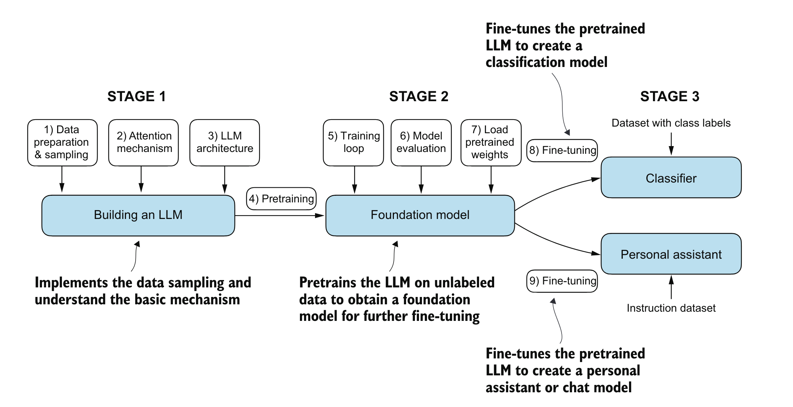 >Source: Book: Build A Large Language Model by *Sebastian Raschka*