UNIVERSITY OF UP-FAMNIT

BOOKSWAP: DESIGN AND IMPLEMENTATION OF A PEER‑TO‑PEER BOOK EXCHANGE PLATFORM
Seminar Report
Author: Vanja Antonovic (ID: 89211069)
Course: Systems III (2024/2025)

Abstract
BookSwap is a web-based information system that enables users to discover, offer, and exchange printed books in a trustworthy, convenient, and environmentally responsible way. The platform delivers user registration and authentication, management of book listings with images and metadata, genre categorisation, search and filtering, buyer–seller messaging, and profile management. The current physical database consists of five tables (login, posts, genres, chats, messages) as implemented in MySQL. This report formalises the problem context, elicits functional and non‑functional requirements, and presents a corrected logical design that resolves many‑to‑many relations and introduces auxiliary entities such as Wishlist, Rating, and Order to improve expressiveness and data integrity. The document also outlines the system architecture, implementation overview, testing approach, and future work. Diagrams required by the seminar template are included as placeholders so they can be inserted in final form.

Contents
Abstract 2
1. Introduction 5
1.1 Objectives and contributions 5
1.2 Stakeholders 5
2. Theoretical background 5
3. System requirements 6
3.1 Functional requirements 6
3.2 Non‑functional requirements 6
4. Feasibility study 6
4.1 Technical feasibility 6
4.2 Legal and compliance feasibility 7
4.3 Economic and organisational feasibility 7
5. Logical design 7
5.1 User role / function matrix 7
5.2 Data dictionary - current physical database 7
5.3 Data dictionary - corrected logical model (proposed) 9
6. Data modelling artefacts 12
6.1 Entity‑Relationship Diagram 12
6.2 Relational model (3NF) 13
6.3 Normalisation notes 13
7. Architecture and object‑oriented design 14
7.1 System architecture 14
7.2 UML class diagram 14
7.3 UML sequence diagram 15
8. Physical model 17
9. Implementation 17
10. Testing 18
11. Future work 18
12. Conclusion 18
References 19

1. Introduction
Despite the rise of e‑reading, printed books remain culturally and practically important. Many readers hold books they no longer need, while others seek affordable access to diverse titles. General‑purpose marketplaces are not optimised for peer exchange, discovery by genre, or low‑friction communication. BookSwap addresses this gap by providing a focused platform where users can list books, search and filter by meaningful attributes, and coordinate exchanges or sales directly with other users.
This seminar follows the official Systems III template. It states the problem, derives requirements, evaluates feasibility, and develops the logical and physical designs. Object‑oriented and process‑oriented views complement the data model. The report concludes with implementation notes, testing, and future improvements.

1.1 Objectives and contributions
The objectives are to design a robust yet practical information system for book exchange and to document the analysis and design artefacts to the standard required by the course. Contributions include: a clear problem framing; a refined logical schema beyond the initial five tables; consistent diagram notation as required by the template; and an implementation‑oriented discussion that maps design decisions to real components.

1.2 Stakeholders
Primary stakeholders are registered users who list or acquire books. Secondary stakeholders include moderators or administrators who maintain catalogues (for example, genres) and ensure acceptable use. External stakeholders include potential partners such as payment providers, if monetisation features are introduced in future work.

2. Theoretical background
The platform is a typical web information system with a browser‑based client, a stateless HTTP API, and a relational database. Core design principles include separation of concerns between presentation, application logic, and persistence, and the use of normalisation to reduce redundancy and anomalies. The data model follows standard entity‑relationship techniques and is refined into a relational schema in third normal form where feasible. Security principles such as password hashing, least privilege, and input validation are considered foundational.

3. System requirements

3.1 Functional requirements
The system supports the following user‑facing capabilities:
User registration and login with profile management.
Create, edit, and delete book listings with title, author, genre, price, description, and image.
Search and filter listings by title, author, genre, condition, and price; sort by recency or price.
Messaging between interested buyers and sellers within the context of a listing.
Notification of unread messages within the interface.
Genre management and browsing by genre.
Responsive design suitable for desktop and mobile use.

3.2 Non‑functional requirements
Security: hashed passwords, transport encryption in deployment, server‑side validation.
Performance: acceptable response times under typical student‑scale usage; indexed lookups on key fields.
Usability and accessibility: clear navigation, readable typography, and sufficient contrast.
Reliability and availability: graceful error handling and routine backups.
Maintainability and scalability: modular code, documented API endpoints, and relational indexes.

4. Feasibility study

4.1 Technical feasibility
The web stack (React, Node.js/Express, MySQL) is mature and appropriate for rapid development. The current physical schema comprises five tables as implemented in MySQL (login, posts, genres, chats, messages). Client–server communication uses HTTP with JSON payloads. Images are stored as file paths in the database.

4.2 Legal and compliance feasibility
User data should be processed according to GDPR principles, with explicit consent and minimised collection. Passwords must be hashed using a strong one‑way function. Content policies and reporting features reduce misuse.

4.3 Economic and organisational feasibility
The platform can be hosted on commodity infrastructure. Initial operation requires modest resources and can be maintained by a small team. Monetisation is optional and can be explored later.

5. Logical design

5.1 User role / function matrix
Function | Guest | Registered User | Administrator
Browse and view listings | Yes | Yes | Yes
Search and filter | Yes | Yes | Yes
Create and manage own listings | No | Yes | Yes
Messaging (buyer–seller) | No | Yes | Yes
Manage genres | No | No | Yes
Moderate users and content | No | No | Yes
Wishlist | No | Yes | Yes
Leave ratings | No | Yes | Yes

5.2 Data dictionary - current physical database
The following tables are implemented in the current MySQL database:
Table: login
Attribute | Type | Key/Constraint | Description
id | INT(10) | Primary key | User identifier
name | VARCHAR(255) |  | Full name
email | VARCHAR(255) | Unique | User email address
password | VARCHAR(255) |  | Password hash
profile_pic | VARCHAR(255) |  | Path to profile image

Table: posts
Attribute | Type | Key/Constraint | Description
id | INT(10) | Primary key | Post identifier
title | VARCHAR(255) |  | Book title
description | TEXT |  | Listing description
email | CHAR(50) | Foreign key to login.email | Owner email
price | DECIMAL(10,2) |  | Listed price
picture | VARCHAR(255) |  | Path to image
time | TIMESTAMP |  | Created timestamp
author | VARCHAR(255) |  | Book author
genre | VARCHAR(255) |  | Genre name or code

Table: genres
Attribute | Type | Key/Constraint | Description
id | INT(10) | Primary key | Genre identifier
name | VARCHAR(255) | Unique (recommended) | Genre name

Table: chats
Attribute | Type | Key/Constraint | Description
id | INT(10) | Primary key | Chat identifier
buyer_id | INT(10) | Foreign key to login.id | Buyer user id
seller_id | INT(10) | Foreign key to login.id | Seller user id
post_id | INT(10) | Foreign key to posts.id | Related post id
postImage | VARCHAR(255) |  | Reference image path
postTitle | VARCHAR(255) |  | Reference title

Table: messages
Attribute | Type | Key/Constraint | Description
id | INT(10) | Primary key | Message identifier
chat_id | INT(10) | Foreign key to chats.id | Related chat id
user_email | CHAR(50) | Foreign key to login.email | Author email
message | TEXT |  | Message body
timestamp | TIMESTAMP |  | Created timestamp
postImage | VARCHAR(255) |  | Optional image path
postTitle | VARCHAR(255) |  | Optional title copy

5.3 Data dictionary - corrected logical model (proposed)
To improve integrity and expressiveness, the corrected logical model replaces email‑based foreign keys with integer user identifiers and introduces additional entities. This section documents the proposed entities.
Entity: User
Attribute | Type | Key/Constraint | Description
id | INT | Primary key | User identifier
name | VARCHAR(255) |  | Full name
email | VARCHAR(255) | Unique | Email address
password_hash | VARCHAR(255) |  | Hashed password
profile_pic | VARCHAR(255) |  | Path to profile image
created_at | TIMESTAMP |  | Creation timestamp

Entity: Book
Attribute | Type | Key/Constraint | Description
id | INT | Primary key | Book identifier
title | VARCHAR(255) |  | Title
author | VARCHAR(255) |  | Author
isbn | VARCHAR(20) | Nullable | ISBN if known
description | TEXT |  | Description
picture | VARCHAR(255) |  | Image path
condition | ENUM |  | Book condition

Entity: Genre
Attribute | Type | Key/Constraint | Description
id | INT | Primary key | Genre identifier
name | VARCHAR(255) | Unique | Genre name

Entity: BookGenre (junction)
Attribute | Type | Key/Constraint | Description
book_id | INT | Primary/Foreign key to Book.id | Book id
genre_id | INT | Primary/Foreign key to Genre.id | Genre id

Entity: Listing
Attribute | Type | Key/Constraint | Description
id | INT | Primary key | Listing identifier
seller_id | INT | Foreign key to User.id | Owner user id
book_id | INT | Foreign key to Book.id | Book id
price | DECIMAL(10,2) |  | Price at offer
status | ENUM |  | For example: active, reserved, sold
created_at | TIMESTAMP |  | Creation timestamp

Entity: Chat
Attribute | Type | Key/Constraint | Description
id | INT | Primary key | Chat identifier
listing_id | INT | Foreign key to Listing.id | Listing id
buyer_id | INT | Foreign key to User.id | Buyer user id
seller_id | INT | Foreign key to User.id | Seller user id
created_at | TIMESTAMP |  | Creation timestamp

Entity: Message
Attribute | Type | Key/Constraint | Description
id | INT | Primary key | Message identifier
chat_id | INT | Foreign key to Chat.id | Chat id
sender_id | INT | Foreign key to User.id | Author user id
body | TEXT |  | Message body
created_at | TIMESTAMP |  | Creation timestamp

Entity: Wishlist (junction)
Attribute | Type | Key/Constraint | Description
user_id | INT | Primary/Foreign key to User.id | User id
listing_id | INT | Primary/Foreign key to Listing.id | Listing id
created_at | TIMESTAMP |  | Added timestamp

Entity: Rating
Attribute | Type | Key/Constraint | Description
id | INT | Primary key | Rating identifier
rater_id | INT | Foreign key to User.id | Reviewer user id
ratee_id | INT | Foreign key to User.id | Reviewed user id
score | TINYINT | Check 1..5 | Score
comment | TEXT | Nullable | Optional comment
created_at | TIMESTAMP |  | Creation timestamp

Entity: Order
Attribute | Type | Key/Constraint | Description
id | INT | Primary key | Order identifier
listing_id | INT | Foreign key to Listing.id (unique) | Listing sold
buyer_id | INT | Foreign key to User.id | Buyer user id
price_at_purchase | DECIMAL(10,2) |  | Captured price
created_at | TIMESTAMP |  | Creation timestamp

6. Data modelling artefacts

6.1 Entity‑Relationship Diagram
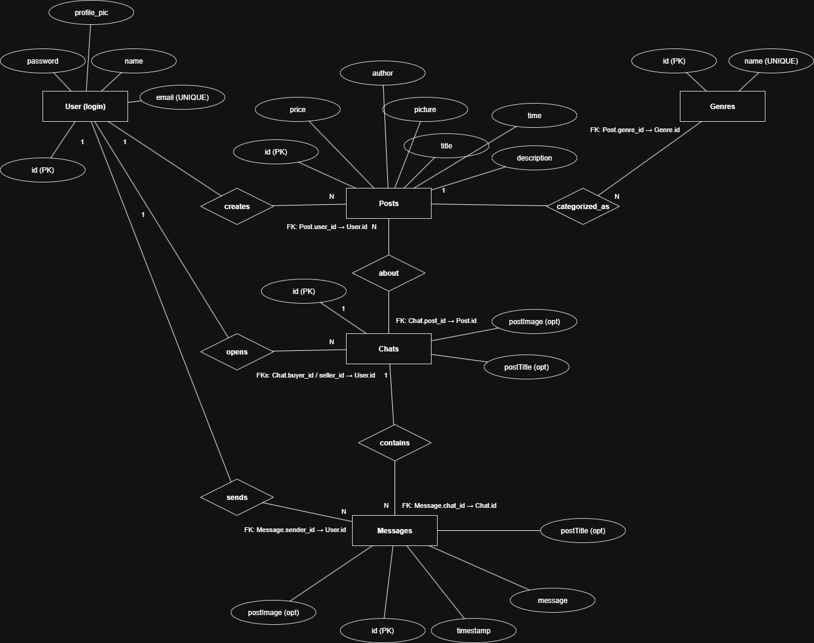
[Figure 6.1: ER diagram.]

6.2 Relational model (3NF)
The relational schema below is consistent with the corrected ER model. For clarity, foreign keys are written in text rather than arrows.
Table | Columns and constraints
Login | id (PK), name, email, password, profile_pic
Posts | id (PK), title, description, email, price, picture, time, author, genre
Genre | id (PK), name
Chats | id (PK), buyer_id (FK to Login.id), seller_id (FK to Login.id), post_id (FK to Posts.id), postImage, postTitle
Messages | id (PK), chat_id (FK to Chats.id), user_email, message, timestamp, postImage, postTitle

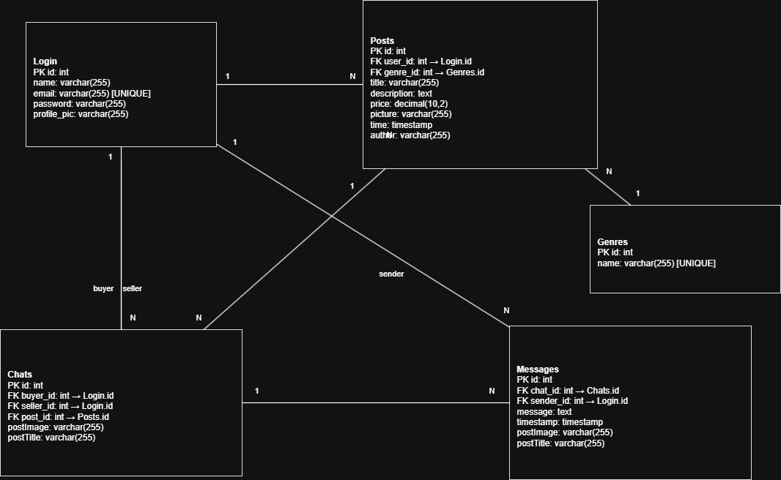
[Figure 6.3: Relational model diagram.]

6.3 Normalisation notes
The proposed schema eliminates repeating groups and ensures atomic attributes (first normal form). There are no partial dependencies on part of a composite key (second normal form), and non‑key attributes depend only on the key, the whole key, and nothing but the key (third normal form). Junction tables resolve many‑to‑many relations.

7. Architecture and object‑oriented design

7.1 System architecture
Presentation layer: React application with pages and components such as Home, Profile, PostDetail, and OwnPostDetail. Application layer: Node.js/Express services exposing REST endpoints for posts, users, genres, chats, and messages. Data layer: MySQL database with relational constraints and indexes. Static assets (images) are referenced via file paths.

7.2 UML class diagram
The class diagram represents key domain classes such as Login, Chats, Messages, Genres, Posts, including attributes and associations. It supports the same semantics as the data model without implying persistence details.
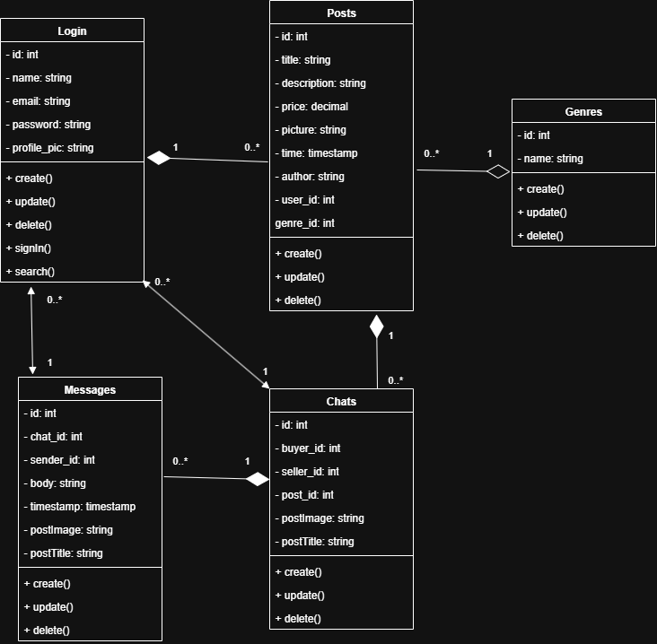
[Figure 8.2: UML class diagram.]

7.3 UML sequence diagram
This sequence diagram illustrates two separate interaction flows:
- Login/Sign Up
  - The User initiates the process by submitting their login or sign-up credentials to the Login System.
  - The Login System forwards the credentials to the Post System, which then requests validation from the Database/Server.
  - The Database/Server checks the credentials and returns the result to the Post System, which relays it back to the Login System.
  - The Login System informs the User whether the login was successful or failed.
- Posting
  - The User submits a new post to the Post System.
  - The Post System saves the post to the Database/Server.
  - Once saved, the Database/Server confirms back to the Post System, which then notifies the User that the post has been created.
The diagram uses vertical lifelines to represent each participant and horizontal arrows to represent synchronous message exchanges. The shaded activation bars along each lifeline indicate when that participant is active in the interaction. Each flow is grouped into a separate fragment for clarity.
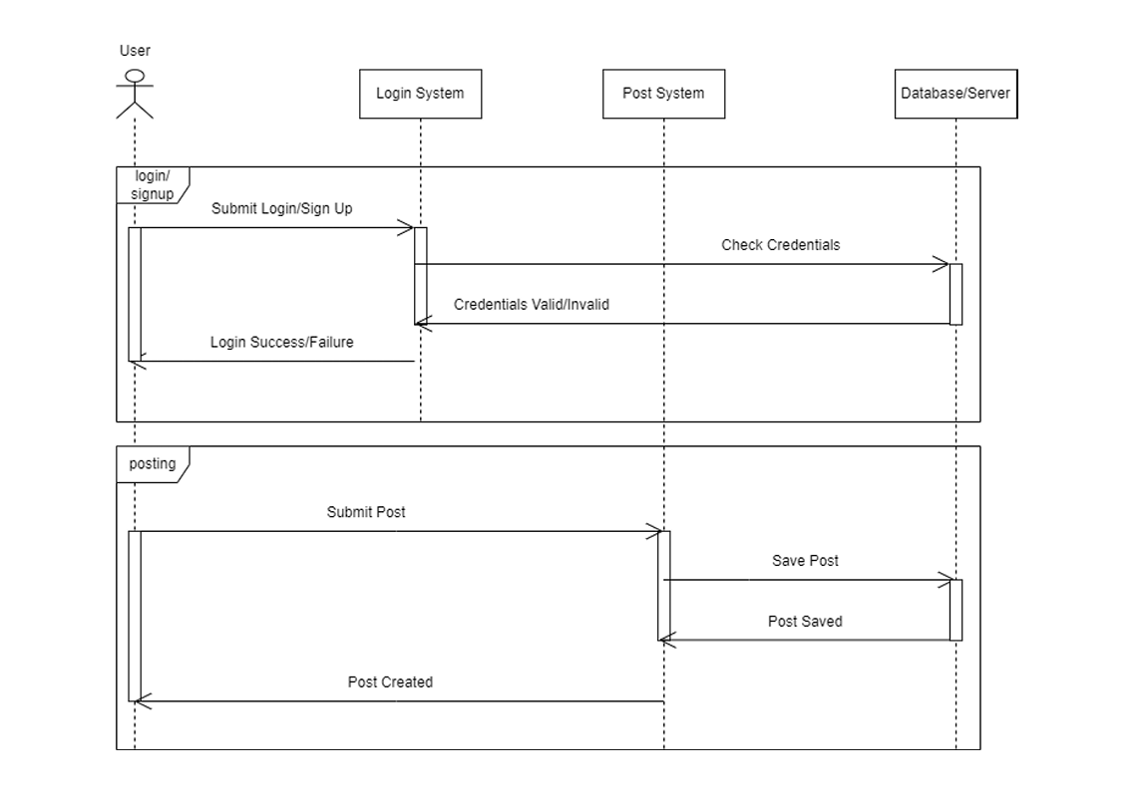
[Insert Figure 8.3a: UML sequence diagram - Contact Seller.]

8. Physical model
The physical model is a faithful implementation of the relational design in MySQL. It defines data types, indexes, and default values. Screenshots from phpMyAdmin Designer should be inserted here as evidence of the implemented schema.
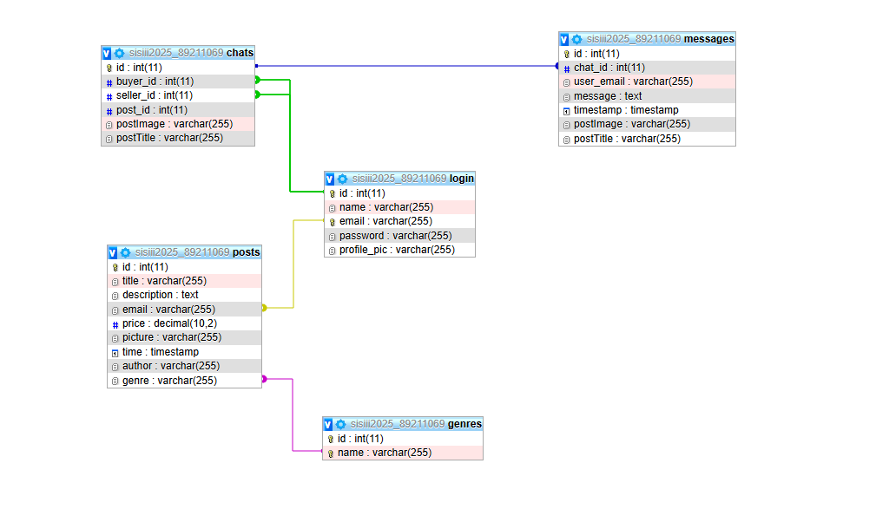
[Figure 9.1: Physical database model (phpMyAdmin Designer).]
Indexing recommendations: B‑tree indexes on posts.title, posts.author, posts.genre, and foreign keys used in joins; composite indexes for frequent query predicates where justified.

9. Implementation
The frontend is implemented in React. The Home page retrieves listings with optional search and filter parameters; Profile shows the user’s own listings; PostDetail displays a listing and offers actions such as contacting the seller; OwnPostDetail allows the seller to edit or delete their own listing.
Representative HTTP endpoints observed in the current code base include retrieval of all posts with query parameters, retrieval of a single post by identifier, and deletion of a post by identifier. Authentication and messaging endpoints follow the same design pattern and can be extended as needed.

Endpoint (method) | Purpose | Notes
GET /posts | List posts with optional search and filter query parameters | Used by Home page
GET /post/{id} | Fetch a single post by identifier | Used by PostDetail and OwnPostDetail
POST /delete-post | Delete a post by identifier | Used by OwnPostDetail
Frontend routing: navigation to /post/{id} for general view and /own-post/{id} when the current user is the owner of the listing.

10. Testing
Testing activities covered functional scenarios, constraints, and edge cases:
Test case | Preconditions | Steps | Expected result
User registration and login | Empty database or new account | Register, then login with the same email | Session established; profile visible
Create listing | Authenticated user | Fill form, upload image, submit | Listing appears on Home and Profile
Messaging | Buyer and seller accounts | Open listing, start chat, send message | Message stored in messages with correct chat_id

11. Future work
Replace email‑based foreign keys with user identifiers consistently across tables.
Introduce wishlist and rating features with appropriate database support.
Payment integration and order capture to support direct purchases where permitted.
Content moderation tools and audit logs for administrative users.
Improve image storage using object storage and signed URLs.

12. Conclusion
BookSwap demonstrates a coherent approach to designing and implementing a focused peer‑to‑peer exchange system. The refined logical model improves integrity and provides room for new features while keeping the current physical schema usable. The artefacts included here align with the seminar template and can be finalised by inserting the corresponding diagrams.

References
[1] Official MySQL Documentation.
[2] React, Node.js, and Express official documentation.
[3] GDPR guidelines for data processing.

