|  |  |  |  |  |  |
| --- | --- | --- | --- | --- | --- |
| **表格名稱** | 中文:購物車/訂單  英文:CART | | **索引鍵** |  | |
| **主鍵** | ORDER_ID | | **外來鍵** |  | |
| **欄位編號** | **欄位名稱** | **欄位敘述** | **資料型態** | **欄位長度** | **備註** |
| 1 | order_id | 訂單編號 | INT |  | Not Null(PK) |
| 2 | order_date | 訂單日期 | DATETIME |  | Not Null |
| 3 | mem_id | 會員編號 | INT |  | FK |
| 4 | order_status | 訂單狀態 | VARCHAR | 10 |  |
| 5 | total_price | 訂單總價 | DECIMAL | (10,2) |  |

|  |  |  |  |  |  |
| --- | --- | --- | --- | --- | --- |
| **表格名稱** | 中文:訂單明細  英文:ORDER_DITAIL | | **索引鍵** |  | |
| **主鍵** | DETAIL_ID | | **外來鍵** |  | |
| **欄位編號** | **欄位名稱** | **欄位敘述** | **資料型態** | **欄位長度** | **備註** |
| 1 | detail_id | 明細編號 | INT |  | Not Null(PK) |
| 2 | order_id | 訂單編號 | INT |  | FK |
| 3 | prod_id | 商品編號 | INT | 10 | FK |
| 4 | prod_name | 商品名稱 | VARCHAR | 20 |  |
| 5 | prod_price | 商品價格 | DECIMAL | (10, 2) |  |
| 6 | quantity | 購買數量 | INT |  |  |
| 7 | subtotal_price | 該項商品總價 | DECIMAL | (10, 2) |  |

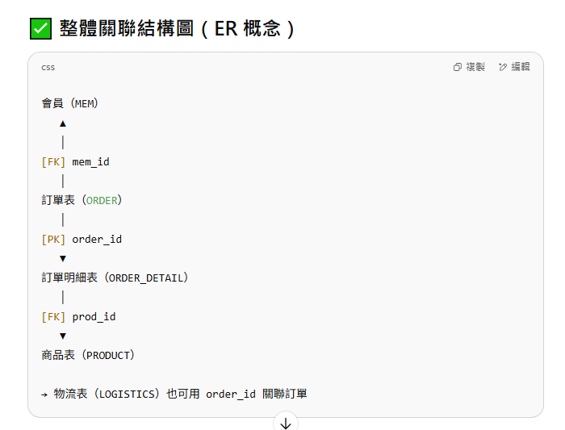

ENUM表示狀態

(1)處理中：在等待客戶付款

**Processing**: Waiting for customer payment.

(2)已確定：已付款，我方已接收訂單，正向國外下訂單

**Confirmed**: Payment has been made; we have received the order and are placing an order abroad.

(3)已完成：已出貨，完成此訂單作業

**Completed**: Shipped, the order is completed.

(4)已取消：客戶於7日內未付款或客戶告知棄單

**Cancelled**: The customer did not pay within 7 days or the customer cancel this order.