**Kubernetes**

● Create deployments and services for two Pods:

○ One for the app version 1.0 from the last homework

notepad deployment-v1.yaml

cat deployment-v1.yaml

○ One for the app version 2.0 from the last homework

notepad deployment-v2.yaml

cat deployment-v2.yaml

k3d cluster create mycluster –api-port 6443

kubectl config set-cluster k3d mycluster –server=https://localhost:6443

–insecure-skip-tls-verify=true

kubectl apply -f deployment-v1.yml

kubectl apply -f deployment-v1.yml

kubectl get services

kubectl port-forwars service/student-info-nginx-v1-service 8080:80



kubectl port-forwars service/student-info-nginx-v2-service 8081:80

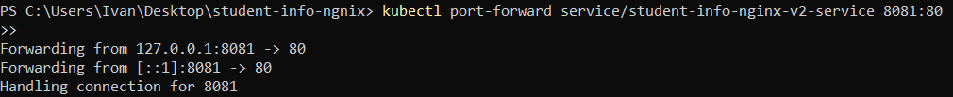

● Installing NGINX Ingress Controller

kubectl get pods -n ingress-nginx

● Create ingress pointing to the two apps:

○ path based: localhost/ver1

○ path based: localhost/ver2

○ host based: ver1..com

○ host based: ver2..com

notepad ingress.yaml

cat ingress.yaml

● Deploy manifests and ingress

kubectl apply -f ingress.yaml



● Access the four ingress rules in your local browse

Editing hosts file

kubectl get pods-n ingress-nginx

kubectl get ing

