**Kubernetes**

notepad emqx-cluster.yaml

cat emqx-cluster.yaml



* **Creating a ConfigMap for EMQX Configuration.**

* **Creating a Headless Service for Cluster Discovery.**

* **Defining a StatefulSet for 3 EMQX Nodes.**

* **Deploying.**

**kubectl apply -f emqx -f emqx-cluster.yaml**

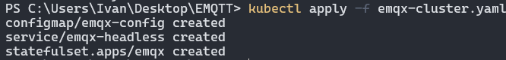

**kubectl get pods -l app=emqx**

* **Access and Verify Cluster Status.**

**kubectl exec -it emqx-0 -c emqx – emqx_ctl cluster status**

