**Docker Orchestration**

docker-compose –version



mkdir composeapp

cd composeapp

notepad app.py

notepad requirements.txt

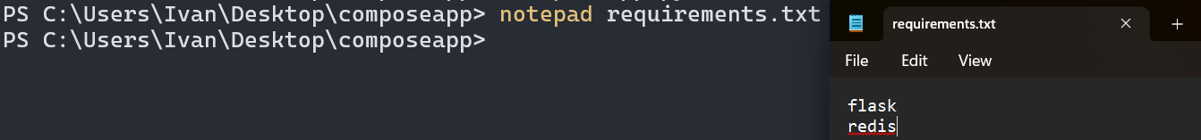

notepad Dockerfile

docker build -t ivkeex/composeapp .

docker images



Indendation Fixed

docker-compose up

http://localhost:5000/

docker-compose up -d



docker-compose ps



docker-compose logs

…

docker-compose stop | docker-compose kill



docker-compose rm

