Docker

docker info

docker run -i -t ubuntu /bin/bash

ps -aux

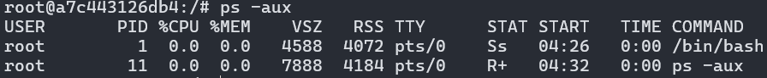

apt-get update; apt-get install vim

docker ps



docker ps -a



docker ps -l



docker run --name my_first_container -i -t ubuntu /bin/bash



docker ps -a



docker start my_first_container



docker start 7f9580fd3113



docker ps



docker attach my_first_container



docker run –name daemon_dave -d ubuntu /bin/sh

-c “while true; do echo Hello World!; sleep 1; done”



docker logs daemon_dave

docker logs -f daemon_dave

docker logs –tail 3 daemon_dave

docker top daemon_dave



docker stats daemon_dave



...

docker exec -d daemon_dave touch /etc/first_file

docker exec -i -t daemon_dave /bin/bash







docker stop daemon_dave

docker stop 3b7d39d02c18

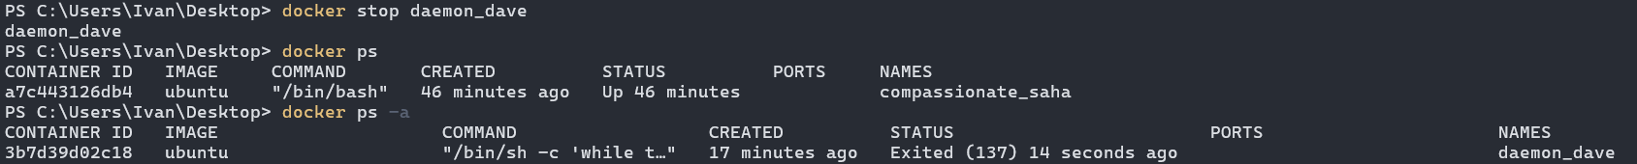

docker run --restart=always --name daemon_alice -d ubuntu /bin/sh

-c “while true; do echo Hello World!!!; sleep 1; done”



docker run --restart=on-failure:5 --name daemon_max -d ubuntu /bin/sh

-c “while true; do echo Hello World!!!; sleep 1; done”



docker inspect daemon_max

...

docker inspect -f “{{ .State.Running }}” daemon_alice

docker inspect --format “{{ .State.Running }}” daemon_max

PS C:\Users\Ivan\Desktop> docker inspect

--format "{{ .Name }} {{ .State.Running }}" daemon_alice daemon_max

docker rm daemon_alice daemon_max

docker images



docker pull ubuntu:18.04

docker images  

docker run -i -t --name my_new_container ubuntu:18.04 /bin/bash



docker search puppet

docker login

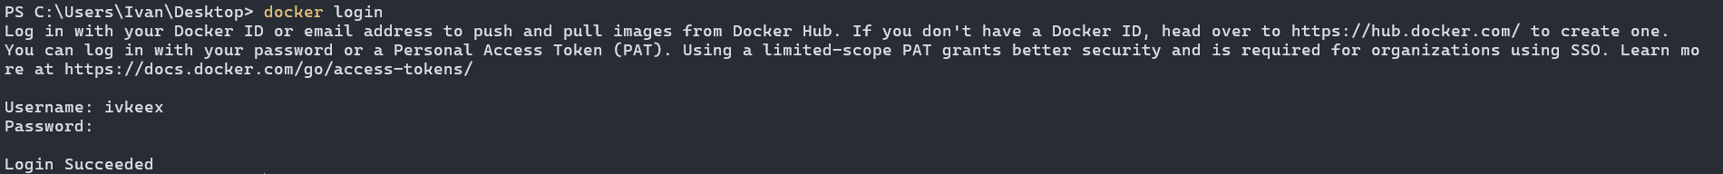

docker logout

docker run -i -t ubuntu /bin/bash

...

docker ps -l -q



docker commit 23a483cb7b6f apache2



docker images apache2



docker commit -m “A New Custom Image!” -a “Ivan Pupinoski”

23a483cb7b6f apache2:webserver



docker inspect apache2:webserver

docker run -i -t apache2:webserver /bin/bash



docker build -t=”ivanpupinoski03@gmail.com” .

Rename-Item -Path "Dockerfile.txt" -NewName "Dockerfile"

docker build -t="ivKeeX/static_web:v1" .

docker images

docker build --no-cache -t="ivKeeX/static_web" .

docker history 46b7c0cfb1de

docker run -d -p 80 --name static_web ivKeeX/static_web nginx

-g "daemon off;"



docker ps -l



docker port 8fe8d54d5994 80



docker port static_web 80



docker run -d -p 80:80 --name static_web_port_80 ivKeeX/static_web

nginx -g "daemon off;"



docker run -d -p 127.0.0.1::80 --name static_web_random_port

ivKeeX/static_web nginx -g "daemon off;"





docker run -d -P --name static_web_all_exposed ivKeeX/static_web

nginx -g "daemon off;"





Rename-Item -Path "Dockerfile.txt" -NewName "Dockerfile"



docker build -t ivkeex/apache2 .

docker build --no-cache -t="ivkeex/static_web" .

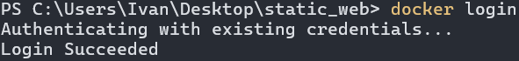

docker build --no-cache -t="ivkeex/static_web" .

docker push ivkeex/static_web

docker images

docker rmi ivkeex/static_web

