Kubernetes

● Create a nginx image with static content

mkdir nginx-static-site

cd nginx-static-site

echo “<h1>Hello I’m Ivan Pupinoski!</h1>” > index.html

ls

notepad Dockerfile

Rename-Item Dockerfile.txt Dockerfile

ls

docker build -t ivkeex/nginx-static:latest .

● Upload to Dockerhub

docker login

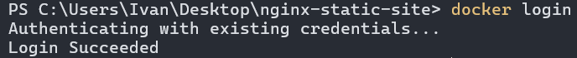

docker push ivkeex/nginx-static:latest

● Create a Pod manifest that implements that image

notepad nginx-pod.yaml

ls

k3d cluster create mycluster –agents 5 –servers 3 –api-port 6550

k3d cluster list

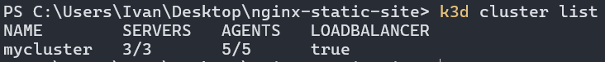

kubectl config set-cluster k3d-mycluster –server=//localhost:6550 –insecure-skip-tls-verify=true



kubectl get nodes

● Deploy the Pod to your cluster

kubectl apply -f nginx-pod.yaml



kubectl get pods



kubectl describe pod nginx-static-pod

● Watch it being deployed

kubectl port-forward pod/nginx-static-pod 8080:80



kubectl get pods -o wide

