**Source Control**

* Part 1: Working with your own Git repository.
  + **Create a GitHub account.**

**Create an SSH key pair and add it to GitHub.**

**Alternatively, create a personal access token.**

1. Creating an SSH key.

1. Checking if the key has been created.

* id_rsa -> private key
* id_rsa,pub -> public key

1. Starting the SSH agent and adding the key.

1. Copy the key.

E) Adding a key to Git.

Log in to GitHub -> Settings -> SSH and GPG keys -> New SSH key

Then click -> Add SSH key.

1. Testing the SSH connection.  
   Successfully added the key.

* + **Create a new GitHub repository and clone it locally.**

1. Creating GitHub repository.

First, go to **Repositories** section, then click on the **New button**.

Then there is an option to add Repository name (---KIII-Homeworks---) and Description, also a choice for what the repository should be, whether public or private.

Finally, click **Create repository**.

Then the SSH link is copied, which will further serve for local cloning of the repository.

1. Local cloning.

To perform a local clone, first open Git Bash, then navigate to the path where we want the local repository to be.

Then with the command git clone https://github.com/iSqloud7/---KIII-Homeworks---.git, the repository was successfully cloned locally.

* + **Work locally to add new content, stage the files, make a commit, and push the changes to GitHub.**

1. Work locally in Git Bash.

First we go into out working directory, and start running commands.

1. GitHub repository after the executed commands.

* + **Create develop, test and production branches.**

* + **Make several changes and commit to the develop branch, then merge it into the other two branches. Push the changes to GitHub.**

1. Changes in the develop branch.

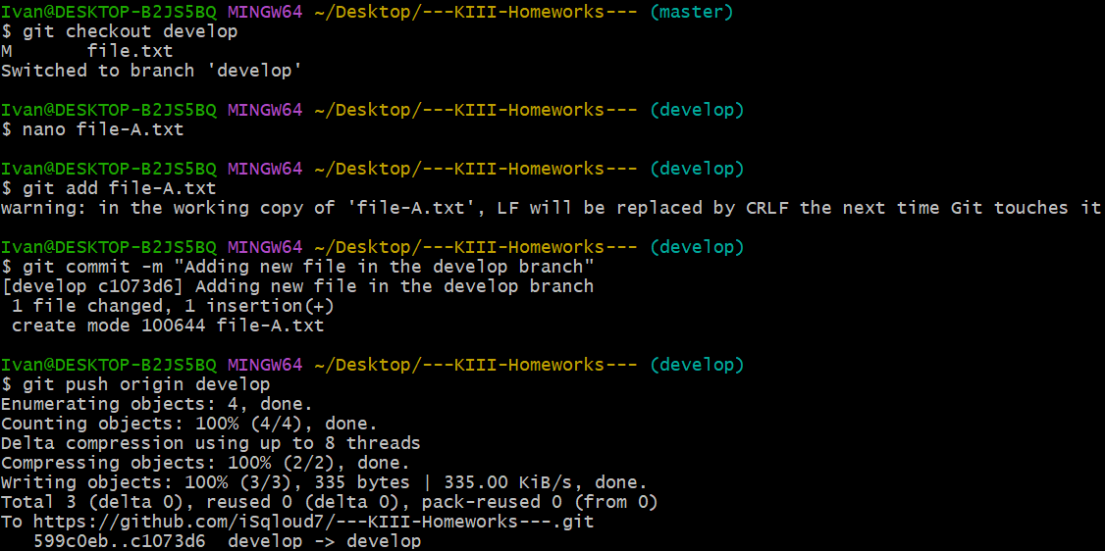

1. Merging with the two other branches.

* + **When you’re done with the branch, merge it to main. Then, commit and push to GitHub.**

* Part 2: Contributing to another Git repository on GitHub.
  + **Fork a colleague's GitHub repository.**

1. The first thing we need to do is go to the repository we want to fork, which is from our colleague and click on **Create new fork**.

1. We can give it another name in the Repository name field, as well as a description, and finally press **Create fork**.

* + **Create a new branch for a new feature.**

* + **Make changes, commit and push the changes to your GitHub repo.**

* + **When you’re done, make a Pull Request with the new feature, via GitHub’s website.**

**Compare & pull request -> Create pull request**



* + **Ask your colleague to merge the Pull Request and close the issue.**