



Research Policy 34 (2005) 1591–1607

Inventive progress measured by multi-stage patent citation analysis
Iwan von Wartburg a,∗, Thorsten Teichert a, Katja Rost b
a University of Hamburg, Marketing and Innovation, Von-Melle-Park 5, D-20146 Hamburg, Germany
b University of Zurich, Switzerland
Accepted 4 August 2005
Available online 21 September 2005

Abstract

Studies of technological change constitute a field of growing importance and sophistication. In this paper we contribute to the discussion with a methodological reflection and application of multi-stage patent citation analysis for the measurement of inven-tive progress. Investigating specific patterns of patent citation data, we conclude that single-stage citation analysis cannot reveal technological paths or lineages. Therefore, one should also make use of indirect citations and bibliographical coupling. To measure aspects of cumulative inventive progress, we develop a “shared specialization measure” of patent families. We relate this measure to an expert rating of the technological value added in the field of variable valve actuation for internal combustion engines. In sum, the study presents promising evidence for multi-stage patent citation analysis in order to explain aspects of technological change.
© 2005 Elsevier B.V. All rights reserved.

JEL classiﬁcation: O31

Keywords: Patents; Technological change; Bibliometrics; Citation analysis; Social network analysis

Introduction

Given that the study of technological change and knowledge generation is an important research field (Rosenberg, 1982, 1996), the question still remains of how such a complex, interrelated and cumulative pro-cess like technological change may be analyzed. The use of patents and patent statistics as indicators of tech-

∗ Corresponding author. Tel.: +49 40 428 38 46 43.
E-mail address: Wartburg@econ.uni-hamburg.de (I. von Wartburg).
nological progress stands for both, a long tradition and a controversial discussion about the value of patents as indicators of technological progress (Schmookler, 1966; Griliches, 1990).
Patents are a direct output category of industrial R&D and other inventive activity and mirror the cumu-lative process of technological change: on the one hand patent data enable longitudinal research and on the other hand they contain citation information that link different patents at different stages of technologi-cal development (Griliches, 1990). They cover almost every field of technology that is useful for analyzing

0048-7333/$ – see front matter © 2005 Elsevier B.V. All rights reserved. doi:10.1016/j.respol.2005.08.001

the diffusion and the development of key technologies. However, there are several drawbacks for patent data analysis that have important implications for the valid-ity of patents as measures (Pavitt, 1985; Basberg, 1987; Griliches, 1990; Archibugi, 1992). Firstly and most importantly, not all inventions are patented. Inventions may not meet the patentability criteria in the respective jurisdiction, i.e. inventions have to be novel, non-trivial, and possess a commercial application potential. The inventor might also strategically decide to exploit his intellectual property by other measures, such as keep-ing it secret or enforce copyright (Mansfield, 1986; Arundel and Kabla, 1998; Hall et al., 2001). Secondly, invention is not equal to innovation. Whereas ‘inven-tion’ refers to a supply side output of inventive activity that may or may not become economically relevant, ‘innovation’ takes the view of the demand side and refers to inventions that were introduced in the market-place.
The most common method for early patent data anal-ysis was to simply count them and to compare how many patents (applications and granted patents) had been assigned to different entities, e.g. firms, nations, and technology fields. The validity of studies compar-ing different technologies is dependent on the accuracy of the underlying patent classification systems. The classification problem addresses the necessity and diffi-culty of mapping the technological categories included in a Patent Classification Systems to economically meaningful entities like products, firms or industries (Schmookler, 1966; Grupp, 1998). A second problem with simple patent counts is the patent value problem that resides in the accepted observation that the dis-tribution of patent values is highly skewed: a small fraction of a patent sample mostly accounts for the largest part of its value (Griliches, 1990; Harhoff et al., 2003). A simple count of the number of patents equals these differences in value and importance out. In simple patent count studies the phenomenon analyzed might at best be called “invention” and not “innovation”.
The research progress achieved during little more than the last decade has been impressive. However, although today researchers can stand on the shoulders of giants there exists a shared understanding among experts that much work remains to be done in order to unpack the black box of technological change and knowledge generation. In this paper, we contribute to both, content and methodology in the study of techno-
logical invention. Our study aims to add to the discus-sion in three respects. Firstly, concerning the process of technological invention, we develop measures based on patent data to gauge the technical value added of inventions for a technological field in mechanical engi-neering. The technical value added of a single invention will be judged based on expert opinion in the form of technical scoring tables. The data set used to construct measures that help explaining technical value added consists of patent data. Secondly, we make use of net-work analysis and bibliometrics with patent citation data in order to develop an algorithm that allows laymen to cluster technical subfields. Thirdly, we contribute to the thriving discussion about patent analysis by look-ing at the explanatory value added researchers may gain by tracking technological change along patent citation chains longer than one citation step.

Theoretical development

  - Patent citation analysis

Patent citation analysis is based on the examination of citation links among different patents, and between patents and scientific literature (Narin, 1994).¹ When applying for a patent, the assignee has to prove the nov-elty, non-obviousness and usefulness of his invention. For this reason, his own invention is compared both by the inventor and the patent examiner with prior art in the respective technological field. The relevant sources for judging novelty and inventive step are referenced in the patent application.
A patent can be valuable from a technological (basicness) and/or from an economical (appropriabil-ity) point of view. The long-term technological value is the importance of a patent as a foundation for subse-quent technological inventions. It can be approximated by the number of times a patent is cited subsequently. This relation is validated by a number of evidences (Carpenter et al., 1981; Albert et al., 1991; Harhoff et al., 2003; Trajtenberg et al., 2002). The economic

1 Citations between patents and scientific literature are not the sub-ject of this paper, but they are important to mention. An interesting pioneering paper in which a lot of basic issues, also related to clas-sification problems, are discussed is the work of van Vianen et al. (1990).

value of patents is measurable by their impact on out-put success measures of the entity studied. For a firm, the question is how strong a relation between the cita-tion information of patents and the performance of the firm can be found. Empirical studies revaled a positive relationship between “times cited” of patents and firm performance or stock market valuations. Therefore, one may conclude that more often cited patents seem to gen-erate higher economic value (Narin et al., 1987; Tra-jtenberg, 1990; Griliches, 1990; Deng et al., 1999; Bre-itzman and Thomas, 2002; Harhoff et al., 2003). Thus, by shifting the focus from counting patents to analyz-ing patent citation information, output success may be measured indirectly and researchers may be legitimized to call the phenomenon studied not only “invention” but also “innovation”. However, addressing both, tech-nological invention and commercial innovation may still be a too ambitious task. Since Schumpeter’s sem-inal work, these processes are believed to represent different phenomena (Schumpeter, 1939). Therefore, researchers who try to “get their arms around” both fields simultaneously may find themselves caught in a complexity trap. Thus, this paper will focus on techni-cal invention. As theoretical underpinning we assume a path-dependent and boundedly rational search and selection process of technological inventions on behalf of participating organizations.
Patent citation analyses base on “backward” mea-sures (derived from the citations made by a patent) or “forward” measures (derived from the citations that a patent subsequently receives from other patents). For-ward citation studies used counts of patent citations as a measure of inventive quality in terms of techno-logical or economic value (Harhoff et al., 1999, 2003; Henderson et al., 1998; Trajtenberg, 1990; Trajtenberg et al., 2002). Studies using backward citation informa-tion investigated spillovers called “knowledge flows” between technology classes (Trajtenberg et al., 2002; Rosenkopf and Nerkar, 2001) or geographic regions (Jaffe et al., 1993; Tijssen, 2001). Other studies used backward citations as a means to analyze the localness of technological search by organizations (Podolny and Stuart, 1995; Fleming and Sorenson, 2001). It is impor-tant to state that the studies so far mostly used single-stage citation information. Yet, although Trajtenberg et al. (2002) use three generations of patents to assess the importance (forward citations) or basicness (backward citations) of inventions, their forward and backward
measures primarily take into account the direct cita-tions, i.e. the counts of indirect succesors’ or predeces-sors’ citations is attenuated by a factor of 0.5. Thus, to investigate longer citation chains and getting more out of the historical citation information has rarely been undertaken.

  - On the comparability of citation data

Citation analysis has its origins within bibliomet-rics, i.e. the study of citation behaviour on behalf of scientific authors or academic journals. By analysing patent citation information, it has to be taken into account that there are important differences (Meyer, 2000). Firstly, the propensity to cite original refer-ences that mark the beginning of a thinking tradition is higher in scientific publications than in patent doc-uments. In scientific literature, new articles often refer to classics in their field of study. Secondly, differences can be attributed to different motivations and actors in the citing process (Meyer, 2000). In scientific pub-lications, references are stemming mainly from the authors and occasionally from comments on behalf of the reviewers. In patent documents, in any juris-diction, the ultimate authority to place references on patent documents is the patent examiner. Compared to the sometimes flawed citation behaviour of schol-ars (MacRoberts and MacRoberts, 1988), the use of patent citation data may be advantageous in terms of validity and reliability: Patent citation data may have a high validity in terms of content quality attributed. To receive a granted patent, the inventor may carefully explore the state of the “prior art”. Foremost, an exam-iner will evaluate both the invention as well as the scope of the claims applied for by performing an in-depth review of existing patents and non-patent literature. The findings are documented as citations to patents and non-patent literature in the search and examina-tion reports and eventually on the patent granted.
It is therefore questionable, whether the motivations for citing and the resulting citing behaviour of scholarly publications and patent documents can be compared. Meyer (2000) concludes that patent citation data adhere better to the citing ideal assumed by early bibliometri-cians such as Garfield (1972) than scholarly citation data. Meyer (2000, p. 112) also concludes that “one needs to have a thorough understanding of patenting practices in order to interpret patent citation data prop-

erly. Understanding the differences between European and US patent practice, for instance, is necessary to select the appropriate data sets for the analysis.”

  - On the compatibility of US and “European”patent citation data

An especially important caveat for patent citation analysis is the comparison of US with European or similar citation information. Firstly, search reports will end up containing different kinds of references for US and Europe. US patent law requires an inventor to dis-close all prior art that is relevant to patentability of the invention in question (“duty of candour”). Failing to keep up to this duty can cause severe penalties (Akers, 2000). Therefore, applicants provide extensive lists of citations in order not to run the risk of filing an incom-plete list of references that may lead to the revocation of a granted patent in the future. Many times US exam-iners do not limit the lists of references provided by the applicants. In the end, this leads to US search reports that have more of the characteristics of a documentary search than that of patentability search (Michel and Bettels, 2001). However, there is no duty of candour in Europe. Applicants can choose whether or not to supply a list of prior art. Even if they do supply one, examiners preparing the search report will screen and filter all the references according to their relevance with respect to patentability.
Secondly, examination procedures are different for US and European patent applications. Stated roughly, the examination procedures are less standardized in the US compared to the very standardized procedures in Europe. The distribution of the examiner at the USPTO cites per patents are highly skewed (Cockburn et al., 2003). The authors concluded that “examiners matter: although highly structured and carefully monitored by the USPTO, patent examination is not a mechanical process.” (Cockburn et al., 2003, p. 52).
Further, the patentability requirements are lower for US than for European patents (Cohen and Mer-rill, 2003). Quillen and Webster (2001) report that the patent approval rates in the USPTO are in the order of 80–90% or more. Therefore, in the US many refer-ences are making it to the front page of US patents that are not significantly relevant for patentability and one is able to find references counts in the order of more than 100–200 references (Harhoff et al., 1999; Hall
et al., 2000). Besides, there is a strong “home bias”: US patent references tend to stay within the US patent system.
All these differences on behalf of inventors and examiners taken together lead us to conclude that US citation data seem to be less reliable for studying path dependencies in technological change due to a lesser degree of standardization in search and examination procedures. Concerning validity, we do not want to take a stance for “European” or against US patent citation data. Keeping in mind that US citations tend to cite older patents than European patent documents, they have to be treated differently when deriving at vari-ables based on the respective citation data. Therefore, to avoid biases in our study below, we feel urged to solely utilize citation data stemming from patents that were examined in a comparable way to the European search and examination procedure like German, British and PCT applications (WO patents) (Michel and Bettels, 2001). Given that the differences in US and “European style” citation data are now obvious it seems worth-while to take a look at the guidelines and practices for examination at the EPO, in particular the search for prior art.

  - Examination at the EPO

Before the implementation of the “Bringing Exami-nation and Search Together” project at the EPO, search and substantial examination were strictly separated tasks at the EPO. The search was carried out by ded-icated search examiners at The Hague, whereas the substantial examination was done by a colleague in Munich. Searches for European patents can also be carried out at “authorized” national offices, particularly when the language of the patent application is not one of the official languages of the EPO. The basic idea behind this split approach was that the search examiner should be able to fully concentrate on the search task, while the person doing the substantial examination should not be influenced in his judgement of newness and presence of an inventive step by all the prior art that would other-wise have passed before his eyes. The task of the search examiner is to identify the closest state-of-the-art patent to the claims of the patent application. The search doc-umentation, both in paper and electronically, is at the examiner’s disposal and enables him to carry out a thor-ough an assessment as possible. The documentation

includes the PCT minimum documentation, which is a well-defined collection of patent documents for inter-national patent applications, and thus represents a lower limit for the search standard. Since there is no proof of completeness of a search report, much emphasis is put on the training and experience of examiners. At sev-eral places in the guidelines, the examiner is asked to “exercise his judgment”. The European patent office claims to have relatively low miss rates. This can be confirmed by additional, much more profound searches that are carried out to identify novelty destroying sub-ject matter.²
Today, the task of an examiner is to identify and to examine the closest state-of-the-art in patent and non-patent prior art in order to judge novelty, inven-tive step and commercial application potential of the claimed inventions. EPO examiners are asked to base their search on the claims, usage description and draw-ings for interpretation where necessary. At first, the focus is on locating novelty-destroying material, thus subject matter pertaining to the same technological field is searched for. Only if no such documents are found, the search will be extended to similar or related fields. The search is to be stopped when documents have been found clearly demonstrating a lack of novelty in the entire subject-matter of the claimed invention. If this is not the case, the examiner stops his search when the probability of discovering further relevant prior art becomes very low.
Then, the selection of documents is guided by the following principles (EPO Guidelines, 2005): most rel-evant documents first; less relevant documents only when they concern aspects or details of the claimed invention not found in the documents already selected for citation. In borderline cases or cases of doubt, a larger amount of documents should be cited. However, no more documents than necessary are to be cited. If there are several documents of equal relevance, the search report should only cite one of them. The cited documents should be preferably in the language of the application if available, i.e. the respective patent from the to be cited patent family. At the European Patent Office, examination experience has shown that most of the relevant information on the criteria of patentabil-ity is obtained from 1 to 2 documents: “according to

2 The Swiss Federal Institute of Intellectual Property which sup-ported this research project regularly performs such searches.
the EPO philosophy, a good search report contains all the technically relevant information within a minimum number of citations.” (Michel and Bettels, 2001, p. 189) The differences between patent citation and schol-arly publication citation data mentioned above are rooted in this search procedure: because a minimum number of references are targeted cited patent refer-ences point only to the ‘closest’ prior art. Thus, single-stage citation entries regularly lack references to basic inventions in a technology field, and are therefore not appropriate for the study of whole networks and lin-eages of technological inventions. Accordingly, to map actual developments in a certain technical field and to draw on technological trajectories (Dosi, 1982) or avenues (Sahal, 1985), citation analysis should rely on everything, bibliographical coupling, co-citations, direct and indirect citations. Based on this discussion, we infer three basic presumptions that should hold true when working on empirical studies with European or
comparable patent citation data:
- In contrast to bibliometrical studies where citation analysis has been originated, “European” patent citation data are unlikely to reference all relevant prior work.
- Citation analyses of “European” patents will reveal only loosely coupled direct cross citation networks among patents of a sample group.
- Extended “European” patent citation analysis that include multi-stage citation chains are able to reveal highly connected citation networks.

Measuring cumulative technological invention with multi-stage citation analysis

  - Network measurements

A network for patent citation analysis consists of patent families and linkages between them (citing and cited citation information). Bibliometrical analysis draws on different information types (see Fig. 1). If a patent family cites or is cited by another patent family, this link is called a ‘direct citation’ link (B → D). If a cited patent family in turn cites another patent family, an ‘indirect citation’ chain between the first citing and the last cited patent family is in place (B → D → C). A ‘bibliographical coupling’ refers to a ‘shared’ citation

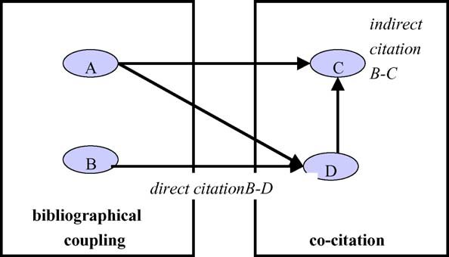

Fig. 1. Citation types.

link where two or more patent families cite another patent family (A/B → D). A ‘co-citation link’ occurs if two or more patent families are cited together by another patent family (A → C/D) (Braam et al., 1991a, 1991b; Egghe and Rousseau, 2002).
Having a network of citations, one is able to cal-culate network measures that characterize either holis-tic network characteristics or individual actors’ posi-tions within a network. There are different approaches for evaluating individual actors’ positions within such a network (Wassermann and Faust, 1994). Three common definitions of centrality are degree central-ity, closeness centrality, and betweenness centrality (Freeman, 1979).
Measures of degree centrality have been implicitly deployed by previous studies and were used as an indi-cator of importance of inventions (Trajtenberg et al., 2002).
- Freeman in-degree: importance in the sense of tech-nological impact was calculated by counting the number of citations received and adding to that num-ber the attenuated amount of citations received by the citing patents.
- Freeman out-degree: importance in the sense of
basicness of an invention was calculated by count-ing the number of references made by a patent and adding to that number the attenuated amount of cita-tions made by the cited patents.
More basic patents possess low values for back-ward importance: “[.. .] our presumption is that more basic patents would have fewer and/or less important predecessors, and therefore lower values of backward importance.” (Trajtenberg et al., 2002, p. 62). Thus,
ceteris paribus patents that are the offspring of a new technological trajectory are expected to score low on the freeman out-degree. Trajtenberg et al. (2002) found empirical evidence for this hypothesis using US patent citation data.
However, because we use citation information stem-ming from DE/EP/GB/WO patent families that are supposed to cite only the closest and most relevant prior art, we do not suppose that this finding will be repro-duced. On the contrary, we expect that a simple count of backward citations for “European” style citation infor-mation will not yield a significant correlation between the amount of backward citations and the expert indi-cator for technological value added:

Hypothesis 1. The technological value added is inde-pendent from the number of backward citations of a patent family (Freeman out-degree).

Degree centrality measures, i.e. Freeman in-degree and out-degree may be refined along three dimensions for patent citation network analysis. Firstly, not all ties between patent families should be treated equally. Therefore, a probabilistic weitghting scheme of ties between patent families is constructed and used for the measurement of direct and indirect citation links (Section 3.2). Secondly, degree centrality measures only take into account the immediate ties of actors and neglect their indirect ties other actors. Thus, the considerations for measuring direct citation links need to be extended accordingly (Section 3.3). Thirdly, patent citation information is of an inherent asymmetric nature, i.e. newer inventions citing older ones. There-fore, we have to consider bibliographical couplings and tie directional issues (Section 3.4).

  - Measurement of direct citation links

To construct probabilistic measures of ties between patent families, one has to take into account that citation links between patent families must not be of uniform weight and importance. We argue that the more prio inventions are referenced, the broader is the technolog-ical base of the citing invention. This holds since patent examiners are required to limit the cited references to the least amount required. If a single prior patent encompasses all relevant state-of-the-art, only this one will be referenced. In this case, the citing patent can

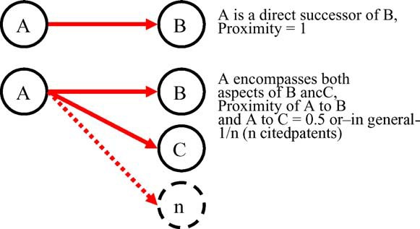

Fig. 2. Measurement of direct citation links.

be regarded as an immediate successor of the former one. Accordingly, the proximity between those patents is of maximum value. If two patents are cited, the new invention can be assumed to base equally on both prior patents. Vice versa, the proximity between the citing and any of the two cited patents should be regarded as only half of the maximum value. The rationale is that the new invention is likely to integrate certain aspects of both former ones, and thus can be regarded as a hybrid development.
Thus, we divide the number of direct citation links between two patent families by the total number of ref-erences stemming from the citing patent. This scheme serves as a standardization by which single relation-ship strengths are treated in a probabilistic manner: if a citing patent references only a single other patent, a probability value of 1 will be attributed to this relation-ship. For any other case, a probability of 1/n is allo-cated to the relationship between two patents, whereby the citing patent references a total of n other patents (see Fig. 2). This probabilistic interpretation limits the strength of direct relationships between any two patents to a maximum value of one.

  - Measurement of indirect citation links

Whereas in traditional network theory indirect links are in general of less value than direct links, this does not hold true in case of patent citations. As explained above, patent citations differ from scholarly publication citations in regard to the fact that references are strictly limited to the nearest, i.e. most recent prior art. It is however reasonable to assume that the technological foundation of citing patents does not only encompass the most recent developments cited directly. It also
draws on basic principles provided by earlier patents. Connections to basic patents are revealed by indirect linkages which are captured by citation chains. In order to assess indirect citation relationships, the considera-tions for direct citations are extended to longer citation chains:
- Given that a patent A cites exclusively patent B which in turn solely cites another patent C, a unique development path can be assumed which stems from C and leads to A. A and B can be regarded as technological improvements of C. Thus, we have to conclude that A does not only base on B but in the same way on C. Accordingly, we attribute an identi-cal proximity of A versus B, B versus C and A versus C (see upper part of Fig. 3).
- A differentiated view is necessary if more than one
patent is cited at any one level of the citation flow. Here, the reduced proximity between those directly linked patents influences the entire chain of relation-ships. Accordingly, the indirect relationship between any two patents X and Y is assessed by multiplying the strengths of the direct relationships connecting both patents (see lower part of Fig. 3).
Thus, we define the ‘reachability out-degree’ as the probability weighted direct Freeman out-degree times the probability weighted direct Freeman out-degrees of the cited patents. As the probability weight we use the inverse of the number of citations made. If a patent cites n patents, then every citation will be counted by a weight of 1/n. The reachability out-degree is a proxy for the “specialization” in what we call “shared spe-cialization”. Thus, we hypothesize:
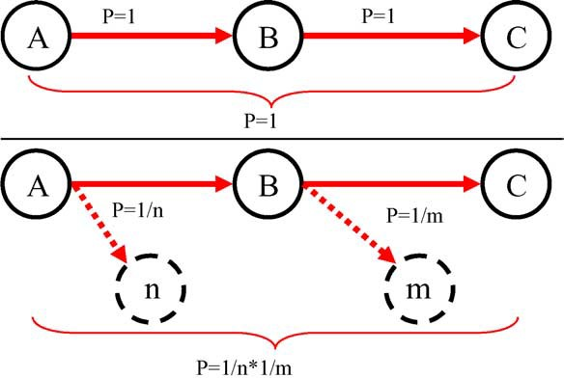

Fig. 3. Measurement of indirect citation links.

Hypothesis 2. The higher the reachability out-degree of a patent family (specialization), the higher the degree of technological value added.

  - Measurement of bibliographical coupling and directional changes

Patent citation data are of inherent asymmetric nature. This is due to the time-based character of cita-tion information, whereby only the younger patent is able to cite the elder one. Given that patents A and D cite B, we retrieve the directed relationships A → B as well as D → B (see Fig. 4). A strict vector interpretation of relationship patterns would suggest the absence of any relationship between A and D. Otherwise, neglecting the vector direction, one would infer larger proximities for A-B and D-B compared to A-D (given by A-B-

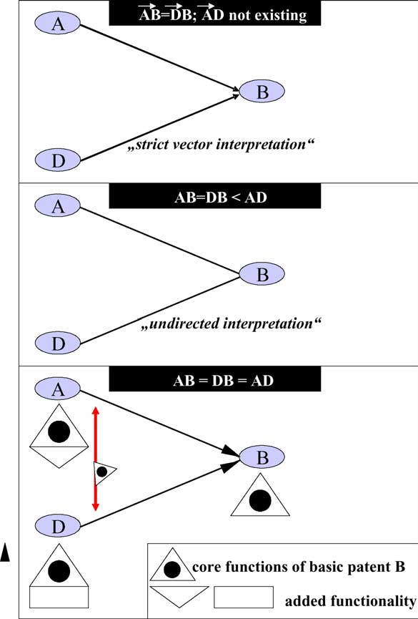

Fig. 4. Interpretation of directional changes and bibliographical cou-plings.

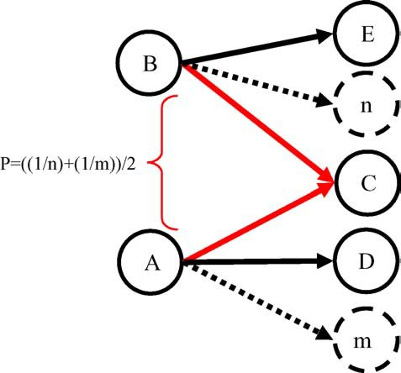

Fig. 5. Measurement of bibliographical couplings.

D). Both interpretations are inadequate: Since A and D built on B the shared amount of B-technology is the same for A and D. Thus, we can treat the bibliograph-ical coupling A-D as being equal to the ties A-B and D-B.
For simplification, we neglect any relationship between two patents containing more than one stage of biographical coupling. This seems reasonable, since such complex relationship patterns are hard to assess and may well be misleading, as they may be based on specific technological details which are only loosely related to the core of the patented invention. This con-ceptualization of bibliographical coupling had been validated during discussions with experts of the Swiss Federal Institute of Intellectual Property. We expect it to be especially apt to fields of technology that show a pattern of cumulative innovation in the sense that new inventions will be more successful if they build on prior knowledge which is rooted in even earlier inventions and so on. Since a bibliographical coupling represents two patents citing a common third patent, this is a proxy for what we call ‘shared-ness’ between these patents.
We define the degree of bibliographical coupling as one divided by the average of the direct out-degrees of the bibliographically coupled patents (see Fig. 5). Based on this discussion we infer Hypothesis 3:
Hypothesis 3. The higher patent families are bib-liographically coupled, the higher their technological value added (shared-ness).

  - Shared specialization measure

In order to come to grips with patterns of spe-cialized technological lineages and interrelated cumu-lative invention at the same time we have to com-bine the respective measures described. Whereas the reachability out-degree measures technological lin-eages by extending the focus beyond direct linkages, the measure of bibliographical coupling is a proxy for the amount of “shared-ness” of technological fea-tures among technological variants. Thus, the former describes the specialization along technological trajec-tories while the latter shows how much technologies have in common (shared technology). Together, the two measures can be viewed as a measure for “shared specialization”.
Hypothesis 4. The higher the patent families rate on the combined measure for ‘shared specialization’ derived by adding reachability out-degree and biblio-graphical coupling, the higher the degree of technolog-ical value added.
The expert criteria for application potential of patented technologies used in our empirical study (see Section 4.1 below) include items like maintenance effort or manufacturing effort. These considerations are important from a managerial point of view for the evaluation of different technological principles to be incorporated in products. However, as we found in dis-cussions with patent examiners, these criteria are not on the “hitlist” of concerns of examiners during patentabil-ity search and examination. Therefore, we do not expect any of our measures to be correlated with the expert opinion score on application potential of rated inven-tions:
Hypothesis 5. The degree of application potential is independent from the measures of Freeman out-degree, reachability out-degree, bibliographical coupling and shared specialization.
Likewise, we expect that the total score of the expert rating, i.e. the sum of the application potential, techno-logical value added, and other criteria is unrelated to the proposed patent citation network measures:
Hypothesis 6. The total score of the inventions is independent from the measures of freeman out-degree,
reachability out-degree, bibliographical coupling and shared specialization.

Methodology

  - Sample design and data gathering

We used the automotive sector to address the research questions and hypotheses. Data were collected from two sources: (1) expert ratings, and (2) archival data from patent records. By choosing an indicator for technological impact that is based in expert judgement of a technology, we follow Albert et al. (1991) who used expert opinions in order to directly validate the measure of received citations of patents as a proxy for technological quality.

    - Expert ratings
The choice of our core patent sample was driven by an engineering dissertation in the field of four strokes internal combustion engines. Hannibal (1993) stud-ied 201 camshaft and variable valve actuation patents and valued their quality along 14 criteria. In his sam-ple design, he focused on camshaft and valve control patents that at the time of his dissertation’s publication seemed to be the most promising ones in terms of their potential to influence the makers of vehicles in the next years or decades. Variable valve actuation denotes the mechanism used to shift the cams to optimal positions depending on RPM. A fixed-profile camshaft will be optimal only at one engine speed. At every other engine speed, the engine would not perform to its full poten-tial. This is why carmakers have developed schemes to vary the cam profile as the engine speed changes.
Table 1 contains our division of the criteria cho-sen by Hannibal (1993) into indicators of technological value added and application potential. The former indi-cates the inherent technological value of an invention. The latter indicates the potential that the invention may become an innovation by becoming incorporated in engines which will be manufactured and built into cars. The 14 criteria together make up the total score of a valued patent family. These indicators still limit our conjectures to the level of inventions but they allow for also assessing the application potential of inventions in terms of manufacturing or maintenance efforts required and the like.

Table 1
The criteria for the evaluation of the variable valve control patents
Dimensionality | Criterion | What it measures
Technological value added | Functionality Variability | Detailed valuation of the basic and general technical features. Central for development of products. Low rating is only possible for research prototypes Variability of valve lift curve. There are different avenues to improve on the valve lift curve that are incommensurable, i.e. cannot be combined within one solution
Application potential | Development effort  Space | Effort for the development of the technical into a productized solution. Dependent on the degree of variability: more variability means more development effort Need of space for the variable valve actuation in a motor
 | Construction effort Information  Cost Production  Control Maintenance effort Time | Effort to build the solution in question  Amount of additional electronic information needed in order to steer the variable valve actuation  Need for capital and expenditures in order to construct and develop a solution Complexity, availability and flexibility of process to manufacture the solution in masses  Feasability and ease of quality control Effort and time interval for maintenance  Possibility to influence the time needed to develop and commercialize a solution for variable valve actuation
Other | Energy efficiency  Security | How efficiently energy is used in order to improve the energy effectiveness of the motor  Risk for the driver in case of a defect of variable valve control
 | Environment | Amount of emissions for the environment (noise, gasoline, etc.)

    - Archival data from patent records
Taking the patents valued by Hannibal (1993) as our core sample we gathered a snowball sample. A snowball sample begins with a set of actors (Goodman, 1961). The actors to whom they have ties of a specific kind constitute the first-order zone. Actors tied by the actors in the first-order zone who are not among the original respondents constitute the second-order zone. This snowballing proceeds through several zones. In this study we walked “backward” by gathering patent documents referenced by the core sample. We pro-ceeded as follows:
      - First we searched for the 201 Hannibal-patents in EPOQUE’s EPODOC database and found 178 patents. Almost all missing patents were Japanese patents and applications.
      - We then grouped the patents found by patent fami-
lies. Only four patent families contained two of the original patents, so that in our core sample 174 core patent families remained.
      - Next, we gathered all the family members of the
174 families, i.e. 671 patents. We then selected this group of patents by applying what we call the “DE/EP/GB/WO”-filter. It selected only the German
(DE), European (EP), British (GB) and World (WO) patents out of the family members of the core sample patent families.
      - The remaining 276 DE/EP/GB/WO family members
were taken as the starting point for extracting the first generation of references made by the core family members. The 276 family members cited 403 differ-ent patents. Out of these, 385 patents were found in and downloaded from the EPODOC database.
      - These 385 patents were associated with 981 fam-
ily members. From all these family members, we again selected the DE/EP/GB/WOs, i.e. 347 patents. Together with the non-DE/EP/GB/WO’s out of the 385, 540 patents that were referenced by the core patents entered the database. Seventy-one patents were already contained in the core patents. That means that there are cross citations within the core patent sample.
      - The 347 DE/EP/GB/WOs served as the starting point
for extraction of the second generation of references made. The 347 family members cited 503 different patents. Out of these, 489 were found in EPODOC and entered in the database. The 489 then were grouped by patent families and again the respec-tive family members were collected: 1333 patents.

The amount of DE/EP/GB/WOs is 463. From these 463, 191 did not enter our database priorly and were included. Since we did not go any further backwards in looking for references made, our reference hunt-ing routine came to a halt.

  - Development of the citation network

As step one, we looked at the cross citations among the core sample patent families and found only 53 patent families that were in some way connected to other of the 173 nodes in the core sample. Thus, by drawing this citation network we find a very small and loosely coupled network. As a second step we traced citation chains of the length of two: core patent fami-lies cite a non-core patent family which in turn cites a core-patent family. By doing so, we were able to add 21 patent families to the small citation network found in step one. After that we added citation chains of length three, i.e. we ‘walked along’ three edges: from a core sample patent family to a non-core family (first step). From there to another non-core family (second step), and finally back to a core family (third step). By doing so, we arrived at 117 connected patent families of the 174 core patent families (see Fig. 6).
From this network consisting of 117 connected patent families, we extracted the largest network com-ponent. A component is a part of a network that is fully connected. It contains 107 core patent families. By inserting attribute data for different groups of techno-logical solutions for variable valve actuation proposed
by Hannibal (1993) we arrived at Fig. 7. The technolog-ical clusters in the main component are approximately marked by circles. Each circle represents a different technical principle to achieve a greater variability in valve actuation. Core-patent families are marked by rectangles. Dots symbolize non-core patent families found during the first and second citation steps which lead back to core-patent families. Since the patent fam-ily grouping algorithm in the programmed database system takes the first patent found in a patent family as its label, it is possible that a patent family con-taining at least one DE/EP/GB/WO patent carries a US-label.
From analyzing this derived main citation network component, we can already observe some interesting preliminary findings. Firstly, the resulting clusters by analyzing patent citation chains by the length of three match the clusters identified by the expert opinion pretty well. We interpret this as both a positive sign for the applicability of patent citation analysis along longer citation chains for European patent citation data, and for the validity of the expert judgment we are relying upon for the technological impact measure in our study. Secondly, the patterns found are in accordance with the discussion of the “European” examination practice. If the patents in our core sample had cited significantly more, our cross-citation network resulting from step one would already be denser and we would not observe such high levels in denseness increase by walking along the citation chain. Thus, we find support for the pro-posed basic presumptions. Thirdly, one can infer that

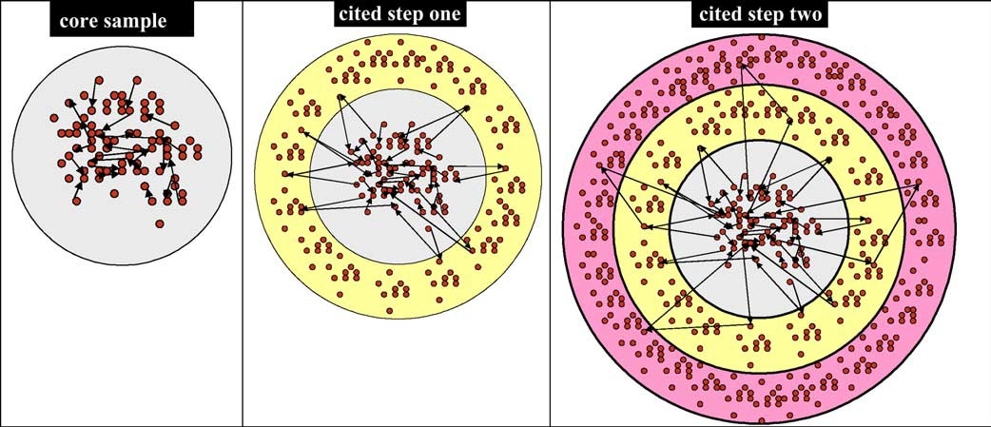

Fig. 6. Stepwise development of the citation network.

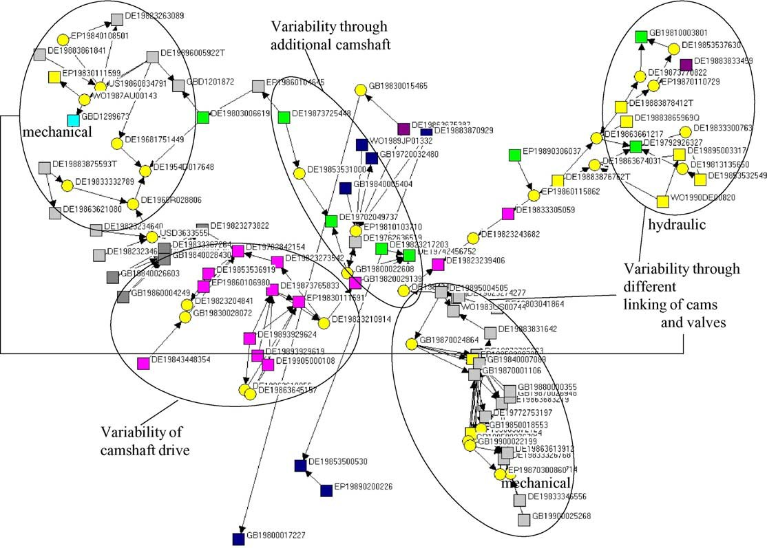

Fig. 7. Main component of citation step two network with non-core families grouped according to technological clusters.

variable valve actuation indeed represents a technolog-ical field which is characterized by highly cumulative and interrelated inventive progress. We arrive at this conclusion by observing that the removal of certain technological clusters leads to a falling apart of the main component of the core patent family citation net-work. By removing one of these binding technological clusters, we are able to reveal which technological clus-ters draw on the removed cluster. These clusters can be considered to represent different offsprings of an initial technological avenue. They recombine what has been proposed by the initial technological variant. Accord-ingly, the technical field of variable valve actuation seems to be appropriate for deploying the measures for “shared specialization”.

  - Calculation of measurements

In order to run the measurement calculations, we relied on the whole citation network contain-
ing core patent families as well as non-core patent families. In fact, all the patent families that were stored in the database during the data gathering pro-cess described above were used as sources for back-ward citations. These citations were extracted by appropriate queries using SQL language and con-verted into an edge-list format in order to represent input data for the network analytical software pack-age UCINET 6.0. After creating the whole citation network we calculated the freeman out-degree, the reachability out-degree and the bibliographical cou-pling measures. In order to calculate the indirect citation measure and the measure for bibliographical coupling, several transformations of the initial adja-cency matrix representing citation information were necessary.³

3 A detailed description of the algorithms and the matrix algebra used can be requested by contacting the corresponding author.

Results

  - General results for the shared specialization measure

By applying the algorithms of the proposed net-work measures, i.e. direct citation weights, reachability out degree, bibliographical coupling, and the com-bined measure for “shared specialization” we derive at a new network visualized in Fig. 8. The network now represents the proximity of technological clusters. Previously unrelated patent families are now related via direct, indirect, and bibliographical coupling linkages.
From a comparison of Figs. 7 and 8 we can infer that the previously identified bridging technology clusters still bridge the previously highlighted technologies: the cluster “variability of camshaft drive” still links together the different subgroups of the cluster “vari-ability through different linking mechanisms of cams and valves”, i.e. the hydraulic and mechanic subcat-egories. Further, it is evident that the technological cluster which seeks variability through an additional camshaft is occupying central positions linking the whole closeness network together. This makes intu-itively sense, since including additional camshafts is an opportunity that can be followed in the most of the
already described technological clusters. The cluster “variability by electrical systems without camshafts” represents a technological trajectory that has been cited more from other clusters that it cites them. This obser-vation can also be readily explained, since this the cluster without a camshaft is the only “camshaft-free” variable valve actuation solution that draws necessar-ily on certain functioning principles of (prior) solutions employing camshafts.

  - Hypotheses proof

To investigate the proposed hypotheses, the calcu-lated measures were correlated with the variables taken from the expert rating. Table 2 shows the resulting cor-relation matrix. We find no significant relation between the Freeman out-degree measure and the technological value added of the citing patent families determined by the expert score. Thus, we gain preliminary support for Hypothesis 1. By including indirect citation links and measuring the logarithm of the reachability out-degree measure, we find a significantly positive correlation with the technological value added. Thus, we also gain support for Hypothesis 2. By looking at bibliographical couplings as a measure of bringing different technical principles together, we find a significantly positive cor-relation of the bibliographical coupling of core patent

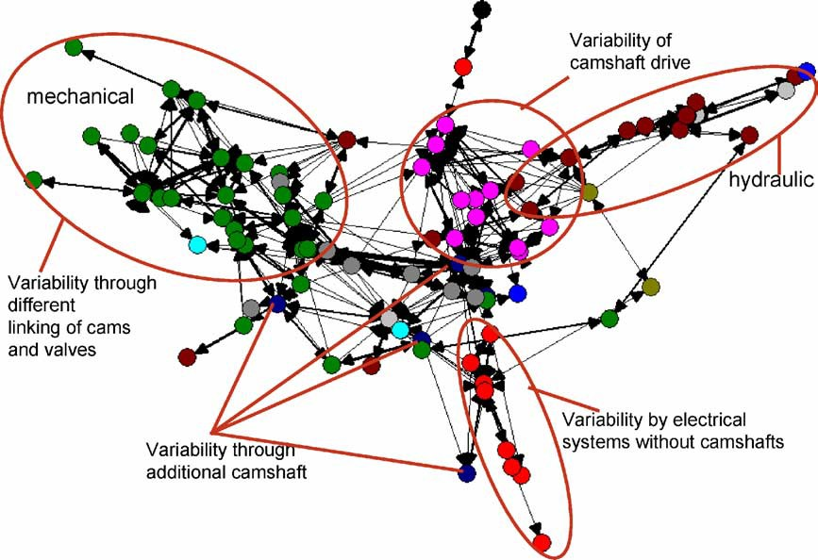

Fig. 8. Patent citation network after running the closeness algorithms.

Table 2
Resulting correlation matrix
Variable |  | 1 | 2 | 3 4 5 6
Expert Ratings
- Technological value added  - Application potential |  | 0.48**
3 Total score |  | 0.64** |  | 0.95**
Patent records
4 | Freeman out-degree | −0.09 | −0.02 |  | −0.01
5 | Reachability out-degree | 0.38** | 0.14 |  | 0.14 | −0.16
6 | Bibliographical coupling | 0.34** | 0.08 |  | 0.28** | 0.11 | 0.18
7 | Shared specialization | 0.45** | 0.08 |  | 0.27* | 0.03 | 0.53** | 0.93**
n = 107.
* p < 0.05.
** p < 0.01.

families with technological value added. Hypothesis 3 is supported. The same holds for Hypothesis 4: the mea-sure for shared specialization is significantly positive correlated to technological value added.
However, our network measures do not correlate sig-nificantly with the expert rating on application potential of the inventions. Thus, Hypothesis 5 is supported. Hence, no matter how sophisticatedly one deploys patent data, if one uses them to judge some sort of an economic value of patents, they will embody strongly limited indicators in cases where this value is rooted in cost efficiencies concerning the operational sphere of companies. This is an important caveat when working with patent data in inventive fields that are charac-terized by cumulative and interrelated technological change.
Since both bibliographical coupling and shared spe-cialization are significantly and positive correlated to the total score of the expert rating, we find no support for Hypothesis 6. Although the total score correlates heavily with the valuation of the application potential of inventions, bibliographical coupling and shared spe-cialization measures are significantly related to the total score and not related to the application potential. Given that the correlation between bibliographical coupling and total score is stronger than the relation between shared specialization and total score, we may offer a tentative explanation for this finding: the cumulative nature and interrelatedness of technological change in variable valve actuation places a premium on the combinatory search when designing new inventions. However, this proposition needs dedicated further research.

Conclusions

Studies of technological change constitute a research field of growing importance and sophistica-tion. State-of-the-art methods of patent analysis go well beyond simple patent counts and utilize patent citation analysis as a means to reveal information on the complex, interrelated and cumulative processes of technological change. With the presented study, we contributed to the discussion with an in-depth method-ological reflection on the potential of patent citation network analysis for explaining technological change. Pointing to the very specific patterns of patent citation information, we concluded that single-stage citation analyses are insufficient for revealing specific paths of technological development. To mirror actual develop-ments in a certain technological field, citation anal-ysis should rely on all, bibliographical coupling, co-citations, direct and indirect citations.
Furthermore, we explained that standard measures of network analysis have to be adjusted to the spe-cific conditions and purposes of patent citation network analysis. Most notably the degree centrality measure (Freeman out-degree) has to be questioned as an indi-cator of technological basicness of inventions. This is especially true if one uses “European style” patent cita-tion data and is less true if working with US patent citation information (Trajtenberg et al., 2002). When using mixed datasets consisting of “European” and US patents one should be cautious because the analysis can become biased because of the home-bias in citations or the significantly higher number of citations on US documents. As a consequence, we introduced a novel

approach for assessing technological proximity based on such adjusted measures in patent citation networks. We specifed rules for measuring both direct and indirect citation links and propose a way to deal with biblio-graphical couplings. In particular, in directed citation networks there is no connection between later patents that share prior technology. The measure of biblio-graphical coupling developed in this paper adds to the current discussion of patent citation networks.
To exemplify the feasibility of our approach, we relied our patent citation network measures to expert evaluation of technological value added of the patent families. These measures included the reachability out-degree as a proxy for the specialization in techno-logical lineages and the bibliographical coupling as a proxy for the shared-ness of priory known technolog-ical principles in inventions. We found that inventions with a higher technological value added relate sig-nificantly positive to the measures of reachability out degree, bibliographical coupling and the additive index of shared specialization. The Freeman out-degree does not relate to the technological value added of inven-tions. If these measures can be reproduced in future studies in different fields of technology characterized by supposedly different patterns of inventive progress (e.g. pharmaceuticals), it can become a viable com-plement to other proxies of patent quality like amount of citations received, geographical breadth, amount of claims or duration of renewal fees payment (Lanjouw et al., 1998).
From a managerial perspective this would be a wor-thy achievement: except for the amount of claims, the other proxies are only retrievable after a certain amount of time. However, the measure of shared spe-cialization can be determined by using backward cita-tion information that is available ex ante. Therefore, from a technology intelligence point of view, fur-ther validation of a measure for shared specialization could become a promising avenue for further research. Another achievement of the presented approach with managerial relevancy is the possibility to classify tech-nological subgroups efﬁciently. Again, before claiming a universal viable method for grouping technological fields in a cost and time efficient manner, further vali-dation examples are necessary.
Last, we like to point to several deliberately cho-sen simplifications and omissions in our study that can be relaxed or included in the future. Firstly, we
focus on one citation information in patent documents: patent citations. We do not further consider non-patent-citations like scientific literature. By adding this infor-mation, one could perform methodologically novel research about the science-technology linkage. Sec-ondly, in this study the weighting of patent citation relationships between patent families was done in a probabilistic manner. For “European” citation informa-tion, there is precious additional information in patent documents that was not included yet in this study: the references made by examiners are classified according to their specific relevancy for the patentability decision. There are, for instance, “particularly relevant docu-ments” marked by an [X] taking away the novelty of the essential features of the invention, “documents describ-ing the technical background” marked by an [A] or documents that are particularly relevant in combina-tion with other documents marked by a [Y]. One could use this weighting information in order to enhance the validity of the constructed measures. Thirdly, this study looks at inventive progress exclusively from a techni-cal perspective. We may gain many more interesting research findings when including the relational context of the inventors as this has been done for example by Podolny and Stuart (1995) or by Balconi et al. (2004). Fourthly, we are aware of the fact that methodologi-cally much more can be done in terms of multivariate analysis of network calculations. Keeping the limita-tions of the study explicitly in mind, we nevertheless see preliminary evidence for great potential benefits of patent citation network analysis, and thus encourage further research in this area.

Acknowledgments

We thank Harald Pier and his colleagues at the Swiss Federal Institute of Technology for supporting this research with expert insight concerning search and examination procedures. We also thank a peer reviewer for thoughtful comments concerning the state of the art in bibliometrical analysis.

References

Akers, N.J., 2000. The referencing of prior art documents in european patents and applications. World Patent Information 22, 309–315.

Albert, M.B., Avery, D., Narin, F., McAllister, P., 1991. Direct val-idation of citation counts as indicators of industrially important patents. Research Policy 20, 251–259.
Archibugi, D., 1992. Patenting as an indicator of technological inno-vation: a review. Science and Public Policy 19, 357–368.
Arundel, A., Kabla, I., 1998. What percentage of innovations are patented? empirical estimates for european firms. Research Pol-icy 27, 127–141.
Balconi, M., Breschi, S., Dissoni, F., 2004. Networks of inventors and the role of academia: an exploration of Italian patent data. Research Policy 33, 127–145.
Basberg, B., 1987. Patents and measurement of technological change: a survey of the literature. Research Policy 16, 131–141. Braam, R.R., Moed, H.F., van Raan, A.F.J., 1991a. Mapping of sci-ence by combined co-citation and word analysis. I. Structural aspects. Journal of the American Society for Information Sci-
ence (JASIS) 42, 233–251.
Braam, R.R., Moed, H.F., van Raan, A.F.J., 1991b. Mapping of sci-ence by combined co-citation and word analysis. II: dynamical aspects. Journal of the American Society for Information Science (JASIS) 42, 252–266.
Breitzman, A., Thomas, P., 2002. Using patent citation analysis to tar-get/value M&A candidates. Research Technology Management 45, 28–46.
Carpenter, M.P., Narin, F., Woolf, P., 1981. Citation rates to tech-nologically important patents. World Patent Information 3, 160–163.
Cockburn, I.M., Kortum, S., Stern, S., 2003. Are all patent examiners equal? examiners, patent characteristics, and litigation outcomes. In: Cohen, W.M., Merill, S.A. (Eds.), Patents in the Knowledge-Based Economy. National Research Council. The National Aca-demic Press, Washington, D.C, pp. 1–16.
Cohen, W.M., Merrill, S.A., 2003. Introduction. In: Cohen, W.M., Merill, S.A. (Eds.), Patents in the Knowledge-Based Economy. National Research Council. The National Academic Press, Wash-ington, D.C, pp. 1–16.
Deng, Z., Lev, B., Narin, F., 1999. Science and technology as pre-dictors of stock market performance. Financial Analysts Journal 55, 20–32.
Dosi, G., 1982. Technological paradigms and technological trajec-tories. Research Policy 11, 147–162.
Egghe, L., Rousseau, R., 2002. Co-citation, bibliographic coupling and a characterization of lattice citation networks. Scientometrics 55, 349–361.
EPO, 2005. Guidelines for examination in the EPO, Part B: Guide-lines for the search, Chapter IV: Search Procedure and Strat-egy, 3. Procedure after searching, http://www.european-patent-office.org/legal/gui lines/.
Fleming, L., Sorenson, O., 2001. Technology as a complex adap-tive system: evidence from patent data. Research Policy 30, 1019–1039.
Freeman, L.C., 1979. Centrality in social networks: conceptual clar-ification. Social Networks 1, 215–239.
Garfield, E., 1972. Citation analysis as a tool in journal evaluation.
Science, 471–479.
Goodman, L.A., 1961. Snowball sampling. Annals of Mathematical Statistics 32, 148–170.
Griliches, Z., 1990. Patent statistics as economic indicators: a survey.
Journal of Economic Literature 28, 1661–1707.
Grupp, H., 1998. Foundations of the Economics of Innovation.
Edward Elgar, Cheltenham/Northhampton, MA.
Hall, B.H., Jaffe, A.B., Trajtenberg, M., 2000. Market Value and Patent Citations: A First Look. NBER Working Paper No. 7741. National Bureau of Economic Research, Cambridge, MA.
Hall, B.H., Jaffe, A.B., Trajtenberg, M., 2001. The NBER Patent Citations Data File: Lessons, Insights and Methodological Tools. NBER Working Paper 8498. National Bureau of Economic Research, Cambridge, MA.
Hannibal, W., 1993. Vergleichende Untersuchung verschiedener variabler Ventilsteuerungen fu¨r Serien-Ottomotoren Disserta-tion. Institut fu¨r Verbrennungsmotoren und Kraftfahrwesen der Universita¨t Stuttgart, Stuttgart.
Harhoff, D., Narin, F., Scherer, F.M., Vopel, K., 1999. Citation frequency and the value of patented inventions. Review of Eco-nomics & Statistics 81, 511–515.
Harhoff, D., Scherer, F.M., Vopel, K., 2003. Citations, family size, opposition and the value of patent rights. Research Policy 32, 1343–1363.
Henderson, R., Jaffe, A., Trajtenberg, M., 1998. Universities as a source of commercialtechnology: a detailed analysis of university patenting 1965–1988. Review of Economics and Statistics 80, 119–127.
Jaffe, A.B., Trajtenberg, M., Henderson, R., 1993. Geographic local-ization of knowledge spillovers as evidenced by patent citations. Quarterly Journal of Economics 108, 577–598.
Lanjouw, J.O., Pakes, A., Putnam, J., 1998. How to count patents and value intellectual property: uses of patent renewal and application data. Journal of Industrial Economics XLVI (4), 405–433.
MacRoberts, M.H., MacRoberts, B.R., 1988. Problems of citation analysis: a critical review. Journal of the American Society for Information Science 40, 342–349.
Mansfield, E., 1986. Patents and innovation: an empirical study. Man-agement Science 32, 173–181.
Meyer, M., 2000. What is special about patent citations? Differ-ences between scientific and patent citations. Scientometrics 49, 93–123.
Michel, J., Bettels, B., 2001. Patent citation analysis, a closer look at the basic input data form patent search reports. Scientometrics 51, 185–201.
Narin, F., 1994. Patent bibliometrics. Scientometrics 30, 147–155.
Narin, F., Noma, E., Perry, R., 1987. Patents as indicators of corporate technological strength. Research Policy 16, 143–155.
Pavitt, K., 1985. Patent statistics as indicators of innovative activities: possibilities and problems. Scientometrics 7, 77–79.
Podolny, J.M., Stuart, T.E., 1995. A role-based ecology of techno-logical change. American Journal of Sociology 100, 1224–1260. Quillen, C.D., Webster, O.H., 2001. Continuing patent applications and performance of the U.S. patent office. Federal Circuit Bar
Journal 11, 1–21.
Rosenberg, N., 1982. Inside the Black Box: Technology and Eco-nomics. Cambridge University Press, Cambridge.
Rosenberg, N., 1996. Uncertainty and technological change. In: Lan-dau, R., Taylor, R., Wroght, G. (Eds.), The Mosaic of Economic Growth. Stanford University Press, Stanford.

Rosenkopf, L., Nerkar, A., 2001. Beyond local search: boundary-spanning, exploration, and impact in the optical disc industry. Strategic Management Journal 22, 287–306.
Sahal, D., 1985. Technological guideposts and innovation avenues.
Research Policy 14, 61–82.
Schmookler, J., 1966. Invention and Economic Growth. Harvard Uni-versity Press, Cambridge.
Schumpeter, J.A., 1939. Business Cycles. McGraw-Hill, New York. Tijssen, R.J.W., 2001. Global and domestic utilization of industrial relevant science: patent citation analysis of science–technology
interactions and knowledge flows. Research Policy 30, 35–54.
Trajtenberg, M., 1990. A penny for your quotes: patent citations and the value of inventions. RAND Journal of Economics 21, 172–187.
Trajtenberg, M., Henderson, R., Jaffe, A.B., 2002. University ver-sus corporate patents: a window on the basicness of inven-tion. In: Jaffe A., Trajtenberg, M. (Eds.), Patents, Cita-tions and Innovations—A Window on the Knowledge Econ-omy. MIT Press, Cambridge, MA, pp. 51–88, first pub-lished in: Economics of Innovation and New Technology 5, 19–50.
van Vianen, B.G., Moed, H.F., van Raan, A.F.J., 1990. An exploration of the science base of recent technology. Research Policy 19, 61–81.
Wassermann, S., Faust, K., 1994. Social Network Analy-sis. Methods and Applications. Cambridge University Press, Cambridge.

