The Jungle

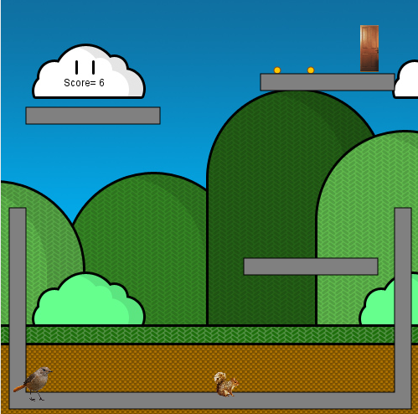

# Game Description

The game is single/multiple player(s) game (The first player can use the right/left to move the bird and the second one use the keyboard buttons to move the squirrel) . The Player need to move the squirrel in correct way to collect the acorn and drops the grain down to feed the bird . The score will increment by one for each grain the bird eats .

The main objects in the Game:

* Bird.
* Squirrel.
* Grain .
* Acorn .
* Door .
* Hurdles .

Main goal of the player is to collect the all Grain and Acorn .

Game will be controlled by Arrow keys and keyboard buttons.

The arrows will give the ability to the player to move the bird right/left to collect the grains. Also the player will use the keyboard buttons to move the Squirrel as following :

1. A > Right .
2. D > Left .
3. Space > Jump .

* The player can use the Pause button to pause the game and restart the current level .

# Game rules for Points

* Every grain collected you get one point .

# The usage images

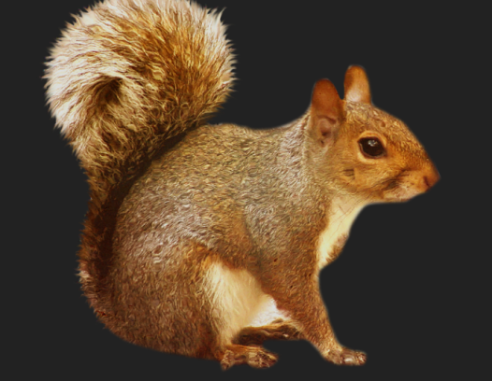

This image represents the bird .

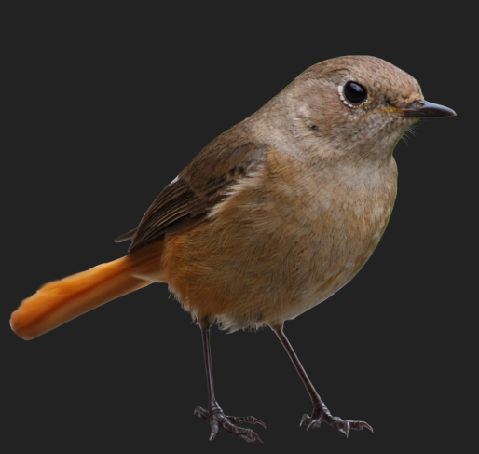

This image represents the bird.

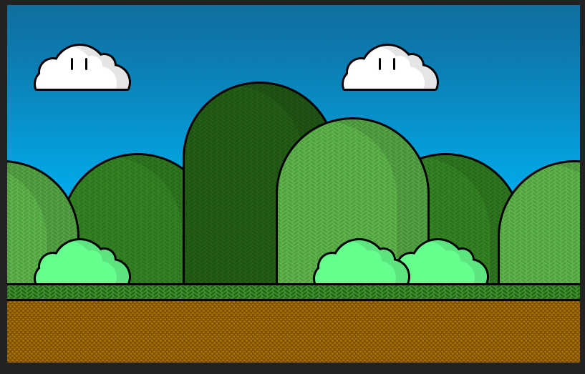

This image represents the Jungle .

