Cris Ramirez
04/03/2026
Improving Weak Prompts

- “Explain Regression”
- Explain what regression is in simple terms for an entry level data analyst with no knowledge in data analytics. Include a real world example.

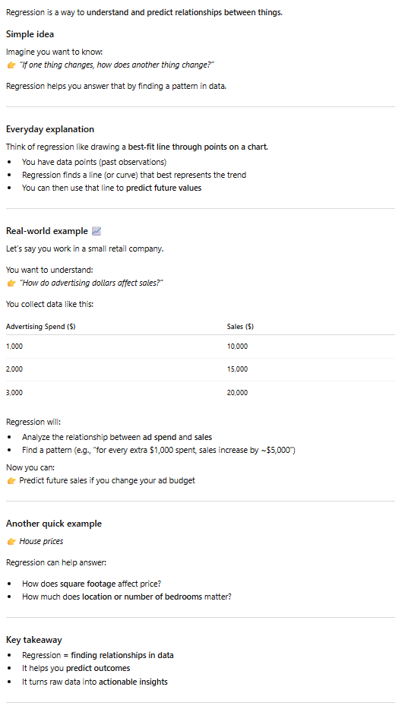
- This prompt is stronger because it provides context about the topic, and defines a persona for the audience, so AI knows to keep the explanation at beginner level.

- “Help me understand SQL”
- Explain what SQL is for a beginner student in data analytics, what its used for and show a simple example.

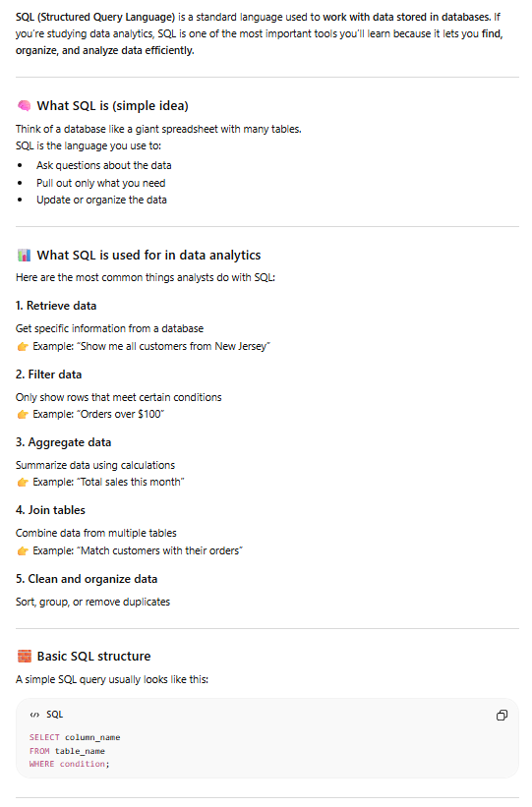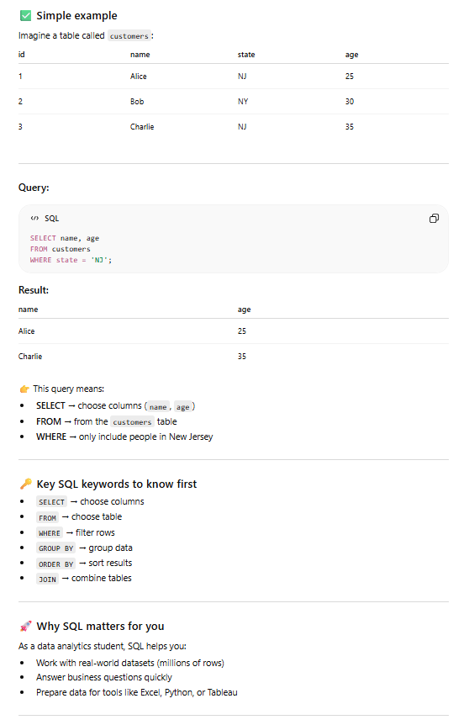
- This prompt is stronger because it provides context about the topic, defines a persona for the audience, and specifies a format by asking for a simple example.

- “Create a dataset”
- Create a dataset with 5 rows & 4 columns & format it as a table. Include Song Title, Genre, BPM, and streams. BPM should range between 120 to 160. Stream should range between 10,000 and 500,000.

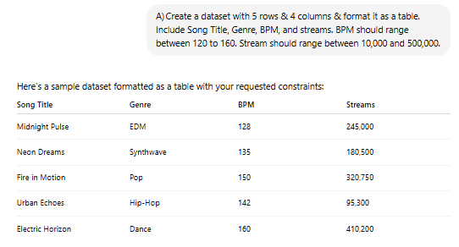
- This prompt is stronger because it provides context with a clear topic, format by asking for a table, and included references to specific column names and value ranges.

