Create New Lead (Page 1)
- No confirmation/success notification post image upload in OCR uploader
- OCR processing is taking too much time.
- ⁠OCR is failing: connection lost
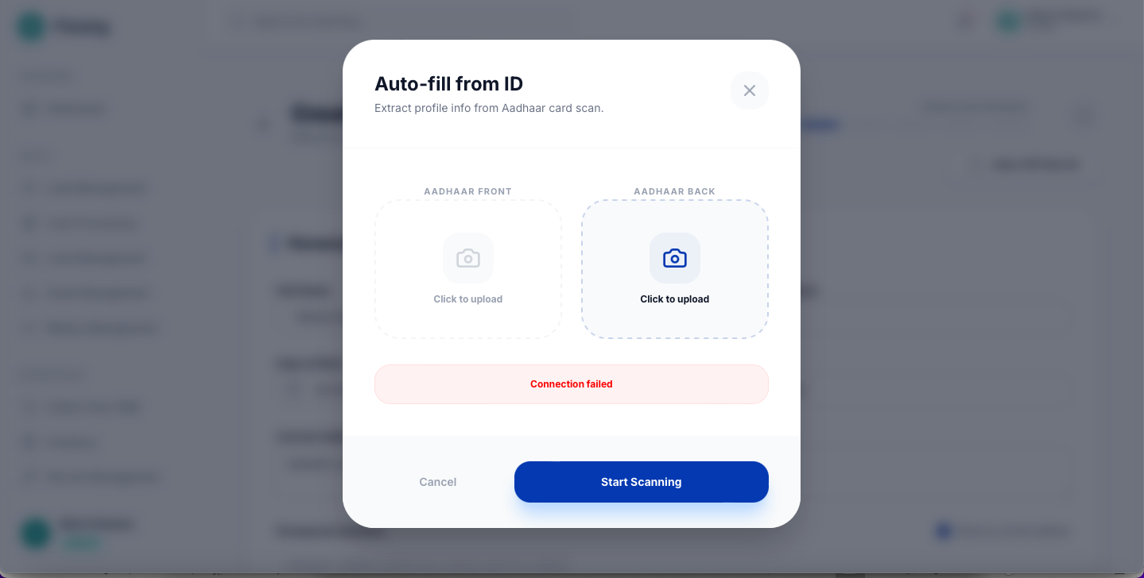
- Need to change birth date picker widget, current widget is not user friendly
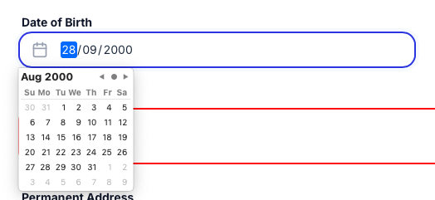
- The new form should be refreshed, it is carrying the last lead data and ID
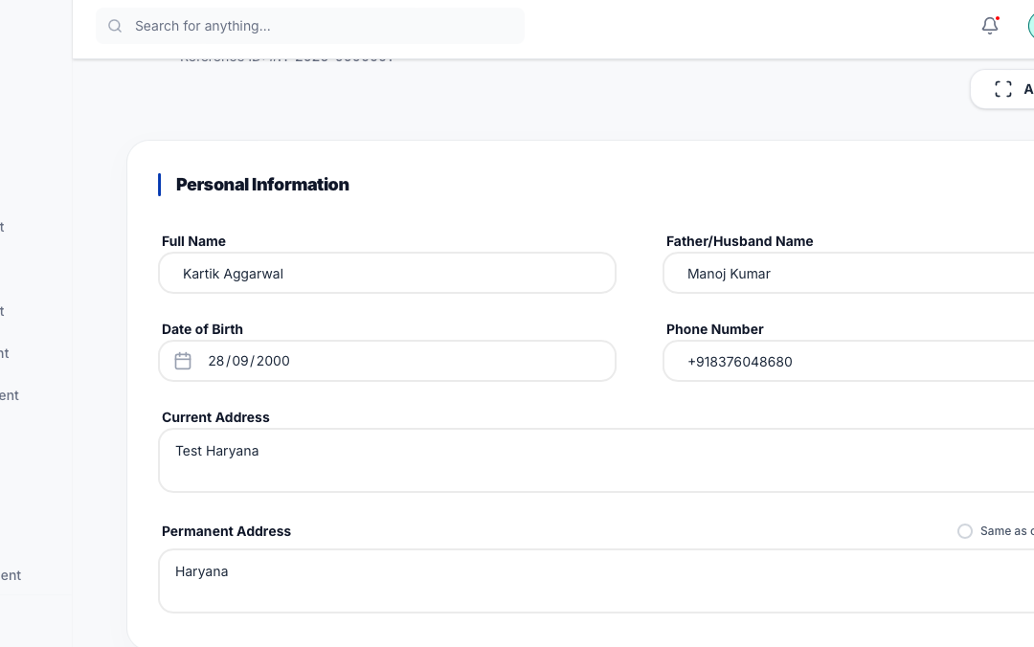

Customer KYC (Page 2)
- Upfront full payment: should skip the customer KYC and direct land to product page
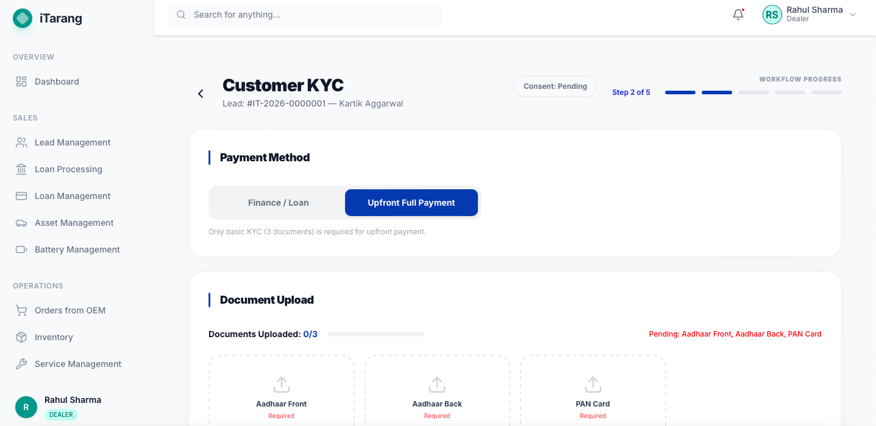
- s

