iTarang CRM
Database Schema & Process-Flow Documentation
AWS RDS · database-1 · generated 2026-05-13
42 tables across 5 business flows
This document is generated from the live Drizzle schema in src/lib/db/schema.ts. Every column, foreign key, index, and unique constraint reflects what is declared in code. Five business flows are documented in order; each flow has an entity-relationship diagram followed by per-table column reference and relationship listings.

Contents
• 1. Dealer Onboarding Flow — 9 tables
• 2. Lead Creation, KYC, Co-borrower & Consent Flow — 14 tables
• 3. Product Selection (Step 4) & Coupon Distribution — 9 tables
• 4. Inventory Lifecycle (Upload, Single Item, Transfer, Write-off, Dispatch) — 5 tables
• 5. Loan / Finance Flow (Application → Sanction → Disbursal → Repayment) — 5 tables
• Cross-flow narrative (end-to-end sale lifecycle)

1. Dealer Onboarding Flow
Captures the dealer's onboarding lifecycle: application creation, document upload, admin verification, correction rounds, e-Sign agreement, and final activation of the dealer record. An approved application produces a row in `dealers` (soft FK back to the application).

Entity-relationship diagram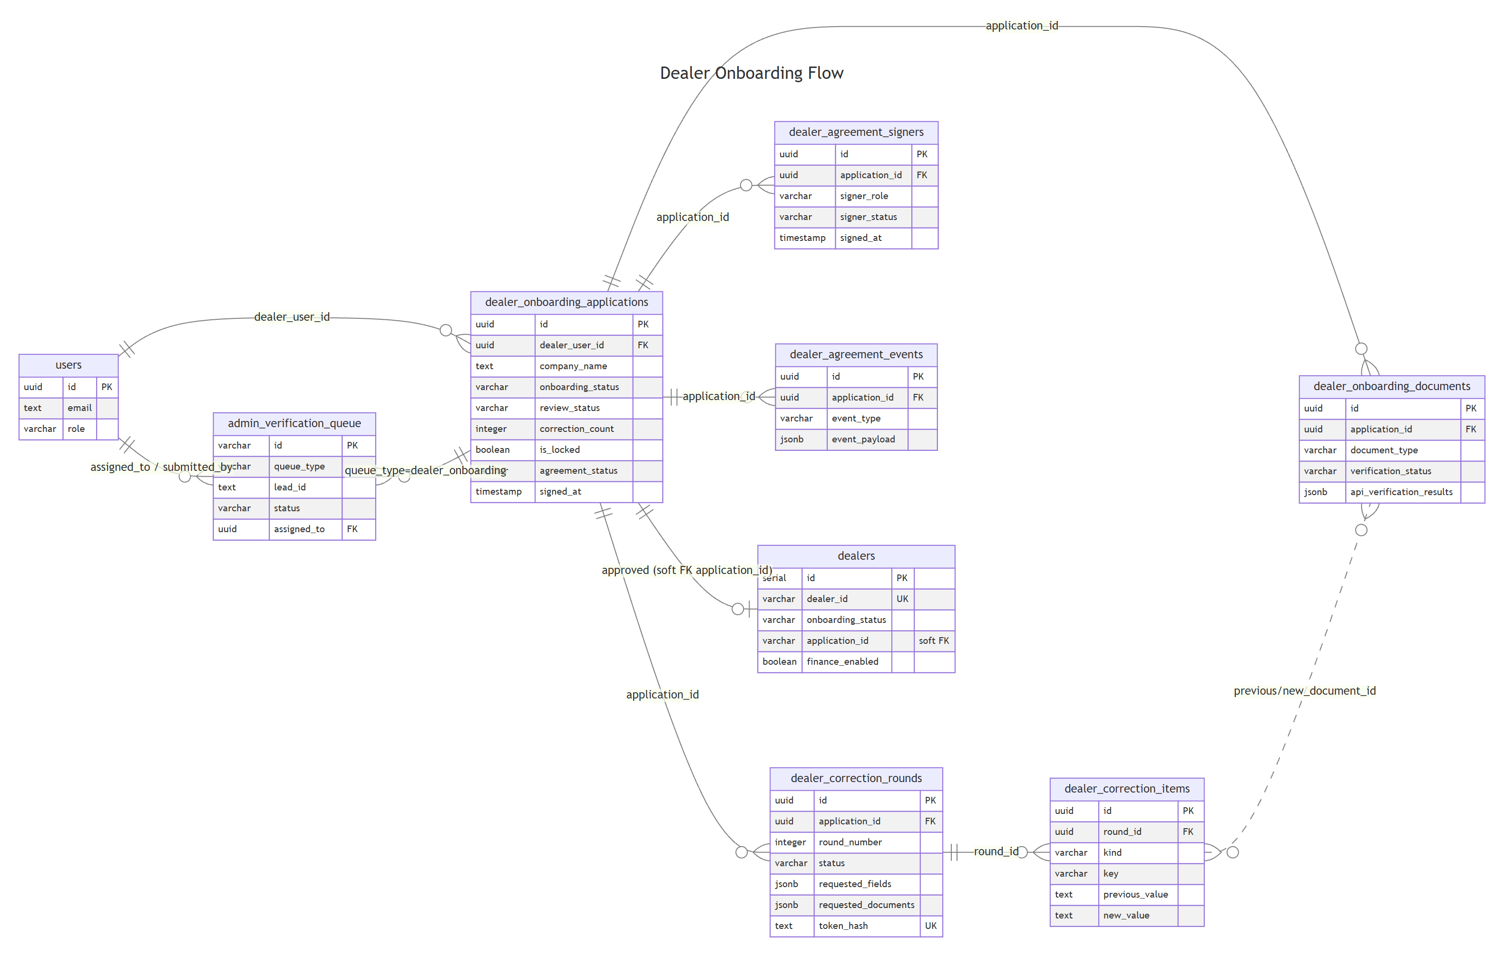

Source: docs/diagrams/01-dealer-onboarding.mmd

Tables in this flow
• users — All platform users (admin, dealer, sales staff). Referenced as actor on most other tables.
• dealer_onboarding_applications — In-flight onboarding workflow (draft → submitted → approved/rejected) with e-Sign agreement state.
• dealer_onboarding_documents — Dealer-uploaded onboarding documents (GST, PAN, bank proof, board resolution) with API verification results.
• dealer_correction_rounds — Each iteration of admin → dealer correction requests (token-protected, time-bounded).
• dealer_correction_items — Granular before/after diff for each requested field or document inside a correction round.
• dealer_agreement_signers — e-Sign signers per dealer agreement (dealer principal, Itarang signatories) with provider state.
• dealer_agreement_events — Provider webhook event log for the agreement lifecycle (initiated, signed, failed, stamped).
• admin_verification_queue — Admin task queue used to route onboarding and KYC verification work (priority, SLA, assignee).
• dealers — Master dealer account record created on application approval (legal + banking, finance flag).

users
All platform users (admin, dealer, sales staff). Referenced as actor on most other tables.
Column | Type | Flags | Default | FK / Notes
id | UUID | PK | — | —
email | Text | NOT NULL | — | —
name | Text | NOT NULL | — | —
role | Varchar(50) | NOT NULL | — | —
dealer_id | Varchar(255) | NULL | — | —
phone | Text | NULL | — | —
avatar_url | Text | NULL | — | —
is_active | Boolean | NOT NULL | true | —
created_at | Timestamp | NOT NULL | sql expression | —
updated_at | Timestamp | NOT NULL | sql expression | —
password_hash | Text | NULL | — | —
must_change_password | Boolean | NOT NULL | false | —

Foreign keys
None.

Indexes & unique constraints
None declared in schema.

dealer_onboarding_applications
In-flight onboarding workflow (draft → submitted → approved/rejected) with e-Sign agreement state.
Column | Type | Flags | Default | FK / Notes
id | UUID | PK | sql expression | —
dealer_user_id | UUID | NULL | — | —
company_name | Text | NOT NULL | — | —
company_type | Text | NULL | — | —
gst_number | Text | NULL | — | —
pan_number | Text | NULL | — | —
cin_number | Text | NULL | — | —
finance_enabled | Boolean | NULL | false | —
onboarding_status | Varchar(30) | NOT NULL | draft | —
review_status | Varchar(30) | NULL | pending | —
submitted_at | Timestamp | NULL | — | —
approved_at | Timestamp | NULL | — | —
rejected_at | Timestamp | NULL | — | —
rejection_reason | Text | NULL | — | —
admin_notes | Text | NULL | — | —
created_at | Timestamp | NOT NULL | sql expression | —
updated_at | Timestamp | NOT NULL | sql expression | —
owner_name | Text | NULL | — | —
owner_phone | Text | NULL | — | —
owner_email | Text | NULL | — | —
bank_name | Text | NULL | — | —
account_number | Text | NULL | — | —
beneficiary_name | Text | NULL | — | —
ifsc_code | Text | NULL | — | —
correction_remarks | Text | NULL | — | —
rejection_remarks | Text | NULL | — | —
dealer_account_status | Varchar(30) | NULL | inactive | —
dealer_code | Text | NULL | — | —
correction_requested_at | Timestamp | NULL | — | —
revalidated_at | Timestamp | NULL | — | —
last_action_by | UUID | NULL | — | —
last_action_at | Timestamp | NULL | — | —
approved_by | UUID | NULL | — | —
rejected_by | UUID | NULL | — | —
correction_count | Integer | NOT NULL | 0 | —
is_locked | Boolean | NOT NULL | false | —
business_address_new | Jsonb | NULL | (default) | —
city | Varchar(100) | NULL | — | —
state | Varchar(100) | NULL | — | —
pincode | Varchar(20) | NULL | — | —
contact_name | Text | NULL | — | —
contact_phone | Varchar(20) | NULL | — | —
contact_email | Varchar(150) | NULL | — | —
agreement_id | UUID | NULL | — | —
registered_address | Jsonb | NULL | (default) | —
business_address | Text | NULL | — | —
request_id | Text | NULL | — | —
provider_document_id | Text | NULL | — | —
provider_signing_url | Text | NULL | — | —
signed_at | Timestamp | NULL | — | —
last_action_timestamp | Timestamp | NULL | — | —
stamp_status | Varchar(50) | NULL | — | —
completion_status | Varchar(50) | NULL | — | —
agreement_audit_trail_url | Text | NULL | — | —
sales_manager_name | Text | NULL | — | —
sales_manager_email | Text | NULL | — | —
sales_manager_mobile | Text | NULL | — | —
itarang_signatory_1_name | Text | NULL | — | —
itarang_signatory_1_email | Text | NULL | — | —
itarang_signatory_1_mobile | Text | NULL | — | —
itarang_signatory_2_name | Text | NULL | — | —
itarang_signatory_2_email | Text | NULL | — | —
itarang_signatory_2_mobile | Text | NULL | — | —
agreement_last_initiated_at | Timestamp | NULL | — | —
agreement_expired_at | Timestamp | NULL | — | —
agreement_failed_at | Timestamp | NULL | — | —
agreement_failure_reason | Text | NULL | — | —
agreement_completed_at | Timestamp | NULL | — | —
signed_agreement_storage_path | Text | NULL | — | —
audit_trail_storage_path | Text | NULL | — | —
agreement_status | Varchar(50) | NULL | not_generated | —
provider_raw_response | Jsonb | NULL | — | —
signed_agreement_url | Text | NULL | — | —
audit_trail_url | Text | NULL | — | —
owner_landline | Varchar(20) | NULL | — | —
agreement_language | Varchar(30) | NOT NULL | english | —
is_branch_dealer | Boolean | NOT NULL | false | —
stamp_certificate_ids | Jsonb | NULL | (default) | —

Foreign keys
None.

Indexes & unique constraints
None declared in schema.

dealer_onboarding_documents
Dealer-uploaded onboarding documents (GST, PAN, bank proof, board resolution) with API verification results.
Column | Type | Flags | Default | FK / Notes
id | UUID | PK | sql expression | —
application_id | UUID | NOT NULL | — | —
document_type | Varchar(100) | NOT NULL | — | —
bucket_name | Text | NOT NULL | — | —
storage_path | Text | NOT NULL | — | —
file_name | Text | NOT NULL | — | —
file_url | Text | NULL | — | —
mime_type | Varchar(100) | NULL | — | —
file_size | BigInt53 | NULL | — | —
uploaded_by | UUID | NULL | — | —
uploaded_at | Timestamp | NOT NULL | sql expression | —
doc_status | Varchar(30) | NOT NULL | uploaded | —
verification_status | Varchar(30) | NULL | pending | —
verified_at | Timestamp | NULL | — | —
verified_by | UUID | NULL | — | —
rejection_reason | Text | NULL | — | —
extracted_data | Jsonb | NULL | (default) | —
api_verification_results | Jsonb | NULL | (default) | —
metadata | Jsonb | NULL | (default) | —
created_at | Timestamp | NOT NULL | sql expression | —
updated_at | Timestamp | NOT NULL | sql expression | —
admin_comment | Text | NULL | — | —

Foreign keys
None.

Indexes & unique constraints
• idx dealer_onboarding_documents_application_id_idx: (application_id)

dealer_correction_rounds
Each iteration of admin → dealer correction requests (token-protected, time-bounded).
Column | Type | Flags | Default | FK / Notes
id | UUID | PK | sql expression | —
application_id | UUID | NOT NULL | — | → dealer_onboarding_applications.id
round_number | Integer | NOT NULL | — | —
status | Varchar(30) | NOT NULL | pending | —
requested_by | UUID | NULL | — | —
remarks | Text | NOT NULL | — | —
requested_fields | Jsonb | NOT NULL | (default) | —
requested_documents | Jsonb | NOT NULL | (default) | —
dealer_submitted_at | Timestamp | NULL | — | —
dealer_note | Text | NULL | — | —
applied_by | UUID | NULL | — | —
applied_at | Timestamp | NULL | — | —
token_hash | Text | UK / NOT NULL | — | —
token_expires_at | Timestamp | NOT NULL | — | —
created_at | Timestamp | NOT NULL | sql expression | —
updated_at | Timestamp | NOT NULL | sql expression | —

Foreign keys
• application_id → dealer_onboarding_applications(id) ON DELETE cascade ON UPDATE no action

Indexes & unique constraints
• idx dealer_correction_rounds_application_id_idx: (application_id)
• idx dealer_correction_rounds_status_idx: (status)
• idx dealer_correction_rounds_token_hash_idx: (token_hash)

dealer_correction_items
Granular before/after diff for each requested field or document inside a correction round.
Column | Type | Flags | Default | FK / Notes
id | UUID | PK | sql expression | —
round_id | UUID | NOT NULL | — | → dealer_correction_rounds.id
kind | Varchar(20) | NOT NULL | — | —
key | Varchar(100) | NOT NULL | — | —
previous_value | Text | NULL | — | —
new_value | Text | NULL | — | —
previous_document_id | UUID | NULL | — | —
new_document_id | UUID | NULL | — | —
created_at | Timestamp | NOT NULL | sql expression | —

Foreign keys
• round_id → dealer_correction_rounds(id) ON DELETE cascade ON UPDATE no action

Indexes & unique constraints
• idx dealer_correction_items_round_id_idx: (round_id)

dealer_agreement_signers
e-Sign signers per dealer agreement (dealer principal, Itarang signatories) with provider state.
Column | Type | Flags | Default | FK / Notes
id | UUID | PK | sql expression | —
application_id | UUID | NOT NULL | — | —
provider_document_id | Text | NULL | — | —
request_id | Text | NULL | — | —
signer_role | Varchar(50) | NOT NULL | — | —
signer_name | Text | NOT NULL | — | —
signer_email | Text | NULL | — | —
signer_mobile | Text | NULL | — | —
signing_method | Varchar(50) | NULL | — | —
provider_signer_identifier | Text | NULL | — | —
provider_signing_url | Text | NULL | — | —
signer_status | Varchar(50) | NOT NULL | pending | —
signed_at | Timestamp | NULL | — | —
last_event_at | Timestamp | NULL | — | —
provider_raw_response | Jsonb | NULL | (default) | —
created_at | Timestamp | NOT NULL | sql expression | —
updated_at | Timestamp | NOT NULL | sql expression | —

Foreign keys
None.

Indexes & unique constraints
• idx dealer_agreement_signers_application_id_idx: (application_id)
• idx dealer_agreement_signers_provider_document_id_idx: (provider_document_id)
• idx dealer_agreement_signers_signer_status_idx: (signer_status)

dealer_agreement_events
Provider webhook event log for the agreement lifecycle (initiated, signed, failed, stamped).
Column | Type | Flags | Default | FK / Notes
id | UUID | PK | sql expression | —
application_id | UUID | NOT NULL | — | —
provider_document_id | Text | NULL | — | —
request_id | Text | NULL | — | —
event_type | Varchar(100) | NOT NULL | — | —
signer_role | Varchar(50) | NULL | — | —
event_status | Varchar(50) | NULL | — | —
event_payload | Jsonb | NULL | (default) | —
created_at | Timestamp | NOT NULL | sql expression | —

Foreign keys
None.

Indexes & unique constraints
• idx dealer_agreement_events_application_id_idx: (application_id)
• idx dealer_agreement_events_provider_document_id_idx: (provider_document_id)
• idx dealer_agreement_events_created_at_idx: (created_at)

admin_verification_queue
Admin task queue used to route onboarding and KYC verification work (priority, SLA, assignee).
Column | Type | Flags | Default | FK / Notes
id | Varchar(255) | PK | — | —
queue_type | Varchar(50) | NOT NULL | kyc_verification | —
lead_id | Text | NOT NULL | — | —
priority | Varchar(20) | NOT NULL | normal | —
assigned_to | UUID | NULL | — | —
submitted_by | UUID | NULL | — | —
status | Varchar(50) | NOT NULL | pending_itarang_verification | —
submitted_at | Timestamp | NULL | — | —
reviewed_at | Timestamp | NULL | — | —
created_at | Timestamp | NOT NULL | sql expression | —
updated_at | Timestamp | NOT NULL | sql expression | —

Foreign keys
None.

Indexes & unique constraints
• idx admin_verification_queue_lead_idx: (lead_id)
• idx admin_verification_queue_status_idx: (status)
• idx admin_verification_queue_assigned_idx: (assigned_to)
• idx admin_verification_queue_created_idx: (created_at)

dealers
Master dealer account record created on application approval (legal + banking, finance flag).
Column | Type | Flags | Default | FK / Notes
id | Serial | PK | (default) | —
dealer_id | Varchar(50) | UK / NULL | — | —
company_name | Varchar(200) | NOT NULL | — | —
company_type | Varchar(32) | NOT NULL | — | —
gst_number | Varchar(20) | NULL | — | —
pan_number | Varchar(20) | NULL | — | —
registered_address | Jsonb | NULL | — | —
bank_name | Varchar(200) | NULL | — | —
bank_account_number | Varchar(200) | NULL | — | —
bank_ifsc | Varchar(20) | NULL | — | —
bank_beneficiary | Varchar(200) | NULL | — | —
bank_branch | Varchar(200) | NULL | — | —
bank_account_type | Varchar(16) | NULL | — | —
owner_name | Varchar(200) | NULL | — | —
owner_phone | Varchar(20) | NULL | — | —
owner_email | Varchar(200) | NULL | — | —
finance_enabled | Boolean | NOT NULL | false | —
onboarding_status | Varchar(32) | NOT NULL | draft | —
application_id | Varchar(50) | NULL | — | —
created_at | Timestamp | NOT NULL | sql expression | —
updated_at | Timestamp | NOT NULL | sql expression | —
activated_at | Timestamp | NULL | — | —

Foreign keys
None.

Indexes & unique constraints
• idx dealers_onboarding_status_idx: (onboarding_status)
• idx dealers_application_id_idx: (application_id)

2. Lead Creation, KYC, Co-borrower & Consent Flow
Lifecycle of a customer lead from dealer-portal creation through KYC verification, co-borrower capture, supplementary document requests, and e-Sign consent. `kyc_verification_metadata` (one row per lead) is the aggregate state the admin verification queue keys off.

Entity-relationship diagram
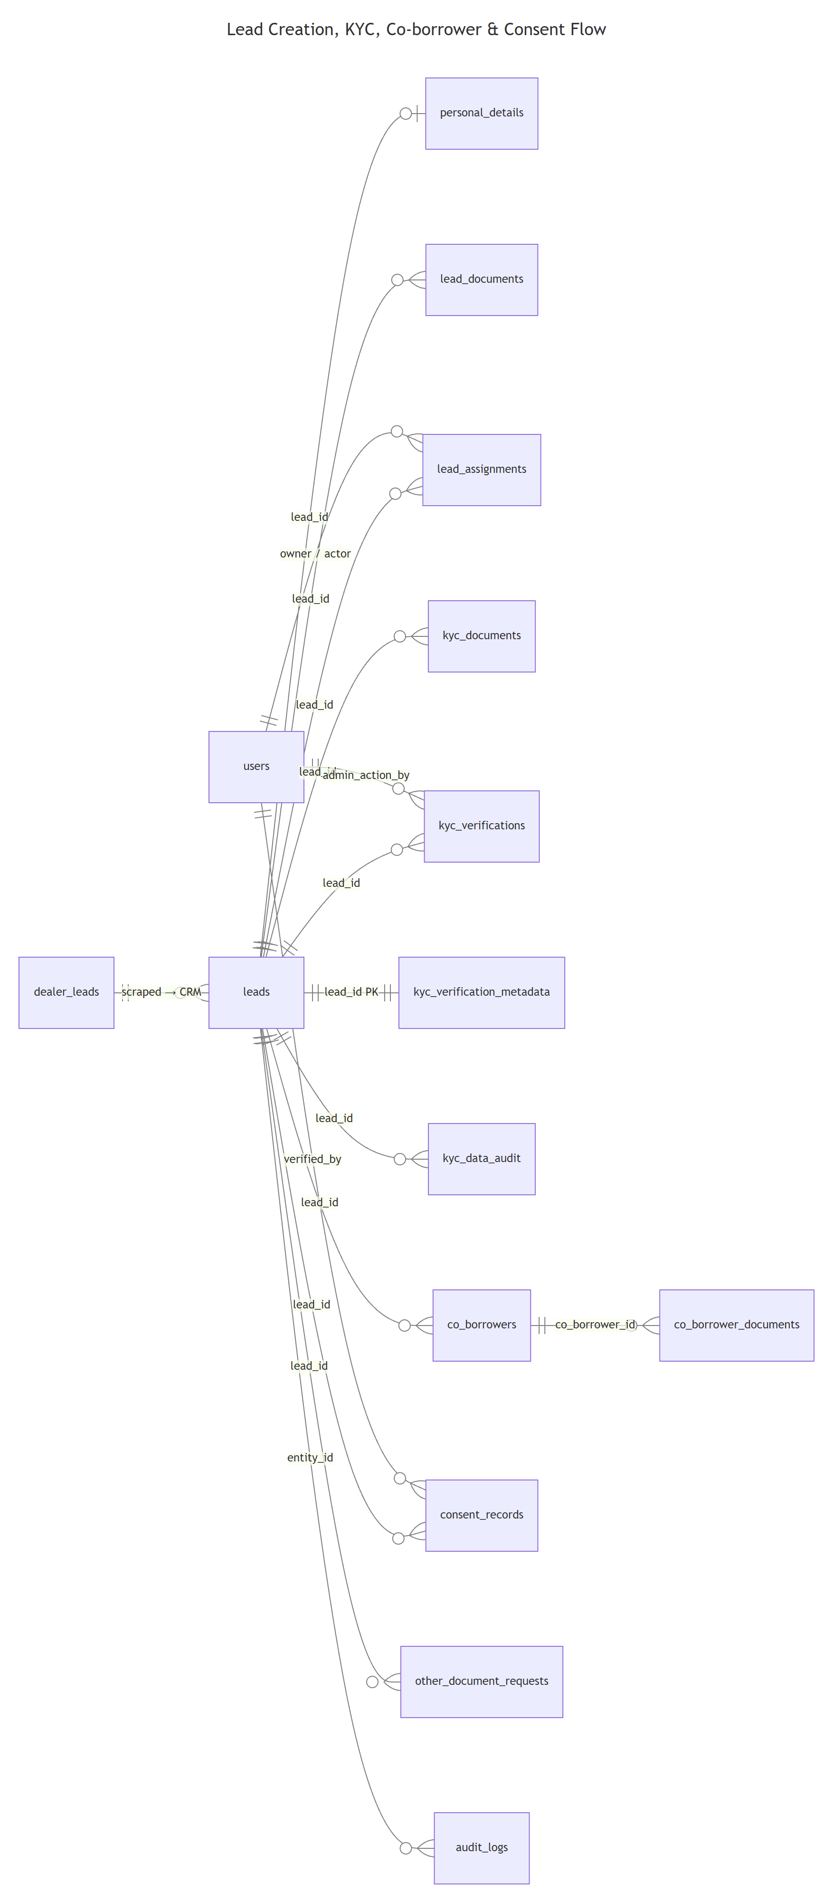
Source: docs/diagrams/02-lead-kyc.mmd

Tables in this flow
• leads — Core lead record — owner contact, workflow step, KYC status, payment method, dealer scope.
• personal_details — Borrower's personal & financial data (OCR-populated, with confidence scores).
• lead_documents — Generic document storage for a lead (legacy + miscellaneous uploads).
• lead_assignments — Tracks lead owner and current actor (AI agent / SM) for workflow routing.
• kyc_documents — KYC document uploads (Aadhaar, PAN, address) with OCR + API verification results.
• kyc_verifications — API verification attempts (Aadhaar, PAN, DigiLocker) with match scores and admin overrides.
• kyc_verification_metadata — One-row-per-lead aggregate KYC state (coupon, consent, final decision).
• kyc_data_audit — Audit trail for manual KYC field corrections entered by admin.
• co_borrowers — Co-borrower / guarantor details (spouse, parent, co-applicant) with KYC + consent state.
• co_borrower_documents — Co-borrower's uploaded KYC documents with OCR data.
• consent_records — e-Signature consent tracking (loan consent, data consent) with provider integration.
• other_document_requests — Admin-requested supplementary documents (Step 3) with upload-token + verification.
• audit_logs — Master audit trail for all entity mutations across flows (polymorphic entity_type / entity_id).
• dealer_leads — Scraper-produced dealer prospect records (separate from CRM `leads` until promoted).

leads
Core lead record — owner contact, workflow step, KYC status, payment method, dealer scope.
Column | Type | Flags | Default | FK / Notes
id | Varchar(255) | PK | — | —
dealer_id | Varchar(255) | NULL | — | —
assigned_to | UUID | NULL | — | —
owner_name | Text | NULL | — | —
owner_contact | Varchar(20) | NULL | — | —
phone | Varchar(20) | NULL | — | —
mobile | Varchar(20) | NULL | — | —
permanent_address | Text | NULL | — | —
local_address | Text | NULL | — | —
vehicle_ownership | Varchar(50) | NULL | — | —
battery_type | Varchar(50) | NULL | — | —
asset_model | Text | NULL | — | —
asset_price | Numeric(12,2) | NULL | — | —
family_members | Integer | NULL | — | —
driving_experience | Integer | NULL | — | —
loan_required | Boolean | NULL | false | —
interest_level | Varchar(20) | NULL | cold | —
lead_score | Integer | NULL | 0 | —
status | Varchar(30) | NULL | new | —
kyc_status | Varchar(30) | NULL | pending | —
kyc_score | Integer | NULL | 0 | —
kyc_completed_at | Timestamp | NULL | — | —
payment_method | Varchar(20) | NULL | — | —
consent_status | Varchar(20) | NULL | pending | —
has_co_borrower | Boolean | NULL | false | —
has_additional_docs_required | Boolean | NULL | false | —
interim_step_status | Varchar(20) | NULL | pending | —
kyc_draft_data | Jsonb | NULL | — | —
step_status | Jsonb | NULL | — | —
source | Varchar(50) | NULL | — | —
remarks | Text | NULL | — | —
created_at | Timestamp | NOT NULL | sql expression | —
updated_at | Timestamp | NOT NULL | sql expression | —
lead_source | Varchar(50) | NOT NULL | — | —
lead_status | Varchar(50) | NOT NULL | new | —
business_name | Text | NULL | — | —
owner_email | Text | NULL | — | —
state | Varchar(100) | NULL | — | —
city | Varchar(100) | NULL | — | —
shop_address | Text | NULL | — | —
lead_type | Varchar(20) | NULL | — | —
vehicle_rc | Varchar(50) | NULL | — | —
full_name | Text | NULL | — | —
father_or_husband_name | Text | NULL | — | —
dob | Timestamp | NULL | — | —
current_address | Text | NULL | — | —
is_current_same | Boolean | NOT NULL | false | —
product_category_id | Varchar(255) | NULL | — | —
product_type_id | Varchar(255) | NULL | — | —
vehicle_owner_name | Text | NULL | — | —
vehicle_owner_phone | Varchar(20) | NULL | — | —
auto_filled | Boolean | NOT NULL | false | —
ocr_status | Varchar(20) | NULL | — | —
ocr_error | Text | NULL | — | —
reference_id | Varchar(255) | NULL | — | —
interested_in | Jsonb | NULL | — | —
battery_order_expected | Integer | NULL | — | —
investment_capacity | Numeric(12,2) | NULL | — | —
business_type | Varchar(50) | NULL | — | —
qualified_by | UUID | NULL | — | —
qualified_at | Timestamp | NULL | — | —
qualification_notes | Text | NULL | — | —
converted_deal_id | Varchar(255) | NULL | — | —
converted_at | Timestamp | NULL | — | —
total_ai_calls | Integer | NULL | 0 | —
last_ai_call_at | Timestamp | NULL | — | —
last_call_outcome | Text | NULL | — | —
ai_priority_score | Numeric(5,2) | NULL | — | —
next_call_after | Timestamp | NULL | — | —
do_not_call | Boolean | NULL | false | —
workflow_step | Integer | NOT NULL | 1 | —
primary_product_id | UUID | NULL | — | —
uploader_id | UUID | NOT NULL | — | —
ai_managed | Boolean | NULL | false | —
ai_owner | Text | NULL | — | —
manual_takeover | Boolean | NULL | false | —
last_ai_action_at | Timestamp | NULL | — | —
intent_score | Integer | NULL | — | —
intent_reason | Text | NULL | — | —
next_call_at | Timestamp | NULL | — | —
call_priority | Integer | NULL | 0 | —
conversation_summary | Text | NULL | — | —
last_call_status | Text | NULL | — | —
sm_review_status | Varchar(30) | NULL | not_submitted | —
submitted_to_sm_at | Timestamp | NULL | — | —
sm_assigned_to | UUID | NULL | — | —
consent_link_url | Text | NULL | — | —
consent_link_sent_at | Timestamp | NULL | — | —
consent_link_expires_at | Timestamp | NULL | — | —
consent_delivery_channel | Varchar(50) | NULL | — | —
esign_transaction_id | Varchar(255) | NULL | — | —
esign_certificate_id | Varchar(255) | NULL | — | —
esign_completed_at | Timestamp | NULL | — | —
esign_failed_at | Timestamp | NULL | — | —
esign_error_code | Varchar(100) | NULL | — | —
esign_error_message | Text | NULL | — | —
consent_verified_by | UUID | NULL | — | —
consent_verified_at | Timestamp | NULL | — | —
consent_verification_notes | Text | NULL | — | —
consent_final | Boolean | NULL | false | —
consent_rejection_reason | Varchar(255) | NULL | — | —
consent_rejection_notes | Text | NULL | — | —
consent_rejected_by | UUID | NULL | — | —
consent_rejected_at | Timestamp | NULL | — | —
consent_attempt_count | Integer | NULL | 0 | —
google_place_id | Varchar(255) | NULL | — | —
website | Text | NULL | — | —
google_maps_uri | Text | NULL | — | —
google_rating | Numeric(3,1) | NULL | — | —
google_ratings_count | Integer | NULL | — | —
google_business_status | Varchar(50) | NULL | — | —
google_business_types | Jsonb | NULL | — | —
raw_source_payload | Jsonb | NULL | — | —
scrape_query | Text | NULL | — | —
scrape_batch_id | Varchar(255) | NULL | — | —
scraped_at | Timestamp | NULL | — | —
phone_quality | Varchar(20) | NULL | valid | —
normalized_phone | Varchar(20) | NULL | — | —
intent_band | Varchar(20) | NULL | — | —
intent_scored_at | Timestamp | NULL | — | —
intent_details | Jsonb | NULL | — | —
coupon_code | Varchar(20) | NULL | — | —
coupon_status | Varchar(20) | NULL | — | —
borrower_consent_status | Varchar(30) | NULL | awaiting_signature | —
sold_at | Timestamp | NULL | — | —

Foreign keys
None.

Indexes & unique constraints
None declared in schema.

personal_details
Borrower's personal & financial data (OCR-populated, with confidence scores).
Column | Type | Flags | Default | FK / Notes
id | Varchar(255) | PK | — | —
lead_id | Varchar(255) | NOT NULL | — | —
aadhaar_no | Varchar(12) | NULL | — | —
pan_no | Varchar(10) | NULL | — | —
dob | Timestamp | NULL | — | —
email | Text | NULL | — | —
income | Numeric(12,2) | NULL | — | —
father_husband_name | Text | NULL | — | —
marital_status | Varchar(20) | NULL | — | —
spouse_name | Text | NULL | — | —
created_at | Timestamp | NOT NULL | sql expression | —
updated_at | Timestamp | NOT NULL | sql expression | —
finance_type | Varchar(50) | NULL | — | —
financier | Varchar(100) | NULL | — | —
asset_type | Varchar(50) | NULL | — | —
vehicle_rc | Varchar(50) | NULL | — | —
loan_type | Varchar(100) | NULL | — | —
local_address | Text | NULL | — | —
dob_confidence | Numeric(5,2) | NULL | — | —
name_confidence | Numeric(5,2) | NULL | — | —
address_confidence | Numeric(5,2) | NULL | — | —
ocr_processed_at | Timestamp | NULL | — | —
permanent_address | Text | NULL | — | —
bank_account_number | Varchar(50) | NULL | — | —
bank_ifsc | Varchar(20) | NULL | — | —
bank_name | Varchar(100) | NULL | — | —
bank_branch | Varchar(100) | NULL | — | —

Foreign keys
None.

Indexes & unique constraints
None declared in schema.

lead_documents
Generic document storage for a lead (legacy + miscellaneous uploads).
Column | Type | Flags | Default | FK / Notes
id | Varchar(255) | PK | — | —
lead_id | Varchar(255) | NOT NULL | — | —
document_type | Varchar(50) | NOT NULL | — | —
document_url | Text | NOT NULL | — | —
status | Varchar(20) | NULL | uploaded | —
created_at | Timestamp | NOT NULL | sql expression | —
dealer_id | Varchar(255) | NULL | — | —
user_id | UUID | NULL | — | —
doc_type | Varchar(100) | NULL | — | —
storage_path | Text | NULL | — | —

Foreign keys
None.

Indexes & unique constraints
None declared in schema.

lead_assignments
Tracks lead owner and current actor (AI agent / SM) for workflow routing.
Column | Type | Flags | Default | FK / Notes
id | Varchar(255) | PK | — | —
lead_id | Varchar(255) | NOT NULL | — | —
lead_owner | UUID | NOT NULL | — | —
assigned_by | UUID | NOT NULL | — | —
assigned_at | Timestamp | NOT NULL | sql expression | —
lead_actor | UUID | NULL | — | —
actor_assigned_by | UUID | NULL | — | —
actor_assigned_at | Timestamp | NULL | — | —
updated_at | Timestamp | NOT NULL | sql expression | —

Foreign keys
None.

Indexes & unique constraints
None declared in schema.

kyc_documents
KYC document uploads (Aadhaar, PAN, address) with OCR + API verification results.
Column | Type | Flags | Default | FK / Notes
id | Varchar(255) | PK | — | —
lead_id | Varchar(255) | NOT NULL | — | —
doc_type | Varchar(50) | NOT NULL | — | —
file_url | Text | NULL | — | —
verification_status | Varchar(30) | NULL | pending | —
ocr_data | Jsonb | NULL | — | —
api_response | Jsonb | NULL | — | —
uploaded_at | Timestamp | NULL | sql expression | —
verified_at | Timestamp | NULL | — | —
created_at | Timestamp | NOT NULL | sql expression | —
updated_at | Timestamp | NOT NULL | sql expression | —
file_name | Text | NULL | — | —
file_size | Integer | NULL | — | —
failed_reason | Text | NULL | — | —
file_type | Varchar(50) | NULL | — | —
doc_status | Varchar(30) | NULL | not_uploaded | —
rejection_reason | Text | NULL | — | —
uploaded_by | UUID | NULL | — | —
verified_by | UUID | NULL | — | —
doc_for | Varchar(20) | NOT NULL | customer | —
purged | Boolean | NOT NULL | false | —
purged_at | Timestamp | NULL | — | —

Foreign keys
None.

Indexes & unique constraints
• idx kyc_documents_lead_id_idx: (lead_id)
• idx kyc_documents_doc_type_idx: (doc_type)

kyc_verifications
API verification attempts (Aadhaar, PAN, DigiLocker) with match scores and admin overrides.
Column | Type | Flags | Default | FK / Notes
id | Varchar(255) | PK | — | —
lead_id | Varchar(255) | NOT NULL | — | —
verification_type | Varchar(50) | NOT NULL | — | —
status | Varchar(30) | NULL | pending | —
api_provider | Varchar(50) | NULL | — | —
api_request | Jsonb | NULL | — | —
api_response | Jsonb | NULL | — | —
failed_reason | Text | NULL | — | —
submitted_at | Timestamp | NULL | — | —
completed_at | Timestamp | NULL | — | —
created_at | Timestamp | NOT NULL | sql expression | —
updated_at | Timestamp | NOT NULL | sql expression | —
match_score | Numeric(5,2) | NULL | — | —
retry_count | Integer | NULL | 0 | —
admin_action | Varchar(30) | NULL | — | —
admin_action_by | UUID | NULL | — | —
admin_action_at | Timestamp | NULL | — | —
admin_action_notes | Text | NULL | — | —
verification_for | Varchar(20) | NOT NULL | customer | —
applicant | Varchar(20) | NOT NULL | primary | —

Foreign keys
None.

Indexes & unique constraints
• idx kyc_verifications_lead_id_idx: (lead_id)
• idx kyc_verifications_type_idx: (verification_type)

kyc_verification_metadata
One-row-per-lead aggregate KYC state (coupon, consent, final decision).
Column | Type | Flags | Default | FK / Notes
lead_id | Varchar(255) | PK | — | —
submission_timestamp | Timestamp | NULL | — | —
case_type | Varchar(20) | NULL | — | —
coupon_code | Varchar(100) | NULL | — | —
coupon_status | Varchar(30) | NULL | reserved | —
documents_count | Integer | NULL | — | —
consent_verified | Boolean | NULL | false | —
dealer_edits_locked | Boolean | NULL | false | —
verification_started_at | Timestamp | NULL | — | —
first_api_execution_at | Timestamp | NULL | — | —
first_api_type | Varchar(50) | NULL | — | —
final_decision | Varchar(20) | NULL | — | —
final_decision_at | Timestamp | NULL | — | —
final_decision_by | UUID | NULL | — | —
final_decision_notes | Text | NULL | — | —
created_at | Timestamp | NOT NULL | sql expression | —
updated_at | Timestamp | NOT NULL | sql expression | —

Foreign keys
None.

Indexes & unique constraints
• idx kyc_verification_metadata_coupon_idx: (coupon_code)
• idx kyc_verification_metadata_coupon_status_idx: (coupon_status)

kyc_data_audit
Audit trail for manual KYC field corrections entered by admin.
Column | Type | Flags | Default | FK / Notes
id | Serial | PK | (default) | —
lead_id | Varchar(255) | NULL | — | —
field_name | Varchar(50) | NULL | — | —
field_value | Varchar(500) | NULL | — | —
data_source | Varchar(20) | NULL | — | —
entered_by | UUID | NULL | — | —
entered_at | Timestamp | NULL | sql expression | —
reason | Text | NULL | — | —
created_at | Timestamp | NOT NULL | sql expression | —

Foreign keys
None.

Indexes & unique constraints
• idx kyc_data_audit_lead_idx: (lead_id)

co_borrowers
Co-borrower / guarantor details (spouse, parent, co-applicant) with KYC + consent state.
Column | Type | Flags | Default | FK / Notes
id | Varchar(255) | PK | — | —
lead_id | Varchar(255) | NOT NULL | — | —
full_name | Text | NULL | — | —
phone | Varchar(20) | NULL | — | —
aadhaar_no | Varchar(12) | NULL | — | —
pan_no | Varchar(10) | NULL | — | —
dob | DateString | NULL | — | —
relationship | Varchar(50) | NULL | — | —
income | Numeric(12,2) | NULL | — | —
address | Text | NULL | — | —
created_at | Timestamp | NOT NULL | sql expression | —
updated_at | Timestamp | NOT NULL | sql expression | —
father_or_husband_name | Text | NULL | — | —
permanent_address | Text | NULL | — | —
current_address | Text | NULL | — | —
is_current_same | Boolean | NULL | false | —
auto_filled | Boolean | NULL | false | —
kyc_status | Varchar(30) | NULL | not_started | —
consent_status | Varchar(30) | NULL | awaiting_signature | —
verification_submitted_at | Timestamp | NULL | — | —

Foreign keys
None.

Indexes & unique constraints
• idx co_borrowers_lead_id_idx: (lead_id)

co_borrower_documents
Co-borrower's uploaded KYC documents with OCR data.
Column | Type | Flags | Default | FK / Notes
id | Varchar(255) | PK | — | —
lead_id | Varchar(255) | NOT NULL | — | —
co_borrower_id | Varchar(255) | NULL | — | —
document_type | Varchar(50) | NOT NULL | — | —
document_url | Text | NULL | — | —
status | Varchar(30) | NULL | pending | —
ocr_data | Jsonb | NULL | — | —
uploaded_at | Timestamp | NULL | sql expression | —
created_at | Timestamp | NOT NULL | sql expression | —
updated_at | Timestamp | NOT NULL | sql expression | —
file_name | Text | NULL | — | —
file_size | Integer | NULL | — | —
verification_status | Varchar(30) | NULL | pending | —

Foreign keys
None.

Indexes & unique constraints
None declared in schema.

consent_records
e-Signature consent tracking (loan consent, data consent) with provider integration.
Column | Type | Flags | Default | FK / Notes
id | Varchar(255) | PK | — | —
lead_id | Varchar(255) | NOT NULL | — | —
consent_type | Varchar(30) | NOT NULL | — | —
channel | Varchar(20) | NULL | — | —
consent_token | Text | NULL | — | —
consent_link_url | Text | NULL | — | —
consent_status | Varchar(20) | NULL | awaiting_signature | —
signed_at | Timestamp | NULL | — | —
generated_pdf_url | Text | NULL | — | —
created_at | Timestamp | NOT NULL | sql expression | —
updated_at | Timestamp | NOT NULL | sql expression | —
consent_for | Varchar(20) | NOT NULL | primary | —
consent_link_sent_at | Timestamp | NULL | — | —
signed_consent_url | Text | NULL | — | —
verified_by | UUID | NULL | — | —
verified_at | Timestamp | NULL | — | —
consent_link_expires_at | Timestamp | NULL | — | —
consent_delivery_channel | Varchar(20) | NULL | — | —
sign_method | Varchar(30) | NULL | — | —
esign_transaction_id | Varchar(255) | NULL | — | —
esign_certificate_id | Varchar(255) | NULL | — | —
esign_provider | Varchar(50) | NULL | — | —
esign_error_code | Varchar(50) | NULL | — | —
esign_error_message | Text | NULL | — | —
signer_aadhaar_masked | Varchar(20) | NULL | — | —
rejected_by | UUID | NULL | — | —
rejected_at | Timestamp | NULL | — | —
rejection_reason | Varchar(255) | NULL | — | —
reviewer_notes | Text | NULL | — | —
consent_attempt_count | Integer | NULL | 0 | —
esign_retry_count | Integer | NULL | 0 | —
admin_viewed_by | UUID | NULL | — | —
admin_viewed_at | Timestamp | NULL | — | —

Foreign keys
None.

Indexes & unique constraints
None declared in schema.

other_document_requests
Admin-requested supplementary documents (Step 3) with upload-token + verification.
Column | Type | Flags | Default | FK / Notes
id | Varchar(255) | PK | — | —
lead_id | Varchar(255) | NOT NULL | — | —
requested_by | UUID | NULL | — | —
doc_label | Text | NOT NULL | — | —
description | Text | NULL | — | —
file_url | Text | NULL | — | —
upload_status | Varchar(20) | NULL | pending | —
uploaded_at | Timestamp | NULL | — | —
created_at | Timestamp | NOT NULL | sql expression | —
updated_at | Timestamp | NOT NULL | sql expression | —
upload_token | Varchar(255) | NULL | — | —
token_expires_at | Timestamp | NULL | — | —
doc_for | Varchar(20) | NOT NULL | primary | —
doc_key | Varchar(100) | NOT NULL | other | —
is_required | Boolean | NULL | true | —
rejection_reason | Text | NULL | — | —
reviewed_by | UUID | NULL | — | —
reviewed_at | Timestamp | NULL | — | —
document_name | Text | NULL | — | —
document_url | Text | NULL | — | —
status | Varchar(20) | NULL | pending | —

Foreign keys
None.

Indexes & unique constraints
None declared in schema.

audit_logs
Master audit trail for all entity mutations across flows (polymorphic entity_type / entity_id).
Column | Type | Flags | Default | FK / Notes
id | Varchar(255) | PK | — | —
entity_type | Varchar(50) | NULL | — | —
entity_id | Varchar(255) | NULL | — | —
action | Varchar(50) | NULL | — | —
performed_by | UUID | NULL | — | —
old_data | Jsonb | NULL | — | —
new_data | Jsonb | NULL | — | —
created_at | Timestamp | NOT NULL | sql expression | —
changes | Jsonb | NULL | — | —
timestamp | Timestamp | NOT NULL | sql expression | —

Foreign keys
None.

Indexes & unique constraints
None declared in schema.

dealer_leads
Scraper-produced dealer prospect records (separate from CRM `leads` until promoted).
Column | Type | Flags | Default | FK / Notes
id | Text | PK | — | —
dealer_name | Text | NULL | — | —
phone | Text | UK / NULL | — | —
language | Text | NULL | — | —
follow_up_history | Jsonb | NULL | (default) | —
current_status | Text | NULL | — | —
total_attempts | Integer | NULL | 0 | —
final_intent_score | Integer | NULL | 0 | —
created_at | Timestamp | NULL | sql expression | —
location | Text | NULL | — | —
memory | Jsonb | NULL | — | —
next_call_at | Timestamp | NULL | — | —
shop_name | Text | NULL | — | —
overall_summary | Text | NULL | — | —
assigned_to | Text | NULL | — | —
approved_by | Text | NULL | — | —
rejected_by | Text | NULL | — | —
dealer_id | Text | NULL | — | —
provider | Text | NULL | bolna | —

Foreign keys
None.

Indexes & unique constraints
None declared in schema.

3. Product Selection (Step 4) & Coupon Distribution
Step 4 captures the dealer's product configuration as a frozen snapshot (`product_selections`) with complete pricing breakdown. Master tables (`product_master_batteries`, `_chargers`, `_paraphernalia`) are the authoritative BRD-compliant catalog. Coupons attach to a lead at checkout and have an immutable audit log.

Entity-relationship diagram
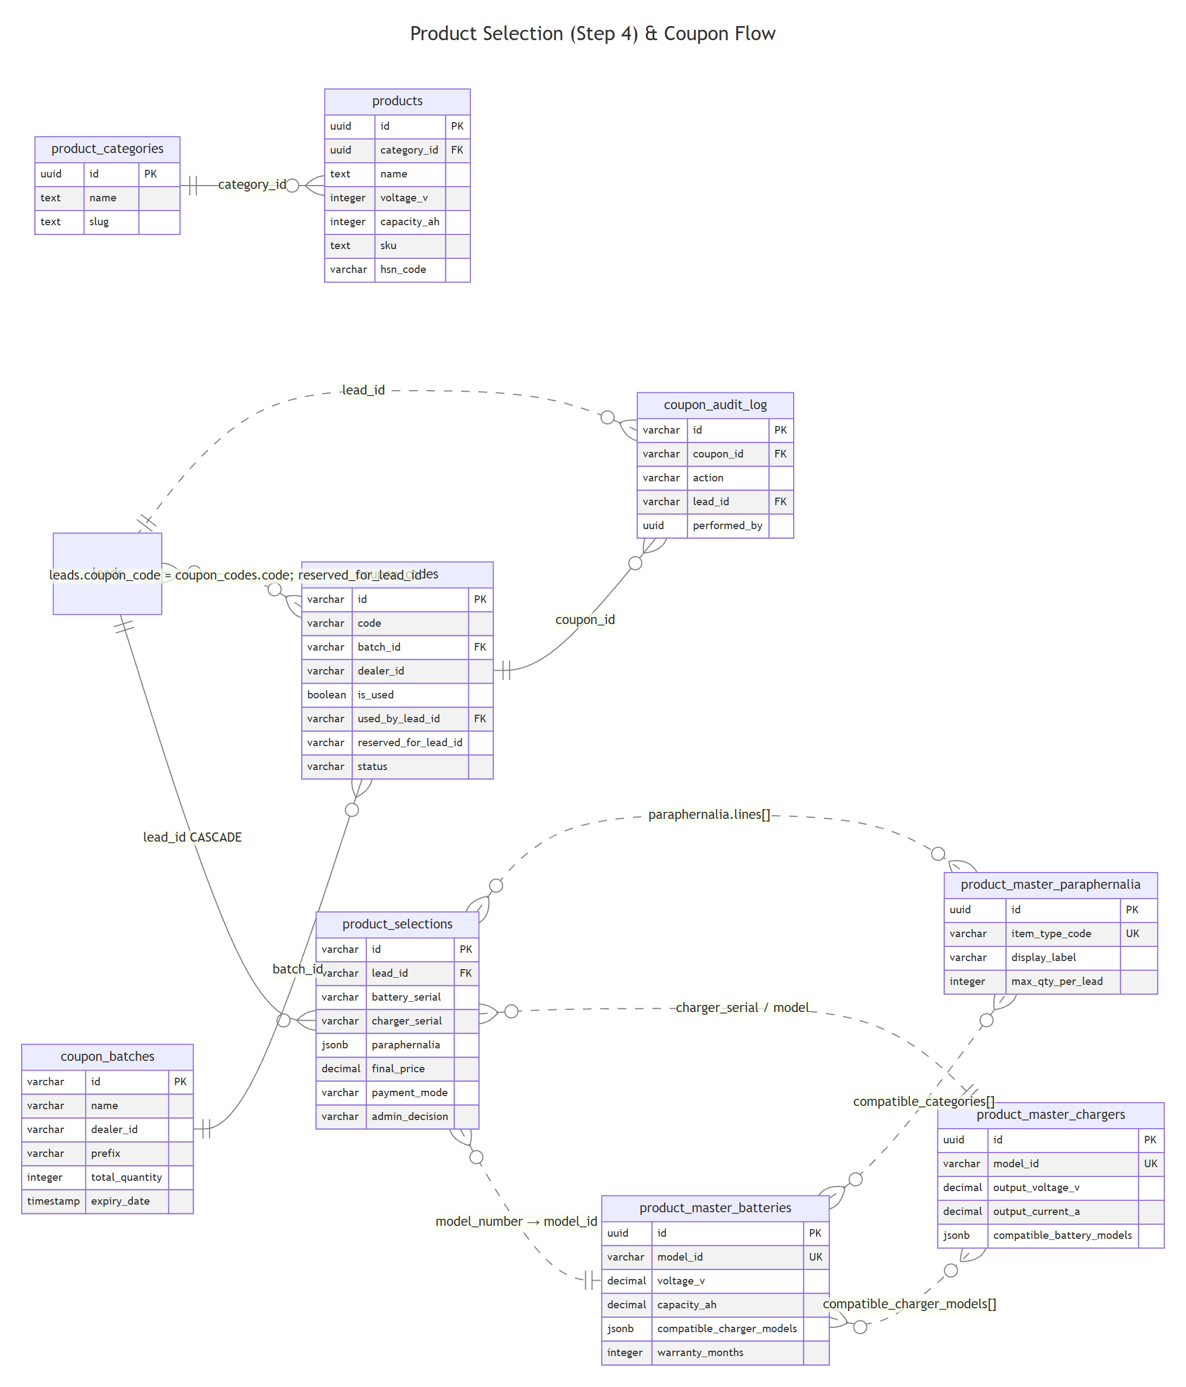
Source: docs/diagrams/03-product-coupon.mmd

Tables in this flow
• product_selections — Step-4 snapshot — battery/charger serials, paraphernalia lines, GST breakdown, admin decision.
• products — Legacy product catalog (being superseded by `product_master_*` tables).
• product_categories — Top-level product taxonomy (3-wheeler, 4-wheeler, etc).
• product_master_batteries — BRD-compliant authoritative battery master (model, voltage, capacity, compatibility, warranty).
• product_master_chargers — BRD-compliant charger master (output V/A, charging protocol, compatible batteries).
• product_master_paraphernalia — BRD-compliant accessories master (cables, harness variants, qty limits).
• coupon_batches — Batch creation of promo coupon codes per dealer (prefix, quantity, expiry, value).
• coupon_codes — Individual coupon codes with reservation / redemption state.
• coupon_audit_log — Immutable audit trail of every coupon state change (created, reserved, used, revoked, expired).

product_selections
Step-4 snapshot — battery/charger serials, paraphernalia lines, GST breakdown, admin decision.
Column | Type | Flags | Default | FK / Notes
id | Varchar(255) | PK | — | —
lead_id | Varchar(255) | NOT NULL | — | → leads.id
battery_serial | Varchar(255) | NULL | — | —
charger_serial | Varchar(255) | NULL | — | —
paraphernalia | Jsonb | NULL | — | —
category | Varchar(100) | NULL | — | —
model_number | Varchar(100) | NULL | — | —
battery_price | Numeric(12,2) | NULL | — | —
charger_price | Numeric(12,2) | NULL | — | —
paraphernalia_cost | Numeric(12,2) | NULL | — | —
dealer_margin | Numeric(12,2) | NULL | — | —
final_price | Numeric(12,2) | NULL | — | —
battery_gross | Numeric(12,2) | NULL | — | —
battery_gst_percent | Numeric(5,2) | NULL | — | —
battery_gst_amount | Numeric(12,2) | NULL | — | —
battery_net | Numeric(12,2) | NULL | — | —
charger_gross | Numeric(12,2) | NULL | — | —
charger_gst_percent | Numeric(5,2) | NULL | — | —
charger_gst_amount | Numeric(12,2) | NULL | — | —
charger_net | Numeric(12,2) | NULL | — | —
paraphernalia_lines | Jsonb | NULL | — | —
gross_subtotal | Numeric(12,2) | NULL | — | —
gst_subtotal | Numeric(12,2) | NULL | — | —
net_subtotal | Numeric(12,2) | NULL | — | —
payment_mode | Varchar(20) | NULL | — | —
admin_decision | Varchar(30) | NULL | pending | —
submitted_by | UUID | NULL | — | —
submitted_at | Timestamp | NULL | sql expression | —
created_at | Timestamp | NOT NULL | sql expression | —
updated_at | Timestamp | NOT NULL | sql expression | —

Foreign keys
• lead_id → leads(id) ON DELETE cascade ON UPDATE no action

Indexes & unique constraints
None declared in schema.

products
Legacy product catalog (being superseded by `product_master_*` tables).
Column | Type | Flags | Default | FK / Notes
id | UUID | PK | sql expression | —
category_id | UUID | NOT NULL | — | —
name | Text | NOT NULL | — | —
slug | Text | NOT NULL | — | —
voltage_v | Integer | NOT NULL | — | —
capacity_ah | Integer | NOT NULL | — | —
sku | Text | NOT NULL | — | —
sort_order | Integer | NOT NULL | 0 | —
is_active | Boolean | NOT NULL | true | —
created_at | Timestamp | NOT NULL | sql expression | —
updated_at | Timestamp | NOT NULL | sql expression | —
hsn_code | Varchar(8) | NULL | — | —
asset_type | Varchar(50) | NULL | — | —
is_serialized | Boolean | NOT NULL | true | —
warranty_months | Integer | NOT NULL | 0 | —
status | Varchar(20) | NOT NULL | active | —
price | Integer | NULL | — | —

Foreign keys
None.

Indexes & unique constraints
• idx idx_products_category_sort: (category_id, sort_order)
• idx idx_products_voltage_capacity: (voltage_v, capacity_ah)

product_categories
Top-level product taxonomy (3-wheeler, 4-wheeler, etc).
Column | Type | Flags | Default | FK / Notes
id | UUID | PK | sql expression | —
name | Text | NOT NULL | — | —
slug | Text | NOT NULL | — | —
is_active | Boolean | NOT NULL | true | —
created_at | Timestamp | NOT NULL | sql expression | —
updated_at | Timestamp | NOT NULL | sql expression | —

Foreign keys
None.

Indexes & unique constraints
None declared in schema.

product_master_batteries
BRD-compliant authoritative battery master (model, voltage, capacity, compatibility, warranty).
Column | Type | Flags | Default | FK / Notes
id | UUID | PK | sql expression | —
model_id | Varchar(50) | NOT NULL | — | —
model_name | Varchar(100) | NOT NULL | — | —
compatible_categories | Jsonb | NOT NULL | (default) | —
compatible_sub_categories | Jsonb | NOT NULL | (default) | —
voltage_v | Numeric(6,2) | NULL | — | —
capacity_ah | Numeric(8,2) | NULL | — | —
battery_chemistry | Varchar(20) | NULL | — | —
warranty_months | Integer | NOT NULL | 0 | —
iot_compatible | Boolean | NOT NULL | false | —
compatible_charger_models | Jsonb | NOT NULL | (default) | —
status | Varchar(20) | NOT NULL | active | —
created_by | UUID | NULL | — | —
created_at | Timestamp | NOT NULL | sql expression | —
updated_at | Timestamp | NOT NULL | sql expression | —

Foreign keys
None.

Indexes & unique constraints
• idx pm_battery_status_idx: (status)
• unique pm_battery_model_id_unique: (model_id)

product_master_chargers
BRD-compliant charger master (output V/A, charging protocol, compatible batteries).
Column | Type | Flags | Default | FK / Notes
id | UUID | PK | sql expression | —
model_id | Varchar(50) | NOT NULL | — | —
model_name | Varchar(100) | NOT NULL | — | —
output_voltage_v | Numeric(6,2) | NULL | — | —
output_current_a | Numeric(6,2) | NULL | — | —
charging_type | Varchar(30) | NULL | — | —
compatible_battery_models | Jsonb | NOT NULL | (default) | —
base_price | Numeric(12,2) | NULL | — | —
warranty_months | Integer | NOT NULL | 0 | —
status | Varchar(20) | NOT NULL | active | —
created_by | UUID | NULL | — | —
created_at | Timestamp | NOT NULL | sql expression | —
updated_at | Timestamp | NOT NULL | sql expression | —

Foreign keys
None.

Indexes & unique constraints
• idx pm_charger_status_idx: (status)
• unique pm_charger_model_id_unique: (model_id)

product_master_paraphernalia
BRD-compliant accessories master (cables, harness variants, qty limits).
Column | Type | Flags | Default | FK / Notes
id | UUID | PK | sql expression | —
item_type_code | Varchar(50) | NOT NULL | — | —
display_label | Varchar(100) | NOT NULL | — | —
compatible_categories | Jsonb | NOT NULL | (default) | —
max_qty_per_lead | Integer | NOT NULL | 0 | —
harness_variant | Boolean | NOT NULL | false | —
status | Varchar(20) | NOT NULL | active | —
created_by | UUID | NULL | — | —
created_at | Timestamp | NOT NULL | sql expression | —
updated_at | Timestamp | NOT NULL | sql expression | —

Foreign keys
None.

Indexes & unique constraints
• idx pm_para_status_idx: (status)
• unique pm_para_item_type_unique: (item_type_code)

coupon_batches
Batch creation of promo coupon codes per dealer (prefix, quantity, expiry, value).
Column | Type | Flags | Default | FK / Notes
id | Varchar(255) | PK | — | —
name | Varchar(200) | NOT NULL | — | —
dealer_id | Varchar(255) | NOT NULL | — | —
prefix | Varchar(20) | NOT NULL | — | —
coupon_value | Numeric(10,2) | NOT NULL | 0 | —
total_quantity | Integer | NOT NULL | — | —
expiry_date | Timestamp | NULL | — | —
status | Varchar(20) | NOT NULL | active | —
created_by | UUID | NULL | — | —
created_at | Timestamp | NOT NULL | sql expression | —
updated_at | Timestamp | NOT NULL | sql expression | —

Foreign keys
None.

Indexes & unique constraints
• idx coupon_batches_dealer_idx: (dealer_id)
• idx coupon_batches_status_idx: (status)

coupon_codes
Individual coupon codes with reservation / redemption state.
Column | Type | Flags | Default | FK / Notes
id | Varchar(255) | PK | — | —
code | Varchar(50) | NOT NULL | — | —
dealer_id | Varchar(255) | NULL | — | —
is_used | Boolean | NULL | false | —
used_by_lead_id | Varchar(255) | NULL | — | —
used_at | Timestamp | NULL | — | —
expires_at | Timestamp | NULL | — | —
created_at | Timestamp | NOT NULL | sql expression | —
status | Varchar(20) | NOT NULL | available | —
credits_available | Integer | NULL | 1 | —
used_by | UUID | NULL | — | —
validated_at | Timestamp | NULL | — | —
discount_type | Varchar(20) | NULL | flat | —
discount_value | Numeric(10,2) | NULL | 0 | —
max_discount_cap | Numeric(10,2) | NULL | — | —
min_amount | Numeric(10,2) | NULL | — | —
batch_id | Varchar(255) | NULL | — | —
reserved_at | Timestamp | NULL | — | —
reserved_by | UUID | NULL | — | —
reserved_for_lead_id | Varchar(255) | NULL | — | —

Foreign keys
None.

Indexes & unique constraints
None declared in schema.

coupon_audit_log
Immutable audit trail of every coupon state change (created, reserved, used, revoked, expired).
Column | Type | Flags | Default | FK / Notes
id | Varchar(255) | PK | — | —
coupon_id | Varchar(255) | NOT NULL | — | —
action | Varchar(20) | NOT NULL | — | —
old_status | Varchar(20) | NULL | — | —
new_status | Varchar(20) | NULL | — | —
lead_id | Varchar(255) | NULL | — | —
performed_by | UUID | NULL | — | —
ip_address | Varchar(45) | NULL | — | —
notes | Text | NULL | — | —
created_at | Timestamp | NOT NULL | sql expression | —

Foreign keys
None.

Indexes & unique constraints
• idx coupon_audit_log_coupon_idx: (coupon_id, created_at)
• idx coupon_audit_log_action_idx: (action)

4. Inventory Lifecycle (Upload, Single Item, Transfer, Write-off, Dispatch)
Inventory moves through statuses `available → reserved → dispatched → sold` (plus `written_off`). Every transition appends to `inventory_events`. Bulk uploads write to `inventory_upload_reports`. Inter-dealer movement uses `inventory_transfers`. Write-offs go through `inventory_write_offs` (with optional dual approval).

Entity-relationship diagram
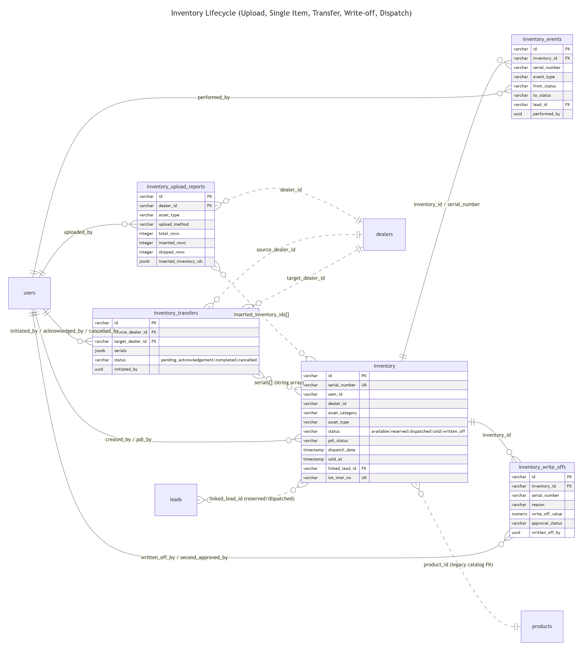
Source: docs/diagrams/04-inventory.mmd

Tables in this flow
• inventory — Physical inventory record with full lifecycle state (serial, status, PDI, dispatch, sold timestamps).
• inventory_events — Append-only event stream of every inventory status mutation.
• inventory_transfers — Inter-dealer transfers (pending_acknowledgement → completed / cancelled).
• inventory_upload_reports — Audit log of bulk inventory uploads (total/inserted/skipped rows, error JSON).
• inventory_write_offs — Write-off records with reason, value, and (when required) second approver.

inventory
Physical inventory record with full lifecycle state (serial, status, PDI, dispatch, sold timestamps).
Column | Type | Flags | Default | FK / Notes
id | Varchar(255) | PK | — | —
oem_id | Varchar(255) | NULL | — | —
oem_name | Text | NULL | — | —
product_catalog_id | Varchar(255) | NULL | — | —
hsn_code | Varchar(8) | NULL | — | —
inventory_type | Varchar(30) | NULL | — | —
asset_category | Varchar(20) | NOT NULL | — | —
asset_type | Varchar(50) | NOT NULL | — | —
sub_category | Varchar(100) | NULL | — | —
model_type | Text | NOT NULL | — | —
serial_number | Varchar(255) | NULL | — | —
material_code | Varchar(100) | NULL | — | —
is_serialized | Boolean | NOT NULL | true | —
warranty_months | Integer | NOT NULL | 0 | —
status | Varchar(30) | NOT NULL | available | —
batch_number | Varchar(100) | NULL | — | —
received_date | Timestamp | NULL | — | —
pdi_status | Varchar(20) | NULL | pending | —
pdi_completed_at | Timestamp | NULL | — | —
pdi_by | UUID | NULL | — | —
dealer_id | Varchar(255) | NULL | — | —
allocated_to_dealer_at | Timestamp | NULL | — | —
sold_at | Timestamp | NULL | — | —
deal_id | Varchar(255) | NULL | — | —
created_by | UUID | NOT NULL | — | —
created_at | Timestamp | NOT NULL | sql expression | —
updated_at | Timestamp | NOT NULL | sql expression | —
product_id | UUID | NULL | — | —
inventory_amount | Numeric(12,2) | NULL | — | —
gst_percent | Numeric(5,2) | NULL | — | —
gst_amount | Numeric(12,2) | NULL | — | —
final_amount | Numeric(12,2) | NULL | — | —
oem_invoice_number | Text | NULL | — | —
oem_invoice_date | Timestamp | NULL | — | —
oem_invoice_url | Text | NULL | — | —
product_manual_url | Text | NULL | — | —
warranty_document_url | Text | NULL | — | —
warehouse_location | Text | NULL | — | —
manufacturing_date | Timestamp | NULL | — | —
expiry_date | Timestamp | NULL | — | —
quantity | Integer | NULL | — | —
iot_imei_no | Varchar(255) | NULL | — | —
iot_enabled | Boolean | NOT NULL | false | —
linked_lead_id | Varchar(255) | NULL | — | —
dispatch_date | Timestamp | NULL | — | —
soc_percent | Numeric(5,2) | NULL | — | —
soc_last_sync_at | Timestamp | NULL | — | —
voltage_v | Numeric(6,2) | NULL | — | —
capacity_ah | Numeric(8,2) | NULL | — | —
output_current_a | Numeric(6,2) | NULL | — | —
compatible_models | Jsonb | NULL | — | —
star_rating | Integer | NULL | — | —
physical_condition | Varchar(20) | NULL | — | —
oem_warranty_date | DateString | NULL | — | —
oem_warranty_months | Integer | NULL | — | —
oem_warranty_expiry | DateString | NULL | — | —
oem_warranty_clauses | Text | NULL | — | —
upload_event_id | Varchar(64) | NULL | — | —

Foreign keys
None.

Indexes & unique constraints
• idx inventory_dealer_status_idx: (dealer_id, status)
• idx inventory_invoice_date_idx: (oem_invoice_date)
• unique inventory_serial_unique: (serial_number)
• unique inventory_imei_unique: (iot_imei_no)

inventory_events
Append-only event stream of every inventory status mutation.
Column | Type | Flags | Default | FK / Notes
id | Varchar(64) | PK | — | —
serial_number | Varchar(255) | NOT NULL | — | —
inventory_id | Varchar(255) | NULL | — | —
event_type | Varchar(40) | NOT NULL | — | —
from_status | Varchar(30) | NULL | — | —
to_status | Varchar(30) | NULL | — | —
lead_id | Varchar(255) | NULL | — | —
performed_by | UUID | NULL | — | —
performed_at | Timestamp | NOT NULL | sql expression | —
notes | Text | NULL | — | —
metadata | Jsonb | NULL | — | —

Foreign keys
None.

Indexes & unique constraints
• idx inventory_events_serial_idx: (serial_number, performed_at)
• idx inventory_events_type_idx: (event_type)

inventory_transfers
Inter-dealer transfers (pending_acknowledgement → completed / cancelled).
Column | Type | Flags | Default | FK / Notes
id | Varchar(64) | PK | — | —
source_dealer_id | Varchar(255) | NOT NULL | — | —
target_dealer_id | Varchar(255) | NOT NULL | — | —
serials | Jsonb | NOT NULL | — | —
reason | Text | NULL | — | —
initiated_by | UUID | NOT NULL | — | —
initiated_at | Timestamp | NOT NULL | sql expression | —
acknowledged_by | UUID | NULL | — | —
acknowledged_at | Timestamp | NULL | — | —
cancelled_by | UUID | NULL | — | —
cancelled_at | Timestamp | NULL | — | —
cancellation_reason | Text | NULL | — | —
status | Varchar(30) | NOT NULL | pending_acknowledgement | —
created_at | Timestamp | NOT NULL | sql expression | —
updated_at | Timestamp | NOT NULL | sql expression | —

Foreign keys
None.

Indexes & unique constraints
• idx inventory_transfers_source_idx: (source_dealer_id)
• idx inventory_transfers_target_idx: (target_dealer_id)
• idx inventory_transfers_status_idx: (status)

inventory_upload_reports
Audit log of bulk inventory uploads (total/inserted/skipped rows, error JSON).
Column | Type | Flags | Default | FK / Notes
id | Varchar(64) | PK | — | —
dealer_id | Varchar(255) | NOT NULL | — | —
asset_type | Varchar(30) | NOT NULL | — | —
inventory_type | Varchar(30) | NULL | — | —
upload_method | Varchar(20) | NULL | — | —
uploaded_by | UUID | NOT NULL | — | —
uploaded_at | Timestamp | NOT NULL | sql expression | —
total_rows | Integer | NOT NULL | 0 | —
inserted_rows | Integer | NOT NULL | 0 | —
skipped_rows | Integer | NOT NULL | 0 | —
rows_imported | Integer | NOT NULL | 0 | —
rows_skipped | Integer | NOT NULL | 0 | —
errors_json | Jsonb | NULL | — | —
inserted_inventory_ids | Jsonb | NULL | — | —
file_url | Text | NULL | — | —
report_url | Text | NULL | — | —
source | Varchar(20) | NOT NULL | bulk | —
notes | Text | NULL | — | —

Foreign keys
None.

Indexes & unique constraints
• idx inventory_upload_reports_dealer_idx: (dealer_id)
• idx inventory_upload_reports_uploaded_by_idx: (uploaded_by)
• idx inventory_upload_reports_uploaded_at_idx: (uploaded_at)

inventory_write_offs
Write-off records with reason, value, and (when required) second approver.
Column | Type | Flags | Default | FK / Notes
id | Varchar(64) | PK | — | —
inventory_id | Varchar(255) | NOT NULL | — | —
serial_number | Varchar(255) | NOT NULL | — | —
reason | Varchar(50) | NOT NULL | — | —
reason_notes | Text | NULL | — | —
supporting_doc_url | Text | NULL | — | —
write_off_value | Numeric(12,2) | NOT NULL | — | —
requires_second_approval | Boolean | NOT NULL | false | —
approval_status | Varchar(30) | NOT NULL | completed | —
second_approved_by | UUID | NULL | — | —
second_approved_at | Timestamp | NULL | — | —
written_off_by | UUID | NOT NULL | — | —
written_off_at | Timestamp | NOT NULL | sql expression | —
created_at | Timestamp | NOT NULL | sql expression | —
updated_at | Timestamp | NOT NULL | sql expression | —

Foreign keys
None.

Indexes & unique constraints
• idx inventory_write_offs_inventory_idx: (inventory_id)
• idx inventory_write_offs_serial_idx: (serial_number)

5. Loan / Finance Flow (Application → Sanction → Disbursal → Repayment)
Finance path runs in parallel with product selection. `loan_applications` and `loan_details` capture the early-stage finance ask. After Step-4 admin sanction, a `loan_sanction` is created (links to the `product_selection`). Disbursal opens a `loan_file`, against which `loan_payments` are recorded.

Entity-relationship diagram
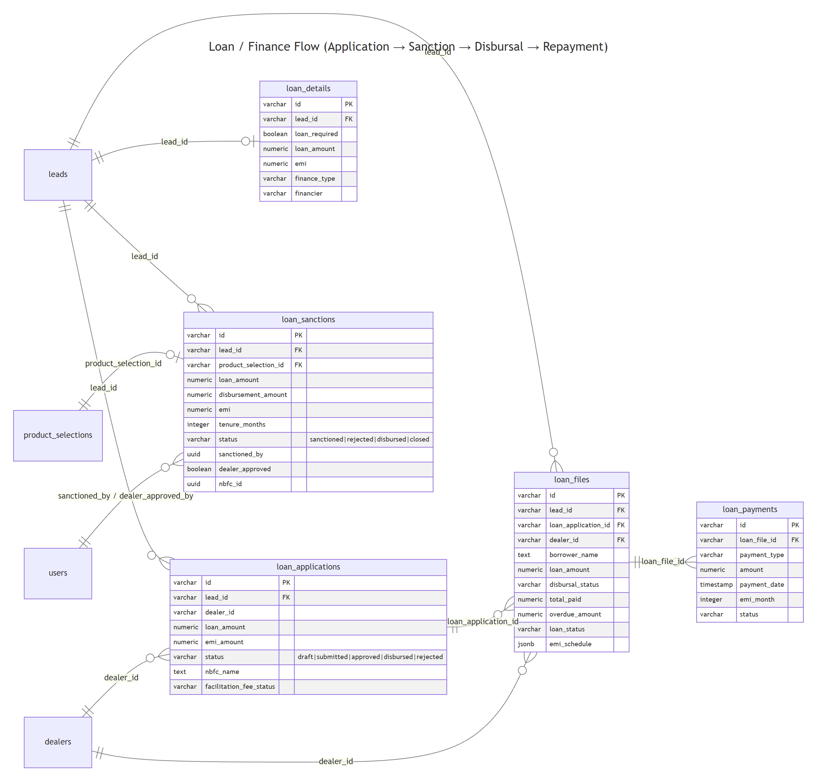
Source: docs/diagrams/05-loan-finance.mmd

Tables in this flow
• loan_applications — Loan origination workflow (draft → submitted → approved → disbursed); NBFC routing + facilitation-fee state.
• loan_details — Loan product details captured at application time (amount, tenure, EMI, financier).
• loan_sanctions — Admin-sanctioned loans post Step-4 product selection; NBFC linkage; dealer approval; recovery flags.
• loan_files — Full post-approval loan file — disbursal status, EMI schedule, total paid, overdue tracking, closure.
• loan_payments — Individual EMI / payment records per loan file.

loan_applications
Loan origination workflow (draft → submitted → approved → disbursed); NBFC routing + facilitation-fee state.
Column | Type | Flags | Default | FK / Notes
id | Varchar(255) | PK | — | —
lead_id | Varchar(255) | NOT NULL | — | —
dealer_id | Varchar(255) | NULL | — | —
applicant_name | Text | NULL | — | —
loan_amount | Numeric(12,2) | NULL | — | —
interest_rate | Numeric(5,2) | NULL | — | —
tenure_months | Integer | NULL | — | —
emi_amount | Numeric(10,2) | NULL | — | —
down_payment | Numeric(12,2) | NULL | — | —
facilitation_fee | Numeric(10,2) | NULL | — | —
facilitation_fee_status | Varchar(20) | NULL | pending | —
documents_uploaded | Boolean | NULL | false | —
status | Varchar(30) | NULL | draft | —
nbfc_name | Text | NULL | — | —
nbfc_ref_id | Text | NULL | — | —
submitted_at | Timestamp | NULL | — | —
approved_at | Timestamp | NULL | — | —
disbursed_at | Timestamp | NULL | — | —
rejection_reason | Text | NULL | — | —
created_at | Timestamp | NOT NULL | sql expression | —
updated_at | Timestamp | NOT NULL | sql expression | —
company_validation_status | Varchar(20) | NOT NULL | pending | —
application_status | Varchar(20) | NOT NULL | new | —
facilitation_fee_amount | Numeric(10,2) | NULL | — | —
created_by | UUID | NULL | — | —

Foreign keys
None.

Indexes & unique constraints
None declared in schema.

loan_details
Loan product details captured at application time (amount, tenure, EMI, financier).
Column | Type | Flags | Default | FK / Notes
id | Varchar(255) | PK | — | —
lead_id | Varchar(255) | NOT NULL | — | —
loan_required | Boolean | NULL | false | —
loan_amount | Numeric(12,2) | NULL | — | —
interest_rate | Numeric(5,2) | NULL | — | —
tenure_months | Integer | NULL | — | —
processing_fee | Numeric(10,2) | NULL | — | —
emi | Numeric(10,2) | NULL | — | —
down_payment | Numeric(12,2) | NULL | — | —
finance_type | Varchar(50) | NULL | — | —
financier | Varchar(100) | NULL | — | —
asset_type | Varchar(50) | NULL | — | —
loan_type | Varchar(50) | NULL | — | —
vehicle_rc | Text | NULL | — | —
created_at | Timestamp | NOT NULL | sql expression | —
updated_at | Timestamp | NOT NULL | sql expression | —

Foreign keys
None.

Indexes & unique constraints
None declared in schema.

loan_sanctions
Admin-sanctioned loans post Step-4 product selection; NBFC linkage; dealer approval; recovery flags.
Column | Type | Flags | Default | FK / Notes
id | Varchar(255) | PK | — | —
lead_id | Varchar(255) | NOT NULL | — | —
product_selection_id | Varchar(255) | NULL | — | —
loan_amount | Numeric(12,2) | NULL | — | —
down_payment | Numeric(12,2) | NULL | — | —
file_charge | Numeric(12,2) | NULL | — | —
subvention | Numeric(12,2) | NULL | — | —
disbursement_amount | Numeric(12,2) | NULL | — | —
emi | Numeric(12,2) | NULL | — | —
tenure_months | Integer | NULL | — | —
roi | Numeric(5,2) | NULL | — | —
loan_approved_by | Text | NULL | — | —
loan_file_number | Varchar(100) | NULL | — | —
status | Varchar(30) | NOT NULL | sanctioned | —
rejection_reason | Text | NULL | — | —
sanctioned_by | UUID | NULL | — | —
sanctioned_at | Timestamp | NULL | sql expression | —
dealer_approved | Boolean | NULL | false | —
dealer_approved_at | Timestamp | NULL | — | —
dealer_approved_by | UUID | NULL | — | —
nbfc_id | UUID | NULL | — | —
disbursed_at | Timestamp | NULL | — | —
closed_at | Timestamp | NULL | — | —
recovery_flagged_at | Timestamp | NULL | — | —
recovery_reason | Text | NULL | — | —
created_at | Timestamp | NOT NULL | sql expression | —
updated_at | Timestamp | NOT NULL | sql expression | —

Foreign keys
None.

Indexes & unique constraints
None declared in schema.

loan_files
Full post-approval loan file — disbursal status, EMI schedule, total paid, overdue tracking, closure.
Column | Type | Flags | Default | FK / Notes
id | Varchar(255) | PK | — | —
lead_id | Varchar(255) | NOT NULL | — | —
loan_application_id | Varchar(255) | NULL | — | —
dealer_id | Varchar(255) | NULL | — | —
borrower_name | Text | NOT NULL | — | —
co_borrower_name | Text | NULL | — | —
loan_amount | Numeric(12,2) | NOT NULL | — | —
interest_rate | Numeric(5,2) | NULL | — | —
tenure_months | Integer | NULL | — | —
emi_amount | Numeric(10,2) | NULL | — | —
down_payment | Numeric(12,2) | NULL | — | —
processing_fee | Numeric(10,2) | NULL | — | —
disbursal_status | Varchar(30) | NOT NULL | pending | —
disbursed_amount | Numeric(12,2) | NULL | — | —
disbursed_at | Timestamp | NULL | — | —
disbursal_reference | Text | NULL | — | —
total_paid | Numeric(12,2) | NULL | 0 | —
total_outstanding | Numeric(12,2) | NULL | — | —
next_emi_date | Timestamp | NULL | — | —
emi_schedule | Jsonb | NULL | — | —
overdue_amount | Numeric(12,2) | NULL | 0 | —
overdue_days | Integer | NULL | 0 | —
loan_status | Varchar(30) | NOT NULL | active | —
closure_date | Timestamp | NULL | — | —
closure_type | Varchar(20) | NULL | — | —
created_at | Timestamp | NOT NULL | sql expression | —
updated_at | Timestamp | NOT NULL | sql expression | —

Foreign keys
None.

Indexes & unique constraints
• idx loan_files_dealer_id_idx: (dealer_id)
• idx loan_files_loan_status_idx: (loan_status)

loan_payments
Individual EMI / payment records per loan file.
Column | Type | Flags | Default | FK / Notes
id | Varchar(255) | PK | — | —
loan_file_id | Varchar(255) | NOT NULL | — | —
payment_type | Varchar(20) | NOT NULL | — | —
amount | Numeric(12,2) | NOT NULL | — | —
payment_mode | Varchar(30) | NULL | — | —
transaction_id | Text | NULL | — | —
payment_date | Timestamp | NOT NULL | — | —
emi_month | Integer | NULL | — | —
status | Varchar(20) | NOT NULL | completed | —
receipt_url | Text | NULL | — | —
created_at | Timestamp | NOT NULL | sql expression | —

Foreign keys
None.

Indexes & unique constraints
None declared in schema.

Cross-flow narrative — end-to-end sale lifecycle

Onboarding
A prospective dealer creates a row in dealer_onboarding_applications. Documents land in dealer_onboarding_documents. The admin verification queue picks up the application; if corrections are needed, a dealer_correction_round is created with one dealer_correction_item per requested field/document. The dealer e-signs through dealer_agreement_signers; provider webhooks land in dealer_agreement_events. On final approval the dealer record is created (dealers.onboarding_status='active'); the activated row soft-references the application via application_id.

Dealer login → lead
An active dealer creates a lead via /api/leads/create. A row is written to leads (dealer_id scope, workflow_step=1, uploader_id = current user). Initial KYC fields land in personal_details. Lead ownership / handoff is tracked in lead_assignments.

KYC + co-borrower
Document uploads write to kyc_documents (doc_for='customer' or 'co_borrower'). Each API call to a KYC provider (Decentro, DigiLocker) is recorded in kyc_verifications, with a match_score and optional admin_action override. The aggregate lifecycle state (coupon, consent, final_decision) is upserted into kyc_verification_metadata (one row per lead). Manual admin field corrections are audited in kyc_data_audit. If a co-borrower is required, co_borrowers + co_borrower_documents are populated; consent for both parties is tracked in consent_records (DigiO/eSign provider state, signed PDF URL). Supplementary admin-requested documents use other_document_requests with a one-time upload_token. audit_logs receives a row for every mutation.

Product selection (Step 4)
The dealer chooses battery + charger + paraphernalia from the product_master_* catalog. A single product_selections row is written per lead (CASCADE on lead delete), capturing serials, GST breakdown, and admin_decision. A coupon (if applied) is resolved against coupon_codes (code lookup + reservation), with every state change appended to coupon_audit_log.

OTP + dispatch (Step 5)
Step-5 OTP confirms the customer and flips inventory.status from 'reserved' to 'dispatched' (inventory.dispatch_date set, inventory_events row appended). On final sale confirmation status moves to 'sold' (inventory.sold_at set). Inter-dealer movements use inventory_transfers; bulk uploads write to inventory_upload_reports. Damaged stock is removed via inventory_write_offs.

Cash vs finance fork
Cash sale: confirm-cash-sale endpoint marks product_selections.payment_mode='cash' and triggers sale finalization. Finance sale: loan_applications captures the loan ask; on Step-4 admin sanction a loan_sanction is created (links to product_selection); disbursal opens a loan_file; each EMI/payment is logged in loan_payments; NBFC scope flows via loan_sanctions.nbfc_id.

