### Studıo bıllıon

ADB Screen Recorder – Editor

ADB Screen Recorder is a tool for record Android device screen via Android Debug Bridge (ADB)

**Setup:**

Import the package via Unity Asset Store.

**Usage:**

1. Connect your Android device to PC via USB cable.
2. Open Screen Record Window from ***StudioBillion->ADB Screen Recorder.***

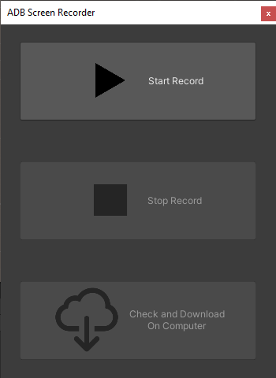

1. Click “Start Record” button to start recording.
2. Click “Stop Record” button to stop recording.

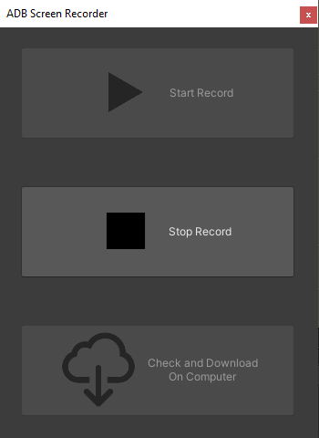

1. After record saved successfully, you can download on computer by click “Check and Download On Computer”

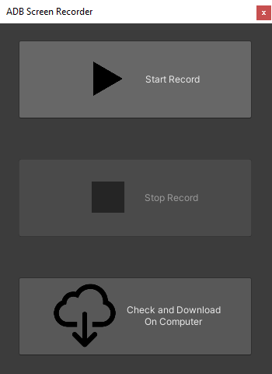

**Support:**

[info@studiobillion.com](mailto:info@studiobillion.com?subject=ADB%20Wifi%20Build)