1、传入参数为ID
1)URL: http://localhost:8080/recActivityServices/findcompany/bycityid?cityid=6

2)形式
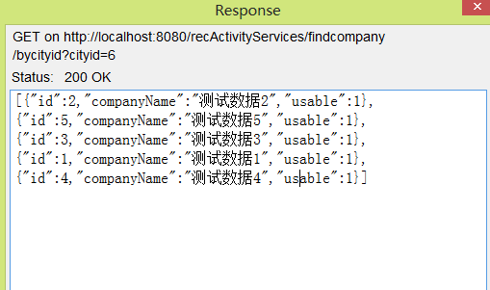

3）代码（方便理解结构）
[{"id":1,"companyName":"测试数据1","usable":1},
{"id":2,"companyName":"测试数据2","usable":1},
{"id":3,"companyName":"测试数据3","usable":1},
{"id":5,"companyName":"测试数据5","usable":1},
{"id":4,"companyName":"测试数据4","usable":1}]

- 传入参数为ID集合
1）URL:
http://localhost:8080/recActivityServices/findcompany/bycityidforString?citiesid=6,7,2

2）
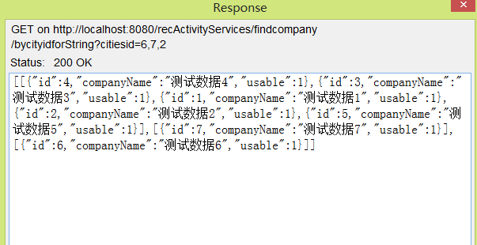

3）代码
[
[{"id":5,"companyName":"测试数据5","usable":1},
{"id":1,"companyName":"测试数据1","usable":1},
{"id":2,"companyName":"测试数据2","usable":1},
{"id":3,"companyName":"测试数据3","usable":1},
{"id":4,"companyName":"测试数据4","usable":1}],

[{"id":7,"companyName":"测试数据7","usable":1}],
[{"id":6,"companyName":"测试数据6","usable":1}]
]

