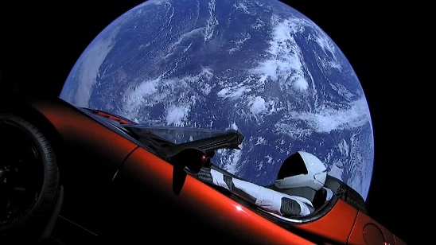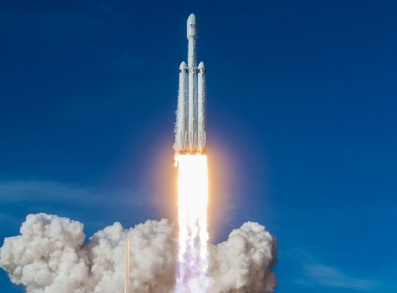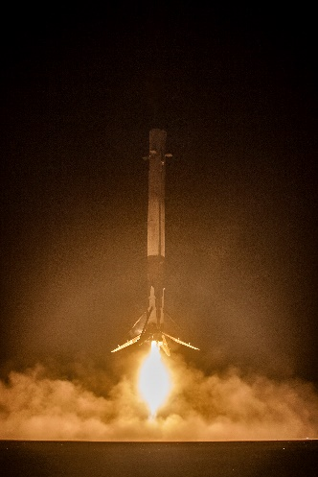

Essay - Luis

Space technology has also been through a bunch of breakthroughs in the last few decades, namely as all of us have probably one way or another either on the news or online on sites like Twitter, SpaceX has been leading the charge as far as new space technology.

We all saw the 2015 Falcon Heavy launch and the cherry red tesla in space with the earth in its background. However, that wasn’t the new revolution after all we’ve been to the moon and we have brought rovers to mars so a car in space is not that much different, the real big deal came from the boosters, usually the rocket’s boosters are thrown into the ocean after being used. This basically means if a rocket costs around $90M if you want to fly 2 rockets it will cost you $180M has you’ll have to build another from scratch. With this new technology breakthrough SpaceX’s able to land their stage 1 booster. We all saw the incredible clip from the falcon heavy launch when the two side boosters landed back at the same time in their landing pads in Cape Canaveral. And the central core landing in a moving pad in a floating ship in the middle of the Atlantic Ocean.

Ever since they’ve been able to at a successful rate retrieve their three boosters from their falcon Heavy or their one booster when it’s the falcon 9. Furthermore, they’ve also attempted and successfully retrieved their stage 2 in the middle of the ocean of bunch of times too now, with that and bunch of other technological breakthroughs they’ve reduced the rockets cost from $90M for launch to $9M and just like a plane you don’t build a new one from scratch after using it once now they’ve re-used their rockets up to over 4 times a unit at the very least which apart from the fuel it basically means they didn’t spend a single cent to have it up flying again. That’s the biggest major revolution in the space industry in the past 40 years.

Thanks to this, SpaceX is not only continuing their plans of bringing the first humans and then a colony to mars, as well as a recently announced idea where they would connect a bit like planes the major cities around the world in minutes Tokyo to New York in less than 1hour as opposed to a 24H plane flight.

Really excited to see what new things they have in store for us in the coming years.