**Name: Zijie Yu**

**Database Management Systems (CSC434)**

**Final Project**

**1) - Define the information content of your database.**

**a)-Define a set of entities and appropriate attributes for each entity. Minimum 10 entities.**

Note: The first attributes are primary key, the Blue color entity means entity created automaticly by Visual Paradigm because of many to many relationship (intermediate table).

* **Students:** Student_ID; First_Name; Last_Name; Country; Age; Phone; Email; Expected_graduation_year; Address;
* **Major**: Major_Name; Department; Minimum_GPA; DepartmentId
* **Students_Major:** Students_StudentId; Major_MajorId
* **Course:** CourseId; Course_Name; Seats Avaliable; Professor_ProfessorId; SubjectId; ClassSceduleId;
* **Student_Course:** Students_StudentId; Course_CourseId
* **Classroom:** ClassroomId; Classroom_Name; Buildings; Location; Capacity;
* **Classroom_Course:** Classroom_ClassroomId; Course_CourseId
* **Course_Scedule**: CourseSceduleId; Meeting_Day; Time_Start; Time_End
* **Subject:** SubjectId; Subject_Name; DepartmentId
* Professors: ProfessorId; First_Name; Last_Name; Email; Phone; Address
* **Subject_Professors:** Subject_SubjectId; Professors_ProfessorId
* **Titles:** TitleId; Type
* **Titles:** Titles_Titled; Professors_ProfessorId
* **Manager:** ManagerId; First_Name; Last_Name; Phone; Address
* **Advisor:** AdvisorId; First_Name; Last_Name; Phone; Address
* **Department:** DepartmentId; Name; AdvisorId; ManagerId

**b)-Define a set of relationships that might exist between/among entities and attributes. Such relationships may include one-to-one, one-to-many and many-to-many associations.**

**Students – Course:** Many to many

(One student can take many course, and one course can have many students)

**Students – Major:** Many to many

(One student can have one or more majore, and one major can have many students.)

**Major – Department:** Many to one

( One major must belong to one department, but one department can have many major)

**Department – Manager:** One to one

(One department can only have one manager, and one manager can only manage one specific department)

**Department – Advisor:** One to one

(One department can only have one advisor, and one advisor can only manage one specific department)

**Department – Subject:** One to many

(One deparment can have many subjects, but one subject can only belong to one department.)

**Subject – Course:** One to many

(One subject can have many different course, but one course must have one subject)

**Course – Course_Schedule:** Many to one

(One course_Schedule can have many different course, but one course can only have on specific schedule.)

**Course – Classroom:** Many to many

(One course may have one or more classroom, and one classroom can have many different course.)

**Professor – titles:** Many to many

(One professor can have one or more titles, and one titles can have many different professor.)

**Professor – subject:** Many to many

(One professor can teach many different subject course, and one subject course can have many different professor.)

**c)-Define a set of constraints that may be imposed on data.**

* One department can only have 1 manager.
* One department can only have 1 advisor.
* Student must take at least one course
* Every Professor must have proper title, sush as Ph.d, Acaemic or assistanmt
* One major can only belong to one department.
* One course can only belong to one subject, such as CSC or MATH.
* A course must have at least one classroom.

**2) - Define an E-R Diagram for your database design.**

**3) - Define a relational schema for your database design.**

**Make sure that you have both one-to-many and many-to-many associations.**

**a)-Define one or more realistic key(s) for every relation scheme. Use both simple and composite keys.**

* **Student:** The primary key should be SutdentId, since StudentId is unque.
* **Students_Course:** Both Students_StudentId and Course_CourseId are foreign keys.
* **Course:** CourseId should be primary key, because it is unique. And Professors_professorId, SubjectId, CourseScheduleId are foregin keys.
* **Students_Major:** Both Students_StudentId and Major_MajorName are foreign keys.
* **Major:** MajorName is primary key because it is unique. The DepartmentId is foregn key.
* **Department:** The primary key should be DepartmentId, the foregn keys are AdvisorId and ManageId.
* **Manager:** ManagerId should be primary key since it is unique.
* **Advisor:** AdvisorId should be primary key.
* **Course_Schedule:** The primary key should be CourseScheduledId since it is unique.
* **Subject:** SubjectId should primary key and the DepartmentId should be foreign key.
* **Ttitles:** The titleId should be primary key.
* **Titles_Professor:** Both Titles_TtitleId and Professor_ProfessorId are foreign keys.
* **Professors:** ProfessorId should be primary key since it is unique.
* **Subject_Professors:** Both Subject_SubjectId and Professors_ProfessorId are foreign keys.
* **Classroom:** The primary key should be classroomId since it is unique.
* **Classroom_Course:** Both Classroom_ClassroomId and Course_CourseId are foreign keys.

**b)-Define a realistic set of Functional / Multi-Valued Dependencies (when appropriate) for every relation scheme.**

**Student:**

StudentId 🡪 First_Name

StudentId 🡪 Last_Name

StudentId 🡪Country

StudentId 🡪 Age

StudentId 🡪Phone

StudentId 🡪 Email

StudentId 🡪 Address

**Major:**

MajorName 🡪 Department

MajorName 🡪 Minimum_GPA

**Manager:**

ManagerId 🡪 First_Name

ManagerId 🡪 Last_Name

ManagerId 🡪 Phone

ManagerId 🡪 Address

**Classroom:**

ClassroomId 🡪 Classroom_Name

ClassroomId 🡪 Buildings

ClassroomId 🡪 Capacity

ClassroomId 🡪 Location

**Course:**

CourseId 🡪 Course_Name

CourseId 🡪 Seats Avaliable

**Department:**

DepartmentId 🡪 Name

**Professors:**

ProfessorId 🡪 First_Name

ProfessorId 🡪 Last_Name

ProfessorId 🡪 Email

ProfessorId 🡪 Phone

ProfessorId 🡪 Address

**Advisor:**

AdvisorId 🡪 First_Name

AdvisorId 🡪 Last_Name

AdvisorId 🡪 Phone

AdvisorId 🡪 Address

**Titles**

TitleId 🡪 Type

**Subjec**

SubjectId 🡪 Subject_Name

**Course_Schedule**

CourseScheduledId 🡪 Meeting_Day

CourseScheduledId 🡪 Time_Start

CourseScheduledId 🡪 Time_End

**C-Check whether your relational schema is in 2NF, 3NF, BCNF, 4NF.**

**d)-Put your relational schema in the highest normal form that is possible.**

**Note that, every relation scheme should be in a specific normal form in order to have the relational schema in that normal form.**

**NOTE: Please provide a detailed explanation for every question when appropriate.**

**4) Implementation: Create your database using Oracle, or MySQL, or… to Perform the following operations.**

1. **You are required to execute SQL queries that include the following operations. For each query, provide the SQL statements along with the output. For each of the following, try different SQL statements (i.e., using one relation, more than one relations,...).**

**select involving one/more conditions in Where Clause**

*select* * *from* advisor  
*where* Last_Name = "Lee";

**Output:**

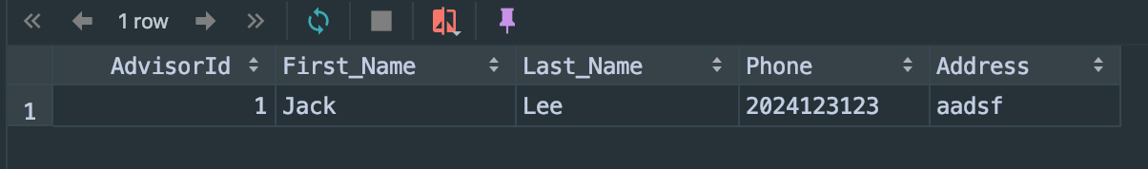

*select* * *from* Course  
*where* SubjectId = 1  
*and* CourseScheduledId = 1;

**Output:**

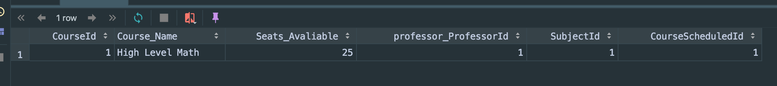

For another more difficult exmaple, if I want to find studnets who major is computer science:

*select* First_Name, Last_Name *from* Students, Students_Major, Major  
*where* studentsId = Students_StudentId  
*and* MajorName = Major_MajorName  
*and* majorName = "computer science";

output:

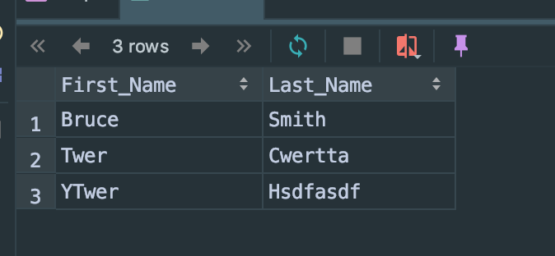

**select with aggregate functions (i.e., SUM,MIN,MAX,AVG,COUNT)**

**Count:**

If I want to know how many students’ major is computer science. Then the SQL should be:

*select* majorName, *count*(StudentsId) *as* number_CS *from* students, Students_Major, Major  
*where* StudentsId = Students_StudentId  
*and* Major_MajorName = MajorName  
*and* MajorName = "Computer Science"  
*group by* majorName;

Output：

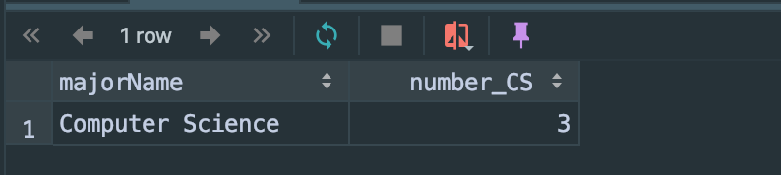

**Min:**

If I want to find youngest studnets in college, I will use sql below:

*select* First_Name, Last_Name, age *from* students *where*age = (*select* min(age) *from* Students);

Output:

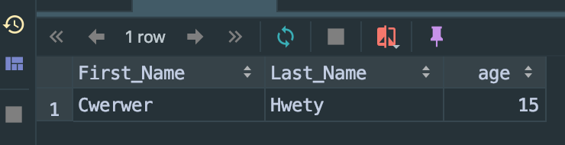

**Max:**

If I want to find which classroom can contain more students than any other classroom, I will use sql below:

*select* Classroom_Name, Capacity *from* Classroom  
*where* Capacity = (*select max*(Capacity) *from* Classroom)

**Output:**

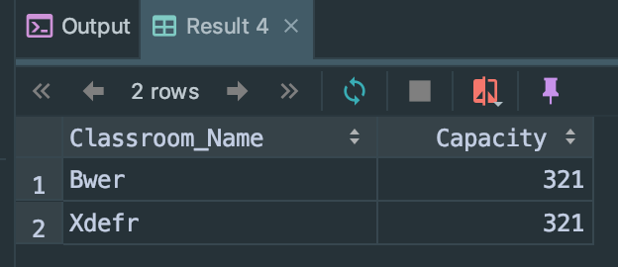

**Sum:**

If I want to find how many total classroom capacity avaliable, I will use sql below:

*select sum*(Capacity) *as* total_number *from* Classroom;

Output:

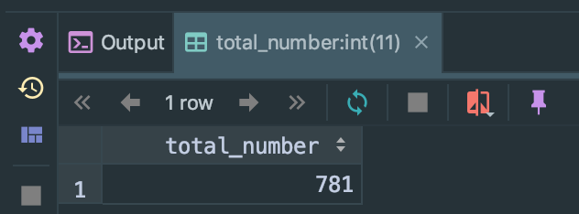

**AVG:**

If I want to find the average seats avaliable for each course, I will use sql below:

*select avg*(Seats_Avaliable) *from* Course;

**Output:**

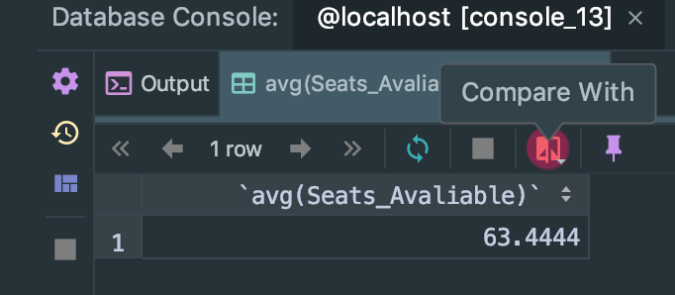

**select with Having, Group By, Order By clause**

**Only “Having”:**

*select* * *from* Course  
*having* Seats_Avaliable = 25;

Output (In this case, having = where):

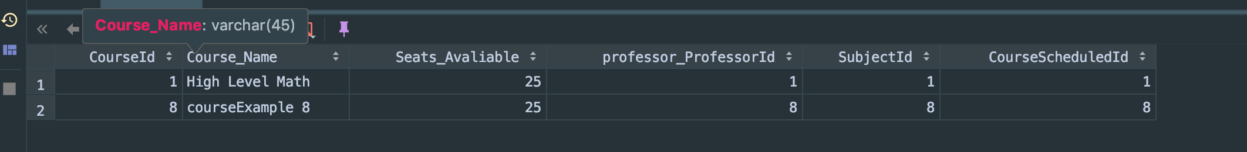

**Having and group by:**

*select* majorName, *count*(StudentsId) *as* number_accounting *from* students, Students_Major, Major  
*where* StudentsId = Students_StudentId  
*and* Major_MajorName = MajorName  
*group by* majorName  
*having* MajorName = "Accounting";

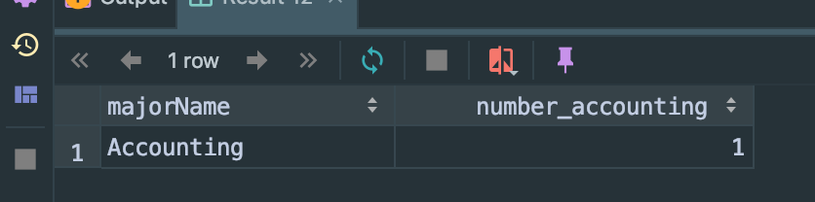

**Order by:**

If I want to compare course’e seats availably, I will write sql below:

*select* * *from* Course  
*order by* Seats_Avaliable;

Output:

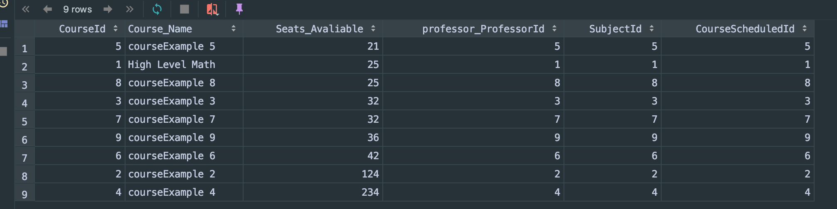

**Nested Select:**