

ImageConverter BETA version
Preliminary Reference Manual

Contents

1. INTRODUCTION 1
2. SYNTAX 2
2.1. Source 2
2.2. Destination 4
2.2.1. Default behavior 4
2.2.2. [-ss] Automatic creation of sub-directories tree 4
2.2.3. [-dn] Destination file names 4
2.2.4. [-ow] Overwriting existing files 4
2.2.5. Examples 4
2.3. Options 5
2.3.1. -? 5
2.3.2. –ss 5
2.3.3. –dn<namingrule> 6
2.3.4. -ow 6
2.3.5. -p<colorspace> 7
2.3.6. -c<codec> 7
2.3.7. -q<quality> 7
2.3.8. -e<encoding> 7
2.3.9. –mr<resampling> 8
2.3.10. -b<blocktype> 8
3. HELP 9
4. USAGE TIPS 12
5. PROGRESS STATUS AND MESSAGES 13
5.1. Progress 13
5.2. Runtime completion message 13
5.3. Usage error messages 15

INTRODUCTION

ImageConverter converts one or more image file of any of the supported formats to iTIFF format. The conversion process can handle the following tasks:

- File format conversion
- Color space transformation
- Image compression

SYNTAX
The general syntax for ImageConverter is the following.

ImageConverter [options] <source> [<destination>]

Example:

ImageConverter –pTrueColor24 c:\images\im1.jpg c:\images\im1.itiff

Source
ImageConverter [options] <source> [<destination>]

The <source> parameter specifies the name of an image file to convert, or the name of a directory containing the image files to convert. The <source> parameter can be specified in one of the following ways:

- A relative of absolute full path name to a single image file to convert.
Example:
ImageConverter c:\images\im1.jpg

- A relative or absolute wildcard path name that specifies a set of image files to convert. All the images found in the directory and matching the specified wildcard file name will be converted.
Example:
ImageConverter c:\images\*.jpg

- The name of a directory containing the images to convert. All the images with supported extensions (see table below) that are found in the directory will be converted.
Example:
ImageConverter c:\images

The images to convert must be of the following types.
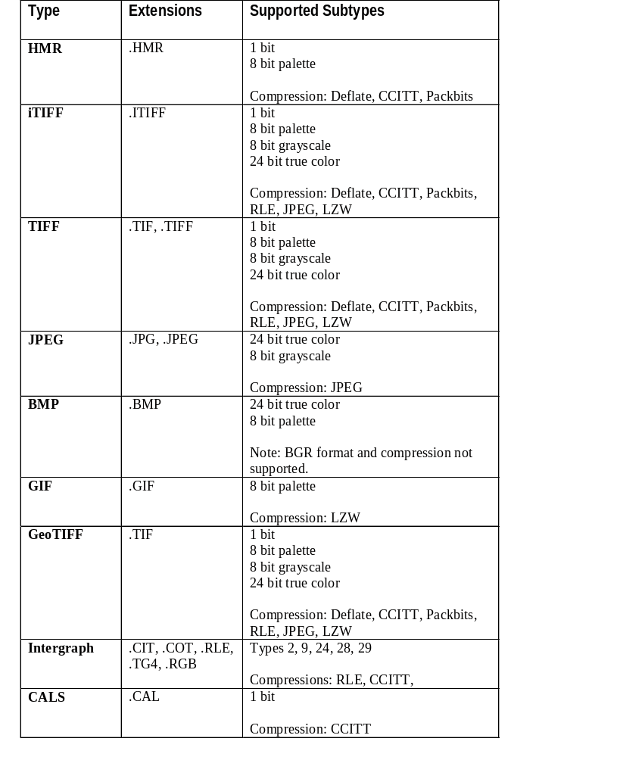

Destination
ImageConverter [options] <source> [<destination>]

The <destination> parameter specifies the name of the output file or directory in one of the following ways, depending on the value of the <source> parameter:

- If the <source> parameter specifies the name of a single file, then the <destination> parameter must specify the name of a file. The .iTIFF extension will be used if no extension is specified.

- If the <source> parameter specifies a wildcard or a directory, then the <destination> parameter must specify the name of a directory.

In both cases, the output directory will be automatically created if it does not already exists.
    - Default behavior
If the <destination> parameter is omitted, then the destination directory is assumed to be the same one as the source directory.
    - [-ss] Automatic creation of sub-directories tree
When the –ss switch is specified to scan sub-directories, the sub-directories tree will automatically be created to replicate the source’s sub-directories tree.
    - [-dn] Destination file names
The –dn option controls the naming of the output files when a directory is specified as the destination.

See the documentation about the –dn option for further details.
    - [-ow] Overwriting existing files
The –ow switch controls whether an output file will be overwritten or not when this file already exists. If the –ow switch is present in the command line then this will force existing files to be overwritten. Otherwise, conversions that would normally overwrite existing files will not be performed.
    - Examples
In the following example, we convert a single image and explicitly name the output file.

ImageConverter c:\images\image1.jpg c:\images\ image1.itff

In the following example, we convert a single image and let ImageConverter generate the output file name based on the input file name. This creates a file named c:\images\image1.itiff.

ImageConverter c:\images\image1.jpg

The following examples demonstrate the usage of a destination directory when the source is the name of a file. This creates a file named d:\images\image1.itiff.

ImageConverter c:\images\image1.jpg d:\images

The remaining examples assume that the c:\images directory contains the following files:

- image1.bmp
- image1.jpg
- image1.itiff

In the following example we convert the images from c:\images and this creates c:\images\image1_bmp.itiff, c:\images\image1_jpg.itiff and c:\images\images1_itiff.itiff.

ImageConverter –dnRetainExt c:\images

The following example is similar to the previous one, but the result is stored in d:\images instead.

ImageConverter –dnRetainExt c:\images d:\images

Options
ImageConverter [options] <source> [<destination>]
    - -?
Displays a detailed help page. Other options, as well as the <source> and <destination> parameters are ignored and no conversion is performed. See chapter 3 for details about the help.

Example:
ImageConverter -?
    - –ss
Scans and processes all the sub-directories of the specified source directory. If the corresponding output sub-directories don’t already exist, they will automatically be created.

This switch has no effect if the source specifies a file name instead of a directory name.

Examples:
ImageConverter –ss c:\images d:\images
ImageConverter –ss c:\images\*.jpg d:\images
    - –dn<namingrule>
Defines the rule for creating the destination file name. The default rule is ReplaceExt. Valid rules are listed in the following table.

Naming Rule | Description
ReplaceExt | The name of the destination file is created by substituting the iTIFF extension for the source file’s extension. For instance, if the name of the source file is image1.jpg, the name of the destination file is image1.itiff.
RetainExt | The name of the destination file is created by substituting underscore characters (‘_’) for all dots (‘.’) in the source file name and by adding the iTIFF extension. For instance, if the name of the source file is image1.jpg, the name of the destination file is image1_jpg.itiff.

You will want to use the RetainExt rule to avoid name clashes when converting an entire directory that contains images with the same name but with different extensions. For instance, if you convert a directory containing the following files:

a.jpg
a.bmp
a.itff

these files will be created in the destination directory:

a_jpg.itiff
a_bmp.itiff
a_itff.itiff

Example:
ImageConverter –dnRetainExt –ss c:\images d:\images
    - -ow
The –ow switch controls whether an output file will be overwritten or not when this file already exists. If the –ow switch is present in the command line then this will force existing files to be overwritten. Otherwise, conversions that would normally overwrite existing files will not be performed.

When the –ow switch is specified and a file cannot be converted because the output file already exists, a message will indicate that the output file already exists, and that the conversion was not performed.

Example:
ImageConverter –ow c:\images d:\images

    - -v
The –ow switch controls the progression time displayed on screen. If the –v switch is present in the command line then this will display a progression message on screen. Otherwise, only the total time will be display at the end..

Example:
ImageConverter –v c:\images d:\images

    - -p<colorspace>
Specifies the color space of the output image. The default is the best match for the color space of the input. Valid color spaces are listed in the following table.

Color Space | Description
Grayscale1 | Black and white image, no palette.
256Colors | 256 colors with palette.
TrueColor24 | Millions of color, no palette.
Grayscale8 | 256 gray levels, no palette.

Example:
ImageConverter –pGrayscale8 c:\images d:\images
    - -c<codec>
Specifies the type of image compression to apply to the output file. If the -c option is omitted, then the compression of the source file is used. If the compression is not applicable to the output color space then no compression is used.

Valid compression types and applicability by color space are specified below:

Compression Type | Applicability | Technical details
None | All color spaces
Deflate | All color spaces
RLE1 | - Grayscale1
CCITT | - Grayscale1
JPEG | - TrueColor24  - Grayscale8
    - -q<quality>
Specifies the quality of compression for the JPEG codec. Must be between 1 (low quality, small files) and 100 (high quality, large files). The default is 80%.
    - -e<encoding>
Specifies the type of depth organization of the output file. The default is Multires. Valid values for the encoding parameter are specified in the table below.

Encoding | Description
Multires | A pyramid of overview images is stored along with the main image. This generally improves the performance of viewing operations.
    - –mr<resampling>
Specifies the resampling method to use for calculation of the overviews when encoding is Multires. The default is Average for types for which it is applicable.

Method | Description | Applicability
NearestNeighbor  NearestNeighbor | This is the fastest method, but it generally yields overview images of low quality. | All color spaces.
Average | This method yields good quality at a good speed. | - TrueColor24  - Grayscale8
    - -b<blocktype>
Specifies the type of planar organization of the output file. The default is Tile. Valid block types are specified in the table below.

Block Type | Description
Tile | The image is stored as a matrix of tiles of 256 by 256 pixels.
Strip | The image is stored as a sequence of horizontal strips.

HELP
When no arguments are specified to ImageConverter, the following short help page is displayed:
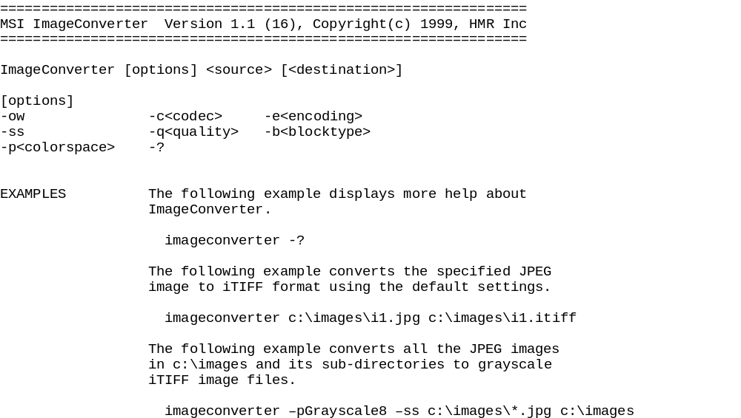

ImageConverter -? displays the following more detailed help
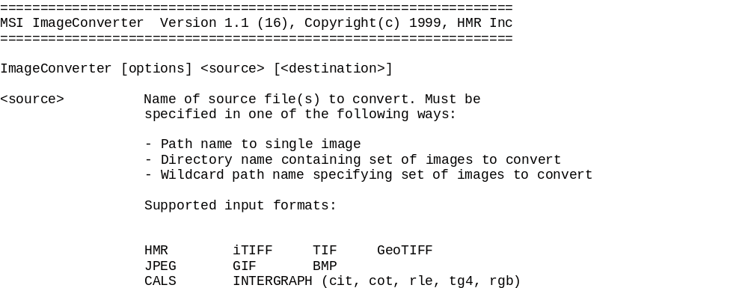

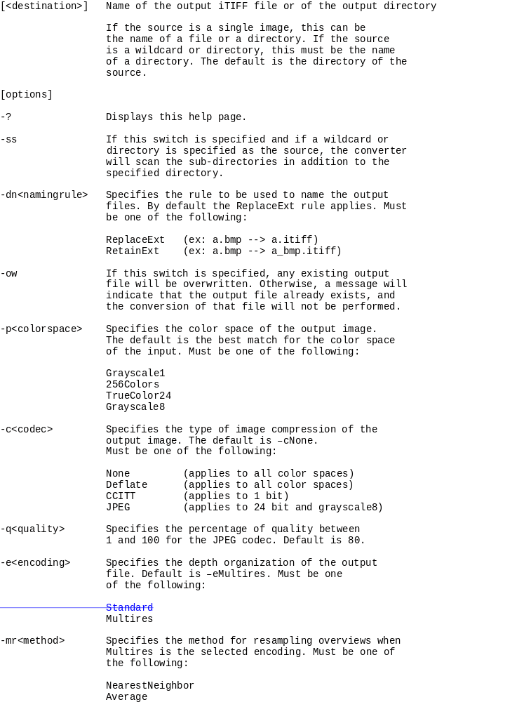

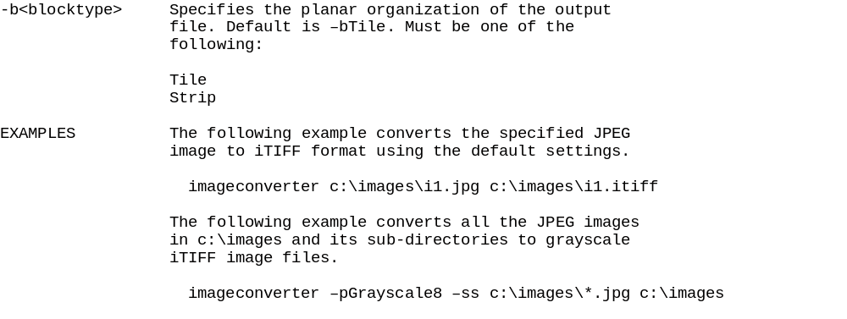

USAGE TIPS
Before you start converting your images to the iTIFF format, you need to decide on which color space and which compression method you are going to use. By default, ImageConverter uses no compression, and selects color space that best matches that of the input image.

However, if you want to optimize the size of the iTIFF image files, you will want to adapt color space and image compression to the types of images that you will be compressing. The following table gives a few hints about which color spaces and image compressions work best with typical types of image data.

If the image to convert is... | You should consider the following type of output color space and compression...
A color photograph or a color scanned document. | Color space: TrueColor24  Compression: JPEG
A grayscale photograph or a grayscale scanned document. | Color space: Grayscale8  Compression: JPEG
A color rasterized vector map with a relatively few numbers of colors and with large of areas of uniform color. | Color space: TrueColor24  Compression: Deflate  The advantage of Deflate is that it is lossless. Deflate compresses very well on images that have large patches of uniform color.
A grayscale rasterized vector map with large areas of uniform gray. | Color space: Grayscale8  Compression: Deflate
Black and white text documents to be viewed at various resolutions. | Color space: Grayscale8  Compression: Deflate
Black and white documents to be viewed mostly at full resolution. | Color space: Grayscale1  Compression: CCITT

The above rules should be used as guidelines, but it is best to conduct your own tests on pilot images before converting large amounts of images.

PROGRESS STATUS AND MESSAGES

Progress
A progress indicator is displayed during the conversion process.

c:\images\im1.jpg PROCESSING

Runtime completion message
Once the conversion is completed, the percentage is replaced by DONE and the name of the output file is written, as in the following example:

c:\images\im1.jpg DONE -> c:\images\im1.itiff

If for any reason the conversion could not be completed, the percentage is replaced by FAILED and an appropriate error message is written, as in the following example:

c:\images\im1.jpg FAILED : R003 Bad or unsupported input format

The following is the list of possible error messages:

Runtime Messages
R001 | Internal error. Contact technical support. [xxxxx]
R002 | Input file not found.
R003 | Bad or unsupported input format.
R004 | No permission to write on output device.
R005 | Not enough disk space on output device.
R006 | Output file already exists.
R007 | Write error on output device.
R008 | Bad page number in input file.
R009 | Bad sub-image in input file.
R010 | Input pixel type not supported.
R013 | Out Of Memory.

Usage error messages
If for any reason the parameters that you supply to ImageConverter are not valid, one or more of the following messages will be displayed.

Error Messages
E000 | Invalid argument specified: xxx
E001 | Invalid source file(s) specification.
E002 | Invalid destination file(s) specification.
E003 | Destination files specification must be the name of a directory.
E004 | Invalid color space specified. [-p]
E005 | Invalid codec specified. [-c]
E006 | Specified codec is not compatible with the selected color space. [-c]
E007 | Quality must be between 1 and 100. [-q]
E008 | Invalid encoding specified. [-e]
E009 | Invalid block type specified. [-b]
E012 | Invalid multiresolution resampling method specified. [-mr]
E013 | Specified resampling method is not compatible with the selected color space [-mr]
E014 | -mrCopyPyramid requires the source image to be multi-resolution.
E015 | -mrCopyPyramid requires the destination image to be multi-resolution.

