作者：刘树伟
日期：2024-12-09

enum LAYOUT_MODE
{
LM_FIT = 1, // 源匹配目标，保证一边对目标对齐。
LM_SRC_ALLOW_ZOOM_OUT = 2, // 允许缩小，不允许放大。
LM_SRC_ALLOW_ZOOM_IN = 3, // 允许放大，不允许缩小。
LM_SRC_CLIP // 通过放大源并裁剪源，不让目标留白。
};

图例：
黑色：目标矩形
红色：源
绿色：源放到目标中布局后的矩形

LM_FIT
等比例缩放源，以匹配目标
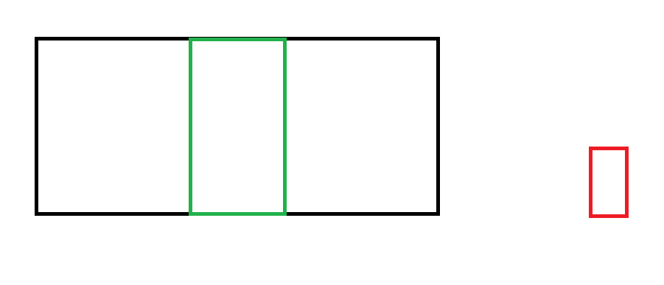

LM_SRC_ALLOW_ZOOM_OUT
只允许缩小源，不允许放大，
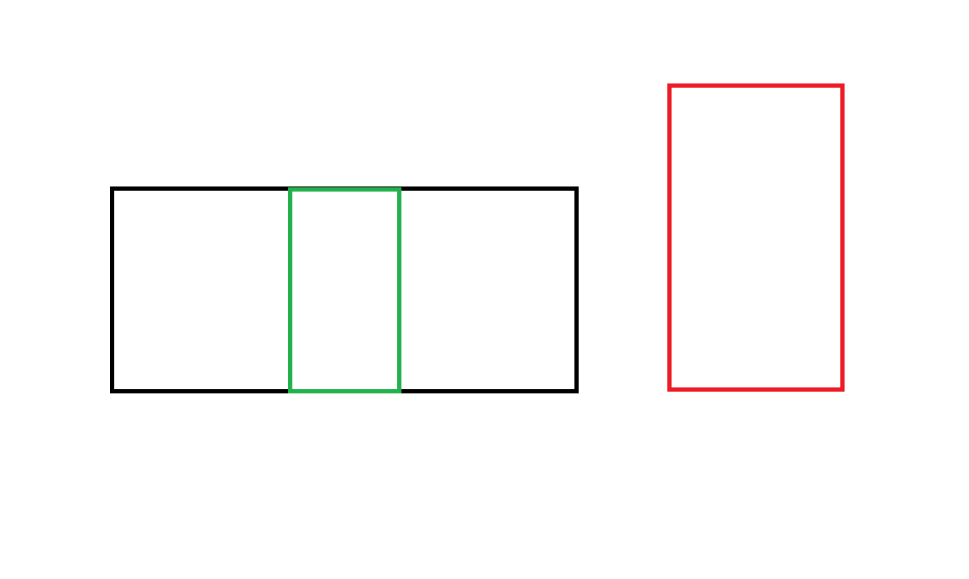
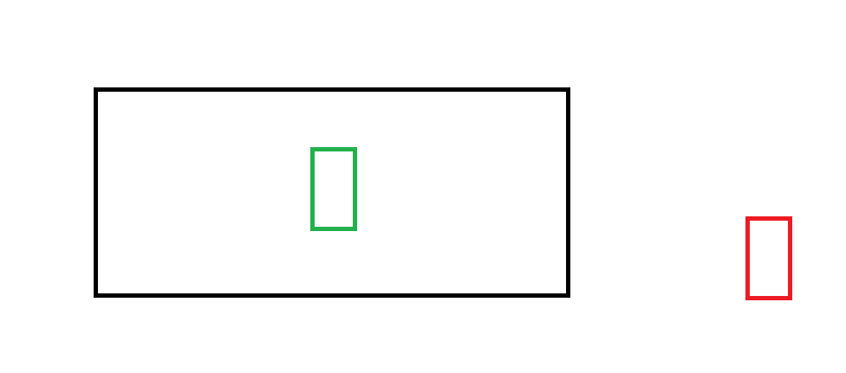

LM_SRC_ALLOW_ZOOM_IN
只允许放大源，不允许缩小
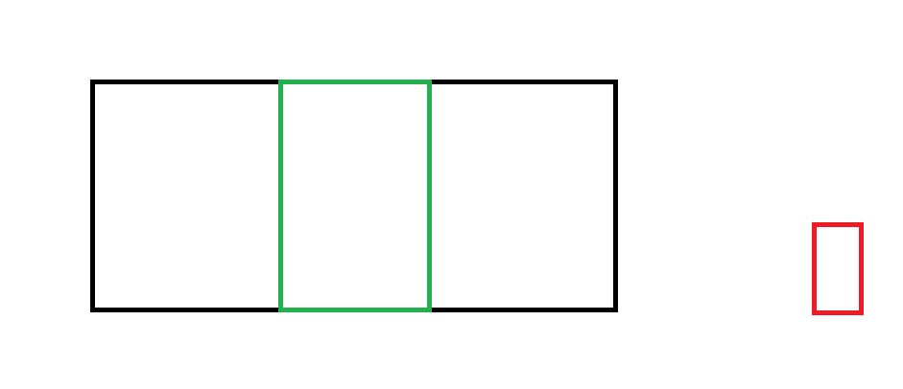
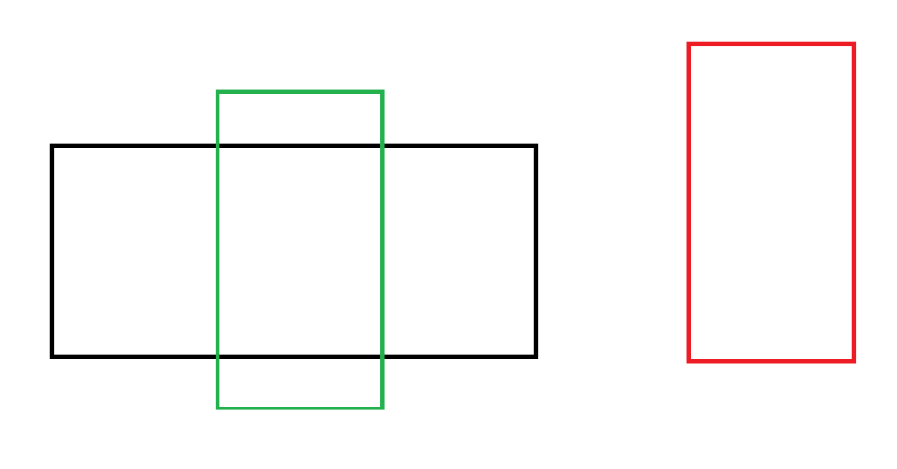

LM_SRC_CLIP
缩放源，让源的一边与目标对齐，另一边超出目标，目标不能留白。
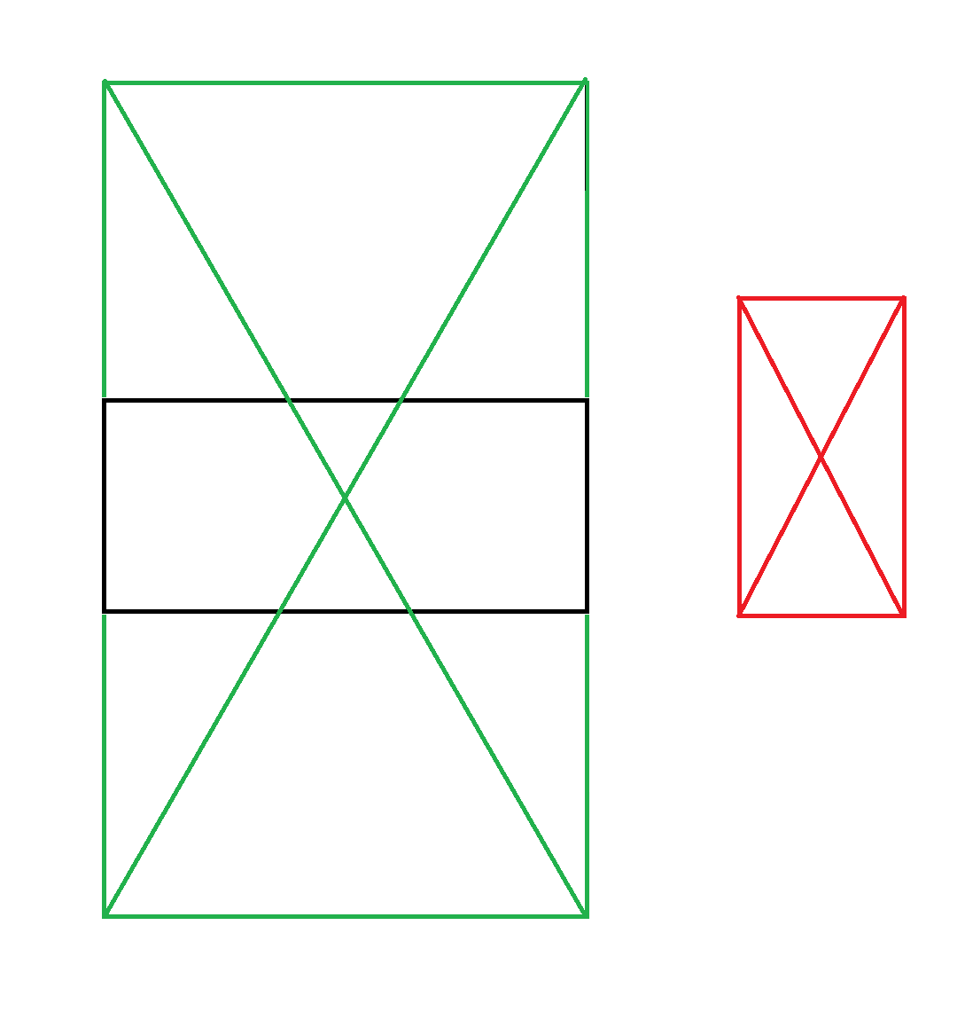

算法
// 把一个(nSrcWidth * nSrcHeight)的矩形，放到lprcDest中后的居中布局，通过返回值返回布局后的坐标。
CRect CenterRect(LPCRECT lprcDest, int nSrcWidth, int nSrcHeight, LAYOUT_MODE eLayoutMode)
{
CRect rcRet;
CRect rcDest = lprcDest;

if (nSrcWidth <= 0 || nSrcHeight <= 0)
{
return rcRet;
}

if (rcDest.Width() * nSrcHeight > rcDest.Height() * nSrcWidth)
{
int nRetHeight = 0;
int nRetWidth = 0;
if (eLayoutMode == LM_FIT)
{
nRetHeight = rcDest.Height();
nRetWidth = ::MulDiv(nRetHeight, nSrcWidth, nSrcHeight);
}
else if (eLayoutMode == LM_SRC_ALLOW_ZOOM_OUT)
{
nRetHeight = rcDest.Height() < nSrcHeight ? rcDest.Height() : nSrcHeight;
nRetWidth = ::MulDiv(nRetHeight, nSrcWidth, nSrcHeight);
}
else if (eLayoutMode == LM_SRC_ALLOW_ZOOM_IN)
{
nRetHeight = rcDest.Height() > nSrcHeight ? rcDest.Height() : nSrcHeight;
nRetWidth = ::MulDiv(nRetHeight, nSrcWidth, nSrcHeight);
}
else if (eLayoutMode == LM_SRC_CLIP)
{
nRetWidth = rcDest.Width();
nRetHeight = rcDest.Width() * nSrcHeight / nSrcWidth;
}

rcRet.top = rcDest.top + (rcDest.Height() - nRetHeight) / 2;
rcRet.bottom = rcRet.top + nRetHeight;
rcRet.left = rcDest.left + (rcDest.Width() - nRetWidth) / 2;
rcRet.right = rcRet.left + nRetWidth;
}
else
{
int nRetHeight = 0;
int nRetWidth = 0;
if (eLayoutMode == LM_FIT)
{
nRetWidth = rcDest.Width();
nRetHeight = ::MulDiv(nRetWidth, nSrcHeight, nSrcWidth);
}
else if (eLayoutMode == LM_SRC_ALLOW_ZOOM_OUT)
{
nRetWidth = rcDest.Width() < nSrcWidth ? rcDest.Width() : nSrcWidth;
nRetHeight = ::MulDiv(nRetWidth, nSrcHeight, nSrcWidth);
}
else if (eLayoutMode == LM_SRC_ALLOW_ZOOM_IN)
{
nRetHeight = rcDest.Height() > nSrcHeight ? rcDest.Height() : nSrcHeight;
nRetHeight = ::MulDiv(nRetWidth, nSrcHeight, nSrcWidth);
}
else if (eLayoutMode == LM_SRC_CLIP)
{
nRetHeight = rcDest.Height();
nRetWidth = rcDest.Height() * nSrcWidth / nSrcHeight;
}

rcRet.top = rcDest.top + (rcDest.Height() - nRetHeight) / 2;
rcRet.bottom = rcRet.top + nRetHeight;
rcRet.left = rcDest.left + (rcDest.Width() - nRetWidth) / 2;
rcRet.right = rcRet.left + nRetWidth;
}

return rcRet;
}

其它
如果希望目标去匹配源，可以把源和目标参数对调调用CenterRect即可。

