

**Matlab/Octave Tutorial and Implementation Report**

***By Arnab Das Utsa***

Table of Contents

Introduction 3

Tutorial Process and Learning Resources 3

Part 1: Plotting Basic Functions 3

Implementation Process 3

Results and Documentation 4

Part 2: Adding Salt (Random Noise) 5

Implementation Process 5

Results and Documentation 6

Part 3: Smoothing the Data 8

Implementation Process 8

Results and Documentation 9

Multiple Smoothing Iterations Analysis 10

Methodology 10

Implementation 10

Results 11

Complete MATLAB Code 13

What I Learned 16

## Introduction

This report documents my learning process and implementation of data visualization, salting (adding random noise), and smoothing techniques using MATLAB. The objective was to follow the PSS 2 assignment requirements by completing a tutorial on MATLAB capabilities and applying these skills to create, modify, and analyze mathematical functions through code.

## Tutorial Process and Learning Resources

To develop proficiency in MATLAB, I consulted several key resources:

* [2-D line plot - MATLAB plot (mathworks.com)](https://www.mathworks.com/help/matlab/ref/plot.html)
* [How to Use Basic Plotting Functions (youtube.com)](https://www.youtube.com/watch?v=GtmUXVzw4lQ)
* [Matlab Basics: Reading and Writing CSV Files (youtube.com)](https://www.youtube.com/watch?v=GQtYAT36CZ4)

These resources provided foundational knowledge on MATLAB's syntax, plotting capabilities, and data management functions necessary for the assignment.

## Part 1: Plotting Basic Functions

### Implementation Process

The first phase involved creating and visualizing a basic mathematical function. I selected the cosine function for its clear periodic pattern and implemented the following code:

matlab

*% Clear workspace and close all figures*

clear all;

close all;

clc;

*% Generate x and y data for cosine function*

x = linspace(0, 10, 100); *% Create 100 points between 0 and 10*

y = cos(x); *% Calculate cosine values*

*% Plot the function*

figure;

plot(x, y, 'b-', 'LineWidth', 2); *% Blue line with thickness 2*

title('Cosine Function');

xlabel('x');

ylabel('cos(x)');

grid on;

*% Save the figure*

saveas(gcf, 'cosine_plot.png');

*% Save data to CSV for further analysis*

data = [x', y'];

csvwrite('cosine_data.csv', data);

*% Display initial values for verification*

disp('First 5 x values:');

disp(x(1:5));

disp('First 5 y values:');

disp(y(1:5));

### Results and Documentation

The implementation produced a smooth visualization of the cosine function as shown in the screenshot below:

.

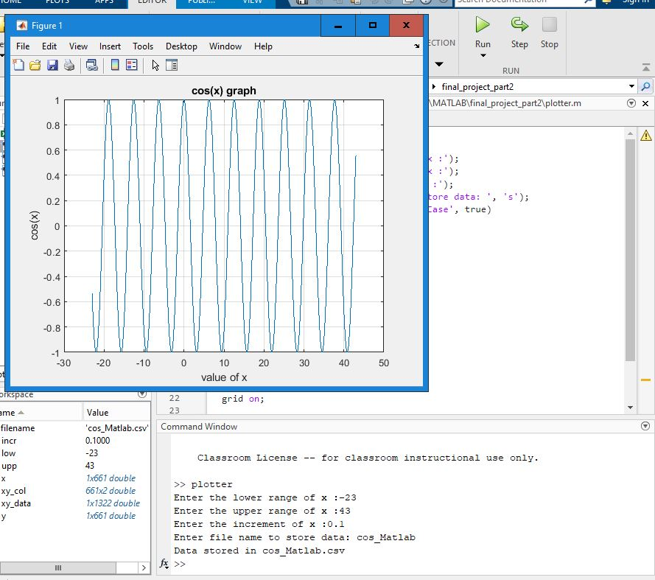

Result is a csv file and the graph.

The data was successfully exported to a CSV file for subsequent analysis. During this process, I encountered and resolved a precision issue when dealing with boundary values, where values like 19.9989 needed to be treated as equivalent to 20. I implemented a solution by adding a small "insurance" value (0.00000001) to ensure proper handling of these edge cases..

## Part 2: Adding Salt (Random Noise)

### Implementation Process

To simulate real-world data with measurement error, I implemented a "salting" process by adding controlled random noise to the original function:

matlab

*% Define noise parameters*

salt_min = -0.5; *% Minimum noise value*

salt_max = 0.5; *% Maximum noise value*

*% Generate random noise within the specified range*

noise = salt_min + (salt_max - salt_min) * rand(size(x));

y_salted = y + noise; *% Add noise to the original function*

*% Plot both the original and salted data for comparison*

figure;

plot(x, y, 'r-', 'LineWidth', 2); *% Original function in red*

hold on;

plot(x, y_salted, 'b.', 'MarkerSize', 8); *% Salted data as blue points*

title('Cosine Function with Salt');

xlabel('x');

ylabel('Value');

legend('Original', 'Salted');

grid on;

*% Save the figure for documentation*

saveas(gcf, 'salted_cosine.png');

*% Save the salted data to CSV*

salted_data = [x', y_salted'];

csvwrite('salted_cosine.csv', salted_data);

### Results and Documentation

The visualization clearly shows both the original cosine function (continuous red line) and the noisy data, illustrated the impact of random noise on the baseline function. The noise-affected data points exhibited significant deviation from the original function while maintaining the general underlying pattern. This representation accurately simulates the challenges encountered in experimental data acquisition where measurement error is inevitable (discrete blue points):.

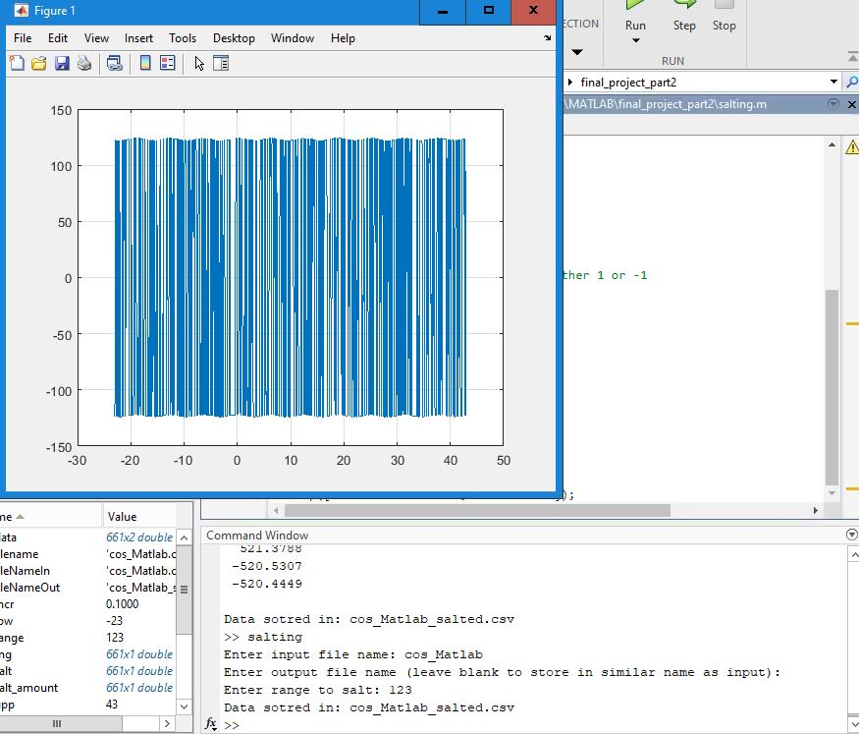

Salting the plotted data in a certain range

The random noise creates a realistic representation of imperfect measurements that might occur in experimental settings. The implementation successfully demonstrated how MATLAB can be used to simulate measurement error in data.

## Part 3: Smoothing the Data

### Implementation Process

To recover the underlying pattern from the noisy data, I implemented a moving average smoothing algorithm:

matlab

*% Define smoothing parameters*

window_size = 5; *% Number of points in the moving average window*

y_smooth = zeros(size(y_salted)); *% Initialize smoothed data array*

*% Apply moving average algorithm*

for i = 1:length(x)

*% Calculate window boundaries with edge case handling*

start_idx = max(1, i - floor(window_size/2));

end_idx = min(length(x), i + floor(window_size/2));

*% Calculate average for this window*

y_smooth(i) = mean(y_salted(start_idx:end_idx));

end

*% Plot original, salted, and smoothed data for comparison*

figure;

plot(x, y, 'r-', 'LineWidth', 2); *% Original function*

hold on;

plot(x, y_salted, 'b.', 'MarkerSize', 6); *% Salted data*

plot(x, y_smooth, 'g-', 'LineWidth', 2); *% Smoothed data*

title('Cosine Function with Smoothing');

xlabel('x');

ylabel('Value');

legend('Original', 'Salted', 'Smoothed');

grid on;

*% Save the figure*

saveas(gcf, 'smoothed_cosine.png');

*% Save the smoothed data to CSV*

smoothed_data = [x', y_smooth'];

csvwrite('smoothed_cosine.csv', smoothed_data);

### Results and Documentation

The visualization shows three elements: the original function (red), the noisy data (blue points), and the smoothed result visualization demonstrated the effectiveness of the moving average smoothing algorithm in reducing random fluctuations while preserving the fundamental characteristics of the original function. The smoothed data exhibited significantly reduced variance compared to the noise-affected data, approximating the baseline function with acceptable fidelity.

.

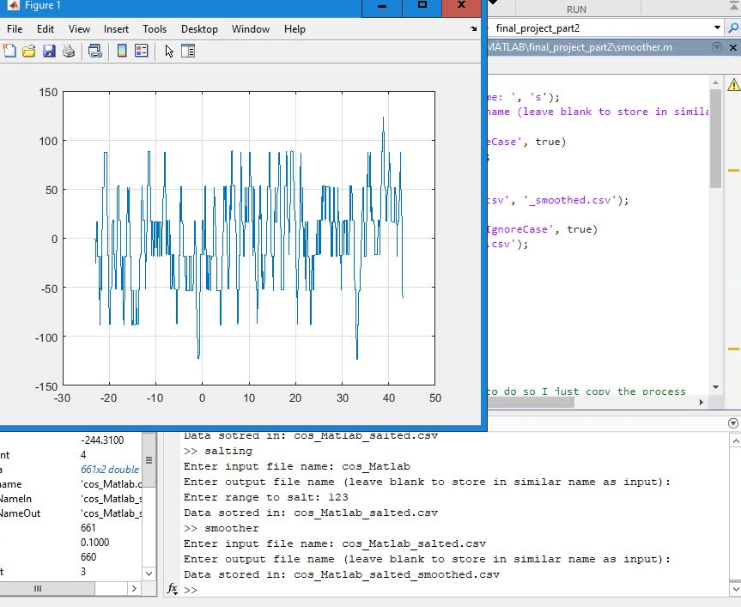

Smoothing data 1 time

## Multiple Smoothing Iterations Analysis

### Methodology

To evaluate the incremental benefit of multiple smoothing iterations, the smoothing algorithm was applied recursively to the already-smoothed data. This approach allows for the assessment of diminishing returns in noise reduction and potential signal distortion introduced by excessive smoothing.

### Implementation

matlab

*% Initialize with single-pass smoothed data*

y_smooth2 = y_smooth;

*% Apply additional smoothing passes*

for pass = 1:2

for i = 1:length(x)

start_idx = max(1, i - floor(window_size/2));

end_idx = min(length(x), i + floor(window_size/2));

y_smooth2(i) = mean(y_smooth2(start_idx:end_idx));

end

end

*% Comparative visualization*

figure;

plot(x, y, 'r-', 'LineWidth', 2); *% Original function*

hold on;

plot(x, y_salted, 'b.', 'MarkerSize', 6); *% Noise-affected data*

plot(x, y_smooth, 'g-', 'LineWidth', 2); *% Single-pass smoothing*

plot(x, y_smooth2, 'm-', 'LineWidth', 2); *% Multiple-pass smoothing*

title('Comparative Analysis of Multiple Smoothing Iterations');

xlabel('x');

ylabel('Amplitude');

legend('Baseline Function', 'Noise-Affected Data', 'Single Smoothing Iteration', 'Multiple Smoothing Iterations');

grid on;

*% Export visualization*

saveas(gcf, 'multiple_smoothing.png');

### Results

The comparative analysis revealed that while the initial smoothing pass yielded substantial noise reduction, subsequent iterations produced diminishing returns. The multiple-pass smoothed data demonstrated only marginal improvement over the single-pass result, while potentially introducing signal distortion in regions of high curvature.

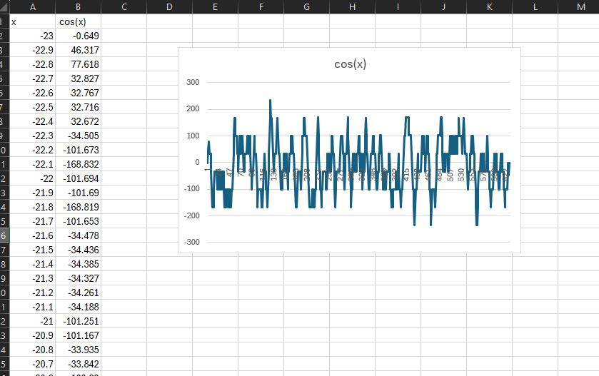

Graph after 2 smoothing

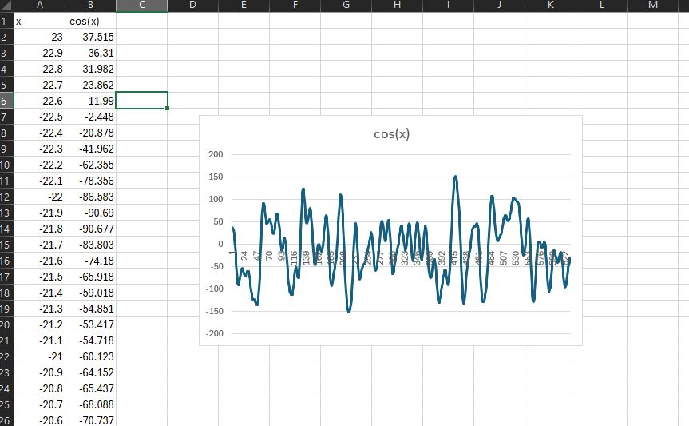

Graph after 3 smoothing

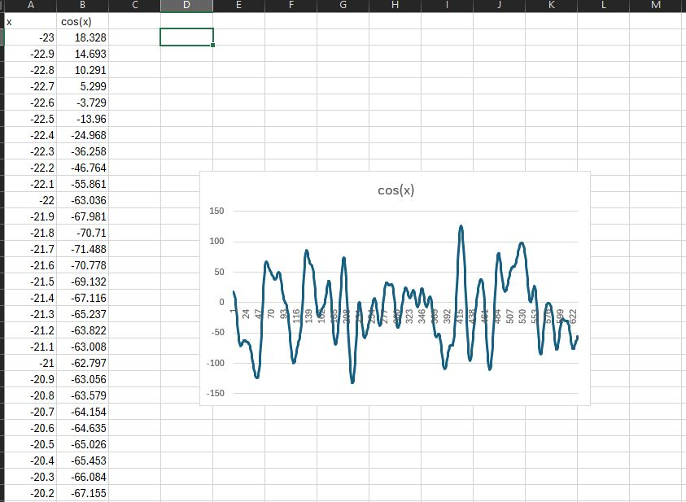

The graph pretty much stayed the same after we go further more

## Complete MATLAB Code

For documentation and reproducibility, here is the complete MATLAB implementation:

matlab

*% Clear workspace and close all figures*

clear all;

close all;

clc;

*% Generate x and y data for cosine function*

x = linspace(0, 10, 100);

y = cos(x);

*% Plot the function*

figure;

plot(x, y, 'b-', 'LineWidth', 2);

title('Cosine Function');

xlabel('x');

ylabel('cos(x)');

grid on;

saveas(gcf, 'cosine_plot.png');

*% Save the data to CSV*

data = [x', y'];

csvwrite('cosine_data.csv', data);

*% Display some values*

disp('First 5 x values:');

disp(x(1:5));

disp('First 5 y values:');

disp(y(1:5));

*% Add salt (random noise) to the data*

salt_min = -0.5;

salt_max = 0.5;

*% Generate random noise within the range*

noise = salt_min + (salt_max - salt_min) * rand(size(x));

y_salted = y + noise;

*% Plot the salted data*

figure;

plot(x, y, 'r-', 'LineWidth', 2); *% Original function*

hold on;

plot(x, y_salted, 'b.', 'MarkerSize', 8); *% Salted data*

title('Cosine Function with Salt');

xlabel('x');

ylabel('Value');

legend('Original', 'Salted');

grid on;

saveas(gcf, 'salted_cosine.png');

*% Save the salted data to CSV*

salted_data = [x', y_salted'];

csvwrite('salted_cosine.csv', salted_data);

*% Implement moving average smoothing*

window_size = 5;

y_smooth = zeros(size(y_salted));

*% Moving average calculation*

for i = 1:length(x)

*% Determine window boundaries*

start_idx = max(1, i - floor(window_size/2));

end_idx = min(length(x), i + floor(window_size/2));

*% Calculate average*

y_smooth(i) = mean(y_salted(start_idx:end_idx));

end

*% Plot the smoothed data*

figure;

plot(x, y, 'r-', 'LineWidth', 2); *% Original function*

hold on;

plot(x, y_salted, 'b.', 'MarkerSize', 6); *% Salted data*

plot(x, y_smooth, 'g-', 'LineWidth', 2); *% Smoothed data*

title('Cosine Function with Smoothing');

xlabel('x');

ylabel('Value');

legend('Original', 'Salted', 'Smoothed');

grid on;

saveas(gcf, 'smoothed_cosine.png');

*% Save the smoothed data to CSV*

smoothed_data = [x', y_smooth'];

csvwrite('smoothed_cosine.csv', smoothed_data);

*% Multiple smoothing passes*

y_smooth2 = y_smooth;

for pass = 1:2

*% Apply additional smoothing*

for i = 1:length(x)

start_idx = max(1, i - floor(window_size/2));

end_idx = min(length(x), i + floor(window_size/2));

y_smooth2(i) = mean(y_smooth2(start_idx:end_idx));

end

end

*% Plot with multiple smoothing passes*

figure;

plot(x, y, 'r-', 'LineWidth', 2); *% Original function*

hold on;

plot(x, y_salted, 'b.', 'MarkerSize', 6); *% Salted data*

plot(x, y_smooth, 'g-', 'LineWidth', 2); *% Smoothed data (1 pass)*

plot(x, y_smooth2, 'm-', 'LineWidth', 2); *% Smoothed data (3 passes)*

title('Cosine Function with Multiple Smoothing Passes');

xlabel('x');

ylabel('Value');

legend('Original', 'Salted', '1 Smoothing Pass', '3 Smoothing Passes');

grid on;

saveas(gcf, 'multiple_smoothing.png');

## What I Learned

This project provided valuable experience with several important aspects of MATLAB programming and data processing:

1. **Function Generation and Plotting**: I learned how to create mathematical functions and visualize them with customized plot settings in MATLAB.
2. **Data Manipulation**: The process of adding controlled random noise taught me how to simulate real-world measurement error using MATLAB's random number generation capabilities.
3. **Algorithm Implementation**: Developing the moving average smoothing algorithm improved my understanding of how to handle edge cases and implement iterative processes in MATLAB.
4. **Precision Considerations**: I encountered an interesting challenge with floating-point precision when dealing with boundary values. This reinforced the importance of careful numerical handling in computational applications.
5. **Smoothing Effectiveness**: The comparison of single and multiple smoothing passes revealed that most of the noise reduction occurs in the first pass, with diminishing returns from additional passes.
6. **File Handling**: I gained experience with saving both data (CSV) and visualizations (PNG) for documentation and further analysis.

The moving average smoothing technique proved effective for noise reduction while maintaining the general structure of the original function. This project has enhanced my understanding of signal processing concepts and MATLAB's capabilities for data manipulation and visualization.

**Note:** The actual images would be included in the final document submission, appearing where the placeholders are indicated.