**HashMapper:Text-Finterprinting-System**

**User Manual**

Developer: Arnab Das Utsa

Version: 1.0.0

Table of Contents

1. Introduction 3

2. System Requirements 3

3. Installation Instructions 3

4. Running the Application 4

5. Using HashMapper 5

6. Viewing and Analyzing Results 6

7. Using Java Backend Separately 9

8. Troubleshooting 9

9. Best Practices 9

10. Closing Notes 10

# 1. Introduction

Welcome to HashMapper — a text fingerprinting and visualization system.  
This user manual will guide you through the setup, usage, and exploration of the application.

# 2. System Requirements

- Python 3.8 or newer  
- Java 8 or newer  
- pip packages: Flask, Pillow  
- A modern web browser (e.g., Chrome, Firefox)

# 3. Installation Instructions

Follow these steps to install and set up HashMapper:

1. Step 1: Download or Clone the Project

* Download the ZIP file or clone the GitHub repository to your local machine.

1. Step 2: Set Up Python Environment

* Open your terminal and create a virtual environment (optional but recommended).

$ python3 -m venv venv  
$ source venv/bin/activate

1. Step 3: Install Python Packages

$ pip install flask Pillow

1. Step 4: Compile Java Files

* Use the provided script to compile Java source files:

$ ./compile_java.sh (Linux/Mac)  
OR  
> compile_java.bat (Windows)

# 4. Running the Application

1. Step 1: Start the Flask Server

* $ python app.py

1. Step 2: Open the Application

* Navigate to http://localhost:5000 in your browser.

# 5. Using HashMapper

1. Step 1: Enter Text

* Input any text into the provided text box.

1. Step 2: Configure Options

* - Choose hash function (SimpleHashMap or DumbHashMap)  
  - Adjust salt level and smoothing radius if needed

1. Step 3: Generate Fingerprint

* Click on the 'Generate Fingerprint' button to create the visual representation.

# 6. Viewing and Analyzing Results

After generating a fingerprint:  
- View the raw and enhanced fingerprint images  
- Download CSV reports for:  
 - Bucket distribution

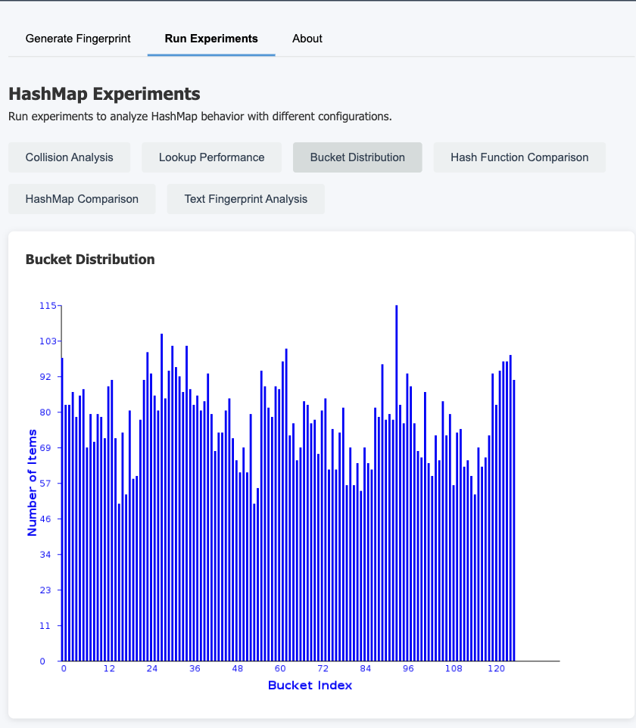

- String collisions

- Lookup performance

-Hash Function Comparison

-HashMap Comparison

-Text fingerprint Analysis

# 7. Using Java Backend Separately

If you want to run the Java part manually without using Flask:  
$ java -cp "lib/*:.:java" HashMapper --text-file yourfile.txt --size 512 --hash-function SimpleHashMap

# 8. Troubleshooting

- Error: "Java not recognized" → Ensure Java is installed and added to PATH.  
- Error: "Flask module missing" → Run `$ pip install flask` inside the virtual environment.  
- Error: "Cannot find HashMapper class" → Re-run the Java compile script before starting.

# 9. Best Practices

- Use short to medium-length texts for faster visualization.  
- Experiment with salt level and smoothing radius to see different styles.  
- Use DumbHashMap for more collisions and chaotic images; SimpleHashMap for cleaner mapping.

# 10. Closing Notes

HashMapper is built not just as a visualization tool, but as an educational system to explore hashing behavior, collisions, and visualization design.