**Lab 4: Building Tables & Inserting Records**

1. Build the CarBuyers table and insert records as directed in the lesson(s).  
     
   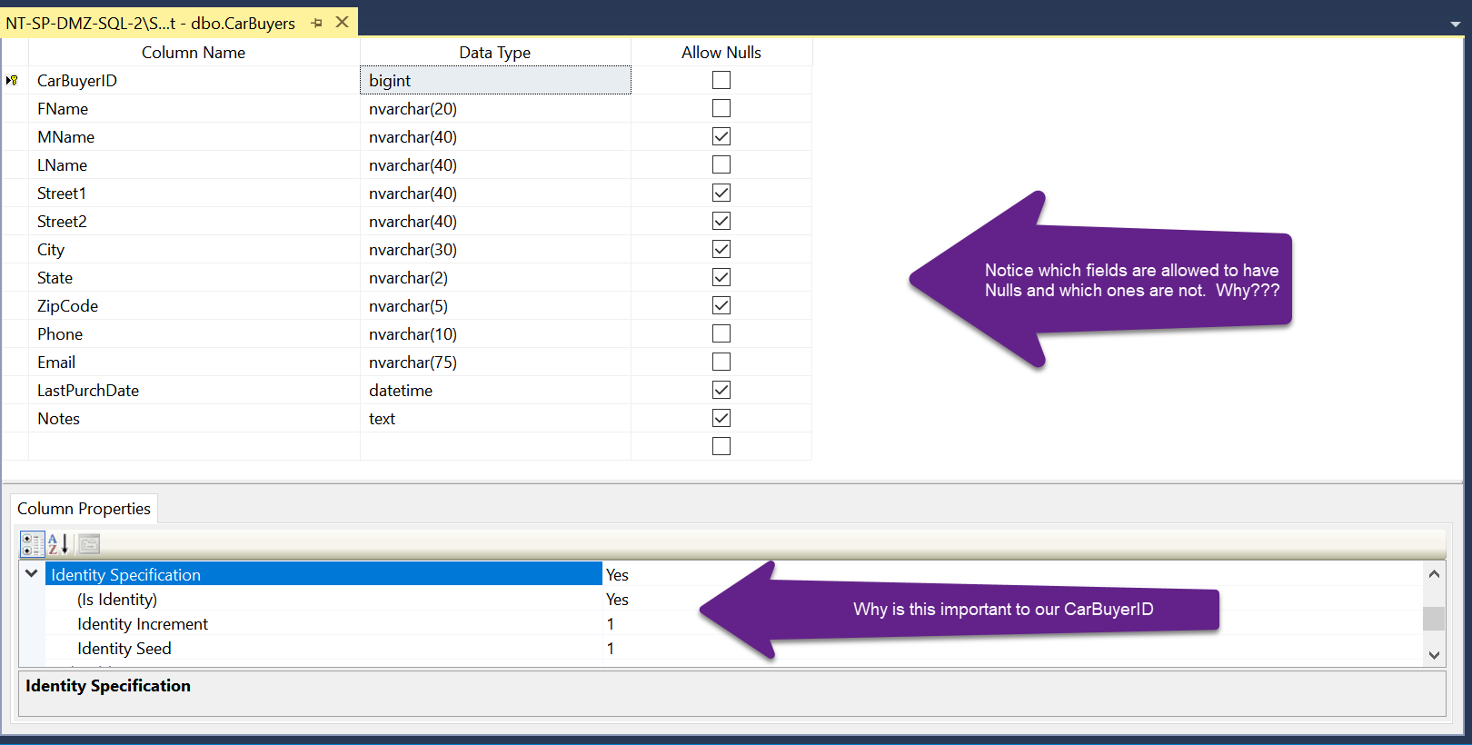
2. Fill the table with the following data:   
     
   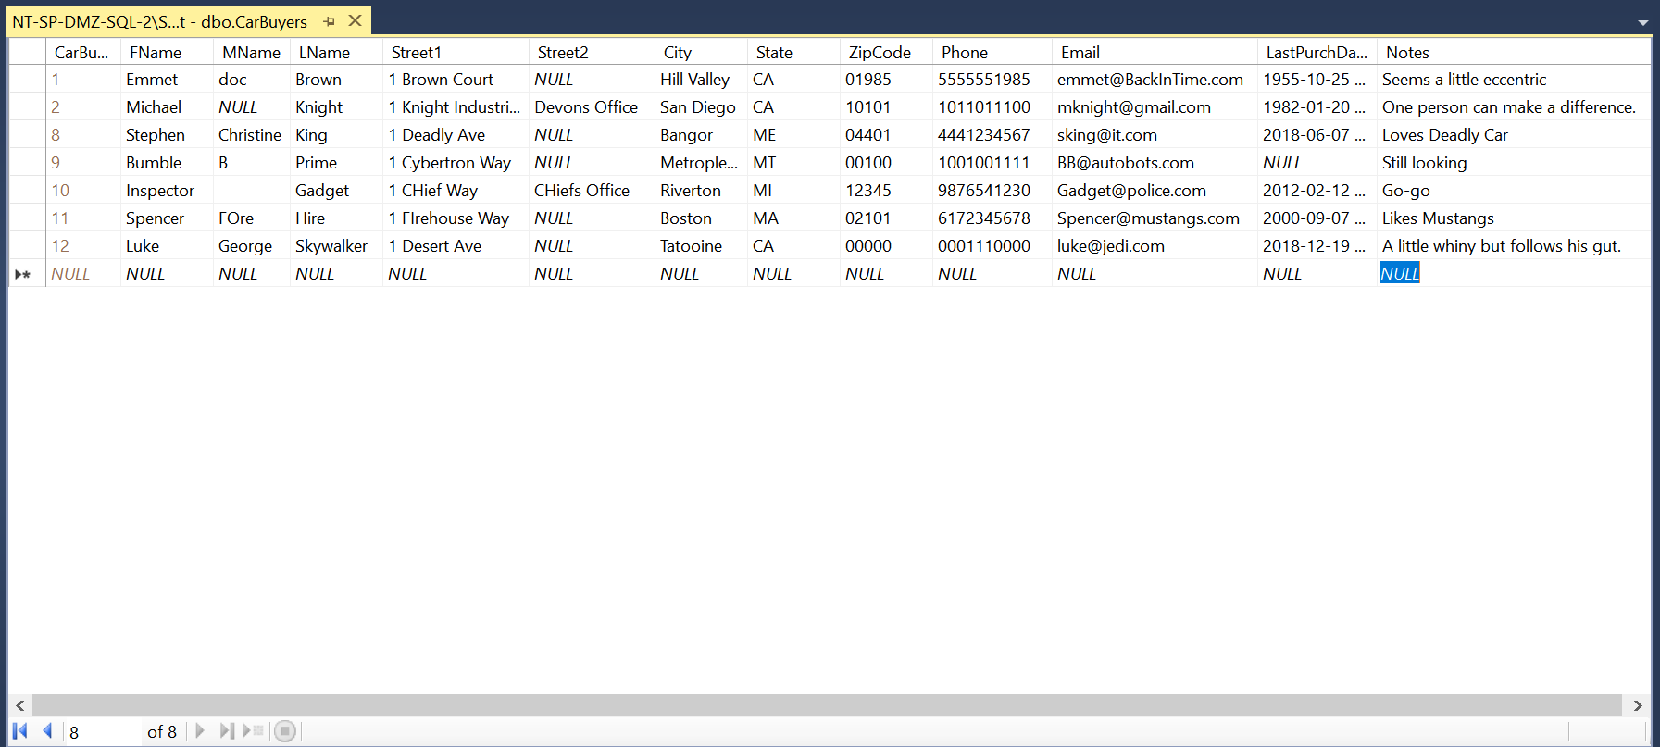  
     
   PLEASE NOTE: Your CarBuyersID’s may not match mine…that is okay. I may have deleted a series of other records along the way or experienced errors/issues during data entry.
3. Create 4 more records of your own.  Please try to create a variety of records with diverse field values for testing.  
   A screenshot of a computer

   Description automatically generated
4. Create a View for the CarBuyers table that selects buyers that have not bought a car in the last 5 years name ‘NoCarPurchaseIn5Years’. Select all records from this view to see the resulting records.  
   A screenshot of a computer

   Description automatically generated
5. Create a View for the CarBuyers table that selects potential buyers that have not bought from us at all. Name this view ‘CarBuyersStillLooking’ Select all records from this view to see the resulting records.  
   A computer screen with a white screen

   Description automatically generated
6. Imagine we are going to create a mass email list for people advertising a maintenance plan or coupon. You only want the first name and email address of people that bought cars in the last five years. Select the records from the view that matches your needs. (This will require you to create a new View named ‘CarPurchaseWithIn5Years’. )  
   A screenshot of a computer

   Description automatically generated
7. Add another record in the CarBuyers table that bought a car in the last year in a new tab. Re-select from the ‘CarPurchaseWithIn5Years’ View. You should see the original records plus the new one.   
   I added Gucci Mane
8. Create a Stored Procedure (SP) that does the same type of search as ‘NoCarPurchaseIn5Years’, but in a form of a Stored Procedure named ‘SP_NoCarPurchaseIn5Years’. Execute this SP and make sure the results match the View results.  
   A screenshot of a computer

   Description automatically generated
9. Now, think about this same stored procedure that would allow the user to specify the number of years since purchased as a parameter, so you could have a bunch of different options other than 5 year purchases. Make this SP and name it ‘SP_NoCarPurchasedInYears’. Try executing it with 5 years, 10 years, 2 years.  
   A screenshot of a computer

   Description automatically generated
10. One last SP for now. Think of a car dealership that just got in a car you think might interest specific customers. Think of how we might know their interests. How about the ‘Notes’ field. Create a SP that receives a string as a parameter and we can use LIKE to see if the string shows up in any records. Name it ‘SP_LookWithinNotes’ and execute it 3 times with words like ‘Mustang’, ‘deadly’, ‘eccentric’.

