**Lessons 6 & 7 Activity:**

**Inserting, Deleting, Updating Car Records and Joining Tables**

For every request, show the code for the query, any code calling it, the results below, and a listing of the records so we can see what happened to the data.

1. Display all records and fields for the Cars table  
   A screenshot of a computer

   Description automatically generated
2. Create a SQL Insert query to add a new car to the Cars table with the following values:  
   Year: 09/01/2019 Transmission: Auto  
   Make: Toyota Active: 0 / False  
   Model: Tundra Liters: 3.4  
   Doors: 4 Cylinder: 6  
   Mileage: 34000 Notes: Still gathering car history  
   A screenshot of a computer

   Description automatically generated
3. Create a SQL Insert query to add a new car to the Cars table with the following values:  
   Year: 09/01/2015 Transmission: Manual  
   Make: Toyota Active: 0 / False  
   Model: Corolla Liters: 2.2  
   Doors: 4 Cylinder: 4  
   Mileage: 56000 Notes: Still gathering car history  
   A screenshot of a computer

   Description automatically generated
4. Gather the Car_ID for the new car created in #2 and create an Update query that will update this new with the following:  
   VIN: “000DESTRUCT0” , Price: 28999.99 , Notes: Deal! Driven only on Sundays  
   A screenshot of a computer

   Description automatically generated
5. Create an Update query that sets all cars to Inactive (Active = 0).  
   A screenshot of a computer

   Description automatically generated
6. Create an Update query that increases the Price by $500 (Price = Price + 500), if the car has 4 cylinders and Transmission is Auto.  
   A screenshot of a computer

   Description automatically generated
7. Create an Update query that sets a car to Active (Active = 1) based on the Car_ID.  
   **Bonus (+5)** Create a Stored Procedure that receives a Car_ID as a parameter and makes that car Active.  
   A screenshot of a computer

   Description automatically generated
8. Create a Delete query that deletes the Yugo based on the specified Car_ID (Car_ID is 7 on my sample data).  
   **Bonus (+5)** Create a Stored Procedure that receives a Car_ID as a parameter and deletes that car.  
   A screenshot of a computer

   Description automatically generated
9. Display all records and fields for the Cars table  
   A screenshot of a computer

   Description automatically generated
10. Create new table: CarPurchases and show your design below.  
    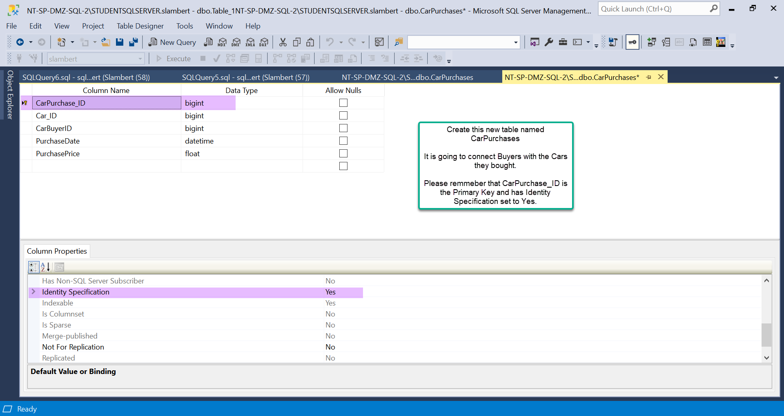  
    A computer screen with a white screen

    Description automatically generated
11. Add the sample data shown as well as create 3 new sample records of your own using existing Cars and Buyers. Show all records below.  
    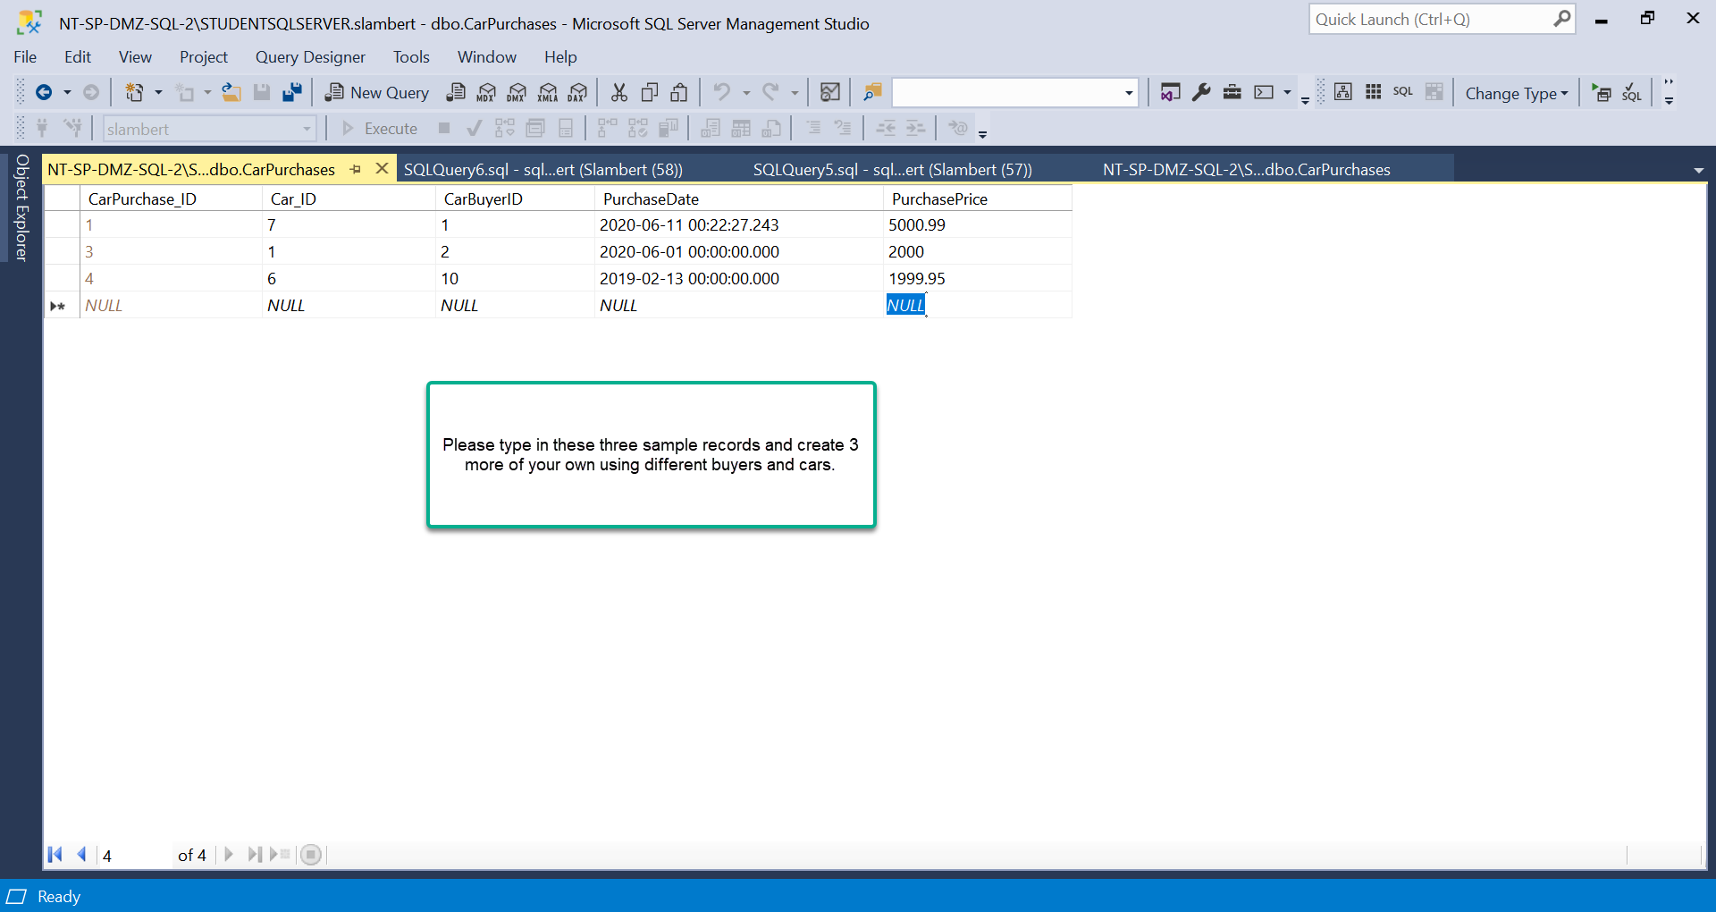  
    A computer screen shot of a white screen

    Description automatically generated
12. Use an Inner Join with the CarPurchases and Cars tables to list the Car’s Make and Model for each purchase recorded in CarPurchases.  
    A screenshot of a computer

    Description automatically generated
13. Use an Inner Join with the CarPurchases and CarBuyers tables to list the Buyer’s First, Last, and Email for each purchase recorded in CarPurchases.

