**Passed test cases output (test_pass function is executed only)**

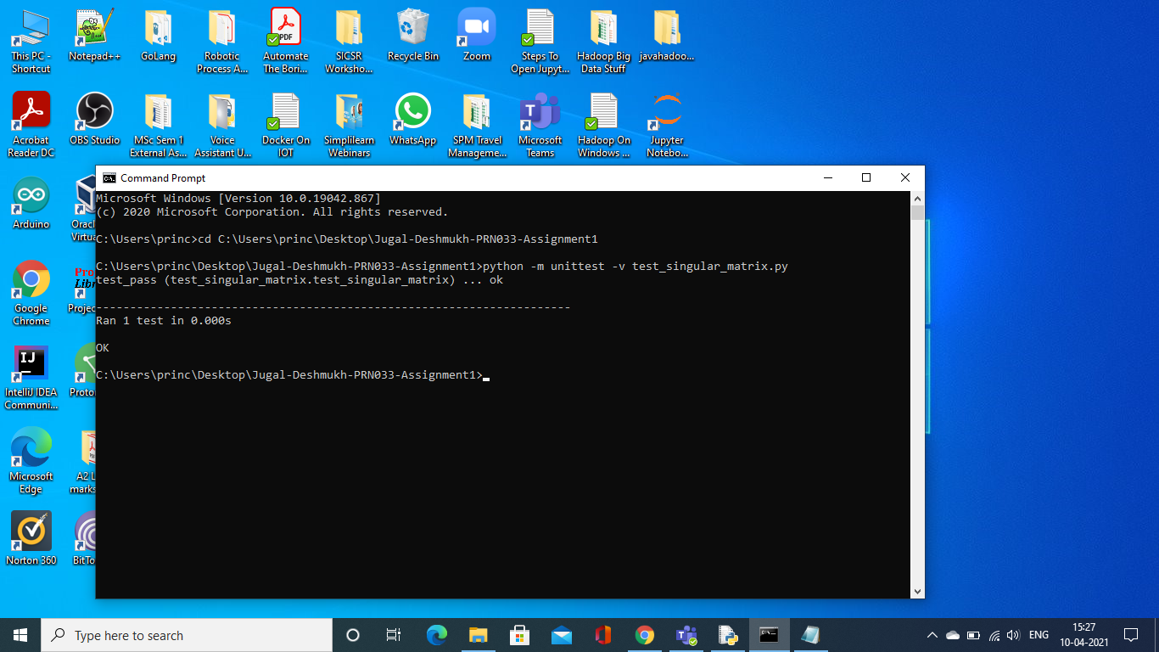

**Failed test cases output (test_fail function is executed only)**

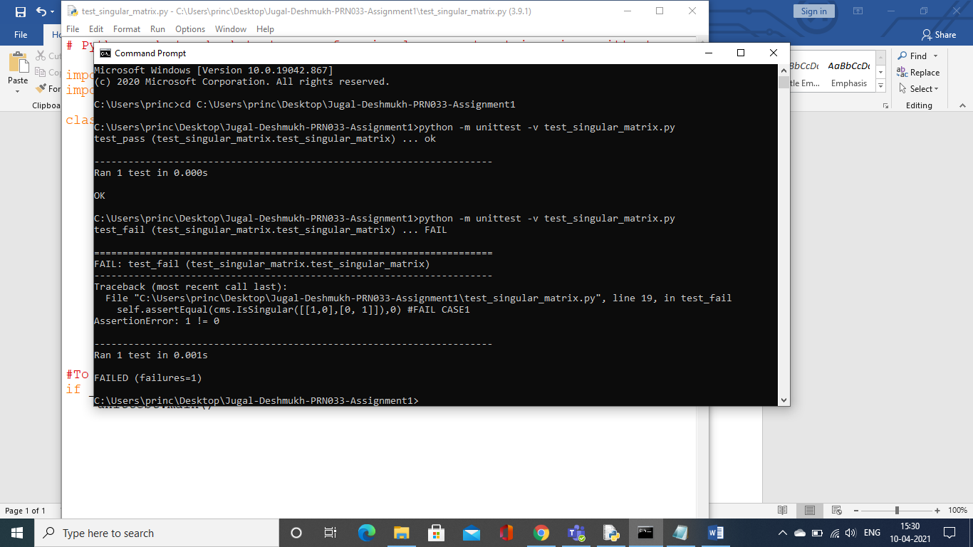

**All test cases output (Both test functions are executed)**

