**Practical Lab 2**

**Q1.** Test the following JavaScript codes:

<html>

<head>

<script type="text/javascript">

function display() {

//get user input

var input = document.getElementById('input').value;

//display result

alert("You entered: " + input);

}

</script>

</head>

<body>

Enter: <input id="input" name="input" >

<br><br>

<! click the button, call the javascript fuction display()>

<button type="button" onclick="display();">

Click me to display your input</button>

<br><br>

</body>

</html>

**Q2.** Test the following JavaScript codes:

<html>

<head>

<script type="text/javascript">

function calcResult() {

var y = 5;

var x = y + 2;

// display result

document.getElementById("result").innerHTML = x;

}

</script>

</head>

<body>

<p>y equals 5, calculate x = y + 2, and display x:</p>

<button onclick="calcResult()">Try it</button>

<br/><br/>

Result: <p id="result"></p>

</body>

</html>

**Q3.** Based on **Q1** & **Q2**, use JavaScript to implement an e-commerce order form as follows:

基于Q1和Q2，使用JavaScript实现了一个电子商务订单如下：

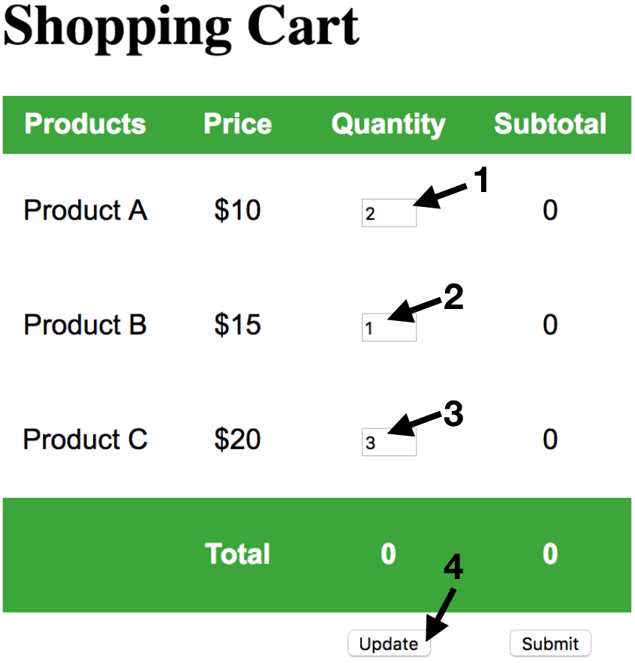 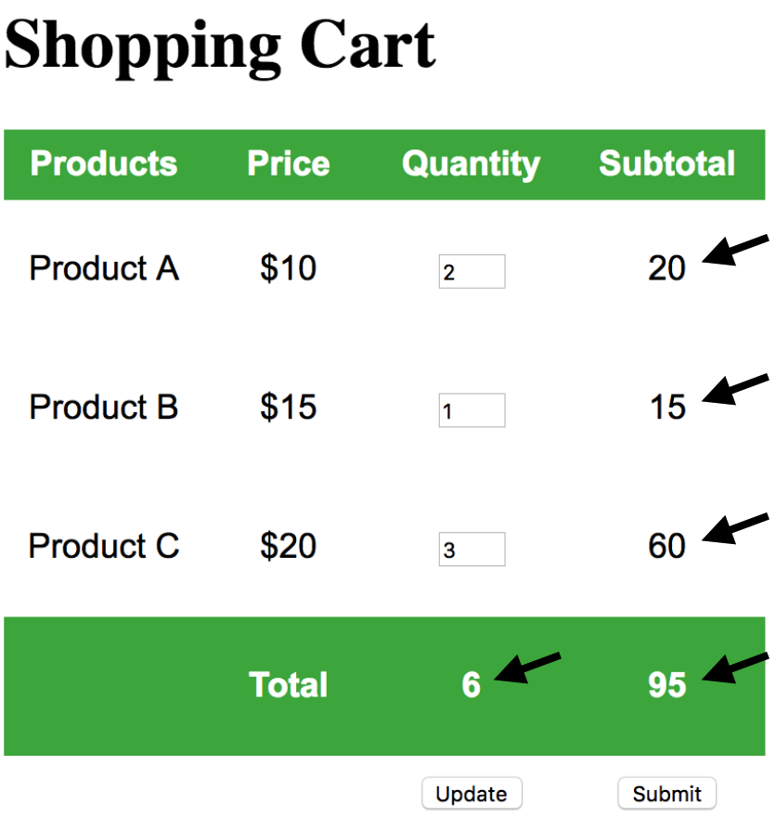

Press “Update” to update the order form before submission.

Key: 1. Get user’s input (e.g. quantity)

2. Calculate result (e.g. subtotal, total)

3. Display on the form

**Q4.** Based on **Q3**, use JavaScript to implement an e-commerce order form as follows:

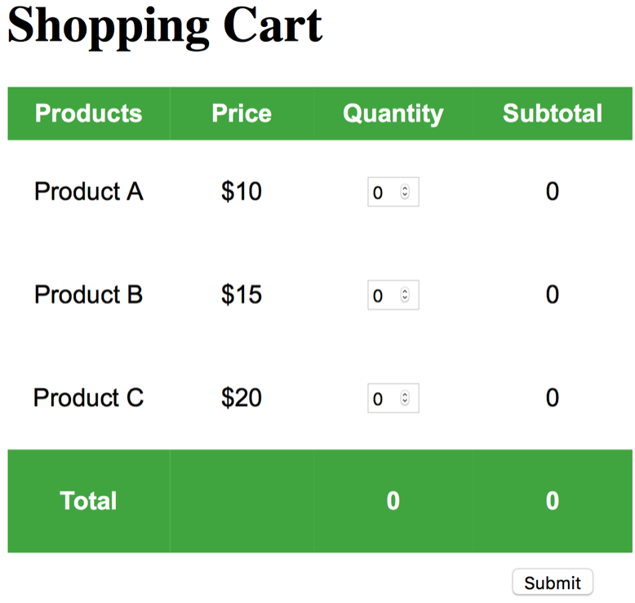 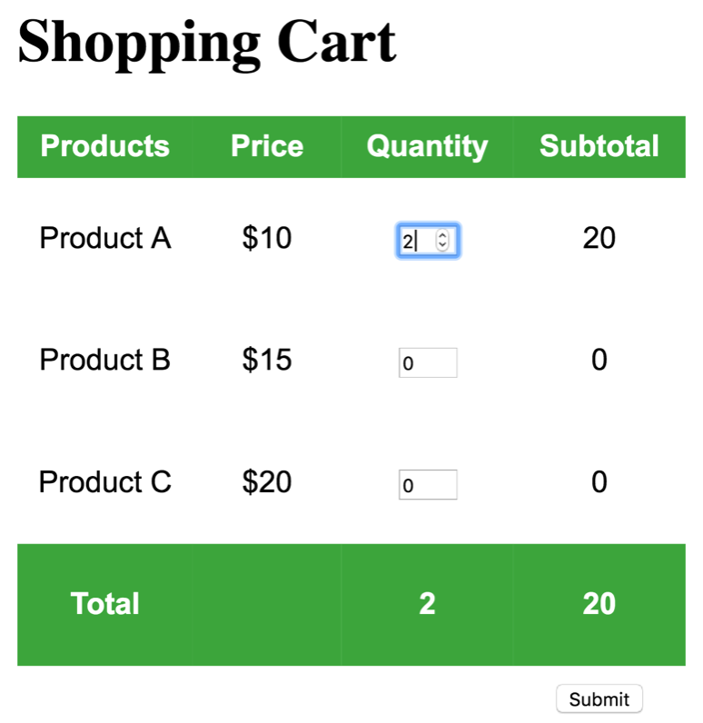

**Without pressing “Update” button**, every time you change the quantity of any product, the total quantity, subtotal, and total amount will be **updated** **automatically**. 无需按下“更新”按钮，每次更改产品数量时，总数量、小计和总金额将自动更新。

Key: 1. html number validation – quantity only accept number as input

2. Set default value, and min/max value for each quantity input

3. Real time update, all results are automatically updated

**Answer:**

**Q3.**

<!DOCTYPE html>

<html>

<head>

<style>

table {

font-family: arial, sans-serif;

border-collapse: collapse;

width: 400px;

}

td, th {

width:100px;

text-align: center;

padding: 8px;

}

th {

background-color: #4CAF50;

color: white;

}

</style>

</head>

<body>

<h1>Shopping Cart</h1>

<FORM ACTION="http://www.rebol.com/cgi-bin/test-cgi.cgi">

<table>

<tr>

<th>Products</th>

<th>Price</th>

<th>Quantity</th>

<th>Subtotal</th>

</tr>

<tr>

<td>Product A<input type="hidden" name="ProductA" id="ProductA" value="ProductA"/></td>

<td>$10<input type="hidden" name="ProductAprice" id="ProductAprice" value="10"/></td>

<td><input id="ProductAquantity" name="ProductAquantity" type="number" value="0" min="0" max="10"/></td>

<td><p id="ProductAsubtotal">0</p><input id="ProductAtotal" name="ProductAtotal" type="hidden"/></td>

</tr>

<tr>

<td>Product B<input type="hidden" name="ProductB" id="ProductB" value="ProductB"/></td>

<td>$15<input type="hidden" name="ProductBprice" id="ProductBprice" value="15"/></td>

<td><input id="ProductBquantity" name="ProductBquantity" type="number" value="0" min="0" max="10"/></td>

<td><p id="ProductBsubtotal">0</p><input id="ProductBtotal" name="ProductBtotal" type="hidden"/></td>

</tr>

<tr>

<td>Product C<input type="hidden" name="ProductC" id="ProductC" value="ProductC"/></td>

<td>$20<input type="hidden" name="ProductCprice" id="ProductCprice" value="20"/></td>

<td><input id="ProductCquantity" name="ProductCquantity" type="number" value="0" min="0" max="10"/></td>

<td><p id="ProductCsubtotal">0</p><input id="ProductCtotal" name="ProductCtotal" type="hidden"/></td>

</tr>

<tr>

<th></th>

<th>Total</th>

<th><p id="Quantity" >0</p><input id="totalQuantity" name="total" type="hidden"/></th>

<th><p id="Price" >0</p><input id="totalPrice" name="totalPrice" type="hidden"/></th>

</tr>

<tr>

<td></td>

<td></td>

<td><button type="button" onclick="updateCart();">Update</button></td>

<td><button type="submit">Submit</button></td>

</tr>

</table>

<br/><br/>

</FORM>

<script type="text/javascript">

function calcSubTotal(productName){

var quantity = parseInt(document.getElementById(productName+'quantity').value);

if(quantity > 0){

var price = parseInt(document.getElementById(productName+'price').value);

var subtotal = price * quantity;

document.getElementById(productName+"subtotal").innerHTML = subtotal;

document.getElementById(productName+"total").value = subtotal;

return subtotal;

}

document.getElementById(productName+"subtotal").innerHTML = 0;

document.getElementById(productName+"total").value = 0;

return 0;

}

function updateCart(){

var total = calcSubTotal('ProductA')+calcSubTotal('ProductB')+calcSubTotal('ProductC');

var quantity = parseInt(document.getElementById('ProductAquantity').value)+parseInt(document.getElementById('ProductBquantity').value)+parseInt(document.getElementById('ProductCquantity').value);

document.getElementById("Quantity").innerHTML = quantity;

document.getElementById("totalQuantity").value = quantity;

document.getElementById("Price").innerHTML = total;

document.getElementById("totalPrice").value = total;

}

</script>

</body>

</html>

**Q4.**

<!DOCTYPE html>

<html>

<head>

<style>

table {

font-family: arial, sans-serif;

border-collapse: collapse;

width: 400px;

}

td,

th {

width: 100px;

text-align: center;

padding: 8px;

}

th {

background-color: #4CAF50;

color: white;

}

</style>

</head>

<body>

<!--

Possible bonus tasks:

1. html number validation - number only, default value, min/max value

2. using post for better security - method="post"

3. real time update - onchange

-->

<h1>Shopping Cart</h1>

<form action="http://www.rebol.com/cgi-bin/test-cgi.cgi" method="post">

<table>

<tr>

<th>Products</th>

<th>Price</th>

<th>Quantity</th>

<th>Subtotal</th>

</tr>

<tr>

<td>Product A

<input type="hidden" name="ProductA" id="ProductA" value="ProductA" />

</td>

<td>$10

<input type="hidden" name="ProductAprice" id="ProductAprice" value="10" /></td>

<td>

<input id="ProductAquantity" name="ProductAquantity" type="number" value="0" min="0" max="10" onchange="updateCart()"/>

</td>

<td>

<p id="ProductAsubtotal">0</p>

<input id="ProductAtotal" name="ProductAtotal" type="hidden" value="0" />

</td>

</tr>

<tr>

<td>Product B

<input type="hidden" name="ProductB" id="ProductB" value="ProductB" />

</td>

<td>$15

<input type="hidden" name="ProductBprice" id="ProductBprice" value="15" />

</td>

<td>

<input id="ProductBquantity" name="ProductBquantity" type="number" value="0" min="0" max="10" onchange="updateCart()"/>

</td>

<td>

<p id="ProductBsubtotal">0</p>

<input id="ProductBtotal" name="ProductBtotal" type="hidden" value="0" />

</td>

</tr>

<tr>

<td>Product C

<input type="hidden" name="ProductC" id="ProductC" value="ProductC" />

</td>

<td>$20

<input type="hidden" name="ProductCprice" id="ProductCprice" value="20" />

</td>

<td>

<input id="ProductCquantity" name="ProductCquantity" type="number" value="0" min="0" max="10" onchange="updateCart()"/>

</td>

<td>

<p id="ProductCsubtotal">0</p>

<input id="ProductCtotal" name="ProductCtotal" type="hidden" value="0" />

</td>

</tr>

<tr>

<th>Total</th>

<th></th>

<th>

<p id="Quantity">0</p>

<input id="totalQuantity" name="total" type="hidden" value="0" />

</th>

<th>

<p id="Price">0</p>

<input id="totalPrice" name="totalPrice" type="hidden" value="0" />

</th>

</tr>

<tr>

<td></td>

<td></td>

<td></td>

<td><button type="submit">Submit</button></td>

</tr>

</table>

</form>

<script type="text/javascript">

var calcSubTotal = function(productName) {

var quantity = parseInt(document.getElementById(productName + 'quantity').value);

if (quantity > 0) {

var price = parseInt(document.getElementById(productName + 'price').value);

var subtotal = price * quantity;

document.getElementById(productName + "subtotal").innerHTML = subtotal;

document.getElementById(productName + "total").value = subtotal;

return subtotal;

}

document.getElementById(productName + "subtotal").innerHTML = 0;

document.getElementById(productName + "total").value = 0;

return 0;

}

function updateCart() {

var total = calcSubTotal('ProductA') + calcSubTotal('ProductB') + calcSubTotal('ProductC');

var quantity = parseInt(document.getElementById('ProductAquantity').value) + parseInt(document.getElementById('ProductBquantity').value) + parseInt(document.getElementById('ProductCquantity').value);

document.getElementById("Quantity").innerHTML = quantity;

document.getElementById("totalQuantity").value = quantity;

document.getElementById("Price").innerHTML = total;

document.getElementById("totalPrice").value = total;

}

</script>

</body>

</html>