**Practical Lab 6**

**Student ID: ____________________ Student Name: _________________________**

**Q1.** Test the following codes to hash a message.

**Test demo1 here:** [**Demo 1**](http://titan.csit.rmit.edu.au/~e23700/Lab6/Demo1/)

1. Download **sha256.js** from the [here](http://titan.csit.rmit.edu.au/~e23700/Lab6/Demo2/client/js/) and put under your student folder.
2. Link **sha256.js** file, see first highlight part
3. Call **sha256** **hash** **function** and hash the user input, see second highlight part

**<html>**

**<body>**

**<h1>Lab 6 Demo 1</h1>**

**<input name="input" id="input" type="text" >**

**<br/><br/>**

**<button type="button" onclick="hash()">Hash</button>**

**<br/><br/>**

**<h3>Hash value</h3>**

**<p name="hash_value" id="hash_value"></p>**

**<!-- refer to the js file, which contains sha256 hash function-->**

**<script src="js/sha256.js"></script>**

**<script type="text/javascript">**

**// Demo code**

**function hash() {**

**// get user input**

**var input = document.getElementById('input').value;**

**// call sha256 hash function**

**var hash = SHA256.hash(input);**

**// print on the screen**

**document.getElementById('hash_value').innerHTML = hash;**

**}**

**</script>**

**</body>**

**</html>**

**Think:** 1. refer a js file in different folder.

2. Try different messages and see the hash results

2.1. When you enter the same messages, the hash value must be the same

2.2. When you enter different messages, the hash values must be different

**Q2.** Test the following codes to save a **hash value** into the “database”.

**Based on the answers of previous lab (Lab 5), test Demo2 here:** [**Demo 2**](http://titan.csit.rmit.edu.au/~e23700/Lab6/Demo2/)

1. Create an empty txt file named: database.txt, set the permission as 777
2. Copy and paste the below code to create a HTML file as client.html, permission as 755
3. Copy and paste the below code to create a PHP file as server.php, permission as 755
4. Go to titan.csit.rmit.edu.au/~sXXXXXXX/…/client.html

**client.html**

**<html>**

**<body>**

**<h2>Lab 6 Demo 2</h2>**

**<form action="../server/server.php" method="POST">**

**Enter: <input type="text" name="input" id="input">**

**<br/><br/>**

**<button type="submit" onclick="hash()">Submit</button>**

**</form>**

**<script src="js/sha256.js"></script>**

**<script type="text/javascript">**

**function hash() {**

**var input = document.getElementById('input').value;**

**var hash = SHA256.hash(input);**

**document.getElementById("input").value = hash;**

**}**

**</script>**

**</body>**

**</html>**

**server.php**

**<html>**

**<body>**

**<?php**

**//Receive user input from clint side**

**$user_input = $_POST['input'];**

**//open the database file named "database.txt"**

**$file = fopen("../database/database.txt","a");**

**//insert $user_input into the database.txt**

**fwrite($file, $user_input."\n");**

**//close the "$file"**

**fclose($file);**

**echo "The hash value has been added to the database/database.txt";**

**?>**

**</body>**

**</html>**

**Q3.** Based on Q1, Q2, update the answers of Lab 5,which contains register.html, register.php, login.html, login.php, users.txt and sha256.js to achieve the following:

**-------------------------------------------------------------------------------------------------------------------------------**

**Expected outcome: users’ passwords have been hashed before saved in the database**

**Register:**

1. Go toregister.html, and enter username and password
2. Go back to check users.txt, the password has been hashed.
3. Username is remained as plaintext, and also do not allow the same user (with same username) to register.

**Login:**

1. Go to login.html
2. Enter the username and password
3. Entered password is hashed before submitted the form
4. Compare the hash values to verify the user

**According to Q2, create the folders/files as below:**

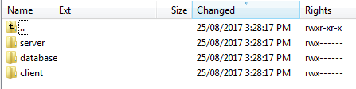

**in the folder server:**

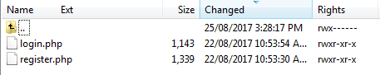

**in the folder database:**

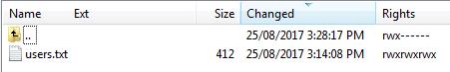

**in the folder client:**

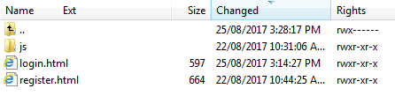

**in the folder js:**

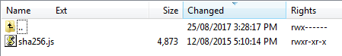

**Step 1.** Update register.html, enter the username and password, such as “**USER1**” and “**PASSWORD1**”, “**USER2**” and “**PASSWORD2**” and “**USER3**” and “**PASSWORD3**”.

**Try**

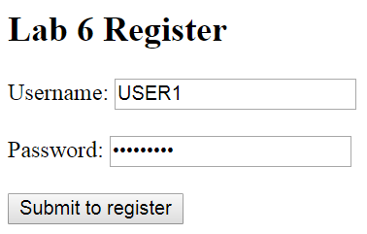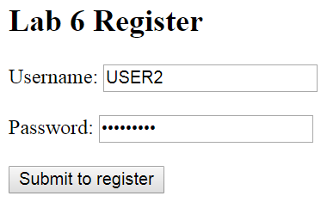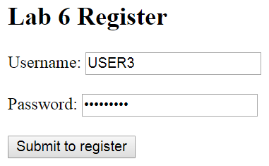

**Check users.txt as below:**

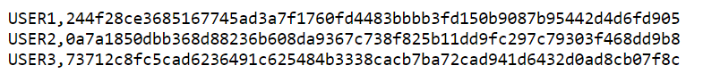

**Please note:** if you entered as “**USER1**” and “**PASSWORD1**”, “**USER2**” and “**PASSWORD2**” and “**USER3**” and “**PASSWORD3**”, it must be the same result as above in the users.txt.

**Step 2.** Update login.html to achieve previous login functions

Case 1: enter correct username and password

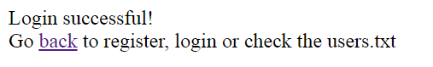

Case 2: enter incorrect username or password

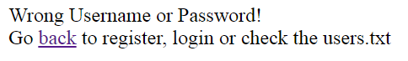

**Step 3.** Update login.html and register.html the **action=”...”** part (refer to highlight part 1 of **Q2**)

Update login.php and register.php the **fopen(…)** part (refer to highlight part2of **Q2**)