Звіт до лабораторної роботи № 3

PR, який був успішно злитий в основну гілку після проходження усіх перевірок:
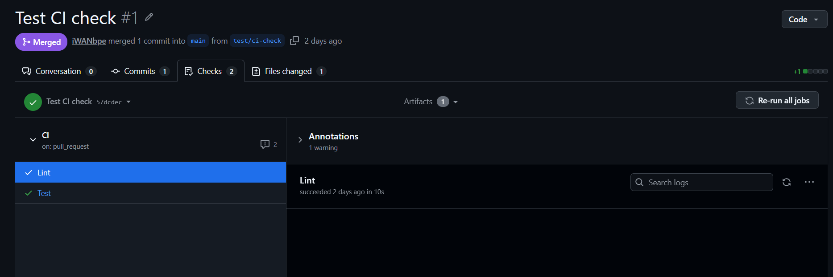

PR, який не може бути злитий в основну гілку, бо не пройшли автоматизовані тести/аналіз:
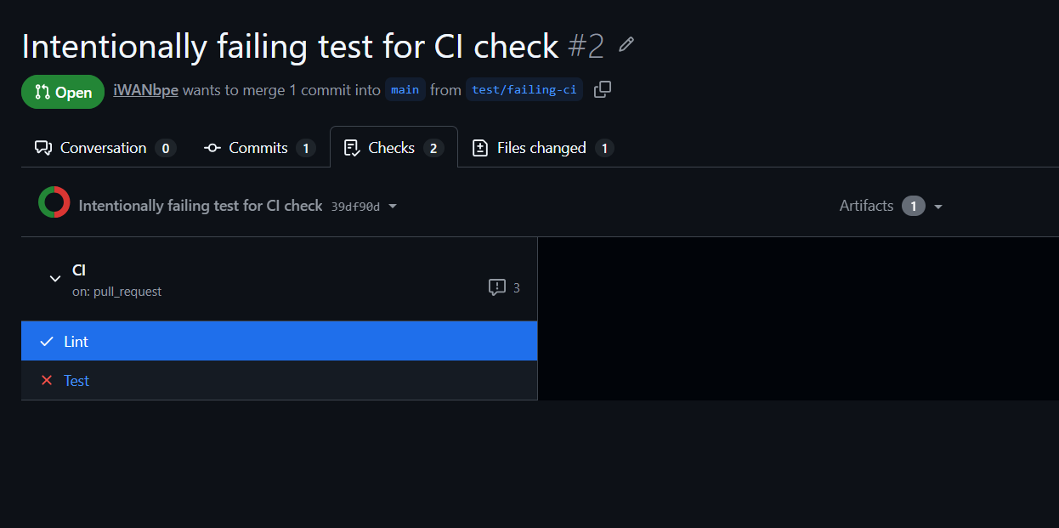
Результат виконання тестів:
Run pytest --cov=app --cov-report=term-missing --cov-report=html --cov-fail-under=40
pytest --cov=app --cov-report=term-missing --cov-report=html --cov-fail-under=40
shell: /usr/bin/bash -e {0}
env:
pythonLocation: /opt/hostedtoolcache/Python/3.12.13/x64
PKG_CONFIG_PATH: /opt/hostedtoolcache/Python/3.12.13/x64/lib/pkgconfig
Python_ROOT_DIR: /opt/hostedtoolcache/Python/3.12.13/x64
Python2_ROOT_DIR: /opt/hostedtoolcache/Python/3.12.13/x64
Python3_ROOT_DIR: /opt/hostedtoolcache/Python/3.12.13/x64
LD_LIBRARY_PATH: /opt/hostedtoolcache/Python/3.12.13/x64/lib
============================= test session starts ==============================
platform linux -- Python 3.12.13, pytest-8.3.5, pluggy-1.6.0
rootdir: /home/runner/work/TaskTrack/TaskTrack
configfile: pyproject.toml
testpaths: tests
plugins: cov-6.1.0
collected 16 items
tests/test_app.py F............... [100%]
=================================== FAILURES ===================================
______________________________ test_health_alive _______________________________
client = <FlaskClient <Flask 'app'>>
def test_health_alive(client):
resp = client.get("/health/alive")
> assert resp.status_code == 999
E assert 200 == 999
E + where 200 = <WrapperTestResponse streamed [200 OK]>.status_code
tests/test_app.py:49: AssertionError
================================ tests coverage ================================
_______________ coverage: platform linux, python 3.12.13-final-0 _______________
Name Stmts Miss Cover Missing
--------------------------------------
app.py 108 6 94% 19-20, 54-57, 150
--------------------------------------
TOTAL 108 6 94%
Coverage HTML written to dir htmlcov
Required test coverage of 40% reached. Total coverage: 94.44%
=========================== short test summary info ============================
FAILED tests/test_app.py::test_health_alive - assert 200 == 999
+ where 200 = <WrapperTestResponse streamed [200 OK]>.status_code
========================= 1 failed, 15 passed in 1.17s =========================
Error: Process completed with exit code 1.

Лог успішного розгортання проєкту і успішної верифікації розгортання:
Deploy to target node:
Run chmod +x scripts/deploy.sh
=== Deploying ghcr.io/iwanbpe/tasktrack:stable to ***@*** ===
Pulling image ghcr.io/iwanbpe/tasktrack:stable...
stable: Pulling from iwanbpe/tasktrack
30209090d7b4: Pulling fs layer
35b39a5b5a1c: Pulling fs layer
ca3ec2e4856e: Pulling fs layer
364159dda7a5: Pulling fs layer
8fe6aeadf46f: Pulling fs layer
80d2c6fd4079: Pulling fs layer
524c22e99326: Pulling fs layer
97deec12ab59: Pulling fs layer
83ed68b5c709: Pulling fs layer
30209090d7b4: Download complete
ca3ec2e4856e: Download complete
364159dda7a5: Download complete
8fe6aeadf46f: Download complete
524c22e99326: Download complete
83ed68b5c709: Download complete
80d2c6fd4079: Download complete
35b39a5b5a1c: Download complete
35b39a5b5a1c: Pull complete
83ed68b5c709: Pull complete
97deec12ab59: Download complete
97deec12ab59: Pull complete
30209090d7b4: Pull complete
364159dda7a5: Pull complete
8fe6aeadf46f: Pull complete
80d2c6fd4079: Pull complete
ca3ec2e4856e: Pull complete
524c22e99326: Pull complete
Digest: sha256:274ba8d338220f2df76505f7fd422cc7c4935cf3dfc344eb26578a20ac0ed84b
Status: Downloaded newer image for ghcr.io/iwanbpe/tasktrack:stable
ghcr.io/iwanbpe/tasktrack:stable
Restarting tasktrack service...
Waiting for service to start...
Service status:
● tasktrack.service - TaskTrack Web Application
Loaded: loaded (/etc/systemd/system/tasktrack.service; enabled; preset: enabled)
Active: active (running) since Thu 2026-05-28 23:08:50 UTC; 5s ago
Invocation: 7ddadf899d314dcca3379d724c0bdaa0
Process: 7708 ExecStartPre=/usr/bin/docker stop tasktrack (code=exited, status=0/SUCCESS)
Process: 7716 ExecStartPre=/usr/bin/docker rm tasktrack (code=exited, status=0/SUCCESS)
Main PID: 7725 (docker)
Tasks: 8 (limit: 1718)
Memory: 8.7M (peak: 9M)
CPU: 201ms
CGroup: /system.slice/tasktrack.service
└─7725 /usr/bin/docker run --name tasktrack --network host -v /opt/tasktrack/config.json:/app/etc/mywebapp/config.json:ro ghcr.io/iwanbpe/tasktrack:stable
May 28 23:08:50 VM1 systemd[1]: Started tasktrack.service - TaskTrack Web Application.
May 28 23:08:50 VM1 docker[7725]: Running migrations...
May 28 23:08:50 VM1 docker[7725]: Start of migration...
May 28 23:08:50 VM1 docker[7725]: Migration done successfully!
May 28 23:08:50 VM1 docker[7725]: Starting gunicorn...
May 28 23:08:50 VM1 docker[7725]: [2026-05-28 23:08:50 +0000] [1] [INFO] Starting gunicorn 22.0.0
May 28 23:08:50 VM1 docker[7725]: [2026-05-28 23:08:50 +0000] [1] [INFO] Listening at: http://0.0.0.0:8000 (1)
May 28 23:08:50 VM1 docker[7725]: [2026-05-28 23:08:50 +0000] [1] [INFO] Using worker: sync
May 28 23:08:50 VM1 docker[7725]: [2026-05-28 23:08:50 +0000] [8] [INFO] Booting worker with pid: 8
May 28 23:08:51 VM1 docker[7725]: [2026-05-28 23:08:51 +0000] [9] [INFO] Booting worker with pid: 9
=== Deploy complete ===

Verify deployment:
Run chmod +x scripts/verify.sh
=== Verifying deployment on *** ===
--- Checking /health/alive...
✓ /health/alive returned 200
--- Checking /health/ready...
✓ /health/ready returned 200
--- Checking Nginx configuration...
nginx: the configuration file /etc/nginx/nginx.conf syntax is ok
nginx: configuration file /etc/nginx/nginx.conf test is successful
✓ Nginx config is valid
✓ Nginx proxy_pass configured
✓ Nginx proxy headers configured
--- Checking systemd service...
✓ tasktrack service is active
--- Checking /tasks endpoint...
✓ /tasks returned 200
=== ✓ Verification PASSED ===

Лог успішного розгортання проєкту і неуспішної верифікації розгортання:
Deploy to target node:
Run chmod +x scripts/deploy.sh
=== Deploying ghcr.io/iwanbpe/tasktrack:stable to ***@*** ===
Pulling image ghcr.io/iwanbpe/tasktrack:stable...
stable: Pulling from iwanbpe/tasktrack
b5a589deb070: Pulling fs layer
5cf829e29b29: Pulling fs layer
003b89253c7e: Pulling fs layer
1f8662952ddf: Pulling fs layer
e8e4cbd3dce6: Pulling fs layer
ac9c39094e19: Pulling fs layer
b047de68d54d: Pulling fs layer
113dae863d1e: Pulling fs layer
848c4988ab49: Pulling fs layer
003b89253c7e: Download complete
b5a589deb070: Download complete
5cf829e29b29: Download complete
1f8662952ddf: Download complete
e8e4cbd3dce6: Download complete
ac9c39094e19: Download complete
b047de68d54d: Download complete
113dae863d1e: Download complete
113dae863d1e: Pull complete
b047de68d54d: Pull complete
848c4988ab49: Download complete
848c4988ab49: Pull complete
b5a589deb070: Pull complete
003b89253c7e: Pull complete
1f8662952ddf: Pull complete
e8e4cbd3dce6: Pull complete
ac9c39094e19: Pull complete
5cf829e29b29: Pull complete
Digest: sha256:734f22106f5dd7bc25905d80aa178d4094cc703d31caebd6338986f2e9ab1e80
Status: Downloaded newer image for ghcr.io/iwanbpe/tasktrack:stable
ghcr.io/iwanbpe/tasktrack:stable
Restarting tasktrack service...
Waiting for service to start...
Service status:
● tasktrack.service - TaskTrack Web Application
Loaded: loaded (/etc/systemd/system/tasktrack.service; enabled; preset: enabled)
Active: active (running) since Thu 2026-05-28 22:56:02 UTC; 5s ago
Invocation: a886e3bc5ed14354875f8b56de1b1b5c
Process: 6760 ExecStartPre=/usr/bin/docker stop tasktrack (code=exited, status=0/SUCCESS)
Process: 6768 ExecStartPre=/usr/bin/docker rm tasktrack (code=exited, status=0/SUCCESS)
Main PID: 6776 (docker)
Tasks: 8 (limit: 1718)
Memory: 8.7M (peak: 9M)
CPU: 191ms
CGroup: /system.slice/tasktrack.service
└─6776 /usr/bin/docker run --name tasktrack --network host -v /opt/tasktrack/config.json:/app/etc/mywebapp/config.json:ro ghcr.io/iwanbpe/tasktrack:stable
May 28 22:56:02 VM1 systemd[1]: Started tasktrack.service - TaskTrack Web Application.
May 28 22:56:03 VM1 docker[6776]: Running migrations...
May 28 22:56:03 VM1 docker[6776]: Exception: connection to server at "127.0.0.1", port 5432 failed: Connection refused
May 28 22:56:03 VM1 docker[6776]: Is the server running on that host and accepting TCP/IP connections?
May 28 22:56:03 VM1 docker[6776]: Starting gunicorn...
May 28 22:56:03 VM1 docker[6776]: [2026-05-28 22:56:03 +0000] [1] [INFO] Starting gunicorn 22.0.0
May 28 22:56:03 VM1 docker[6776]: [2026-05-28 22:56:03 +0000] [1] [INFO] Listening at: http://0.0.0.0:8000 (1)
May 28 22:56:03 VM1 docker[6776]: [2026-05-28 22:56:03 +0000] [1] [INFO] Using worker: sync
May 28 22:56:03 VM1 docker[6776]: [2026-05-28 22:56:03 +0000] [8] [INFO] Booting worker with pid: 8
May 28 22:56:03 VM1 docker[6776]: [2026-05-28 22:56:03 +0000] [9] [INFO] Booting worker with pid: 9
=== Deploy complete ===

Verify deployment:
Run chmod +x scripts/verify.sh
=== Verifying deployment on *** ===
--- Checking /health/alive...
✓ /health/alive returned 200
--- Checking /health/ready...
✗ /health/ready returned 500 (expected 200)
--- Checking Nginx configuration...
nginx: the configuration file /etc/nginx/nginx.conf syntax is ok
nginx: configuration file /etc/nginx/nginx.conf test is successful
✓ Nginx config is valid
✓ Nginx proxy_pass configured
✓ Nginx proxy headers configured
--- Checking systemd service...
✓ tasktrack service is active
--- Checking /tasks endpoint...
✗ /tasks returned 500 (expected 200)
=== ✗ Verification FAILED (2 check(s) failed) ===
Error: Process completed with exit code 1.

Звіт по покриттю коду тестами:
Run pytest --cov=app --cov-report=term-missing --cov-report=html --cov-fail-under=40
pytest --cov=app --cov-report=term-missing --cov-report=html --cov-fail-under=40
shell: /usr/bin/bash -e {0}
env:
pythonLocation: /opt/hostedtoolcache/Python/3.12.13/x64
PKG_CONFIG_PATH: /opt/hostedtoolcache/Python/3.12.13/x64/lib/pkgconfig
Python_ROOT_DIR: /opt/hostedtoolcache/Python/3.12.13/x64
Python2_ROOT_DIR: /opt/hostedtoolcache/Python/3.12.13/x64
Python3_ROOT_DIR: /opt/hostedtoolcache/Python/3.12.13/x64
LD_LIBRARY_PATH: /opt/hostedtoolcache/Python/3.12.13/x64/lib
============================= test session starts ==============================
platform linux -- Python 3.12.13, pytest-8.3.5, pluggy-1.6.0
rootdir: /home/runner/work/TaskTrack/TaskTrack
configfile: pyproject.toml
testpaths: tests
plugins: cov-6.1.0
collected 16 items
tests/test_app.py ................ [100%]
================================ tests coverage ================================
_______________ coverage: platform linux, python 3.12.13-final-0 _______________
Name Stmts Miss Cover Missing
--------------------------------------
app.py 108 6 94% 19-20, 54-57, 150
--------------------------------------
TOTAL 108 6 94%
Coverage HTML written to dir htmlcov
Required test coverage of 40% reached. Total coverage: 94.44%
============================== 16 passed in 0.89s ==============================

