|  |  |
| --- | --- |
|  | const app = Vue.createApp({  // data: function(){}  **data()**{  return {  key1: value1,  ……  }  },  **computed**: {  prop1() {  return …;  },  ……  },  **watch**: {  key1(value) {},  prop1(newValue, oldValue) {},  ……  },  **methods**: {  func1(event, params…) {},  func2(params…) (),  ……  }  });  app.mount("$CSS选择器"); |

* createApp({})
* mount()
* 插值语法: {{ }}
  + <p>{{ message }}</p>
* v-bind(:)
  + <img v-bind:src="imgUrl" />
  + <img :src="imgUrl" />
* v-on(@)
  + <button v-on:click="signUp">Sign Up</button>
  + <input type="text" @input="setInputValue" />
  + 事件修饰符
    - <form @submit.prevent="onSubmit"></form>
    - <input type="text" @input.enter="setInputValue" />
* v-model
  + <input type="text" @input="setInputValue" :value="inputValue" />
  + <input type="text" v-model="inputValue" />
* Inline Style
  + <p :style="{'background-color':'red'}"></p>
  + <p :style="{backgroundColor:'red'}"></p>
* Dynamic CSS class
  + <div :class="boxASelected ? 'demo active' : 'demo'"></div>
  + <div :class="{'demo': true, 'active': boxBSelected}"></div>
  + <div :class="['demo', {'active': boxCSelected}]"></div>
  + <div class="demo" :class="{'active': boxDSelected}"></div>
  + <div :class="boxEClasses"></div>

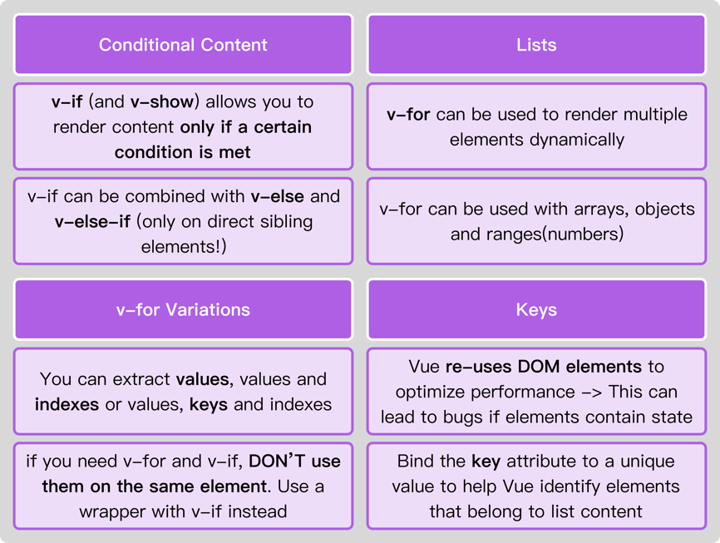

* v-if, v-else, v-else-if
  + v-else和v-else-if元素必须紧跟v-if或v-else-if元素。
  + <p v-if="goals.length === 0"> ... </p>
  + <p v-else> ... </p>
* v-show
  + <p v-show="goals.length === 0"> ... </p>
* v-for
  + 数组
    - <p v-for="name in ['remilia', 'cirno']">{{ name }}</p>
    - <p v-for="(name, index) in ['remilia', 'cirno']">{{ index }} : {{ name }}</p>
  + 数字范围
    - <p v-for="num in 10">{{ num }}</p>
  + 对象
    - <p v-for="value in {'name': 'cirno', 'age': 9}">{{value}}</p>
    - <p v-for="(value, key) in {'name': 'cirno', 'age': 9}">{{key}}: {{value}}</p>
    - <p v-for="(value, key, index) in {'name': 'cirno', 'age': 9}">{{index}} - {{key}}: {{value}}</p>
  + v-bind:key(:key)
    - <p v-for="user in users" :key="user.id">{{ user }}</p>
* Vue Reactivity, JavaScript Proxy.
* One App & Multiple Apps

|  |  |
| --- | --- |
| <section id="app1">  <!-- … -->  </section>  <div id="app2">  <!-- … -->  </div> | Vue.createApp({  // …  }).mount("#app1");    Vue.createApp({  // …  }).mount("#app2"); |

* Templates

|  |  |
| --- | --- |
| <section id="app">  <!--  <ul>  <li v-for="name in names">{{ name }}</li>  </ul>  -->  </section> | Vue.createApp({  **template**: `  <ul>  <li v-for="name in names">{{ name }}</li>  </ul>  `,  **data()** {  return {  names: ["Remilia", "Flandre", "Cirno"]  };  },  //...  }).mount("#app"); |

* $refs

|  |  |
| --- | --- |
| <section id="app">  <input type="text" ref="inputText" />  <button @click="showMsg">Show Message</button>  <p ref="para">{{ msg }}</p>  </section> | Vue.createApp({  **data()** {  return {  msg: ""  }  },  **methods**: {  showMsg() {  console.dir(this.$refs.inputText);  this.msg = this.$refs.inputText.value;  console.dir(this.$refs.para);  }  }  }).mount("#app"); |