开发者文档 : [Android 发送端 SDK · DPS (dolphinstar.cn)](https://dolphinstar.cn/doc/sender_android/started.html)

注意

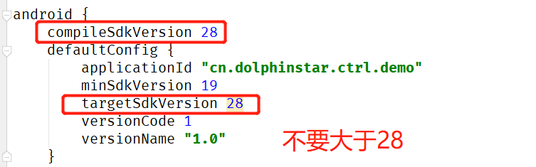

maven {url **'http://nexus.dolphinstar.cn/repo/openmavenx'**}

implementation **'cn.dolphinstar:ctrlCore:4.5.4'**