**SET-A**

**Q1 .**

Code :

Part – 1

<html>

<body>

<form method="post" action="A_Q1(Part-1).php" >

Enter tno : <input type="text" name="txt1" placeholder="enter here.."> <br><br>

Enter tname : <input type="text" name="txt2" placeholder="enter here.."> <br><br>

Enter subject : <input type="text" name="txt3" placeholder="enter here.."> <br><br>

<input type="submit"> &nbsp&nbsp <input type="reset">

</form>

</body>

</html>

<?php

if(!empty($_POST['txt1']) && !empty($_POST['txt2']) && !empty($_POST['txt3']))

{ $tno=$_POST['txt1'];

$tname=$_POST['txt2'];

$subject=$_POST['txt3'];

$servername="localhost";

$username="root";

$pass="";

$db="trial";

$con=mysqli_connect($servername,$username,$pass,$db);

$sql="Insert INTO teacher VALUES('$tno','$tname','$subject')";

if(mysqli_query($con,$sql))

{ echo "Record inserted successfully." ;

}

else

{ echo "Failed to update record." ;

}

}

else

{ echo "Please fill all the details";

}

?>

Output :

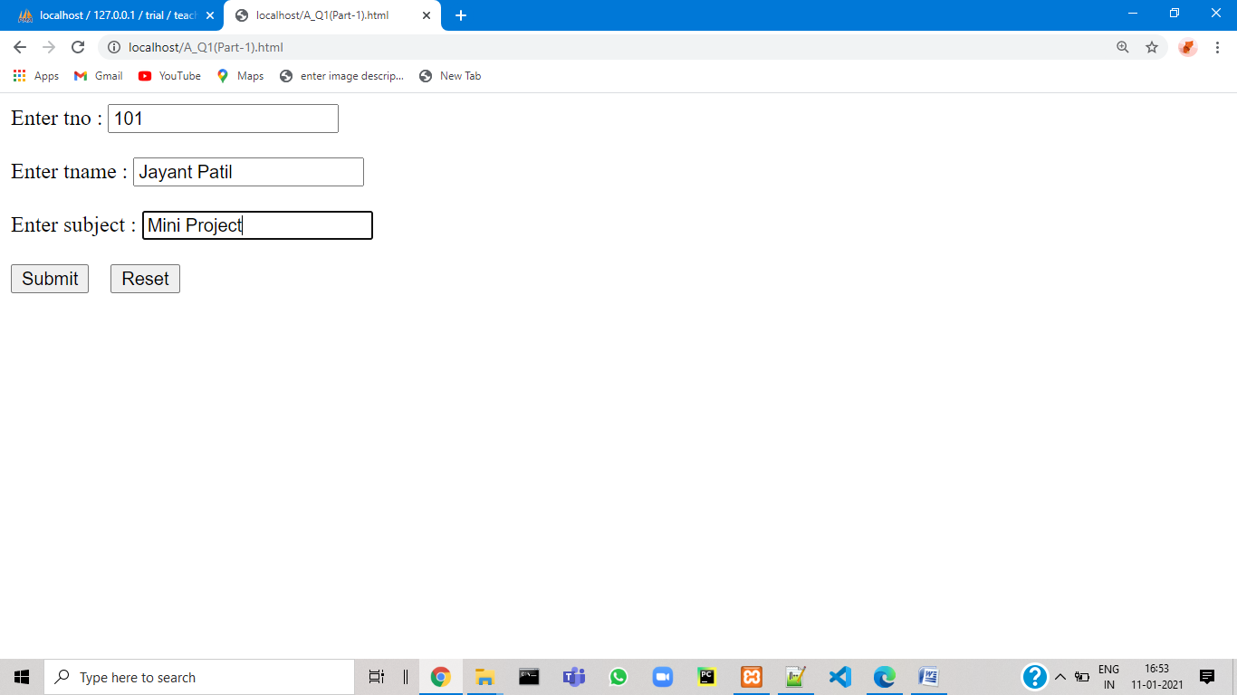

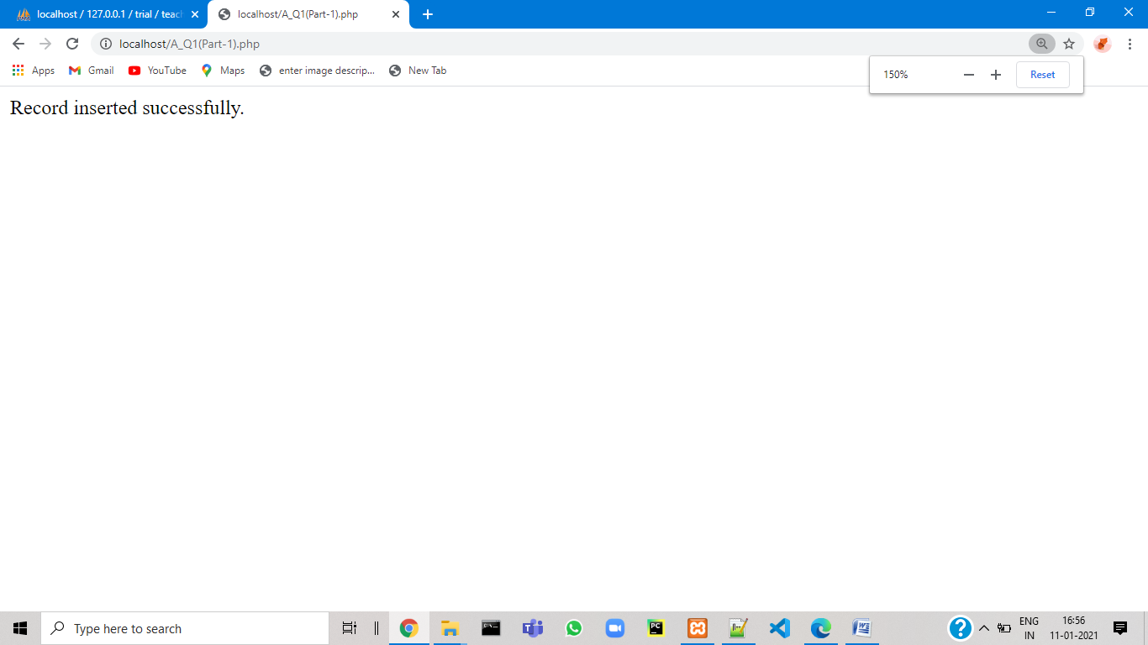

Part- 2

<html>

<body>

<form method="post" action="A_Q1(Part-2).php">

Enter sno : <input type="text" name="txt1" placeholder="enter here.."> <br><br>

Enter sname : <input type="text" name="txt2" placeholder="enter here.."> <br><br>

Enter class : <input type="text" name="txt3" placeholder="enter here.."> <br><br>

Enter marks : <input type="text" name="txt4" placeholder="enter here.."> <br><br>

Enter tno : <input type="text" name="txt5" placeholder="enter here.."> <br><br>

<input type="submit"> &nbsp&nbsp <input type="reset">

</form>

</body>

</html>

<?php

if(!empty($_POST['txt1']) && !empty($_POST['txt2']) && !empty($_POST['txt3']) && !empty($_POST['txt4']) && !empty($_POST['txt5']))

{ $sno=$_POST['txt1'];

$sname=$_POST['txt2'];

$class=$_POST['txt3'];

$marks=$_POST['txt4'];

$tno=$_POST['txt5'];

$servername="localhost";

$username="root";

$pass="";

$db="trial";

$con=mysqli_connect($servername,$username,$pass,$db);

if($con)

{ $sql="Insert INTO student VALUES('$sno','$sname','$class','$marks','$tno')";

$a=mysqli_query($con,$sql);

if($a)

{ echo "Record inserted successfully." ;

}

else

{ echo "Failed to update record." ;

}

}

else if(!$con)

{ echo "Connection error"." ".mysqli_connect_error();

}

}

else

{ echo "Please fill all the details";

}

?>

Output:

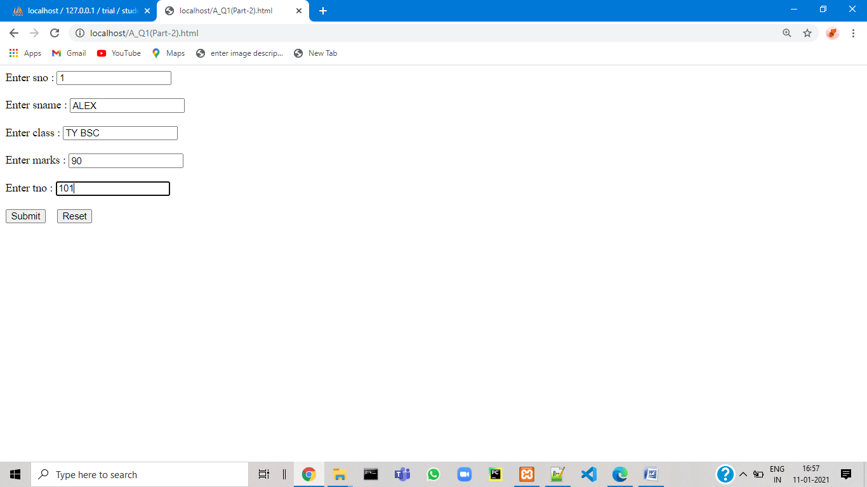

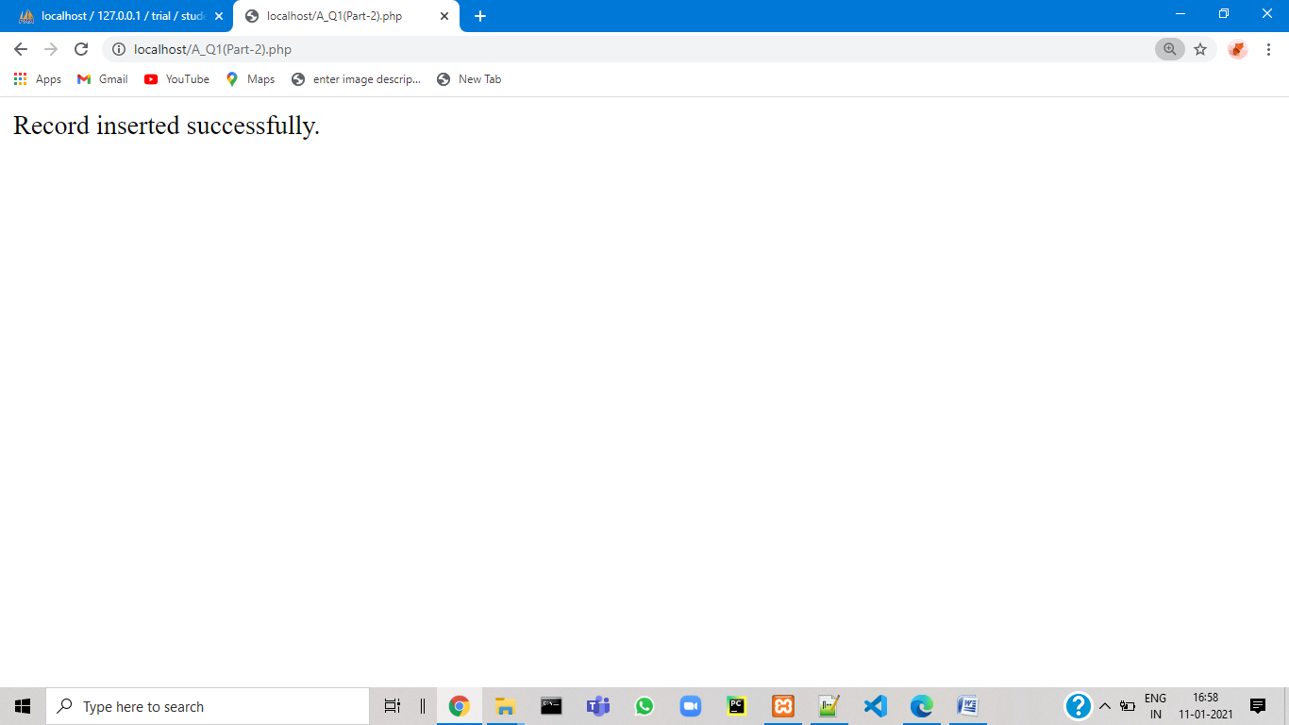

**Q2 .**

Code :

<html>

<body>

<form action="A_Q2.php" method="post">

Enter dept name :<input type="text" name="txt1"> <br>

<input type="Submit">

</form>

</body>

</html>

<?php

$dbhost='localhost';

$username='root';

$pass='';

$db='trial';

$con= mysqli_connect("$dbhost","$username","$pass","$db") ;

$dname=$_POST['txt1'];

if(!$con)

{ die("Connection error".mysqli_connect_error());

}

else if($con)

{ $sql="Select max(sal),min(sal),sum(sal) from emp where dno in(select dno from dept where dname='$dname')";

$q=mysqli_query($con,$sql);

if($q)

{ $c=mysqli_num_rows($q);

if($c>0)

{ while($row=mysqli_fetch_array($q))

{

?>

<html>

<body>

<table>

<tr>

<th>Maximum Salary</th>

<th>Minimum Salary</th>

<th>Sum</th>

</tr>

<tr>

<td><?php echo $row['max(sal)']; ?></td>

<td><?php echo $row['min(sal)']; ?></td>

<td><?php echo $row['sum(sal)']; ?></td>

</tr>

</table>

</body>

</html>

<?php }

}

else

{ echo "0 result"; }

} else { echo "unable to perform query"; }

}

mysqli_close($con);

?>

Output :

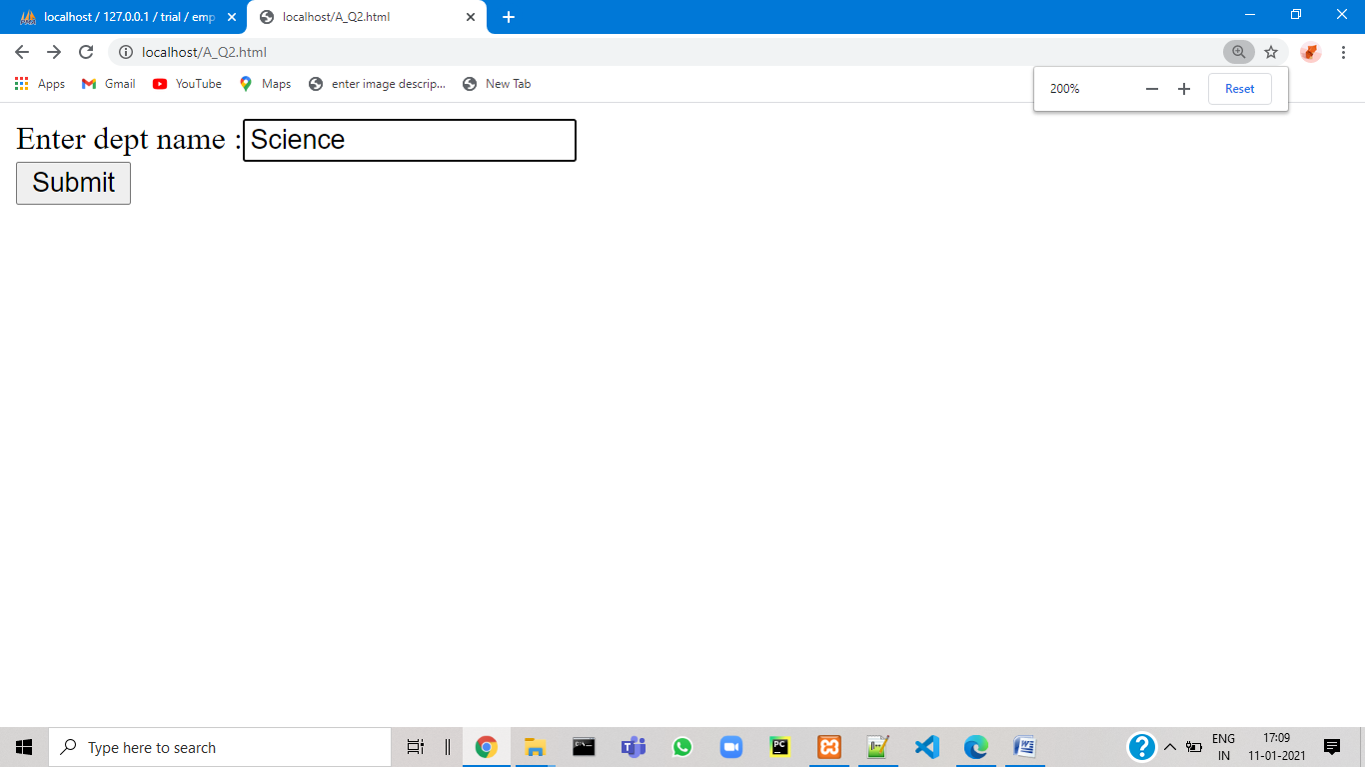

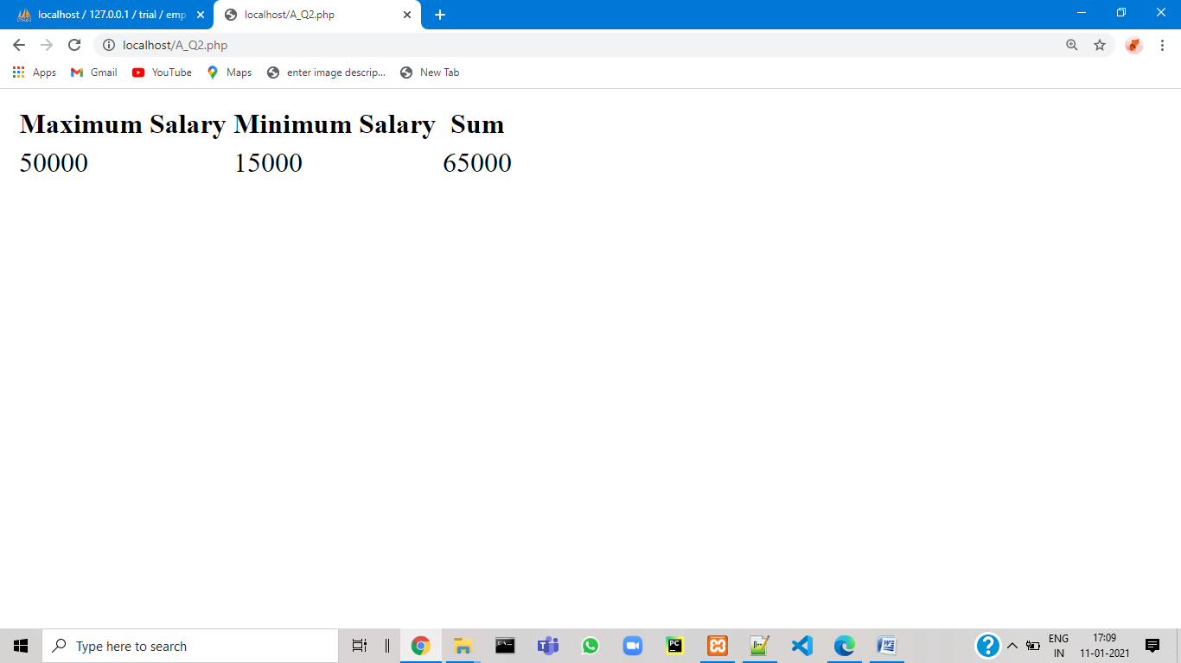

**Q3.**

Code :

<html>

<body>

<form method="post" action="A_Q3.php">

Enter project name :<input type="text" name="pname"> <br>

<input type="Submit">

</form>

</body>

</html>

<?php

$pname=$_POST['pname'];

$dbhost='localhost';

$username='root';

$pass='';

$db='trial';

$con= mysqli_connect("$dbhost","$username","$pass","$db") ;

if($con)

{ $sql="Select * from employee where eno IN(select eno from emproj where pno IN(Select pno from project where p_name='$pname'))";

$result=mysqli_query($con,$sql);

$num=mysqli_num_rows($result);

if($num>0)

{

echo '<html>

<body>

<table border="1">

<tr> <th> Eno </th>

<th> Ename </th>

<th> Qualification </th>

<th> Joining Date </th>

</tr>';

while($row=mysqli_fetch_assoc($result))

{ echo '<tr>

<td>'.$row["eno"].'</td>

<td>'.$row["e_name"].'</td>

<td>'.$row["qualification"].'</td>

<td>'.$row["joindate"].'</td>

</tr>';

}

echo '</table>

</body>

</html>';

}

else

{ echo "No record found.";

}

}

mysqli_close($con);

?>

Output :

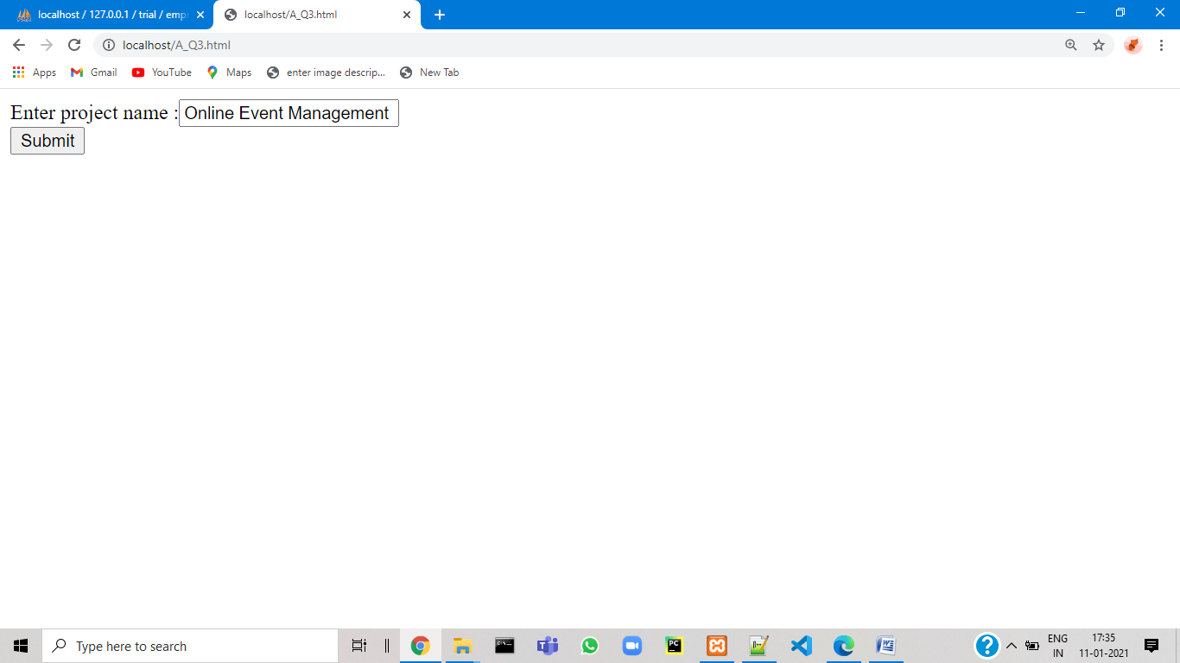

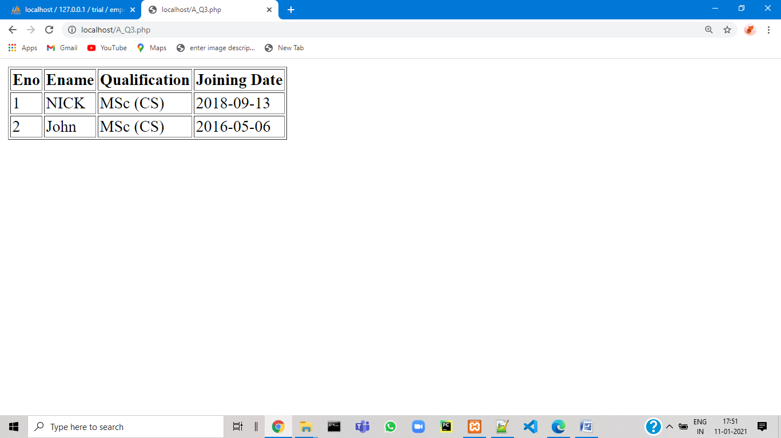

**SET-B**

**Q1 .**

Code :

<html>

<body>

<form method="post" action="B_Q1.php">

Enter hospital name :<input type="text" name="hname"> <br>

<input type="Submit">

</form>

</body>

</html>

<?php

$hname=$_POST['hname'];

$dbhost='localhost';

$username='root';

$pass='';

$db='trial';

$con= mysqli_connect("$dbhost","$username","$pass","$db") ;

if($con)

{ $sql="Select * from doctor where dno IN(select dno from doctor_hospital where hno IN(Select hno from hospital where hname='$hname'))";

$result=mysqli_query($con,$sql);

$num=mysqli_num_rows($result);

if($num>0)

{

echo '<html>

<body>

<table border="1">

<tr> <th> Doctor No </th>

<th> Doctor Name </th>

<th> Address </th>

<th> City </th>

</tr>';

while($row=mysqli_fetch_assoc($result))

{ echo '<tr>

<td>'.$row["dno"].'</td>

<td>'.$row["dname"].'</td>

<td>'.$row["address"].'</td>

<td>'.$row["city"].'</td>

</tr>';

}

echo '</table>

</body>

</html>';

}

else

{ echo "No record found.";

}

}

mysqli_close($con);

?>

Output :

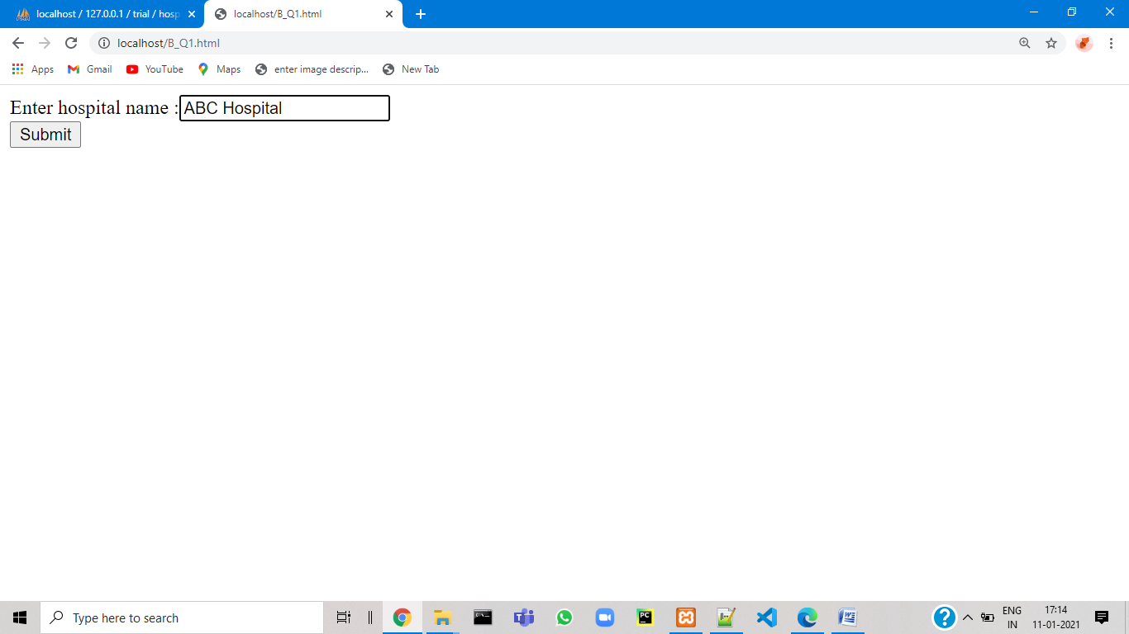

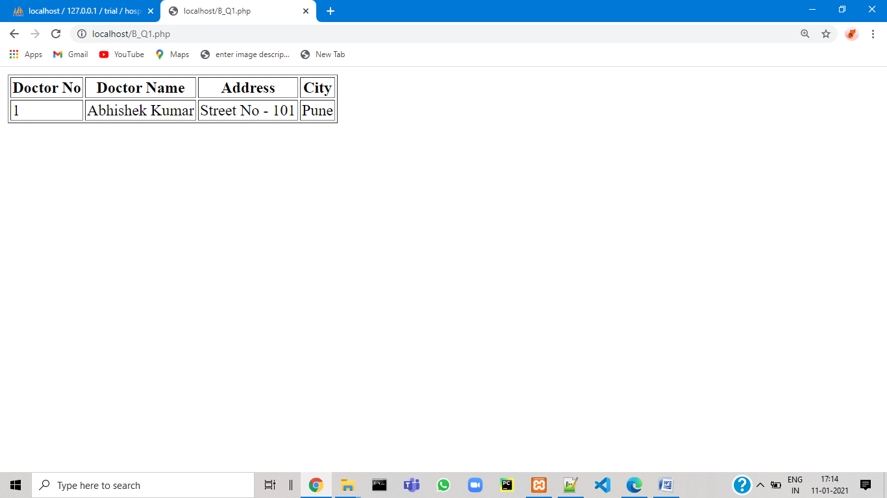

**SET-C**

**Q1 .**

Code :

<html>

<body>

<form method="post" action="cq1.php">

Choose any one option to continue : <br><br>

<fieldset>

1) Display movies name by accepting actor name : <input type="radio" name="Rad" value="1"><br>

2) Insert new movie information : <input type="radio" name="Rad" value="2"><br>

3) Update the release year of a movie : <input type="radio" name="Rad" value="3">

</fieldset>

<br><br>

<input type="submit" name="submit1">

</form>

</body>

</html>

<?php

session_start();

$ch=$_SESSION['ch'];

$dbhost='localhost';

$username='root';

$pass='';

$db='trial';

$con= mysqli_connect("$dbhost","$username","$pass","$db") ;

if($con)

{

switch($ch)

{ case '1':

$aname=$_POST['aname'];

$sql="Select * from movie where mno IN(select mno from actor_movie where ano IN(Select ano from actor where aname='$aname'))";

$result=mysqli_query($con,$sql);

$num=mysqli_num_rows($result);

if($num>0)

{

echo '<html>

<body>

<table border="1">

<tr>

<th> Movie Names </th>

</tr>';

while($row=mysqli_fetch_assoc($result))

{ echo '<tr>

<td>'.$row["mname"].'</td>

</tr>';

}

echo '</table>

</body>

</html>';

}

else

{ echo "No record found.";

}

break;

case '2' :

$mno=$_POST['mno'];

$mname=$_POST['mname'];

$ryear=$_POST['ryear'];

$sql="INSERT INTO movie VALUES('$mno','$mname','$ryear')";

$result=mysqli_query($con,$sql);

if($result)

{

echo "SUCCESSFULLY ADDED NEW INFORMATION.";

}

else

{ echo "ERROR";

}

break;

case '3':

$ryear=$_POST['ryear'];

$mname=$_POST['mname'];

$sql="UPDATE movie SET ryear='$ryear' where mname='$mname'";

$result=mysqli_query($con,$sql);

if($result)

{

echo "SUCCESSFULLY UPDATED RELEASE YEAR.";

}

else

{ echo "ERROR";

}

break;

default : echo "Select proper option.";

}

}

mysqli_close($con);

echo "<br><br>";

echo 'Click <a href="C_Q1.html">here</a> to go back.';

?>

<?php

session_start();

$ch=$_POST['Rad'];

$_SESSION['ch']=$ch;

if($ch==1)

{ echo '<html>

<body>

<form method="post" action="C_Q1.php">

Enter actor name : <input type="text" name="aname" placeholder="enter here.."><br><br>

<input type="submit">

</form>

</body>

</html>' ;

}

else if($ch==2) {

echo '<html>

<body>

<form method="post" action="C_Q1.php">

Enter movie no : <input type="text" name="mno" placeholder="enter here.."><br><br>

Enter movie name : <input type="text" name="mname" placeholder="enter here.."><br><br>

Enter release year : <input type="text" name="ryear" placeholder="enter here.."><br><br>

<input type="submit">

</form>

</body>

</html>' ;

}

else if($ch==3) {

echo '<html>

<body>

<form method="post" action="C_Q1.php">

Enter movie name : <input type="text" name="mname" placeholder="enter here.."><br><br>

Enter new release year : <input type="text" name="ryear" placeholder="enter here.."><br><br>

<input type="submit">

</form>

</body>

</html>' ;

}

else

{ echo "ERROR"; }

?>

Output :

