PYTHON & BASH
DEVOPS ASSIGNMENT

Core Python Programming and File Handling

Submitted By:
Mohd Imran

Topics Covered:
• Conditionals
• Dictionaries
• File Handling
• Bash Scripting

=================================================================
OBJECTIVE

The objective of this assignment is to practise fundamental Python programming concepts such as conditional statements, dictionaries, and file handling. The assignment also includes a basic Bash script to execute the Python programs.

TASK 1 — GRADE CHECKER

Create a Python program that accepts a student's score and determines the grade using conditional statements.

Grade Checker

This program takes a score and determines the grade.
score = float(input("Enter your score: "))
if score >= 90: grade = "A" elif score >= 80: grade = "B" elif score >= 70: grade = "C" elif score >= 60: grade = "D" else: grade = "F"
print(f"Score: {score}") print(f"Grade: {grade}")

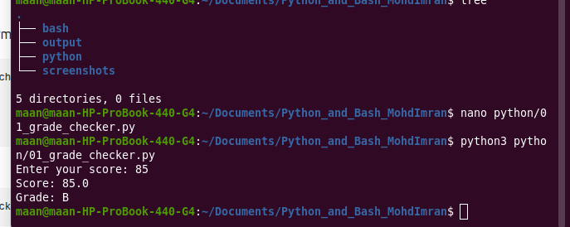
The program accepts a score from the user and uses if, elif and else conditions to determine the grade. A score of 90 or above receives grade A. A score from 80 to 89 receives grade B. A score from 70 to 79 receives grade C. A score from 60 to 69 receives grade D. A score below 60 receives grade F.

TASK 2 — STUDENT GRADES
Create a dictionary containing student names and grades and allow the user to add, update and display student grades.
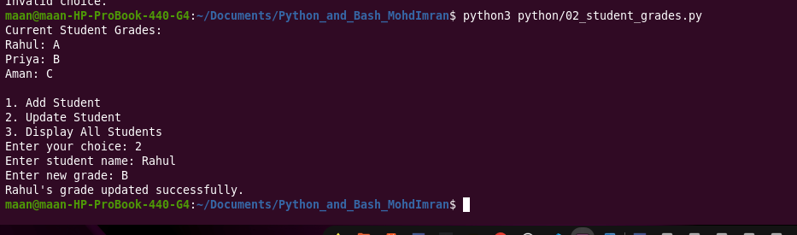

Student Grades

This program uses a dictionary to store student names and grades.
students = { "Rahul": "A", "Priya": "B", "Aman": "C" }
print("Current Student Grades:") for name, grade in students.items(): print(f"{name}: {grade}")
print("\n1. Add Student") print("2. Update Student") print("3. Display All Students")
choice = input("Enter your choice: ")
if choice == "1": name = input("Enter student name: ") grade = input("Enter student grade: ")
if name in students:
print("Student already exists.")
else:
students[name] = grade
print(f"{name} added successfully with grade {grade}.")
elif choice == "2": name = input("Enter student name: ")
if name in students:
grade = input("Enter new grade: ")
students[name] = grade
print(f"{name}'s grade updated successfully.")
else:
print("Student not found.")
elif choice == "3": print("\nAll Student Grades:") for name, grade in students.items(): print(f"{name}: {grade}")
else: print("Invalid choice.")
A Python dictionary is used to store student names as keys and grades as values. The program checks whether a student already exists before adding a new student. It also checks whether a student exists before updating the grade. The items() method is used to display all student names and grades.

TASK 3 — WRITE TO A FILE

Write to a File
file_path = "output/student_data.txt"
content = """Python and Bash Assignment Student Name: Mohd Imran Topic: File Handling This file was created using Python. """
with open(file_path, "w") as file: file.write(content)
print(f"File created successfully: {file_path}") print("Content has been written to the file.")
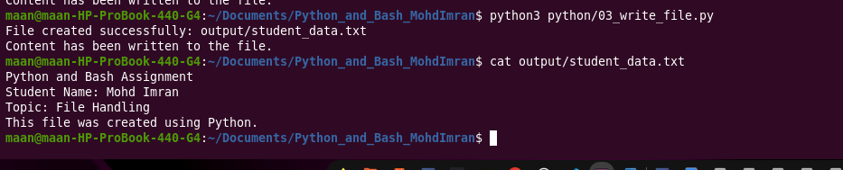
The program creates a text file using Python's open() function. The file is opened in write mode using "w". The write() function is then used to write content into the file. The with statement automatically closes the file after the operation is completed.

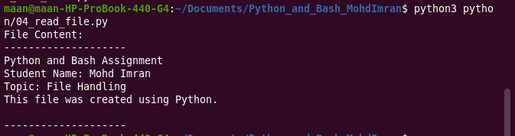
TASK 4 — READ FROM A FILE

Read from a File
file_path = "output/student_data.txt"
with open(file_path, "r") as file: content = file.read()
print("File Content:") print("--------------------") print(content) print("--------------------")
The program opens the previously created text file in read mode using "r". The read() method reads the complete contents of the file and stores them in a variable. The content is then displayed in the terminal.

BASH SCRIPT EXECUTION
chmod +x bash/run_all.sh ./bash/run_all.sh

A Bash script was created to execute the Python programs from a single script. The script uses python3 commands to execute each Python program. This provides basic practice in combining Python programs with Bash scripting, which is useful in DevOps environments.

