Software Requirements Specification
Restaurant App MVP (Frontend Only, React Native)
1. Introduction

1.1 Purpose
This Software Requirements Specification (SRS) defines the functional and non-functional requirements for Version 1.0 (the MVP) of the Restaurant App, a React Native mobile application. The app lets diners browse a single restaurant's menu, search and filter items, build an order cart, reserve a table, and track an order's status in real time. A companion in-app dashboard lets the Restaurant Manager manage incoming orders, table reservations, and the menu itself.
The intended audience for this document is the course instructor/evaluator, the student developer building the prototype, and any future contributor who extends it. The document covers exactly the frontend-only MVP scope described in Section 1.2; a production backend and real payment processing are explicitly excluded from this version.

1.2 Scope
The following functionalities are in scope for Version 1.0:
- Customer sign up and login, authenticated against a local mock user list.
- Menu browsing by category, keyword search, and sorting (price, name).
- A shopping cart with quantity control, per-item special instructions, and promo-code discounts.
- Table reservation with date, time-slot, and party-size selection, and availability checking against mock table data.
- Order placement (Dine-in or Takeaway) with a simulated status lifecycle and live order tracking.
- A Manager Dashboard (visible only to the Manager role) to update order status, accept/decline reservations, and add or edit menu items.
- A profile screen and an app-wide light/dark theme toggle.
- Local persistence of orders, reservations, and menu edits using AsyncStorage, so data survives an app restart on the same device.
The following are explicitly out of scope for Version 1.0:
- A real backend, REST/GraphQL API, or database server.
- Real payment gateways or processing of real card/wallet transactions.
- Push notifications, SMS, or email confirmations.
- Support for more than one restaurant, branch, or menu.
- Password recovery, social login, or any third-party authentication provider.
- Real-time synchronisation between two physical devices; state is local to the device/app session.
- Any external state-management library (Redux, MobX, Zustand); only React's built-in hooks and Context API are used.

1.3 Definitions and Acronyms
Term | Definition
SRS | Software Requirements Specification — this document.
MVP | Minimum Viable Product — the smallest feature set that delivers a usable, demonstrable app.
UML | Unified Modeling Language — the diagram notation used in Section 6 (use case, class, sequence, state, component).
Hook | A React function (e.g. useState, useEffect) that lets a function component use state or lifecycle features.
Context | React's Context API; a way to share values (e.g. the logged-in user, the theme) across the component tree without passing props manually at every level.
Reducer | A pure function (state, action) => newState used with useReducer to manage complex, related state transitions such as the cart or order list.
Mock Data | Hard-coded sample data (JS/JSON files) that stands in for a real backend/database in this frontend-only MVP.
FlatList | A React Native component that efficiently renders large scrollable lists by only mounting the rows currently on screen.
Custom Hook | A reusable function whose name starts with "use" that encapsulates hook-based logic (e.g. useForm, useDebounce) so screens stay focused on UI.
AsyncStorage | A React Native key-value storage API used here to persist orders, reservations, and menu edits locally on the device.
Debounce | A technique that delays running a function (e.g. a search filter) until a pause in input events, to avoid excessive re-computation while typing.

2. Overall Description

2.1 User Roles
Role | Key Permissions & Goals
Customer (Diner) | Sign up/log in; browse and search the menu; add items to a cart and apply promo codes; reserve and cancel a table; place an order and track its status; maintain favourites and a profile; toggle light/dark theme. Cannot access the Manager Dashboard.
Restaurant Manager | Everything a Customer's authentication flow offers, plus: view all incoming orders and change their status manually; accept or decline reservations; add new menu items and edit price/availability of existing ones. The Manager Dashboard tab is visible only when the logged-in user's role is Manager.

2.2 User Stories
The stories below came out of a self-interview brainstorming session (acting as a hurried customer) as required by the assignment brief, plus additional stories written directly from the Restaurant Manager's perspective.

From the customer self-interview
- As a diner in a hurry, I want to see today's specials as soon as I open the app, so that I can decide quickly what to order.
- As a diner, I want to search the menu by name, so that I can jump straight to a dish I already know I want.
- As a diner, I want to reserve a table for a specific time, so that a table is ready when I arrive.
- As a diner, I want to apply a promo code to my cart, so that I can see the discount before I commit to the order.
- As a diner, I want to track my order's status after I place it, so that I know when to expect my food.
- As a diner, I want to mark menu items as favourites, so that I can find my usual order faster next time.
- As a diner, I want to add a special instruction to an item (for example "no onions"), so that the kitchen prepares it the way I like.

From the Restaurant Manager's perspective
- As a restaurant manager, I want to see all incoming orders in one place, so that I do not miss any while working the floor.
- As a restaurant manager, I want to accept or decline table reservations, so that I do not overbook the dining room.
- As a restaurant manager, I want to toggle a menu item's availability instantly, so that customers cannot order a dish the kitchen has run out of.
- As a restaurant manager, I want to update an order's status manually, so that I can correct the workflow if the automatic demo timer does not match reality.

3. Functional Requirements
Every requirement below is independently testable and begins with "The system shall", grouped by module.

Authentication
- FR-01: The system shall allow a new user to sign up with full name, email, password, confirm-password, and a role selection of Customer or Manager.
- FR-02: The system shall validate that the email is well-formed and the password is at least 8 characters and contains at least one digit before allowing signup.
- FR-03: The system shall authenticate a returning user's email and password against the mock users data set and simulate a one-second network delay while an ActivityIndicator is shown.
- FR-04: The system shall route a successfully authenticated Customer to the Menu screen and a Manager to the Manager Dashboard, and shall show a clear Alert on failed login.

Menu
- FR-05: The system shall display the full menu grouped into at least four categories: Starters, Mains, Desserts, and Drinks.
- FR-06: The system shall show a loading indicator while the mock menu data is being "fetched" and an error message with a Retry control if the simulated fetch fails.
- FR-07: The system shall visually flag any menu item whose isSpecial flag is true with a "Daily Special" badge.
- FR-08: The system shall grey out the row and disable the Add-to-Cart control for any item whose isAvailable flag is false.
- FR-09: The system shall let the user pull down on the menu list to refresh it.

Search
- FR-10: The system shall filter the visible menu items as the user types, applying the filter only after 400 ms of typing inactivity (debounce).
- FR-11: The system shall let the user tap a suggestion from their five most recent searches when the search field is focused and empty.
- FR-12: The system shall show a friendly empty-state message when no menu item matches the current search text and category filter.

Cart
- FR-13: The system shall let the user add a menu item to the cart, increment or decrement its quantity, and remove it once its quantity reaches zero.
- FR-14: The system shall let the user attach a free-text special instruction (for example "no onions") to each cart line item.
- FR-15: The system shall validate an entered promo code against a local list of valid codes, apply the corresponding percentage discount on success, and show an error message for an invalid code.
- FR-16: The system shall display a live badge on the Cart tab icon showing the total item quantity currently in the cart.

Reservation
- FR-17: The system shall let the user choose a reservation date, an hourly time slot between 12:00 and 22:00, and a party size between 1 and 12.
- FR-18: The system shall disable a time slot in the picker when no table with sufficient seats is free at that date and time.
- FR-19: The system shall validate that the chosen date is not in the past, the phone number matches the Pakistani mobile format 03XX-XXXXXXX, and the booking is at least one hour ahead of the current time.
- FR-20: The system shall let the user cancel one of their own upcoming reservations after confirming an Alert dialog.

Orders
- FR-21: The system shall let the user choose Dine-in (with a selected table) or Takeaway (with a pickup time) before placing an order.
- FR-22: The system shall create an order record containing a unique id, the cart's items, the computed total, the order type, an initial status of Pending, and a creation timestamp.
- FR-23: The system shall automatically progress a placed order's status from Pending to Preparing, Ready, and Served on fixed demo timers, and shall also let a Manager change the status manually at any time.
- FR-24: The system shall display a step progress indicator and a running elapsed-time counter on the Order Tracking screen.

Manager Dashboard
- FR-25: The system shall show the Manager Dashboard tab only when the logged-in user's role is Manager.
- FR-26: The system shall let the Manager view all incoming orders and change any order's status from a single Incoming Orders screen.
- FR-27: The system shall let the Manager accept or decline a pending reservation.
- FR-28: The system shall let the Manager add a new menu item, edit an existing item's price, and toggle an item's availability, with every change reflected immediately on the customer-facing menu through shared state.
- FR-29: The system shall persist orders, reservations, and menu edits in AsyncStorage so that they survive an app restart on the same device.

4. Non-Functional Requirements

Usability
Primary actions (Add to Cart, Place Order, Reserve, Apply Promo) must be reachable within two taps from the screen where the need arises. Form errors must appear next to the offending field in plain language and clear as soon as the user edits that field.

Performance
The Menu screen's simulated fetch must resolve within 1.5–2 seconds and show a loading state throughout. Lists (menu, cart, orders, reservations) must be rendered with FlatList so that only visible rows are mounted, keeping scrolling smooth (target 60 fps) even with 50+ mock items. Expensive derived values (filtered/sorted lists, cart totals) must be memoised with useMemo so they are only recomputed when their inputs change.

Responsiveness
All screens must use Flexbox layout and relative sizing so they adapt from small phones to larger phones/tablets without overflow or clipped text, and must respect device safe areas (notches, status/home indicators).

Maintainability
Code must be organised under src/ into components, screens, context, reducers, hooks, data, and navigation, so that a new screen or hook can be added without touching unrelated files. Shared UI (menu cards, buttons, badges) must be extracted into reusable components rather than duplicated per screen.

Data Handling Without a Backend
In the absence of a real backend, all "master" data (users, menu, tables) ships as local JS/JSON modules and is loaded into React state/Context at app start. User-generated data (orders, reservations, menu edits made by the Manager) is additionally written to AsyncStorage on every change and reloaded on app start, so the app never silently loses a session's work, while explicitly not providing any real security, encryption, or multi-device guarantees — acceptable for a frontend-only MVP.

5. Client-Side Data Model (Mock Data)
Because no database is used, the data sets below are stored as local JS/JSON files, loaded into React state, and (where noted) mirrored into AsyncStorage so edits persist across app restarts.
Data Set | Fields | Description
Users | id, fullName, email, password, role | Mock accounts used to simulate login; role is Customer or Manager.
Categories | id, name, icon | The menu's top-level groupings (Starters, Mains, Desserts, Drinks) used to render the horizontal category chips.
MenuItems | id, name, description, price, categoryId, image, isSpecial, isAvailable | The restaurant's dishes; editable at runtime by the Manager and persisted to AsyncStorage.
Tables | id, seats | The physical tables used for availability checking when reserving.
Reservations | id, customerId, tableId, date, timeSlot, partySize, phone, status | Bookings created by customers and accepted/declined by the Manager; persisted to AsyncStorage.
Orders | id, customerId, items, total, type, status, createdAt | Orders placed from the cart; status advances automatically and can be overridden by the Manager; persisted to AsyncStorage.
PromoCodes | code, discountPercent | A small local lookup (e.g. WELCOME10, FEAST20) used to validate and apply cart discounts.

6. UML Diagrams
The five diagrams below were produced for Question 2 and are reproduced here with a short explanation of each. Full-resolution copies are exported separately to A1/UML in the project repository.

6.1 Use Case Diagram
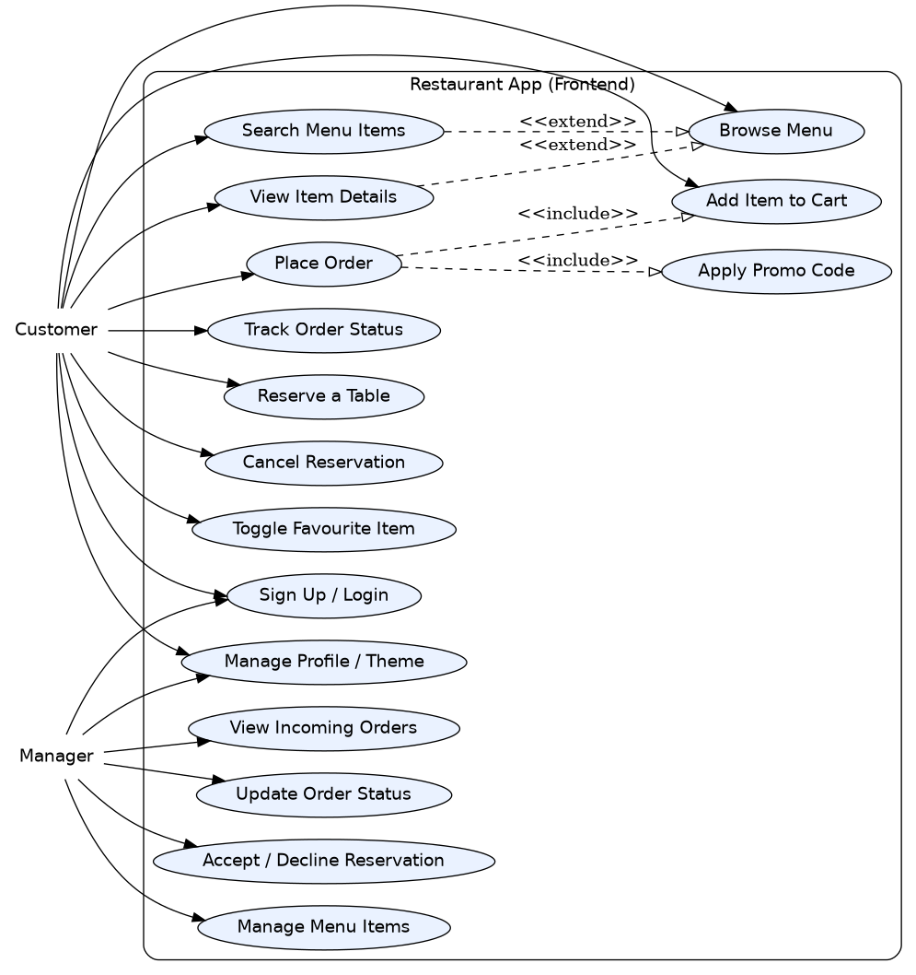
Figure 1 — Use Case Diagram: Customer and Manager actors and their use cases.
The Customer actor covers every diner-facing action, from authentication through browsing, ordering, and reserving a table. The Manager actor shares the login use case but branches into dashboard-only use cases. Place Order includes Add Item to Cart and Apply Promo Code (it cannot happen without them), while Search Menu Items and View Item Details extend the base Browse Menu use case (they are optional enhancements of it).

6.2 Class Diagram
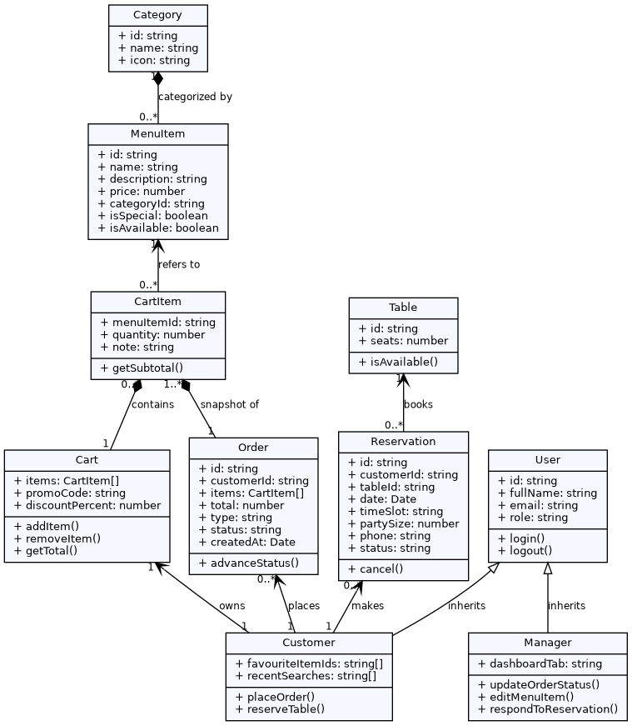
Figure 2 — Class Diagram: core domain classes and their relationships.
User is the base class for Customer and Manager (inheritance). A Customer owns exactly one Cart, which is composed of CartItem entries that each reference one MenuItem; MenuItems are grouped under a Category. Placing an order takes a snapshot of the current CartItems into an Order, and a Reservation books one Table. Multiplicities on each association show, for example, that a Category can have many MenuItems (0..*) while each MenuItem belongs to exactly one Category.

6.3 Sequence Diagram — "Customer places an order"
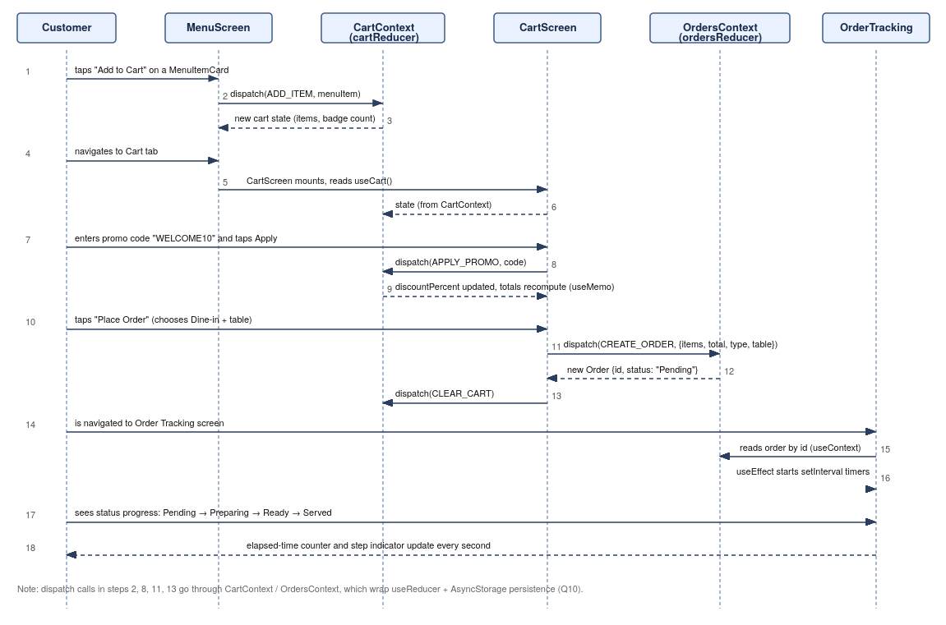
Figure 3 — Sequence Diagram: from tapping Add to Cart to the Order Tracking screen.
The diagram traces one full happy-path flow: the customer adds an item (dispatched into CartContext's reducer), reviews the cart, applies a promo code, places the order (which dispatches a CREATE_ORDER action into OrdersContext and clears the cart), and is navigated to Order Tracking, where a useEffect-driven interval advances the order's status while an elapsed-time counter ticks every second.

6.4 State Machine Diagram — Order Lifecycle
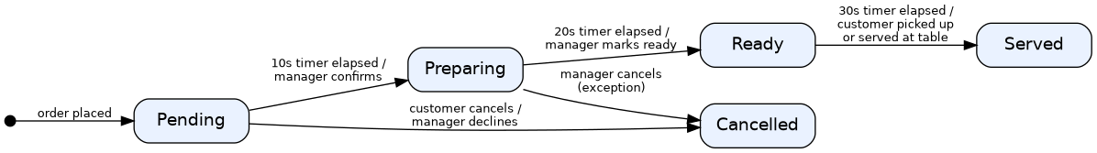
Figure 4 — State Machine Diagram: valid Order status transitions.
An order starts in Pending. On the demo timers (or a manual manager action) it advances to Preparing, then Ready, then Served. Cancellation is only reachable from Pending or Preparing (customer cancels, or the manager declines/cancels); once an order is Served or Cancelled it is a terminal state with no further transitions.

6.5 Component Diagram
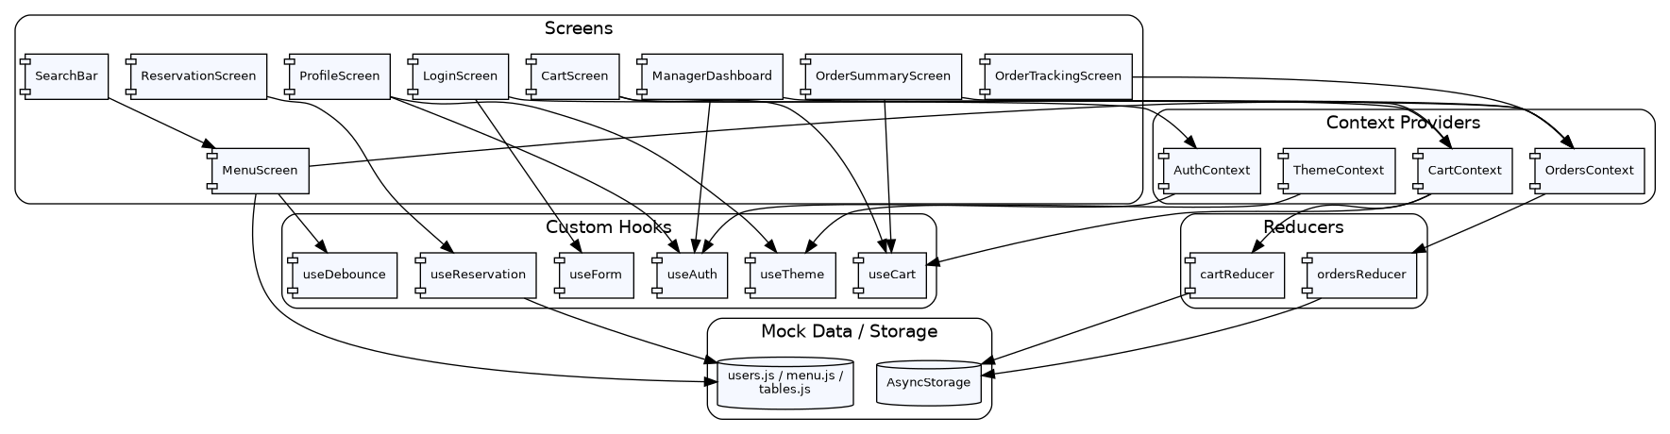
Figure 5 — Component Diagram: screens, context providers, reducers, and hooks.
Screens depend on custom hooks (useAuth, useTheme, useCart, useForm, useDebounce, useReservation) rather than talking to Context or mock data directly. AuthContext and ThemeContext wrap plain React state; CartContext and OrdersContext wrap a useReducer store which, in turn, persists to AsyncStorage. This layering means a screen can be re-skinned or moved without touching the state logic underneath it.

7. MVP Frontend Development (React Native)
For each screen, this section states its purpose, its main UI elements, how the user enters and leaves it, the local data it reads or writes, and the hooks used and why. Full requirements for each screen are detailed under Questions 3–10; this section summarises the resulting design.

7.1 Login and Signup Screen
- Purpose: authenticate an existing user or register a new one, and route by role.
- UI elements: mode switch (Login/Signup), email, password, and (Signup only) full name, confirm password, and a role selector; a show/hide password toggle; a submit button with an ActivityIndicator while submitting.
- Navigation: entry point of the app (unauthenticated stack); exits to the Menu screen (Customer) or Manager Dashboard (Manager) on success.
- Local data: reads src/data/users.js to validate credentials.
- Hooks: useState for form fields, per-field errors, the show-password flag, and isSubmitting (later refactored to the useForm custom hook in Question 9).

7.2 Menu Browsing Screen
- Purpose: show the restaurant's full menu, grouped by category, as the customer's home screen.
- UI elements: horizontal category chips, a FlatList of menu cards (image, name, price, Daily Special badge), loading and error states with Retry, pull-to-refresh.
- Navigation: entry point after login for Customers; a tab reachable from anywhere for both roles; leads into Search, Cart, and item detail interactions.
- Local data: src/data/menu.js, loaded via a simulated 1.5-second Promise.
- Hooks: useState for menuItems/isLoading/error/selectedCategory/filteredItems; two useEffects — one (empty dependency array) to load data with a cleanup that clears the timer, and one (depends on selectedCategory, menuItems) to recompute filteredItems.

7.3 Search and Scroll Controls
- Purpose: let the customer find an item quickly inside a long menu list.
- UI elements: a search bar with a focus/clear icon, recent-search suggestions, a floating "Back to top" button, a small render-count debug label.
- Navigation: lives inside the Menu screen; no separate route.
- Local data: an in-memory list of the last five search terms kept in state.
- Hooks: useRef for the TextInput focus target, the debounce timer id, the FlatList ref, the render counter, and the previous-query guard; useState for the debounced search term and the recent-search list.

7.4 Profile and Theme Screen
- Purpose: show the logged-in user's details and let them switch light/dark mode; also hosts logout.
- UI elements: name, email, role; a light/dark switch; a logout button.
- Navigation: reachable from a tab or header icon on any authenticated screen; logout returns to the Login screen and resets the navigation stack.
- Local data: none of its own — reads AuthContext and ThemeContext.
- Hooks: useContext via the custom useAuth and useTheme hooks.

7.5 Cart Screen
- Purpose: let the customer review, adjust, and discount their order before placing it.
- UI elements: a line per cart item with a quantity stepper, a remove button, and a special-instructions field; a promo-code field; a running subtotal.
- Navigation: reachable from the Cart tab (with a live item-count badge) or right after adding an item; leads to the Order Summary screen.
- Local data: the cart state (items, promoCode, discountPercent) held in CartContext.
- Hooks: useReducer inside CartContext/cartReducer, exposed to the screen through the custom useCart hook; useState for the promo-code input field.

7.6 Order Summary Screen
- Purpose: show the final, computed bill (subtotal, service charge, tax, discount, grand total) and confirm placing the order.
- UI elements: an itemised list, a totals breakdown, a Dine-in/Takeaway choice, a Place Order button.
- Navigation: reached from the Cart screen; on success, navigates to Order Tracking.
- Local data: reads the cart from CartContext; writes a new Order into OrdersContext.
- Hooks: useMemo to compute totals from cart items and discount only when they change; useCallback for stable handlers passed into the memoised MenuItemCard elsewhere on the Menu screen; React.memo on MenuItemCard itself.

7.7 Table Reservation Screen
- Purpose: let the customer book a table for a chosen date, time, and party size, and manage their own bookings.
- UI elements: a date picker, hourly time-slot chips (disabled when unavailable), a party-size stepper, contact fields, a confirmation modal, and a "My Reservations" list with cancel.
- Navigation: reachable from a tab; the confirmation modal is a local overlay, not a separate route.
- Local data: mock Tables and Reservations, checked for availability.
- Hooks: the custom useReservation hook (built on useState/useEffect internally) owns all business logic; the screen itself contains only UI code, per the assignment's hook-rules requirement.

7.8 Order Tracking and Manager Dashboard
- Purpose: let the customer watch their order progress in real time, and let the Manager run the restaurant side of the app.
- UI elements (tracking): a step progress indicator, an elapsed-time counter. UI elements (dashboard): three tabs — Incoming Orders (status buttons), Reservations (accept/decline), Menu Management (add/edit/toggle).
- Navigation: Order Tracking is reached after placing an order; the Manager Dashboard is a role-gated tab set, visible only when user.role is Manager.
- Local data: OrdersContext (orders), Reservations, and MenuItems, all mirrored to AsyncStorage.
- Hooks: useEffect with setInterval to auto-advance order status and tick the elapsed-time counter, with every interval cleared in the cleanup function; useEffect to load/save AsyncStorage on mount and on every change; useReducer (OrdersContext) for order state; useContext throughout to reach Auth, Theme, Cart, and Orders.

