lab assignments/assignment 01/01
01.c
#include <stdio.h>

int main() {
printf("Hello World\n\n");
return 0;
}

Output:
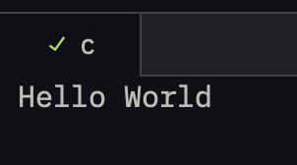
01 output.png

lab assignments/assignment 01/02
02.c
#include <stdio.h>

int main() {
int x;
float y;
char z;

printf("Enter an integer: "); // printf requires value
scanf("%d", &x); // dont forget scanf requires pointer

printf("Enter a decimal point number: ");
scanf("%f", &y);

printf("Enter a character: ");
scanf(" %c", &z); // need to do " %c" cause of input buffer of "\n"
// the extra space means "PICK THE NEXT CHARACTER AFTER WHITESPACE"
// the extra space can also be put in with %d, %f but they automatically skip the whtiespace

printf("\nThe entered numbers are: %d, %f, %c\n", x, y, z);

return 0;
}

Output:
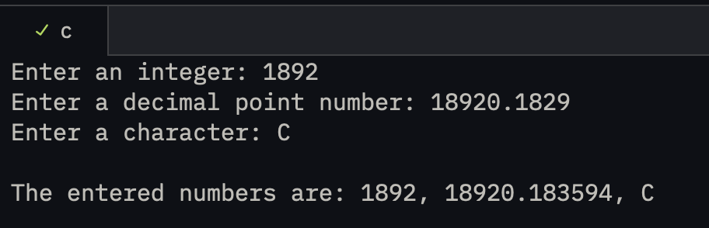
02 output.png

lab assignments/assignment 01/03
03.c
#include <stdio.h>

int main() {
int a, b, result;

printf("\nEnter the 1st number: ");
scanf("%d", &a);

printf("Enter the 2nd number: ");
scanf("%d", &b);

printf("\nThe sum of the entered two numbers is: %d\n", (a + b));
printf("The absolute difference of the entered two numbers (greater - "
"smaller) is: %d\n",
(a > b ? (a - b) : (b - a)));

printf("The product of the entered two numbers is: %d\n", (a * b));

printf(
"The qoutient of the entered two numbers (greater / smaller) is: %f\n",
(a > b ? (a / (b * 1.0)) : (b / (a * 1.0)) ));

return 0;
}

Output:
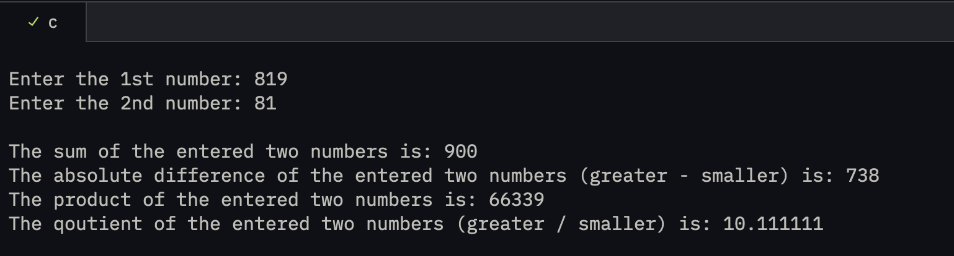
03 output.png

lab assignments/assignment 01/04
04.c
#include <stdio.h>

int main() {
float gross_salary, basic, da, ta;

printf("Enter the basic salary of the variable: ");
scanf("%f", &basic);

da = 0.10 * basic;
ta = 0.12 * basic;

gross_salary = basic + da + ta;

printf("The gross salary of the person is: %.2f\n", gross_salary);

return 0;
}

Output:
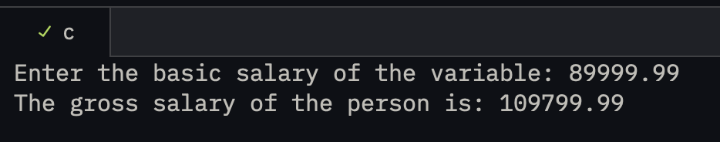
04 output.png

lab assignments/assignment 02/01
01.c
#include <stdio.h>

int main() {
int c, d, temp;

printf("enter a number in location c: ");
scanf("%d", &c);

printf("enter a number in location d: ");
scanf("%d", &d);

printf("\n old c: %d \n old d: %d", c, d);

temp = c;
c = d;
d = temp;

printf("\n\n new c: %d \n new d: %d\n", c, d);
return 0;
}

Output:
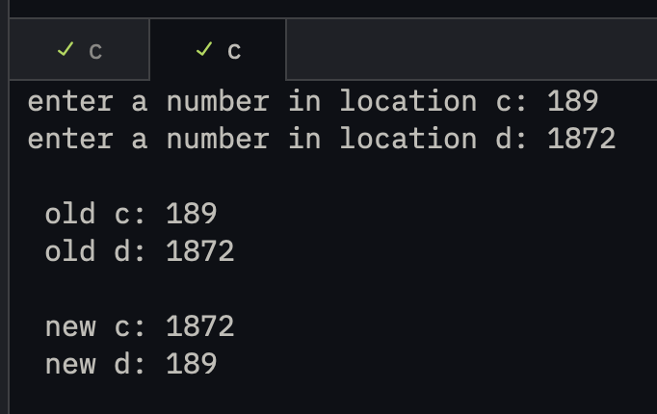
01 output.png

lab assignments/assignment 02/02
02.c
#include <stdio.h>

int main() {
int c, d, temp;

printf("enter a number in location c: ");
scanf("%d", &c);

printf("enter a number in location d: ");
scanf("%d", &d);

printf("\n old c: %d \n old d: %d", c, d);

c = c + d;
d = c - d;
c = c - d;

printf("\n\n new c: %d \n new d: %d\n", c, d);
return 0;
}

Output:
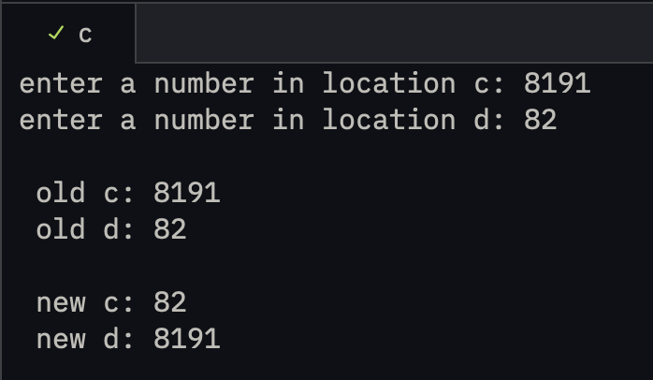
02 output.png

lab assignments/assignment 02/03
03.c
#include <stdio.h>
#define PI (22/7.0)

int main() {
float area, r;

printf("Enter the radius of the circle: ");
scanf("%f", &r);

area = PI * r*r;

printf("The area of the circle is: %.2f sq. units\n", area);
return 0;
}

Output:
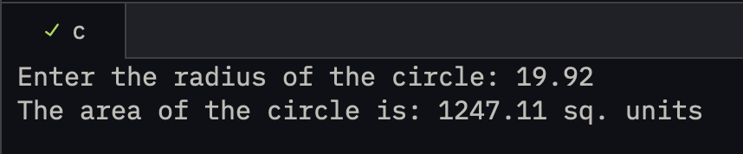
03 output.png

lab assignments/assignment 02/04
04.c
#include <stdio.h>

int main() {
float p, r, t, si;

printf("Enter the principal sum: ");
scanf("%f", &p);

printf("Enter the time period (in years): ");
scanf("%f", &t);

printf("Enter the rate of interest: ");
scanf("%f", &r);

si = (p * r * t) / 100.0;

printf("\nThe simple interest on the principal sum of %.2f over %.2f years is: ₹%.2f\n",
p, t, si);

return 0;
}

Output:
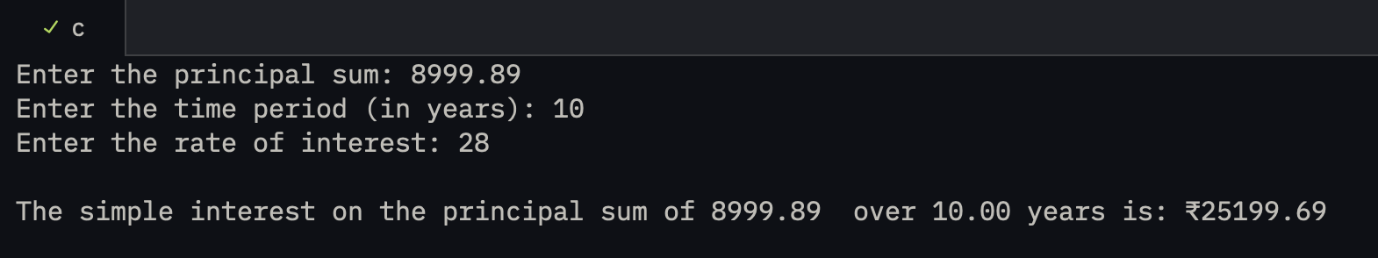
04 output.png

lab assignments/assignment 02/05
05.c
#include <math.h>
#include <stdio.h>

int main() {
float p, r, t, ci;

printf("Enter the principal sum: ");
scanf("%f", &p);

printf("Enter the time period (in years): ");
scanf("%f", &t);

printf("Enter the rate of interest: ");
scanf("%f", &r);

ci = p * (pow((1 + r / 100), t) - 1);

printf("\n\nThe compount interest on the principal sum of %.2f over %.2f "
"years is: ₹%.2f\n",
p, t, ci);

return 0;
}

Output:
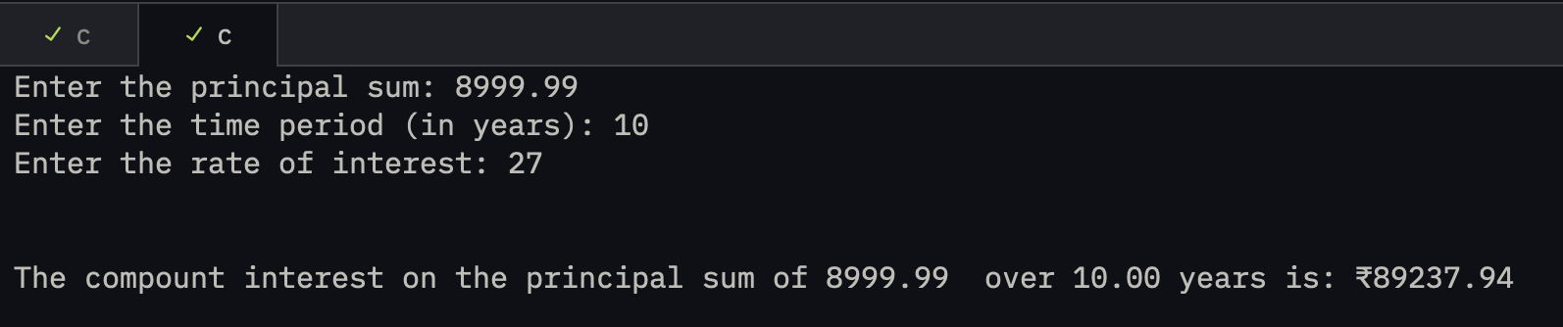
05 output.png

lab assignments/assignment 02/06
06.c
#include <stdio.h>
#include <stdlib.h>

int main() {
int num, temp, revNum = 0, counter = 0;

printf("Enter a 5 digit number: ");
scanf("%d", &num);

temp = num;

while (temp > 0) {
revNum = (revNum * 10) + (temp % 10);
temp /= 10;
counter++;
}

if (counter != 5) {
printf("invalid input\n");
return 0;
}

printf("the reversed number is: %d\n", revNum);
}

Output:
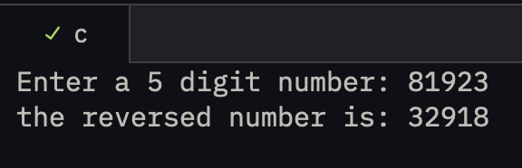
06 output.png

lab assignments/assignment 03/01
01.c
#include <math.h>
#include <stdio.h>

int main() {
printf("sin(22/7) = %lf", sin(M_PI)); // works in radians
printf("\ncos (100) = %lf", cos(100)); // works in radians

printf("\n\nlog(100, e) = %lf", log(100)); // log() --> natural log
printf("\nlog(100, 10) = %lf", log10(100)); // log10() --> log with base 10
printf("\nlog(100, 5) = %lf", (log(100)/log(5))); // method to calculate log base n

printf("\n\npow(100,10) = %lf", pow(100,10)); // log (base, power)
printf("\nsqrt(100) = %lf\n", sqrt(100));

return 0;
}
Output:
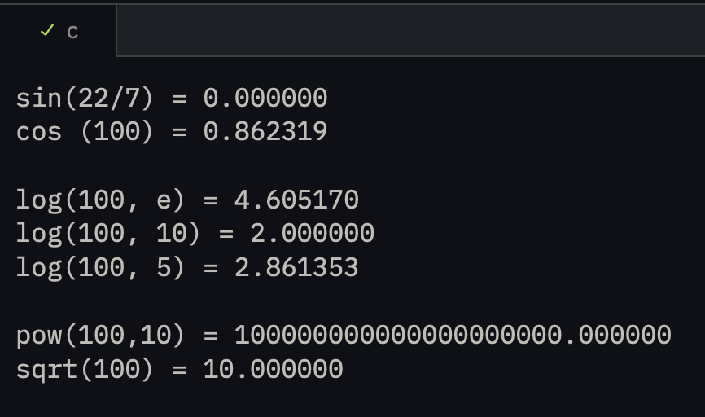
01 output.png

lab assignments/assignment 03/02
02.c
#include <math.h>
#include <stdio.h>

int main() {
double x1, x2, d;
int a, b, c;

printf("Enter the value of a: ");
scanf("%d", &a);

printf("Enter the value of b: ");
scanf("%d", &b);

printf("Enter the value of c: ");
scanf("%d", &c);

d = sqrt(pow(b, 2) - (4.0 * a * c));

x1 = (-b + d) / (2.0 * a);
x2 = (-b - d) / (2.0 * a);

printf(
"\nThe first root of the equation (%d)x\xc2\xb2 + (%d)x + (%d) is: %.2lf",
a, b, c, x1);

printf("\nThe second root of the equation (%d)x\xc2\xb2 + (%d)x + (%d) is: "
"%.2lf\n",
a, b, c, x2);

return 0;
}

Output:
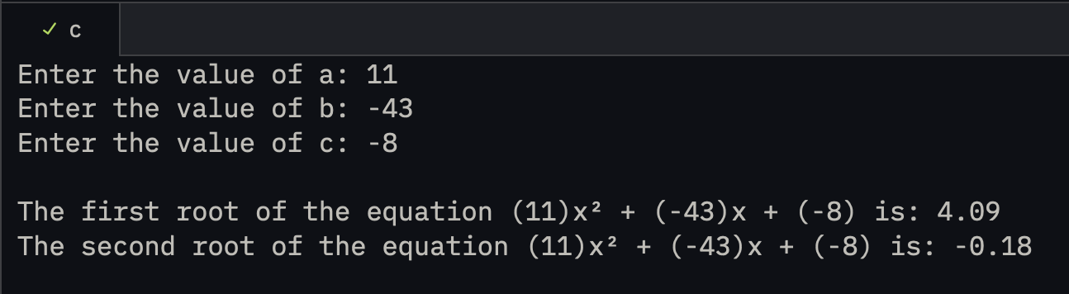
02 output.png

lab assignments/assignment 03/03
03.c
#include <stdio.h>

int main() {
printf("hello world\n");
printf("\nhello\tworld"); // '/t' horizontal tab
printf("\nABC\bD\n"); // '/b' backspace
printf("it's c\n"); // '/n' next line
printf("backslash: \\\n"); // to type '/' we need to type '//'
printf("\"hello\"\n");
printf("Hello is mean\rworld\n"); // '\r' moves cursor back to the start.
printf("\a"); // makes alert sound

return 0;
}
Output:
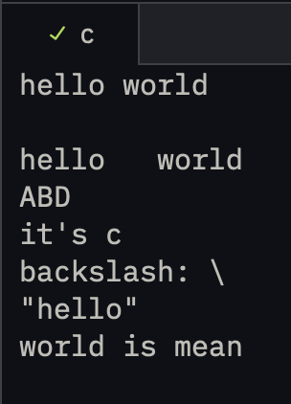
03 output.png

lab assignments/assignment 03/04
04.c
#include <stdio.h>

int main() {
int a = 182909;
printf("the original value of a is: %d\n\n", a);

printf("using += 5 we get: %d\n", (a+=5));
printf("using -= 5 we get: %d\n", (a-=5));
printf("using *= 5 we get: %d\n", (a*=5));
printf("using /= 5 we get: %d\n", (a/=5));
printf("using %%= 5 we get: %d\n", (a%=5)); // %% prints %

return 0;
}
Output:
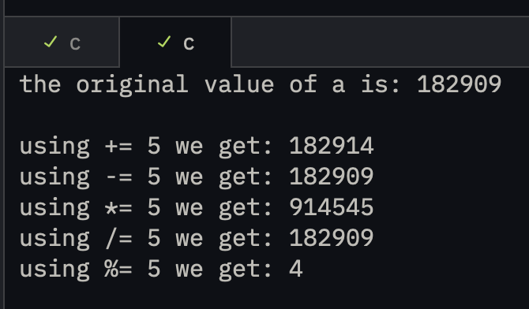
04 output.png

lab assignments/assignment 03/05
05.c
#include <stdio.h>

int main() {
// Left Shift operator (<<)
printf("the number %d left shifted number by 2 is %d", 5, (5<<2)); // 0101 -> 1010 -> 10100
// works like (number) << (no. of shifts)
// number multiplied by 2^n

// Right Shift Operator (>>)
printf("\nthe number %d right shifted number by 2 is %d\n", 7, (7>>2)); // 0111 -> 0011 -> 0001
// works like (number) >> (no. of shifts)
// number divided by 2^n

return 0;
}

Output:
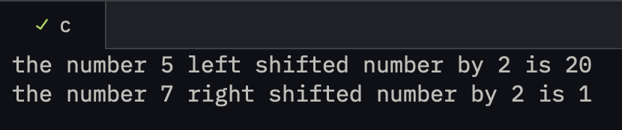
05 output.png

lab assignments/assignment 03/06
06.c
#include <stdio.h>

int main() {
int a;
printf("enter a number: ");
scanf("%d", &a);

printf(a % 2 == 0 ? "even number\n" : "odd number\n");

return 0;
}

Output:
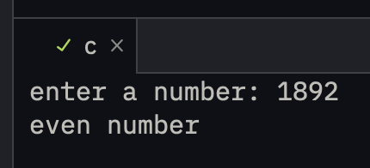
06 output.png

lab assignments/assignment 04/01
01.c
#include <stdio.h>

int main() {
printf("the size of char is: %d bytes\n", (int)sizeof(char));
printf("the size of int is: %d bytes\n", (int)sizeof(int));
printf("the size of long int is: %d bytes\n", (int)sizeof(long int));
printf("the size of float is: %d bytes\n", (int)sizeof(float));
printf("the size of double is: %d bytes\n", (int)sizeof(double));
return 0;
}

Output:
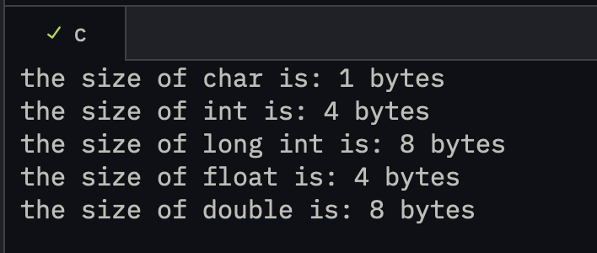
01 output.png

lab assignments/assignment 04/02
02.c
#include <stdio.h>

int main() {
int a, b, sum;
double mean;

printf("enter first number: ");
scanf("%d", &a);

printf("enter second number: ");
scanf("%d", &b);

sum = a+b;
mean = (double)sum/2;

printf("\nthe mean of the entered two numbers: %.2lf\n", mean);

return 0;
}
Output:
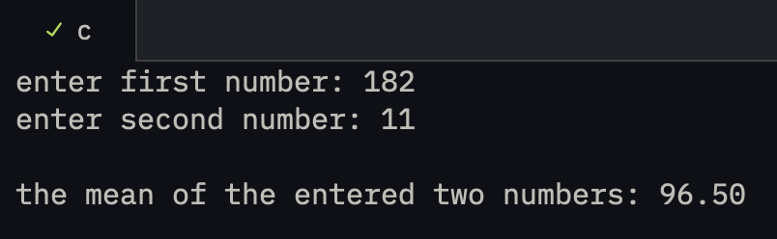
02 output.png

lab assignments/assignment 04/03
03.c
#include <stdio.h>
#include <stdlib.h>

int main() {
char s[] = "3.145";

// String to float
float f = atof(s);
printf("Float: %f\n", f);

// String to int
int i = atoi(s);
printf("Integer: %d\n", i);

// String to long
long l = atol(s);
printf("Long: %ld\n", l);

return 0;
}
Output:
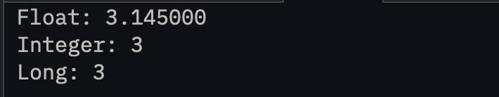
03 output.png

lab assignments/assignment 04/04
04.c
#include <stdio.h>

int main() {
int year, flag = 0;

printf("Enter the year: ");
scanf("%d", &year);

if ((year % 400 == 0) || (year % 4 == 0 && year % 100 != 0))
flag = 1;

if (flag == 1) {
printf("%d is a leap year", year);
}
else {
printf("%d is not a leap year", year);
}

printf("\n\n");
return 0;
}

Output:
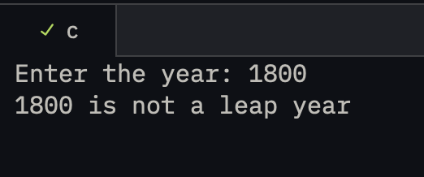
04 output.png

lab assignments/assignment 04/05
05.c
#include <stdio.h>

int main() {
char ch;

for (int i = 0; i < 4; i++) {

printf("enter a character: ");
scanf(" %c", &ch); // " %c" space to ignore the input buffer

if (ch >= 'A' && ch <= 'Z')
printf("%c is a capital letter", ch);

else if (ch >= 'a' && ch <= 'z')
printf("%c is a small letter", ch);

else if (ch >= '0' && ch <= '9')
printf("%c is a number", ch);

else
printf("%c is a special symbol", ch);

printf("\n\n");
}

return 0;
}

Output:
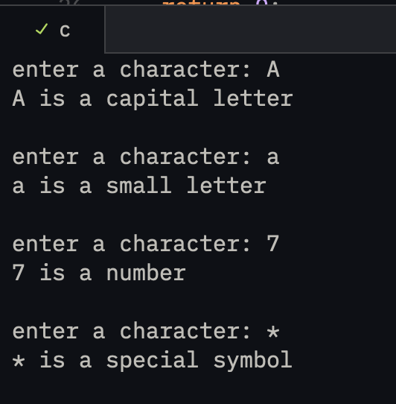
05 output.png

lab assignments/assignment 04/06
06.c
#include <stdio.h>

int main() {
int a, b, c;

printf("enter the first number: ");
scanf("%d", &a);

printf("enter the second number: ");
scanf("%d", &b);

printf("enter the third number: ");
scanf("%d", &c);

printf("\ncalculating using if-else statement...\n");

if (a > b) {
if (a > c)
printf("the largest number is a, or the first number");
else
printf("the largest number is c, or the third number");
} else {
if (b > c)
printf("the largest number is b, or the second number");
else
printf("the largest number is c, or the third number");
}

printf("\n\ncalculating using nested ternary operator...\n");

(a > b) ? ((a > c) ? printf("the largest number is a, or the first number")
: printf("the largest number is c, or the third number"))
: ((b > c) ? printf("the largest number is b, or the second number")
: printf("the largest number is c, or the third number"));

printf("\n");
return 0;
}

Output:
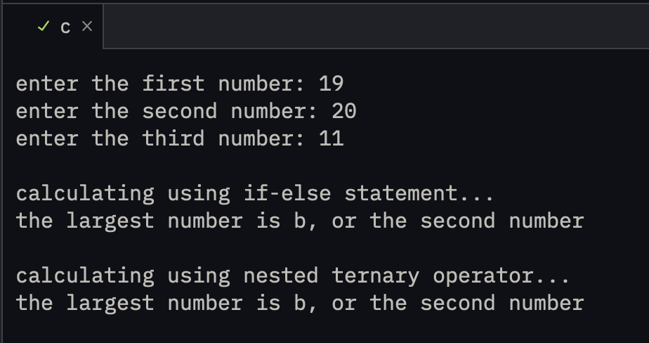
06 output.png

lab assignments/assignment 04/07
07.c
#include <stdio.h>

int main() {
int n;

printf("Enter a number: ");
scanf("%d", &n);

printf("\n\ncalculating even-odd using if-else statement...\n");

if (n % 2 == 0)
printf("Even\n");
else
printf("Odd\n");

printf("\n\ncalculating even-odd using nested ternary operator...\n");
printf("%s\n", (n % 2 == 0) ? "Even" : "Odd");

printf("\n\ncalculating positive-negative using if-else statement...\n");

if (n > 0)
printf("Positive\n");
else if (n < 0)
printf("Negative\n");
else
printf("Zero\n");

printf("\n\ncalculating positive-negative using nested ternary operator...\n");
printf("%s\n", (n > 0) ? "Positive" : (n < 0) ? "Negative" : "Zero");

return 0;
}

Output:
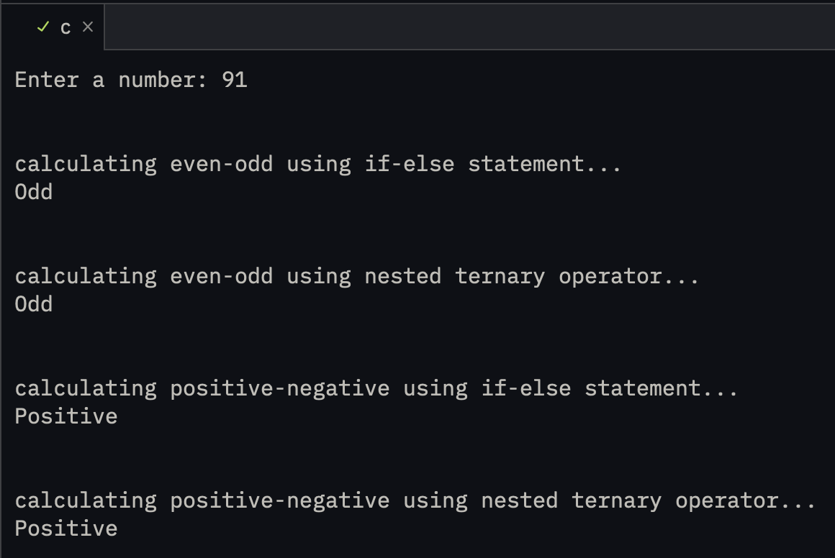
07 output.png

lab assignments/assignment 05/01
01.c
#include <stdio.h>

int main() {
double a, b;
char op;

printf("enter first number: ");
scanf("%lf", &a);

printf("enter operator (+, -, *, /, %%): ");
scanf(" %c", &op);

printf("enter second number: ");
scanf("%lf", &b);

switch (op) {
case '+':
printf("\nresult: %.2lf\n", a + b);
break;
case '-':
printf("\nresult: %.2lf\n", a - b);
break;
case '*':
printf("\nresult: %.2lf\n", a * b);
break;
case '/':
if (b != 0)
printf("\nresult: %.2lf\n", a / b);
else
printf("\ncannot divide by zero\n");
break;
case '%':
if ((int)b != 0)
printf("\nresult: %d\n", (int)a % (int)b);
else
printf("\ncannot divide by zero\n");
break;
default:
printf("\ninvalid operator\n");
}

return 0;
}

Output:
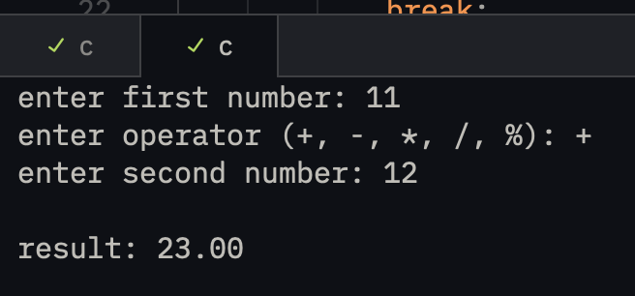
01 output - addition.png
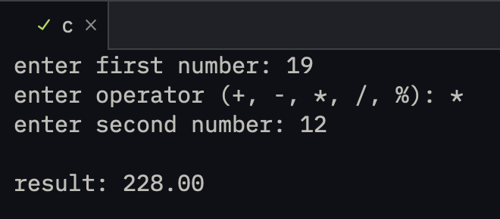
01 output - multiplication.png

lab assignments/assignment 05/02
02.c
#include <stdio.h>

int main() {
int month;

printf("enter month number (1-12): ");
scanf("%d", &month);

switch (month) {
case 1:
printf("January\n");
break;
case 2:
printf("February\n");
break;
case 3:
printf("March\n");
break;
case 4:
printf("April\n");
break;
case 5:
printf("May\n");
break;
case 6:
printf("June\n");
break;
case 7:
printf("July\n");
break;
case 8:
printf("August\n");
break;
case 9:
printf("September\n");
break;
case 10:
printf("October\n");
break;
case 11:
printf("November\n");
break;
case 12:
printf("December\n");
break;
default:
printf("invalid month number\n");
}

return 0;
}

Output:
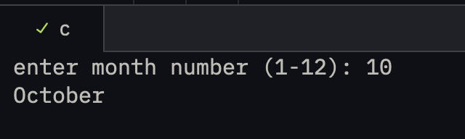
02 output.png

lab assignments/assignment 05/03
03.c
#include <stdio.h>

int main() {
int n;

printf("enter a number: ");
scanf("%d", &n);

if (n % 5 == 0 && n % 8 == 0)
printf("%d is divisible by both 5 and 8\n", n);
else if (n % 5 == 0)
printf("%d is divisible by 5 only\n", n);
else if (n % 8 == 0)
printf("%d is divisible by 8 only\n", n);
else
printf("%d is not divisible by 5 or 8\n", n);

return 0;
}

Output:
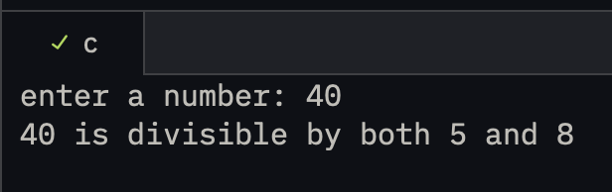
03 output.png

lab assignments/assignment 05/04
04.c
#include <stdio.h>

int main() {
int days;
double fine;

printf("enter number of days late: ");
scanf("%d", &days);

if (days < 0)
printf("invalid number of days\n");
else if (days == 0)
printf("no fine\n");
else if (days <= 5) {
fine = days * 0.50;
printf("fine: Rs. %.2lf\n", fine);
}
else if (days <= 10) {
fine = 5 * 0.50 + (days - 5) * 1.00;
printf("fine: Rs. %.2lf\n", fine);
}
else if (days <= 30) {
fine = 5 * 0.50 + 5 * 1.00 + (days - 10) * 5.00;
printf("fine: Rs. %.2lf\n", fine);
}
else
printf("membership cancelled\n");

return 0;
}

Output:
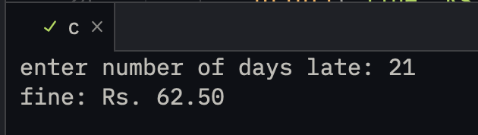
04 output.png

lab assignments/assignment 05/05
05.c
#include <stdio.h>

int main() {
double hardness, carbon, tensile;
int condition1, condition2, condition3, grade;

printf("enter hardness: ");
scanf("%lf", &hardness);

printf("enter carbon content: ");
scanf("%lf", &carbon);

printf("enter tensile strength: ");
scanf("%lf", &tensile);

condition1 = hardness > 50;
condition2 = carbon < 0.7;
condition3 = tensile > 5600;

if (condition1 && condition2 && condition3)
grade = 10;
else if (condition1 && condition2)
grade = 9;
else if (condition2 && condition3)
grade = 8;
else if (condition1 && condition3)
grade = 7;
else if (condition1 || condition2 || condition3)
grade = 6;
else
grade = 5;

printf("\ngrade using nested if-else: %d\n", grade);

if (condition1) {
if (condition2) {
if (condition3)
grade = 10;
else
grade = 9;
}
else if (condition3)
grade = 7;
else
grade = 6;
}
else if (condition2) {
if (condition3)
grade = 8;
else
grade = 6;
}
else if (condition3)
grade = 6;
else
grade = 5;

printf("grade using ladder if: %d\n", grade);

if (condition1 && condition2 && condition3)
grade = 10;
else if (condition1 && condition2)
grade = 9;
else if (condition2 && condition3)
grade = 8;
else if (condition1 && condition3)
grade = 7;
else if (condition1 || condition2 || condition3)
grade = 6;
else
grade = 5;

printf("grade using else-if: %d\n", grade);

return 0;
}

Output:
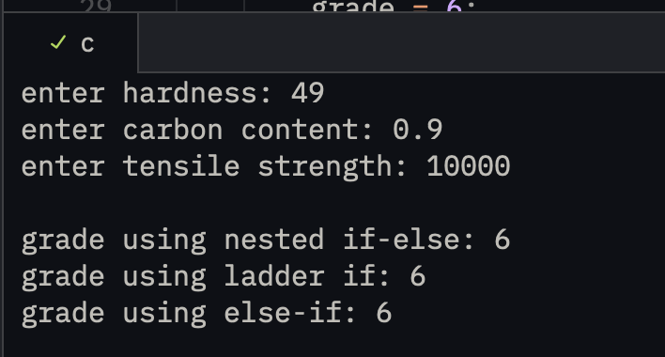
05 output.png

lab assignments/assignment 06/01
01.c
#include <stdio.h>

int main() {
int n, i;
unsigned long long factorial = 1;

printf("enter a non-negative number: ");
scanf("%d", &n);

if (n < 0)
printf("factorial is not defined for negative numbers\n");
else if (n > 20)
printf("number is too large to calculate factorial\n");
else {
for (i = 1; i <= n; i++)
factorial *= i;

printf("factorial of %d is %llu\n", n, factorial);
}

return 0;
}

Output:
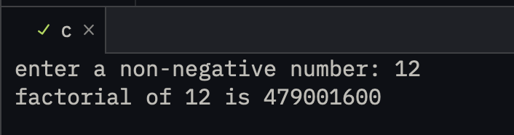
01 output.png

lab assignments/assignment 06/02
02.c
#include <stdio.h>

int main() {
int n, i, isPrime = 1;

printf("enter a number: ");
scanf("%d", &n);

if (n < 2)
isPrime = 0;
else {
for (i = 2; i <= n / i; i++) {
if (n % i == 0) {
isPrime = 0;
break;
}
}
}

if (isPrime)
printf("%d is a prime number\n", n);
else
printf("%d is not a prime number\n", n);

return 0;
}

Output:
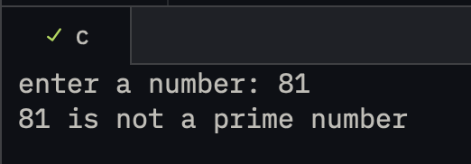
02 output - not prime.png
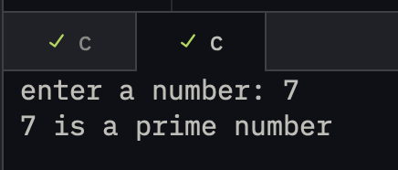
02 output - prime.png

lab assignments/assignment 06/03
03.c
#include <stdio.h>

int main() {
double x, result = 1;
int n, i, power;

printf("enter the number: ");
scanf("%lf", &x);

printf("enter the power: ");
scanf("%d", &n);

power = n;
if (power < 0)
power = -power;

for (i = 0; i < power; i++)
result *= x;

if (n < 0) {
if (x == 0)
printf("zero cannot be raised to a negative power\n");
else
printf("%.2lf raised to %d is %.6lf\n", x, n, 1.0 / result);
}
else
printf("%.2lf raised to %d is %.6lf\n", x, n, result);

return 0;
}

Output:
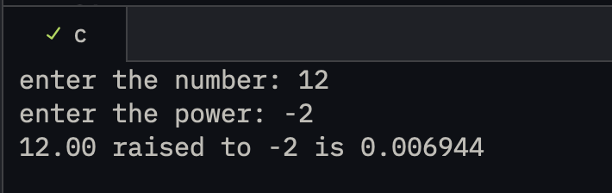
03 output.png

lab assignments/assignment 06/04
04.c
#include <stdio.h>

int main() {
int n, original, digit, sum;

printf("Armstrong numbers between 1 and 500 are:\n");

for (n = 1; n <= 500; n++) {
original = n;
sum = 0;

while (original > 0) {
digit = original % 10;
sum += digit * digit * digit;
original /= 10;
}

if (sum == n)
printf("%d\n", n);
}

return 0;
}

Output:
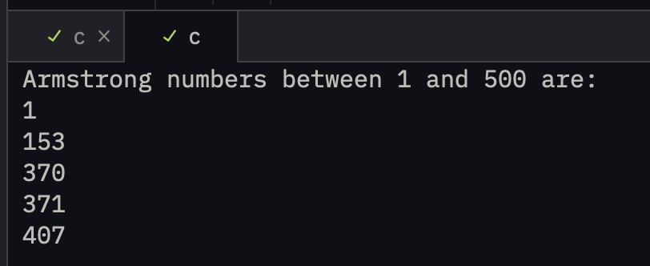
04 output.png

lab assignments/assignment 06/05
05.c
#include <stdio.h>

int main() {
int n, number, smallest, largest, i;

printf("how many numbers do you want to enter? ");
scanf("%d", &n);

if (n <= 0) {
printf("please enter at least one number\n");
return 0;
}

printf("enter number 1: ");
scanf("%d", &number);
smallest = largest = number;

for (i = 2; i <= n; i++) {
printf("enter number %d: ", i);
scanf("%d", &number);

if (number < smallest)
smallest = number;
if (number > largest)
largest = number;
}

printf("\nsmallest number: %d\n", smallest);
printf("largest number: %d\n", largest);
printf("range: %d\n", largest - smallest);

return 0;
}

Output:
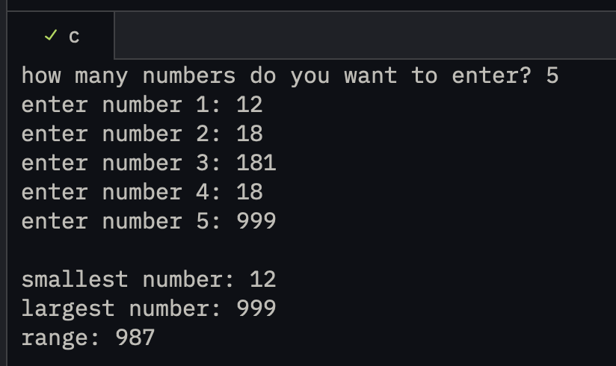
05 output.png

lab assignments/assignment 06/06
06.c
#include <stdio.h>

int main() {
int n, i;

printf("enter a number: ");
scanf("%d", &n);

printf("multiplication table of %d:\n\n", n);
for (i = 1; i <= 10; i++)
printf("%d x %d = %d\n", n, i, n * i);

return 0;
}

Output:
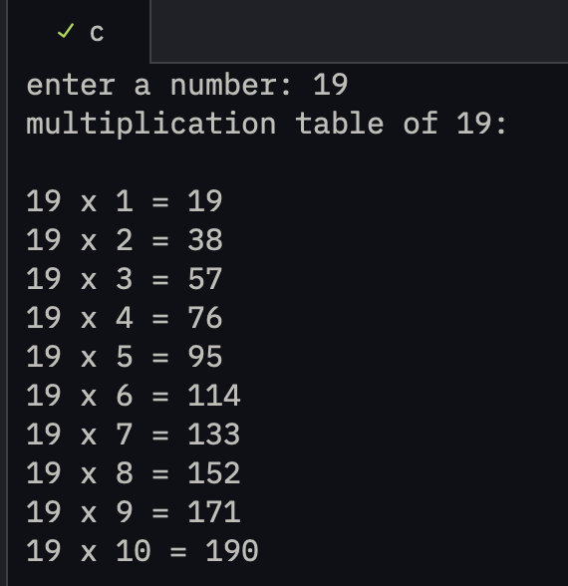
06 output.png

lab assignments/assignment 06/07
07.c
#include <stdio.h>

int main() {
int a, b, divisor, hcf = 1;

printf("enter first number: ");
scanf("%d", &a);

printf("enter second number: ");
scanf("%d", &b);

if (a == 0 && b == 0) {
printf("HCF is not defined for 0 and 0\n");
return 0;
}

if (a < 0)
a = -a;
if (b < 0)
b = -b;

for (divisor = 1; divisor <= a && divisor <= b; divisor++) {
if (a % divisor == 0 && b % divisor == 0)
hcf = divisor;
}

printf("HCF is %d\n", hcf);

return 0;
}

Output:
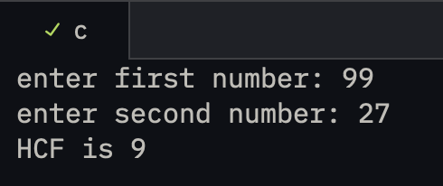
07 output.png

lab assignments/assignment 06/08
08.c
#include <stdio.h>

int main() {
int a, b, remainder;

printf("enter first number: ");
scanf("%d", &a);

printf("enter second number: ");
scanf("%d", &b);

if (a == 0 && b == 0) {
printf("GCD is not defined for 0 and 0\n");
return 0;
}

if (a < 0)
a = -a;
if (b < 0)
b = -b;

while (b != 0) {
remainder = a % b;
a = b;
b = remainder;
}

printf("GCD is %d\n", a);

return 0;
}

Output:
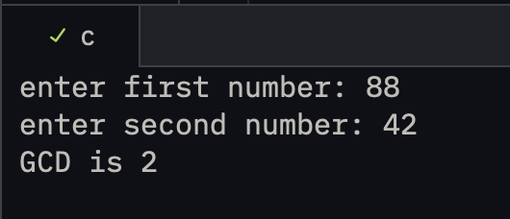
08 output.png

lab assignments/assignment 06/09
09.c
#include <stdio.h>

int main() {
int n, i;
int first = 0, second = 1, next;

printf("how many terms of the Fibonacci series do you want? ");
scanf("%d", &n);

if (n <= 0) {
printf("please enter a positive number of terms\n");
return 0;
}

printf("Fibonacci series: ");
for (i = 1; i <= n; i++) {
printf("%d", first);
if (i < n)
printf(" ");
next = first + second;
first = second;
second = next;
}
printf("\n");

return 0;
}

Output:
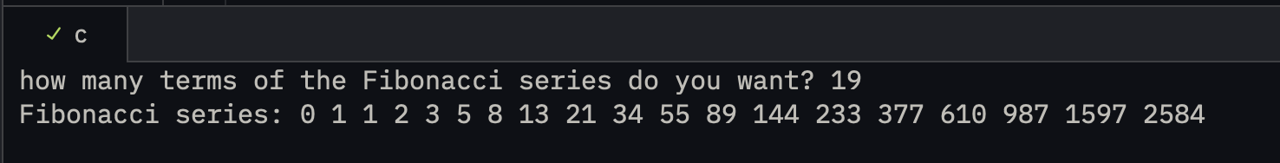
09 output.png

lab assignments/assignment 07/01
01.c
#include <stdio.h>

int main() {
int n;

printf("enter the number of elements in the array: ");
scanf("%d", &n);
printf("\n");

int arr[n], temp;

int len = sizeof(arr) / sizeof(int) - 1;

for (int i = 0; i <= len; i++) {
printf("enter element %d: ", (i + 1));
scanf("%d", &arr[i]);
}

printf("\n\nPRINTING THE ORIGINAL ARRAY...\n");

for (int i = 0; i <= len; i++) {
printf("\n%d", arr[i]);
}

for (int i = 0; i <=(len / 2); i++) {
temp = arr[i];
arr[i] = arr[len - i];
arr[len - i] = temp;
}
printf("\n\nPRINTING THE REVERSED ARRAY...\n");

for (int i = 0; i <= len; i++) {
printf("\n%d", arr[i]);
}

printf("\n");

return 0;
}

Output:
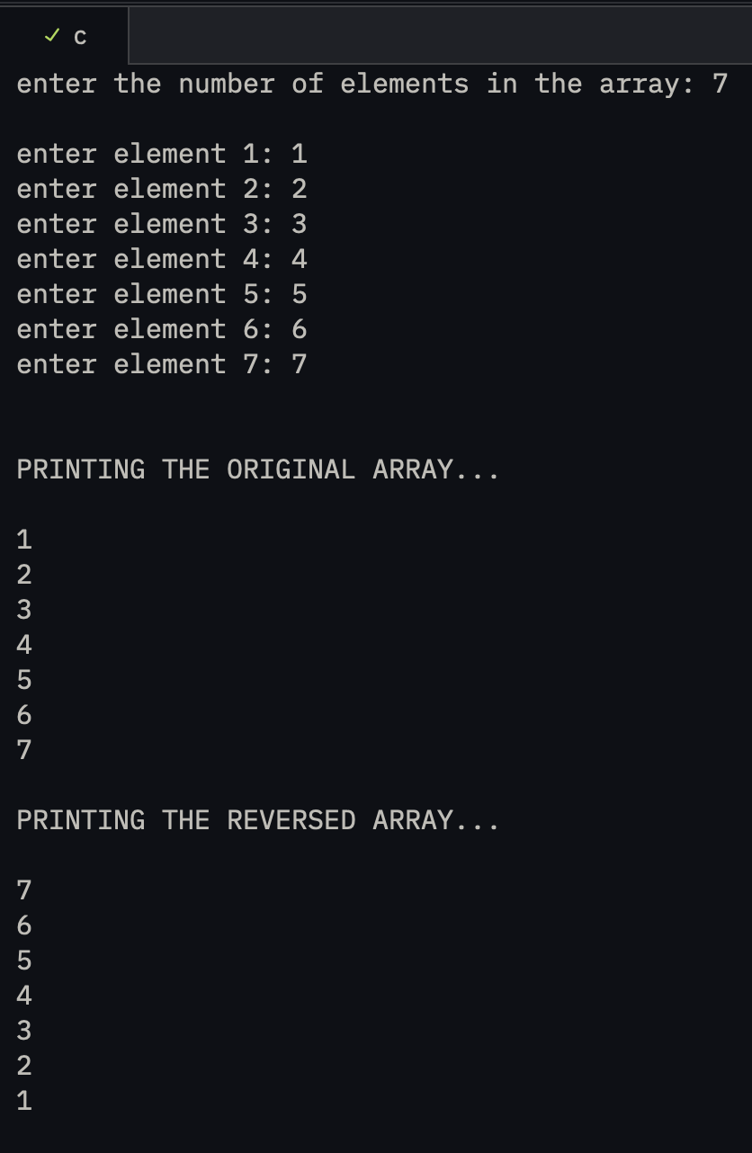
01 output.png

lab assignments/assignment 07/02
02.c
#include <stdio.h>

int main() {
int n;

printf("enter the number of elements in the array: ");
scanf("%d", &n);
printf("\n");

int arr[n + 1], loc, elem;

int len = sizeof(arr) / sizeof(int) - 1;

for (int i = 0; i < len; i++) {
printf("enter element %d: ", (i + 1));
scanf("%d", &arr[i]);
}

printf("\n\nPRINTING THE ORIGINAL ARRAY...\n");

for (int i = 0; i < len; i++) {
printf("\n%d", arr[i]);
}

printf("\n\n\nEnter the location (index) at which the element is to be inserted: ");
scanf("%d", &loc);

printf("Enter the element to be inserted at %d: ", loc);
scanf("%d", &elem);

for (int i = len; i >= loc; i--) {
arr[i] = arr[i - 1];
}

arr[loc] = elem;

printf("\n\nPRINTING THE NEW ARRAY...\n");

for (int i = 0; i <= len; i++) {
printf("\n%d", arr[i]);
}

printf("\n");

return 0;
}

Output:
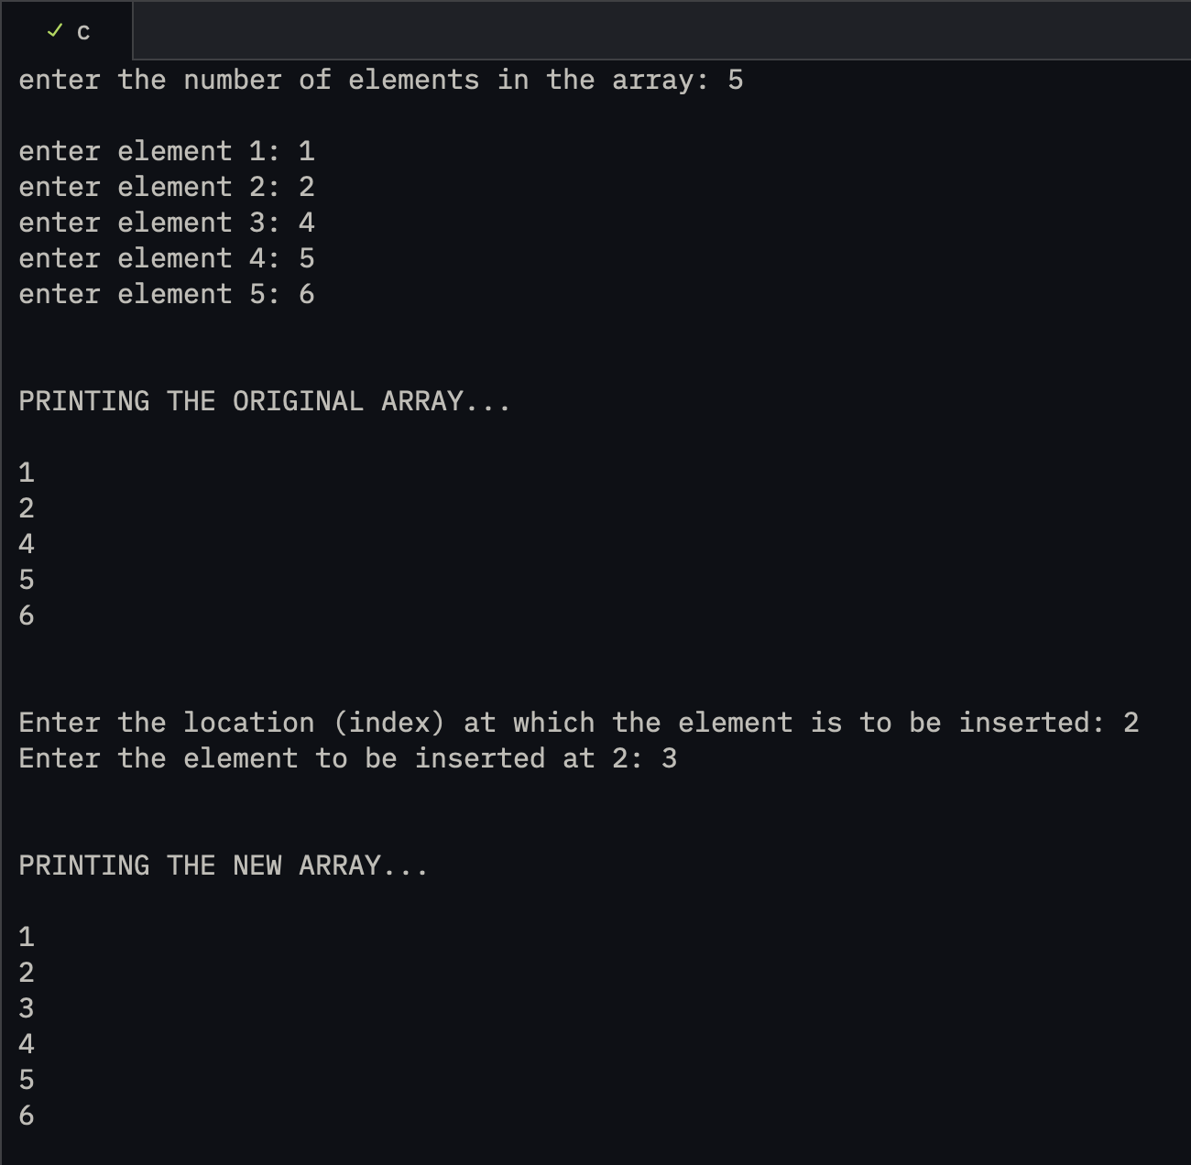
02 output.png

lab assignments/assignment 07/03
03.c
#include <stdio.h>

int main() {
int n;

printf("enter the number of elements in the array: ");
scanf("%d", &n);
printf("\n");

int arr[n];

int len = sizeof(arr) / sizeof(int) - 1;

for (int i = 0; i <= len; i++) {
printf("enter element %d: ", (i + 1));
scanf("%d", &arr[i]);
}

printf("\n\nPRINTING THE ORIGINAL ARRAY...\n");
for (int i = 0; i <= len; i++) {
printf("\n%d", arr[i]);
}

// copying to another array

int arr2[n];
for (int i = 0; i <= len; i++) {
arr2[i] = arr[i];
}

printf("\n\nPRINTING THE COPIED ARRAY...\n");
for (int i = 0; i <= len; i++) {
printf("\n%d", arr2[i]);
}

printf("\n");

return 0;
}

Output:
Paste output screenshot here

lab assignments/assignment 07/04
04.c
#include <stdio.h>

int main() {
int n;

printf("enter the number of elements in the array: ");
scanf("%d", &n);
printf("\n");

int arr[n], loc;

int len = sizeof(arr) / sizeof(int) - 1;

for (int i = 0; i <= len; i++) {
printf("enter element %d: ", (i + 1));
scanf("%d", &arr[i]);
}

printf("\n\nPRINTING THE ORIGINAL ARRAY...\n");

for (int i = 0; i <= len; i++) {
printf("\n%d", arr[i]);
}

printf("\n\nenter the position (index) at which the element is to be deleted: ");
scanf("%d", &loc);

for (int i = loc; i<=len; i++) {
arr[i] = arr[i+1];
}

printf("\n\nPRINTING THE NEW ARRAY...\n");
for (int i = 0; i < len; i++) {
printf("\n%d", arr[i]);
}

printf("\n");

return 0;
}

Output:
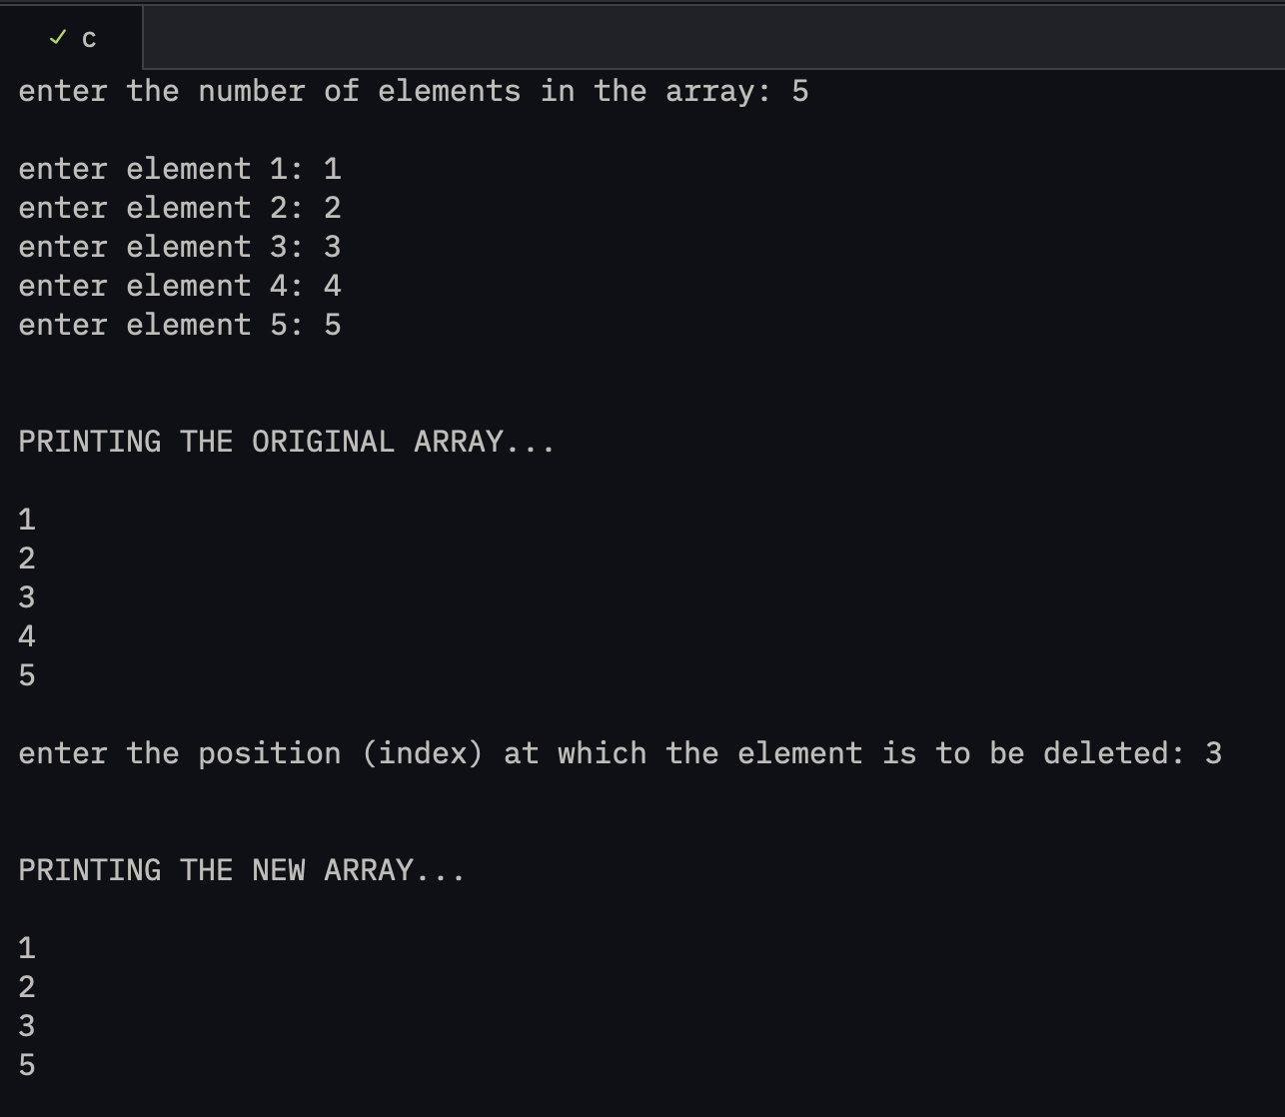
04 output.png

lab assignments/assignment 07/05
05.c
#include <stdio.h>

int main() {
int n;

printf("enter the number of elements in the array: ");
scanf("%d", &n);
printf("\n");

int arr[n], elem, flag = 0, i;

int len = sizeof(arr) / sizeof(int) - 1;

for (int i = 0; i <= len; i++) {
printf("enter element %d: ", (i + 1));
scanf("%d", &arr[i]);
}

printf("\n\nPRINTING THE ORIGINAL ARRAY...\n");

for (int i = 0; i <= len; i++) {
printf("\n%d", arr[i]);
}

printf("\n\nEnter the element to be searched: ");
scanf("%d", &elem);

for (i = 0; i <= len; i++) {
if (arr[i] == elem) {
flag = 1;
break;
}
continue;
}

if (flag == 1) {
printf("element found at index %d", i);
} else {
printf("element not found");
}

printf("\n");

return 0;
}

Output:
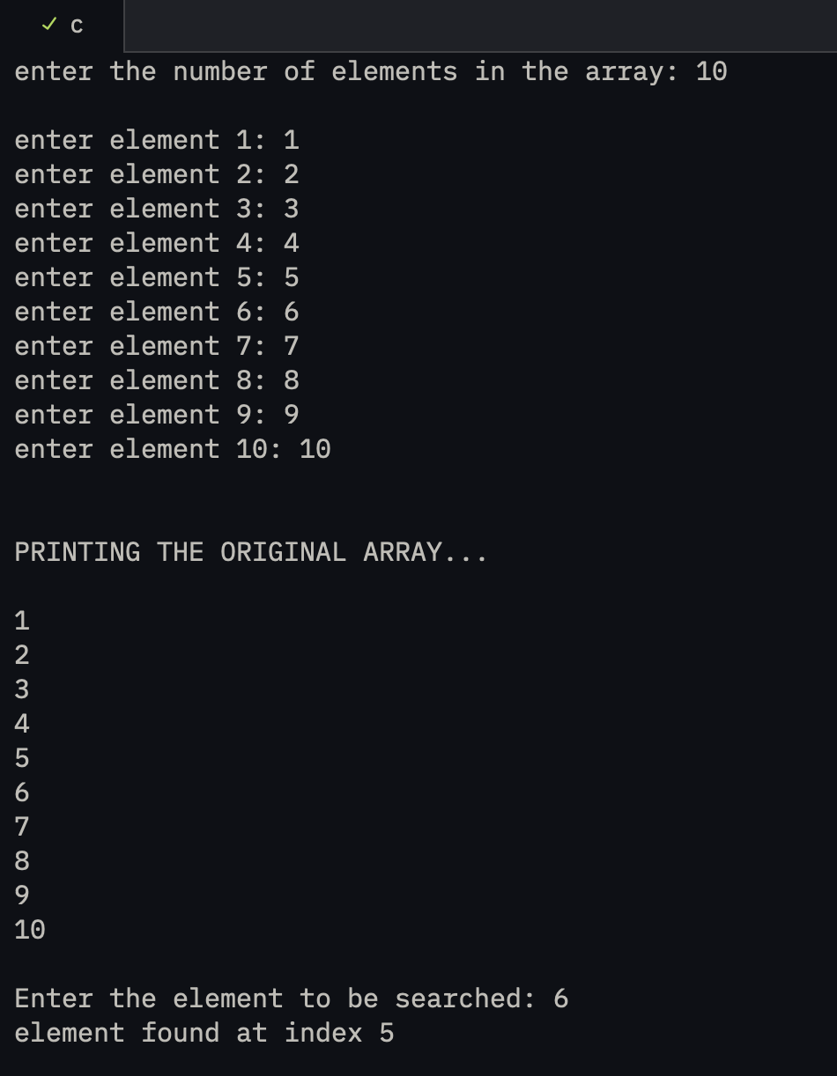
05 output.png

lab assignments/assignment 07/06
06.c
#include <stdio.h>

int main() {
int n;

printf("enter the number of elements in the array: ");
scanf("%d", &n);
printf("\n");

int arr[n], sum;
double average;

int len = sizeof(arr) / sizeof(int) - 1;

for (int i = 0; i <= len; i++) {
printf("enter element %d: ", (i + 1));
scanf("%d", &arr[i]);
}

printf("\n\nPRINTING THE ORIGINAL ARRAY...\n");

for (int i = 0; i <= len; i++) {
printf("\n%d", arr[i]);
}

for (int i = 0; i <= len; i++) {
sum += arr[i];
}

average = sum / ((len + 1) * 1.0);

printf("\n\nthe sum of the array elements is %d and the average of the array "
"elements is %lf",
sum, average);

printf("\n");

return 0;
}

Output:
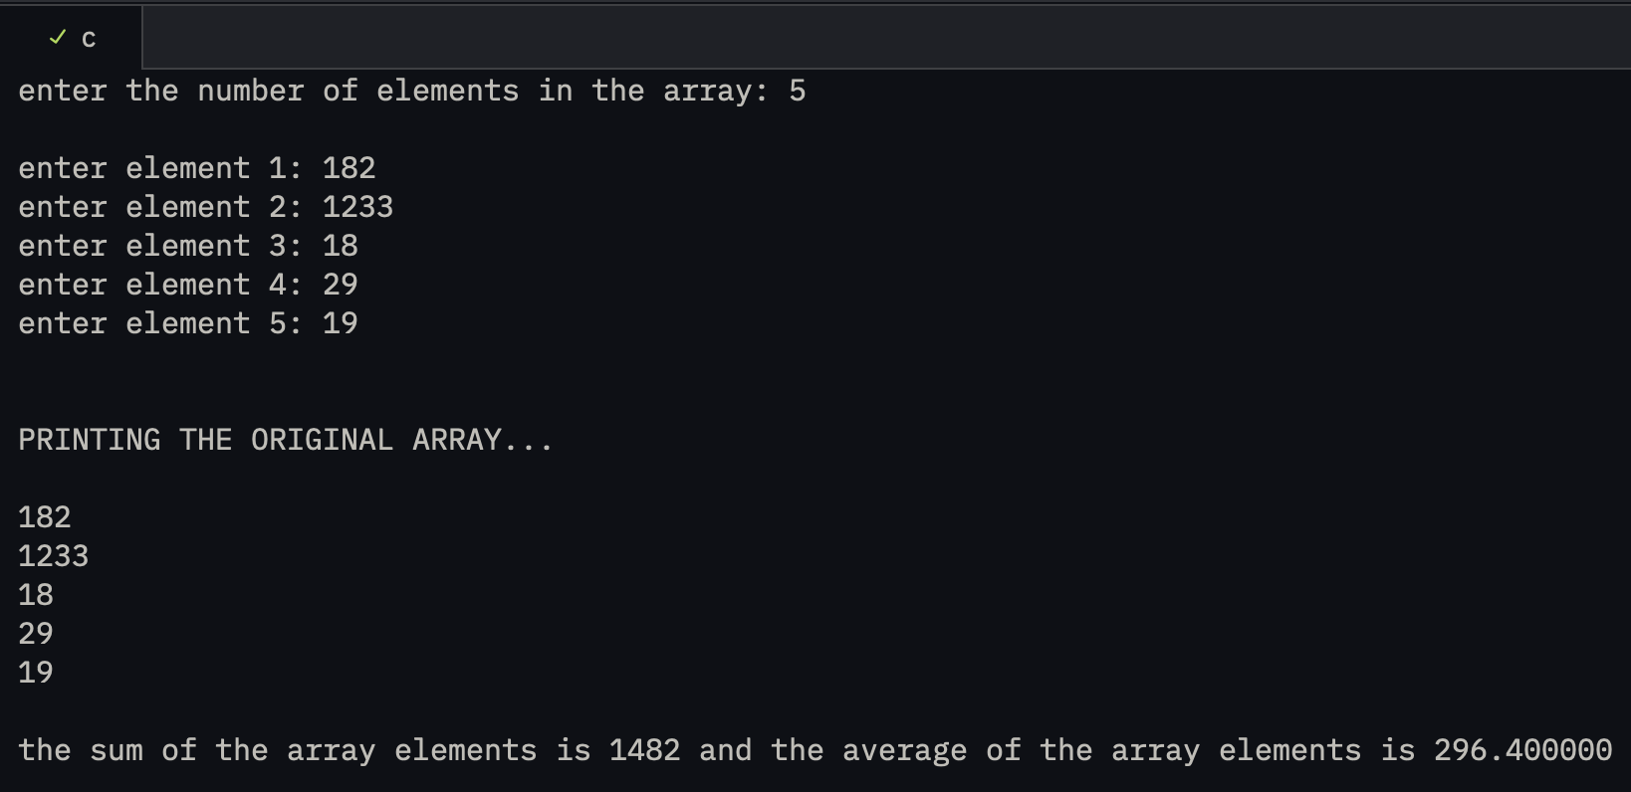
06 output.png

lab assignments/assignment 07/07
07.c
#include <stdio.h>

int main() {
int n;

printf("enter the number of elements in the array: ");
scanf("%d", &n);
printf("\n");

int arr[n], max, min;

int len = sizeof(arr) / sizeof(int) - 1;

for (int i = 0; i <= len; i++) {
printf("enter element %d: ", (i + 1));
scanf("%d", &arr[i]);
}

printf("\n\nPRINTING THE ORIGINAL ARRAY...\n");

for (int i = 0; i <= len; i++) {
printf("\n%d", arr[i]);
}

max = arr[0];
min = arr[0];

for (int i = 1; i <= len; i++) {
if (arr[i] > max)
max = arr[i];

if (arr[i] < min)
min = arr[i];
}

printf("\n\nsmallest element: %d \nlargest element: %d", min, max);

printf("\n");

return 0;
}

Output:
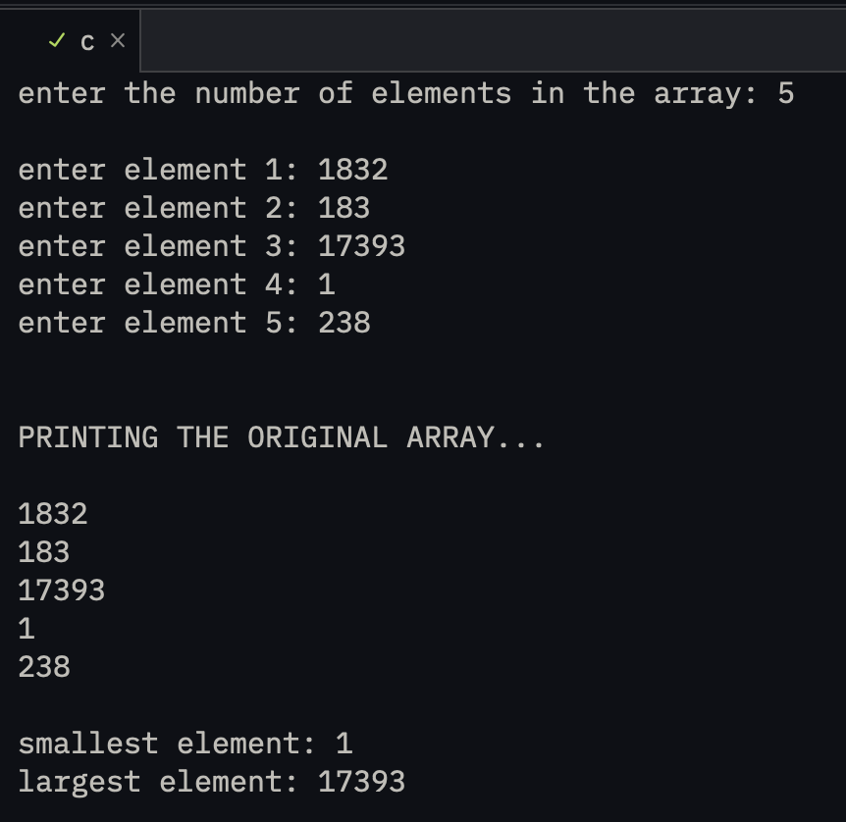
07 output.png

lab assignments/assignment 07/08
08.c
#include <stdio.h>

int main() {
int m, n;

printf(
"\nWARNING: THE NUMBER OF ROWS MUST BE EQUAL TO THE NUMBER OF COLUMNS\n\n");
printf("enter the number of rows in the array: ");
scanf("%d", &m);
printf("enter the number of columns in the array: ");
scanf("%d", &n);
printf("\n");

if (m != n) {
printf("invalid input");
return 1;
}

int arr[m][n];

for (int i = 0; i < m; i++) {
for (int j = 0; j < n; j++) {
printf("enter element at position (%d,%d): ", (i + 1), (j + 1));
scanf("%d", &arr[i][j]);
}
}

printf("\n\nPRINTING THE ORIGINAL ARRAY...\n");
for (int i = 0; i < m; i++) {
for (int j = 0; j < n; j++)
printf(" %d", arr[i][j]);

printf("\n");
}

int transpose[m][n], result[m][n];

for (int i = 0; i < m; i++) {
for (int j = 0; j < n; j++)
transpose[i][j] = arr[j][i];
}

for (int i = 0; i < m; i++) {
for (int j = 0; j < n; j++)
result[i][j] = arr[i][j] + transpose[i][j];
}

printf("\n\nPRINTING THE NEW ARRAY...\n");
for (int i = 0; i < m; i++) {
for (int j = 0; j < n; j++) {
printf("%d ", result[i][j]);
}
printf("\n");
}

printf("\n");

return 0;
}

Output:
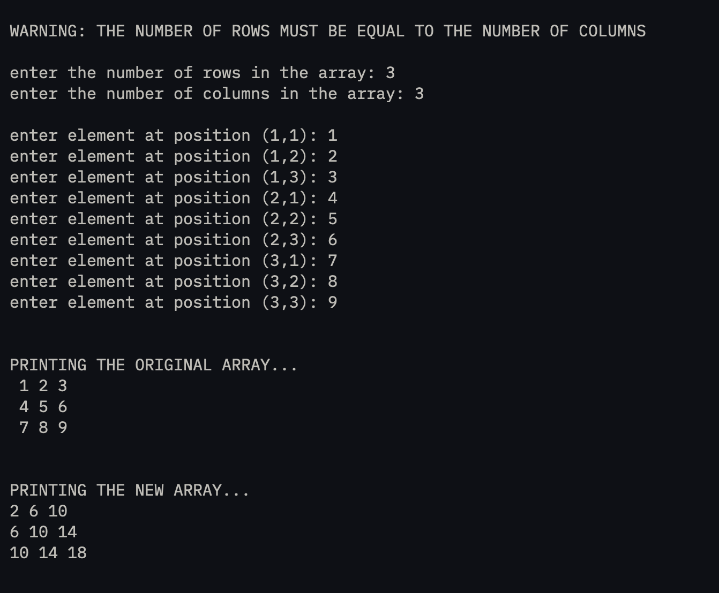
08 output.png

lectures
august26.c
#include <stdio.h> // # is used for preprocessor direectivesR

int _a; // takes 4 bytes for integer (in general)
// we cannot use two underscores successively like a__,
// with an _

int main() { // only use int as standard, void is not used anymore
printf("enter an integer: ");
scanf("%d", &_a); // it will only pick the first digit if we use %c and enter 65

char b = _a; // it will store only 8 bits data of _a
printf("the corresponding character is %c\n", b);

short int a2; // same as short a2
long int a3; // same as long a3
unsigned int c; // takes only 0 and positive values
signed int d; // takes negative, 0 and positive values only

return 0;
}

Output:
Paste output screenshot here

august27.c
#include <stdio.h>

int main(){
unsigned char c2; // the classic char -- range 0 to 255 (1 byte)
signed char c1; // special char used to store small integers, range -128 to 127, NOT RELATED TO ASCII VALUES

int a = 10;
float b = 2.4;
char c = 67;

printf("%d %f %c",a,b,c);
printf("\n%d %f %c", 10 , 2.4 , 67); // implicit tyepcasting wont work here

}

Output:
Paste output screenshot here

august31.c
#define _CRT_SECURE_NO_WARNINGS

#include <stdio.h>
#include <stdlib.h>
#include <string.h>

int main(){
char *name = malloc(1000*sizeof(char));
char *newName = malloc(1000*sizeof(char));

printf("\n\nEnter 1st string: ");
gets(name);

// EXTRA: gets is deprecated, cause it doesnt know the size of the string to be entered and thus is unsafe
// we use fgets(destination, size, source) instead

printf("Enter 2nd string: ");
fgets(newName, sizeof(newName), stdin);

printf("\n The entered strings when concatenated are: ");
puts(strcat(name, newName));

free(name);
free(newName);

return 0;
}

Output:
Paste output screenshot here

september2.c
#include <stdio.h>

int main() {
// anything apart from 0 will be treated as true

if (-18921) {
printf("\nPASS");
} else {
printf("\nFAIL");
}

if (0) {
printf("\nPASS");
} else {
printf("\nFAIL");
}

// bitwise AND operator (&)

printf("\n\nthe bitwise sum of 5 and 3 is %d\n", (5 & 3));

// performs bitwise AND operation --> 5 is 0101 and 3 is 0011 -> 0001 or 1
// number of digitys must be equal, or performs padding using 0 on the LHS in the lesser digit number.

return 0;
}

Output:
Paste output screenshot here

september3.c
#include <stdio.h>

int main() {
// Bitwise OR operator (|)
printf("\nthe bitwise OR addition of 5 and 3 is %d", (5|3));
// 5 - 0101 and 3 = 0011 ---> 0111 (7)

// Bitwise XOR operator (^)
printf("\nthe bitwise XOR addition of 5 and 3 is %d", (5^3));
// 5 - 0101 and 3 - 0011 -----> 0110

// Left Shift operator (<<)
printf("\n\n%d left shifted number by 2 is %d", 4, (4<<2)); // 0100 -> 0010 -> 0001
// works like (number) << (no. of shifts)
// number multiplied by 2^n

// Right Shift Operator (>>)
printf("\n%d right shifted number by 2 is %d\n", 4, (4>>2)); // 0100 -> 0010 -> 0001
// works like (number) >> (no. of shifts)
// number divided by 2^n

int i = 5;
i-=1;

printf("\n%d %d\n",i<<=3, i>>=2); // this is wrong because there is a confusion in the sequence of these operations

return 0;
}

Output:
Paste output screenshot here

september7.c

Output:
Paste output screenshot here

test
testing c.c
#include <stdio.h>
#include <stdlib.h>

int main() {
int arr[] = {91,18920,18,182,182};

printf("%d",arr[3-2]);
}

Output:
Paste output screenshot here

