**Iot based Intelligent Greenhouse using Raspberry Pi**

**ABSTRACT**

Greenhouse are controlled region condition to develop plants. So as to accomplish most extreme plant development, the consistent checking and controlling of natural parameters, for example, temperature, humidity, soil dampness, light power, and so on are essential for a greenhouse framework. The main aim of Designing this Model Of An Intelligent Green House is to Reduce The Work Of Farmers And Work Is Carried Automatically Without The Use Of Manual Inspection. The Panel Protects The Plants From Extreme Weather Conditions. There Are Important Parameters To Be Monitored Inside The Green House. This System Is Made Up Of Front-End Data Acquisition, Data Processing And Data Transmission. A GSM (Global System for Mobile communication) modem is used to send SMS (Short Message Service) which displays the present status of the environmental parameters. The SMS is sent to the user when the sensor value exceeds a defined level. users can control their greenhouses from any place by knowing the status of their greenhouse parameters at any time.All environmental parameters are sent to server through Cloud and stored in the database. So the user can monitor and control parameters through android mobile application and website.We Are Representing The Technology Solution To Automate And Improve The Management Of Greenhouse Using IOT.

**SYSTEM OVERVIEW**

The implemented greenhouse system consists of two section, monitoring section and controlling section. The monitoring section consists of temperature and humidity DHT22 sensor, light intensity,water sensor, Soil moisture sensor to monitor the environmental parameters. Firebase cloud are used to send environmental parameters to android mobile phone and website . The controlling section consists of **solenoid valve** Initially the sensor senses the process towards the outlet side of the solenoid valve. When it senses that certain quantity of the flow of the fluid is required, it allows the current to pass through the solenoid valve. Due to this the valve gets energized and the magnetic field is generated which triggers the movement of the plunger against the action of the spring. Due to this the plunger moves in upwards direction, which allows the opening of the orifice. At this instant the flow of the fluid is allowed from the inlet port to the outlet port.If the current passing through the solenoid valve is constant, the position of the plunger and hence opening of the orifice remains constant. If the sensor senses that more flow of the fluid is required, it allows the increase in current passing through the solenoid valve, which creates more magnetic field and more upwards motion of the plunger. This leads to further opening of the orifice and more flow of the fluid from the inlet port to the outlet. If the required flow of fluid is less, the sensor allows passage of the lesser current to the solenoid valve.When the sensor senses that the fluid is no more required in the process, it stops the flow of the current to the solenoid valve completely. Due to this the solenoid valve gets de-energized and the plunger reaches the bottom most position and closes the orifice completely thus stopping the flow of fluid from the inlet port to the outlet port.In this way the solenoid coil operates the valve as if it is being operated by the human being. When the flow of certain quantity of fluid is required it opens the valve to required extent and when the flow is not required it shuts the valve entirely. **Peltier cooling fan** which is used to create a temperature difference by transferring heat between two electrical junctions.When the current flows through the junctions of the two conductors, heat is removed at one junction and cooling occurs, **exhaust fan** used for vantilation purpose, **Bulb** and **PI camera** to capture current situation. Raspberry pi 3 microcontroller forms the heart of the system.

**RASPBERRY PI 3 MODEL B**

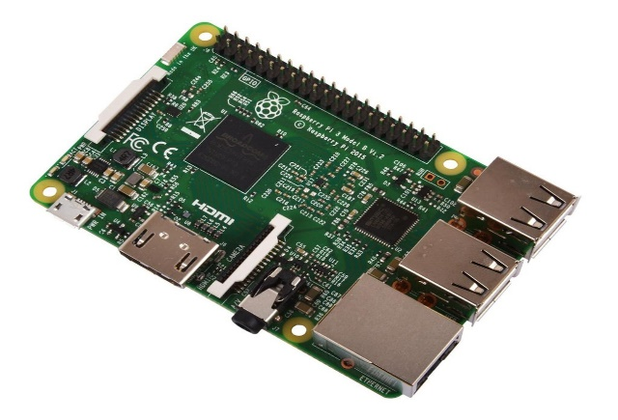The Raspberry Pi 3 Model B is a tiny credit card size computer and has a 64-bit processor and built-in WiFi. The Pi 3 also supports wireless internet out of the box, with built-in Wi-Fi and Bluetooth.it can also boot directly from a USB-attached hard drive or pen drive, as well as supporting booting from a network-attached file system, using PXE, which is useful for remotely updating a Pi and for sharing an operating system image between multiple machines.

**SOIL MOISTURE SENSOR:**

A soil moisture sensor can read the amount of moisture present in the soil around it. It’s a low tech sensor, perfect for monitoring a small garden, alternately your plant’s water level. The Soil Moisture Sensor uses capacitance to measure dielectric constant of the surrounding medium. In soil, dielectric constant is a function of the water content. The sensor creates a voltage proportional to the dielectric constant, and therefore the water content of the soil.

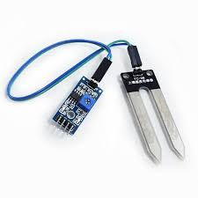

**DHT22 TEMPERATURE AND HUMIDITY SENSOR:**  
The DHT22 is a basic, low-cost digital temperature and humidity sensor. It uses a capacitive humidity sensor and a thermistor to measure the surrounding air, and spits out a digital signal on the data pin (no analog input pins needed).

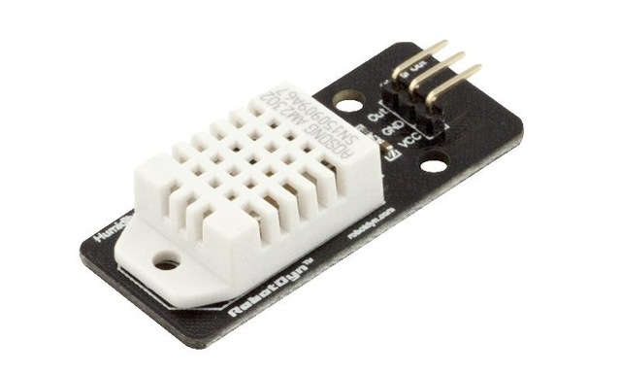

**Water level sensor:**

Although we irrigate the plants automatically, however, we still have to pour water into thebucket. With a fill level measurement, we could send a message as soon as water has to be refilled.

