C:\Users\admin\Downloads\Fig1_pipeline (1).png

**Fig. S1. The pipeline for extracting reliable genomic region.** The raw reads were used for the initial genome assembly. Extraction of reliable genome involved three steps. (i) The reads were filtered (Q30; 50bp). (ii) The filtered reads were mapped to the assembled genome. (iii) Regions covered by lower than three reads or higher than 27 reads or with mapping quality lower than 30 were masked. Guinea pig gene sequences were used to predict capybara genes.

**Fig. S2. Assessing the qualities of the publicly available genomes based on the proportion of undetermined amino acid (left panel) or number of predicted genes (right pannel).**



**Fig. S3. Assessing the quality of the genome annotations based on the lengths of the extrenal branches.** The amino acids of all homologous genes were aligned and used to make phylogenetic trees using the maximum likelihood method.

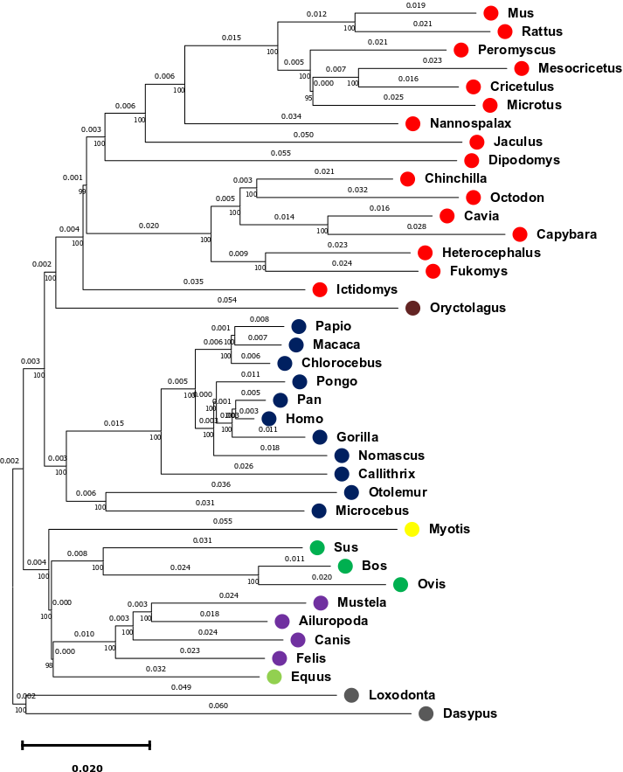

**Fig. S4. The phylogenetic tree of the investigated mammalian species computed with Neighbor-Joining method.** The amino acids of homologous regions for all the 39 species were concatenated and used for the phylogenetic construction. The topology of the tree is similar to the species tree.

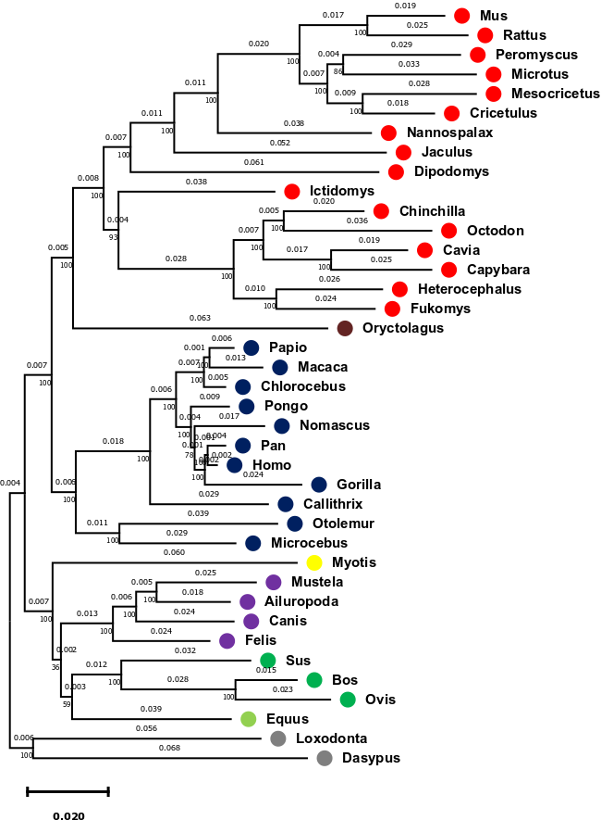

**Fig. S5. The phylogenetic tree of the investigated mammalian species computed with maximum likelihood method.** The amino acids of homologous regions for all the 39 species were concatenated and used for the phylogenetic construction. The topology of the tree is similar to the species tree and consistent with the Neighbor-Joining tree.

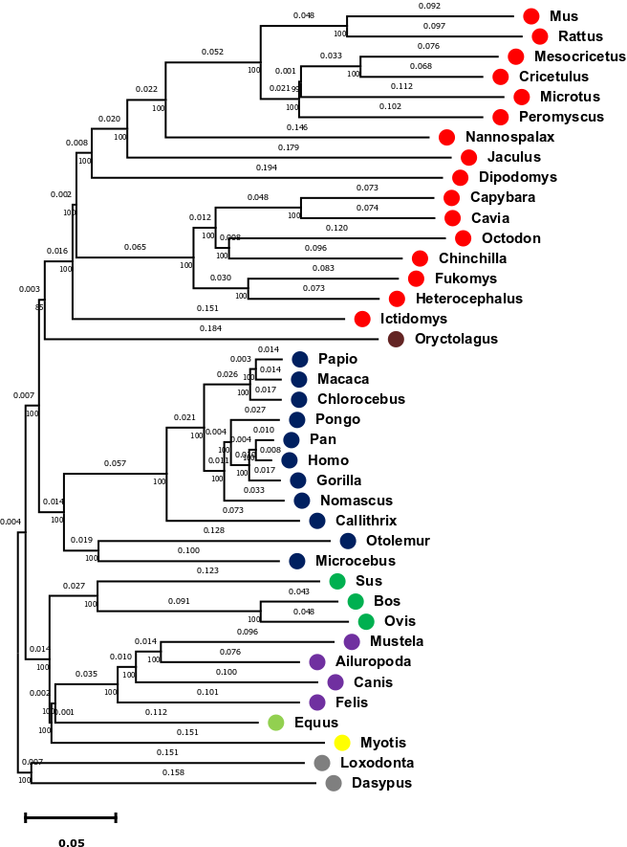

**Fig. S6. The phylogenetic tree showing the synonymous substitution rates.** The aligned codons of homologous regions for all the 39 species were concatenated and used for the phylogenetic construction.

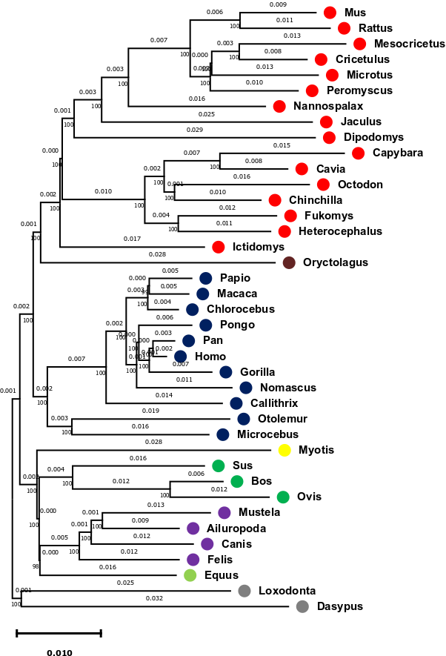

**Fig. S7. The phylogenetic tree showing the nonsynonymous substitution rates.** The aligned codons of homologous regions for all the 39 species were concatenated and used for the phylogenetic construction.

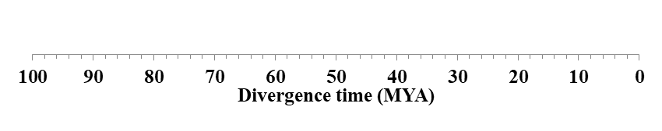

**Fig. S8. Phylogenetic relationships of mammalian species used.** Rodentia, Lagomorpha, Primates, Chiroptera, Cetartiodactyla, Perisodactyla, Carnivora, outgroup species (Cingulata and Proboscidea) are represented in red, brown, blues, dark green, light green, purple and grey colours, respectively. Divergence times were estimated using second codon positions. Calibration points, based on fossil records, are marked with stars.

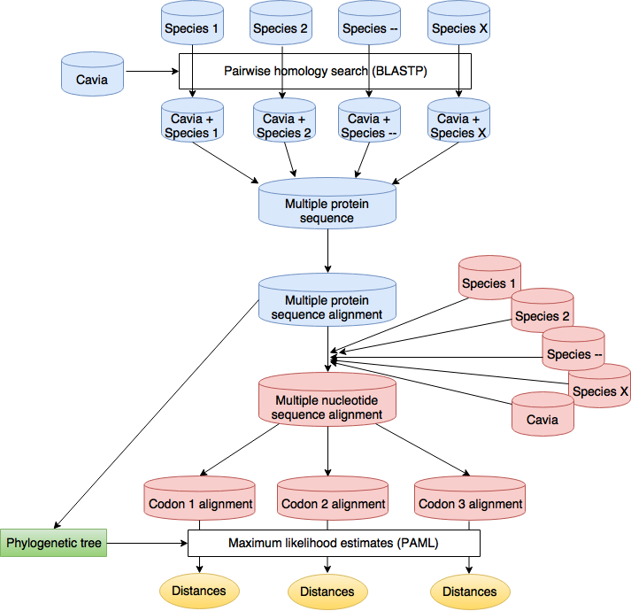

**Fig. S9. Pipeline for the computation of evolutionary distances.** Guinea pig was used as the reference species. Capybara and 37 other mammalian species were included in the analyses. The analyses started with pairwise amino acid homology searches including guinea pig and other species used. Reciprocal best hit were extracted and all the pairwise searched were combined into one multiple sequence alignment. The multiple protein alignment was converted into multiple nucleotide sequence alignment using coding sequences. The alignments were then split based on codon positions before distances were estimated by maximum likelihood method implemented in PAML. For distance estimation, phylogenetic tree made with multiple protein sequence alignment was used.

A

B

**Fig. S10. The read distribution of raw reads (A) and filtered reads (B).** The average depth for raw reads was 15×.Read cleaner was used for the filtering in B. After filtering, the average depth was 10×.

A

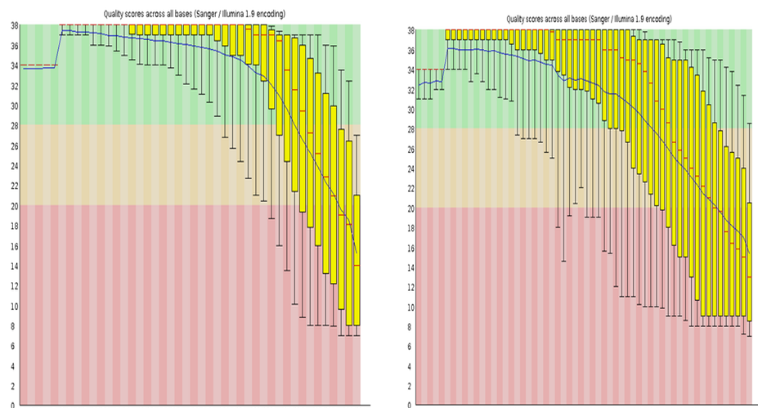

Q20

B

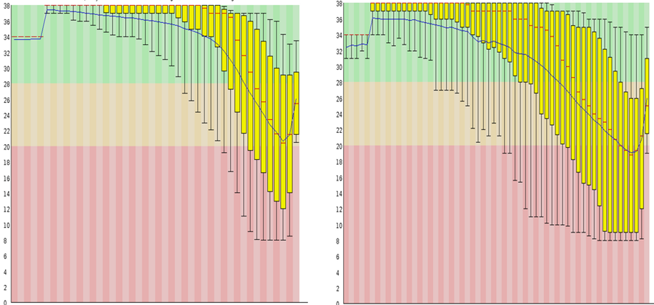

Q20

Q28

C

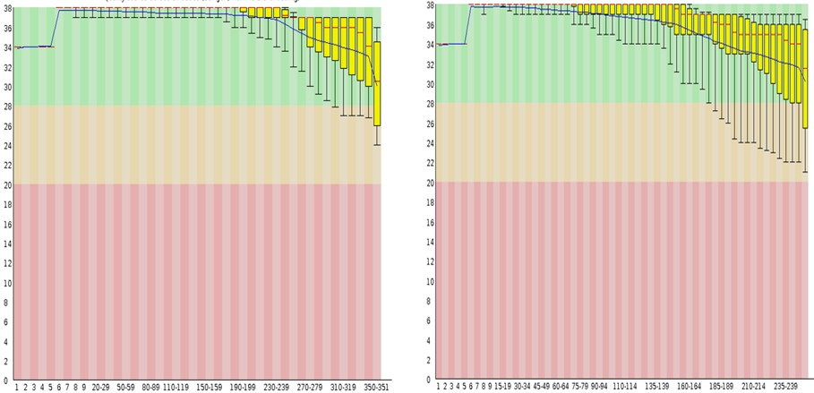

Q20

Q28

**Fig. S11. Quality assessment of filtered reads**. Pannels A, B and C are the quality assessments of raw reads, reads filtered by FastX tool kits and read cleaner, respectively. The figures on the left are read 1 while the figures on the right are read 2 of the paired-end sequencing. For the filtering tools, Q20 and 50bp thresholds were used. Although read cleaner abundantly reduces the yield, the quality of the reads are very high.

A

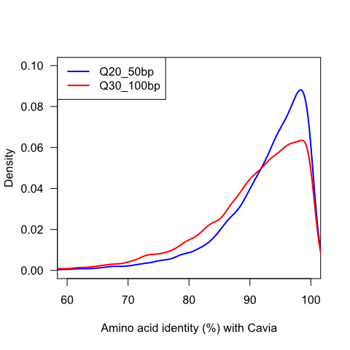

B

**Fig. S12. The reliability of the adopted threshold.** A. More stringent threshold did not improve the result as the distance to percent identity to guinea pig becomes significantly lower (Mann-Whitney U test p value < 2.2 e-16). B. The nucleotide composition of capybara for the thresholds adopted is similar to that of guinea pig.

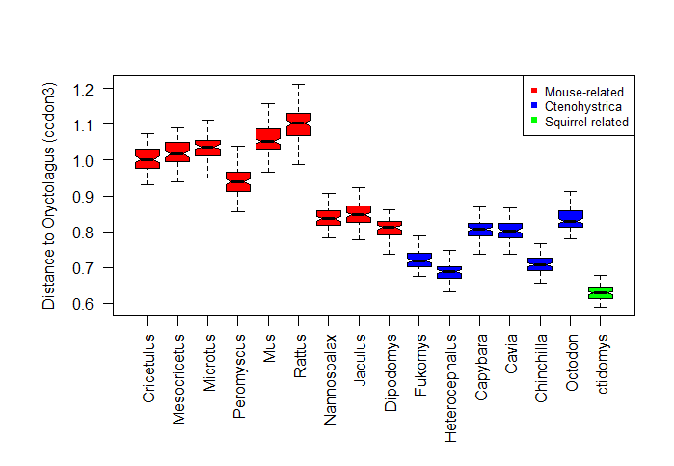

B

A

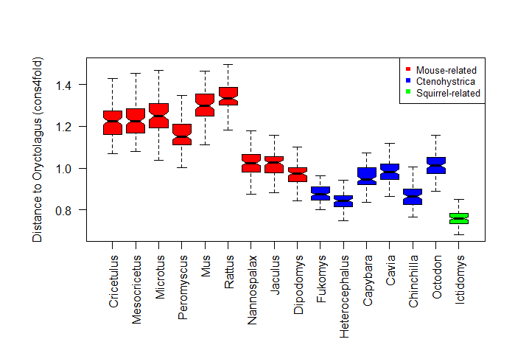

**Fig. S13. Distances of rabbits to the examined rodent species using third codon positions, codon3 (A) and four-fold degenerate sites with conserved first and second codon positions, cons4fold (B).**

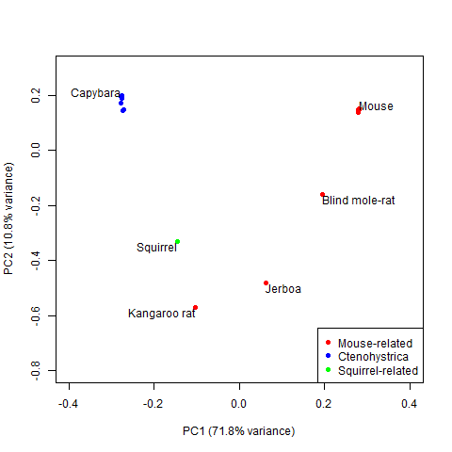

**Fig. S14. PCA analysis reveals heterogeneity among mouse-related rodent species.**

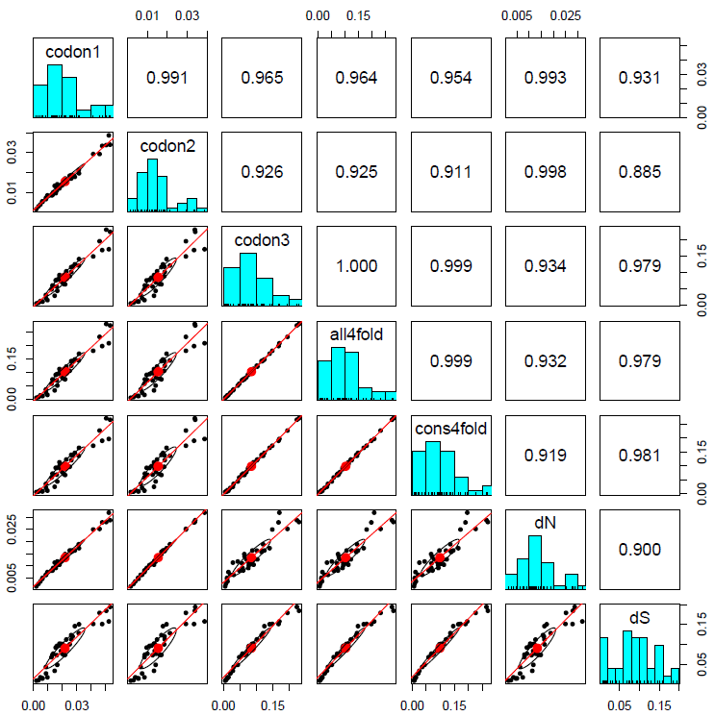

**Fig. S15. Various measures of evolutionary rates in mammalian species are highly correlated.** Evolutionary distances were computed independently for codons 1 (codon1), 2 (codon 2) and 3 (codon3), all four-fold degenerate sites (all4fold), four-fold degenerate sites with conserved first and second positions (cons4fold), nonsynonymous substitution (dN) and synonymous substitution (dS). The lower triangular matrix shows the scatter plots, each point representing a species, with the eclipse shown in black and best-fitting loess shown in red. The red circle represents the center of the distribution. The upper triangular matrix shows Pearson’s correlation coefficients. The diagonal shows the distribution frequency, presented in histogram, for each parameter. The highest correlations were found between measures of neutral evolutions.

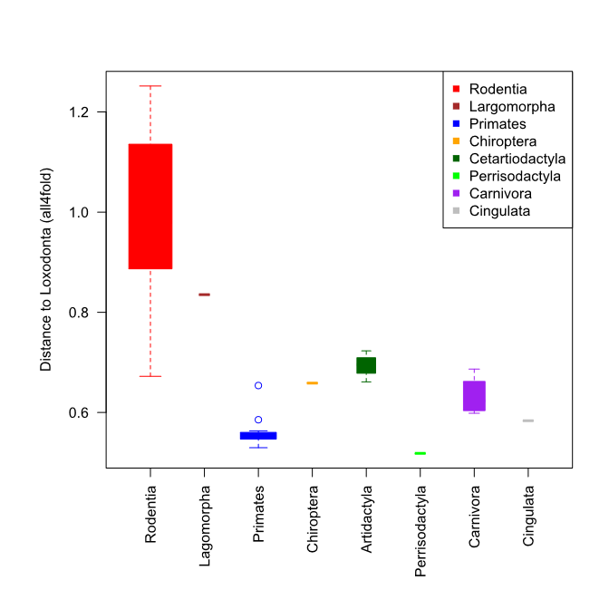

**Fig. S16. Evolutionary distances of various examined orders to elephant.** The widths of the boxplots are proportional to the square roots of the numbers.

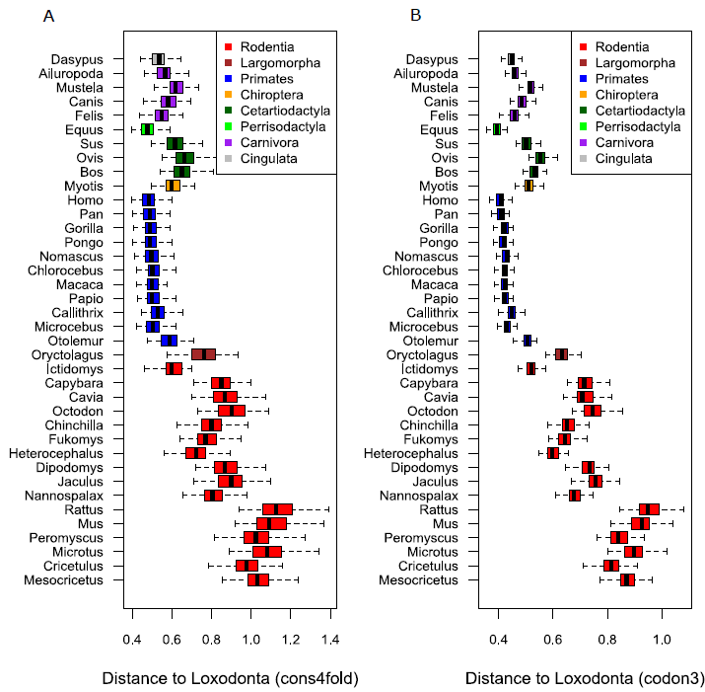

B

**Fig. S17: Mammalian evolutionary distances to elephant using codon3 (A) and cons4fold (B).**

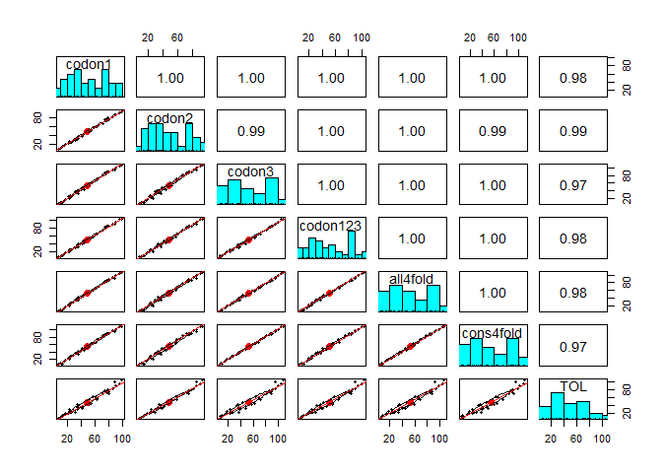

**Fig. S18. Divergence times estimated from various codon positions are highly correlated.** Divergence times were computed independently for codons 1 (codon1), 2 (codon 2), 3 (codon3), combination of codon 1, 2 and 3 (codon123), all four-fold degenerate sites (all4fold) and four-fold degenerate sites with conserved first and second positions. In addition, divergence times were also obtained from TOL (Hedges et al. 2015). The lower triangular matrix shows the scatter plots, each point representing a species, with the eclipse shown in black and best-fitting loess shown in red. The red circle represents the center of the distribution. The upper triangular matrix shows Pearson’s correlation coefficients. The diagonal shows the distribution frequency, presented in histogram, for each parameter.

**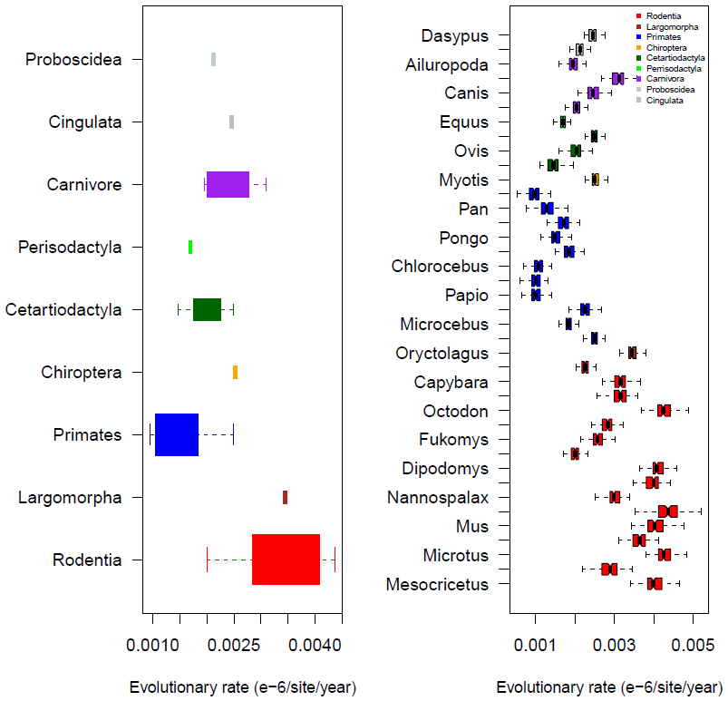**

**Fig. S19. Evolutionary rate dynamics among mammals.** For the rate calculation, all4fold evolutionary distances computed with baseml were used while codon2 MCMCtree time estimates were. Evolutionary rate per unit time of a branch is the evolutionary distance divided by time estimate for the branch. A. The highest evolutionary rate among mammalian orders studied is found in rodents. B. Evolutionary rates of all the species investigated are presented.



**Fig. 20. The phylogenetic tree showing the rate dynamics across phylogenetic timescale.** The value on each branch is the evolution rate (×10-9/site/year) computed from Figs. S7 and evolutionary distances computed from all4fold sites.Under the assumption of molecular clock, all branches would have similar lengths. Different branch lengths imply absence of molecular clock. The highest rate is found in Muidae and Nannosalacidae common ancestor.

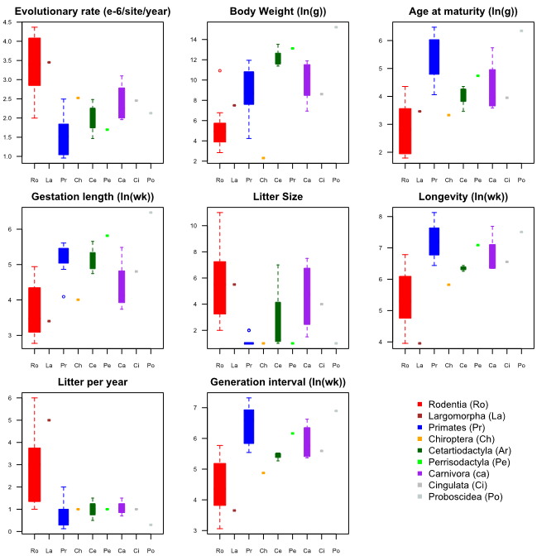

**Fig. S21. Various factors are different across order.** Evolutionary rates, body weight, age at maturity, gestation length, litter size, longevity, number of litter per year and generation interval were all different across orders. Ro, La, Pr, Ch, Ar, Pe, Ca, Ci and Po represent Rodentia, Largomorpha, Primates, Chiroptera, Artiodactyla, Perrisodactyla, Carnivora, Cingulata and Proboscidea, respectively.

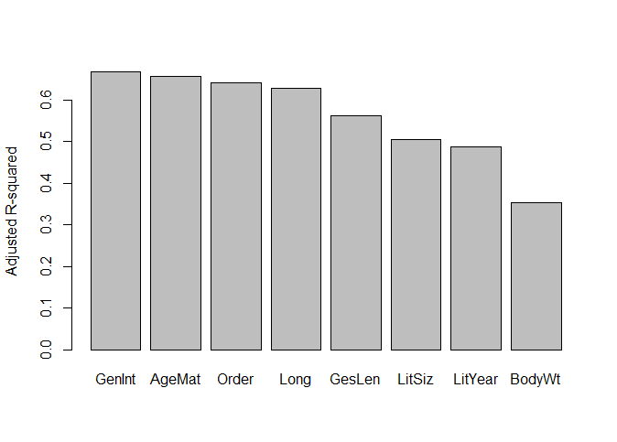

**Fig. S22. The adjusted R-squared for the linear regression analyses for each of the examined factor.**

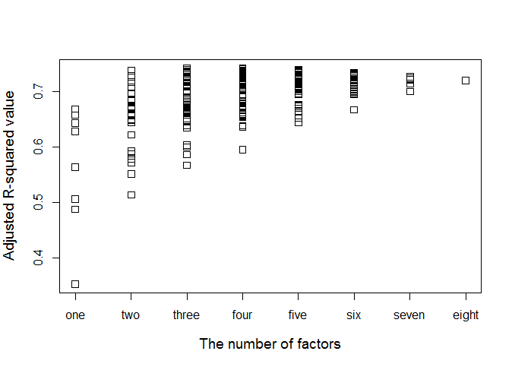

**Fig. S23. Linear regression models involving all possible combinations of factors considered.** The adjusted R-squared values are plotted for various numbers of factors. Models involving one factors are similar to what are presented in Fig. S22.

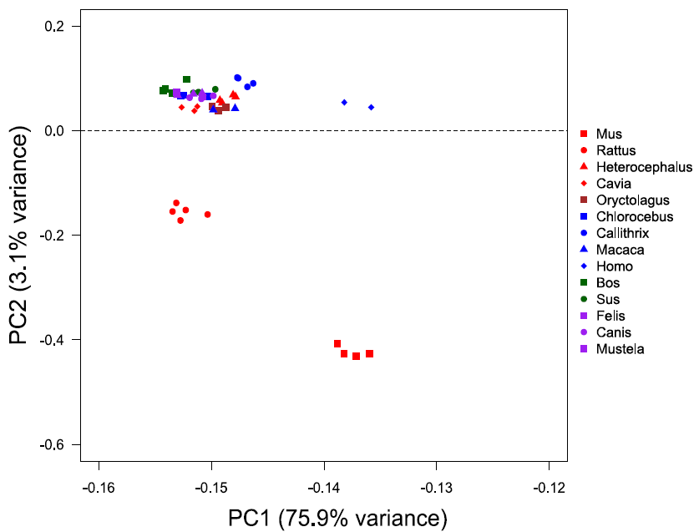

**Fig. S24. Transcriptome analyses reveal higher expression dynamics among rodent species.** PC1 did not classify any sample. The expression values of 9,457 genes with homologs among the 14 species from five orders were computed in 45 liver samples. The complete list of the samples is presented in Table S.